The Electromagnetic Spectrum

Radio Waves
- Longest ___________, lowest _____________  - Wavelength range:____________ to __________  - Usually described by their ____________  - Different types of radio waves (from high f to low f are: ________, ____, ____, ____, ____, ________, ________, ________  - AM stands for _____________ _______________ and is given in _______  - FM stands for _____________ _______________ and is given in _______  - 1st Radio waves were transmitted/detected by _____________ _____________  - The first “wireless” radio device was invented by:________________ ______________  - Can be _________________ or _______________ by Earth’s atmosphere  Cosmic Connection:  - SETI:_______________________  - Closely related to _________ or __________________ events | 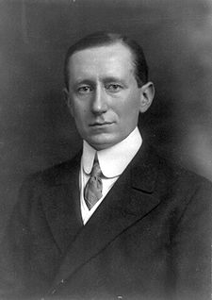  Guglielmo Marconi  (1874-1937)  http://en.wikipedia.org/wiki/Guglielmo_Marconi
Microwaves
- Name means:________________________  - Wavelength range:____________ to ____________  - Non-ionizing; when absorbed they cause ________,  ______________________________.  - First developed during _______ and used for ___________________.  - Causes:________________  Calculating the Speed of Light =  _________________ x _________________  c = ______________  % error =  Cosmic Connection:  _____________ and _____________ detected the ___________ ____________ _____________ _________ (CMBR). Left over radiation from the _________ ___________. Uniform to 1 part in 1 ____________. (Nobel Prize in 1978) | Telescope used by Penzias and Wilson at Bell Labs  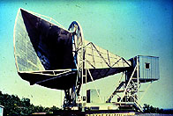  http://www.pbs.org/wgbh/aso/databank/entries/dp65co.html

Infrared Rays
- Name means:________________________  - a.k.a. ____________________  - Wavelength range:  Near:______________  Mid:_____________  Far:_____________  - Uses: _______________________________________  ______________________________________________  - Discovered in 1800 by __________________ __________________ using a prism and a _____________________  - Non-ionizing; when absorbed they cause atoms to _________________  Cosmic Connection:  Great indicator of ______________________________ | 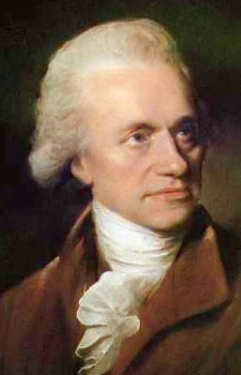  Google Image Search
Visible Light
- Small band of frequencies that the __________ of the eye responds to.  --Color receptors:_________________  --Black/white receptors:________________  - Longest wave, lowest frequency: _____________  - Shortest wave, highest frequency: _____________  - First separated into the visible spectrum by: _______________  Cosmic Connection:  -Identifying atomic ___________________  -Lightcurves of extrasolar _________________ | 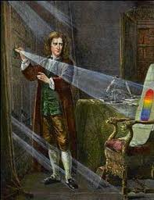  Biographyonline.net

Ultraviolet Rays
- Wavelength range:____________ to ____________
- Discovered in ______________ by ______________
________________--Tried to find “__________________” past the violet end of the spectrum after hearing about Herschel’s heat rays. White Silver Chloride turned dark when exposed to ____________________________________________________________. Named the new wavelength “_________________________”

- 3 Kinds: UVA:_____________________
UVB:_____________________
UVC:_____________________
- UVB and C destroy __________________________
- UVB produces vitamin _______ in skin up to __________IUs per min. Regulates ____________________ ___________________, immunity, and blood pressure.
- Uses: http://en.wikipedia.org/wiki/Johann_Wilhelm_Ritter
- 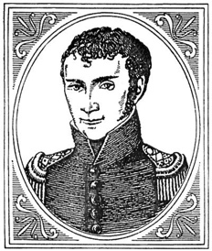
X-Rays
- Wavelength range:____________ to ____________  - Discovered in ______________ by ______________  __________________  - Man-made x-rays are made by a __________________ tube that generates high ______________ to accelerate _________ (cathode). The high velocity _________________ collide with a metal target usually ______________, (___________) .  - Uses:  Hard: Soft: | 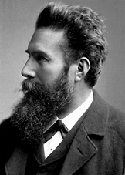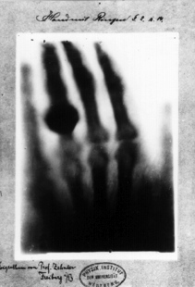  http://nobelprize.org/nobel_prizes/physics/laureates/1901/rontgen-bio.html

Gamma Rays
• Wavelength:____________  • Discovered in ______________ by ______________ ______________________  • Produced by :  Gamma-ray astronomy: Started in late 1960/early 1970 with the __________ satellite. Was used to detect __________  ________________________________, but instead found _________________________  _______________________________________  Ground-based gamma-ray detection: | 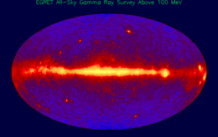
Cosmic Rays
*Not technically light, but travel at or close to c.
• Discovered in ______________ by ______________ ________________
• Energetic ___________________
originating from ______________
• May be:
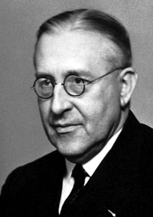
http://en.wikipedia.org/wiki/Victor_Francis_Hess

