Galactic Chocolate Chip Pancakes

Your task is to take what you know about the composition of “galactic chocolate chip pancakes” and relate that to a recipe for spiral galaxies. First one done correctly gets the first pancake!

Pancake Recipe |  |  | Galaxy “Recipe”
A | 4 cups flour |  | ____________ He
B | 0.375 cups (6 tbsp) Sugar |  | ____________ Stars
C | 0.0625 cups (1 tbsp) Baking powder |  | ____________ Other molecules (CO, HCN, H₂O)
D | 0.031 cups (½tbsp) Baking soda |  | ____________ Other gases (C, N, O)
E | 0.031 cups (½ tbsp) Salt |  | ____________ HI, HII, H₂ regions
F | ½ cup Chocolate Chips |  | ____________ Dust
 | 4 cups milk |  | = Gravity binding the galaxy
 | 4 eggs

Match each dry ingredient (white rows) with a galaxy ingredient on the right. Use the hint below to figure out how many chocolate chips are in a galaxy.

Clues:
- Like the universe, most of the galaxy is made up of this smallest element. Therefore, the pancake is made up of mostly this ingredient.
- The next largest ingredient is the second smallest element.
- While this is mostly dead skin cells on Earth (ick), in space this ingredient is essential for making stars in galaxies. It corresponds to the larger of the two ingredients that make pancakes rise.
- This is the smaller of the two ingredients that make pancakes rise. It matches up with the three elements that small stars like our sun will start to fuse Helium into.
- A sprinkling of this ingredient brings out the flavor in foods. These molecules add “flavor” to the interstellar medium.
- 1 cup of chocolate chips = 100 Billion (1x10¹¹ stars)

How many stars are in a typical spiral galaxy? ___________________

Classify the following galaxies as either spiral, barred spiral, elliptical, or irregular.

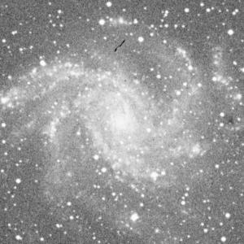 | 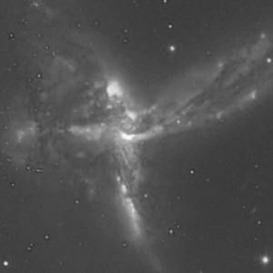 | 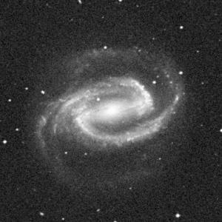
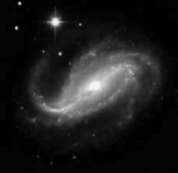 | 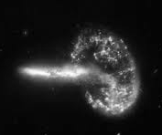
 | 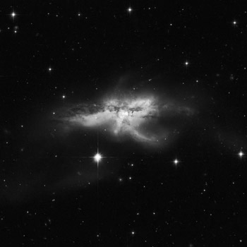 | A Challenge:

