Sundials
Background: Sundials are the oldest known instruments for keeping track of time. It is also one of the most ancient scientific instruments, requiring knowledge of the motion of the Sun over the course of years, knowledge of Polaris, the North Star, and not inconsiderable mathematics for civilizations that had yet to invent the number zero.
The first attempt at marking time, perhaps around 5000 BC, was probably a stick in the ground to cast a moving shadow, the precursor of a sundial's gnomon. By 2500 BC Babylonians and Egyptians were building obelisks (the Washington Monument is an obelisk) that functioned as clocks, dividing the day into before and after noon. They also indicated the longest and shortest day of the year.
The oldest extant sundial was built almost 3000 years ago in Egypt. It had six inscribed time demarcations on the base and a crosspiece to align the device east-west. The crosspiece casts a shadow to give the time.
By 250BC the Greeks produced complex and more accurate sundials using their knowledge of geometry. Their expertise led to the Tower of the Winds in Athens in 100BC. Its eight faces each contained a sundial.
A great improvement to sundial development came circa 100AD with the slanted gnomon, rather than a vertical rod. If the slant causes the gnomon to be parallel with the Earth's rotational axis, the shadow cast will be the same size at any hour. About this time the Greeks started to employ trigonometry to make hour lines more simple to read. The technology was now mature.
Until the invention of mechanical clocks in the 14th century sundials were the best way of telling time (during the day, of course). Types of Sundials: A stick and a board can be made (poorly) into a sundial.

Building a Sundial (http://ccphysics.us/henriques/a105l/Sundial.htm)

Here are some better variations:
Egyptian Shadow Clock | Human Sundial | Classic
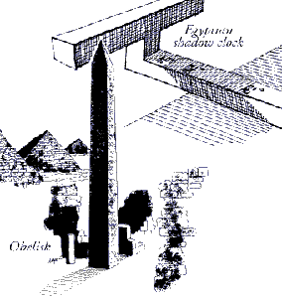 | 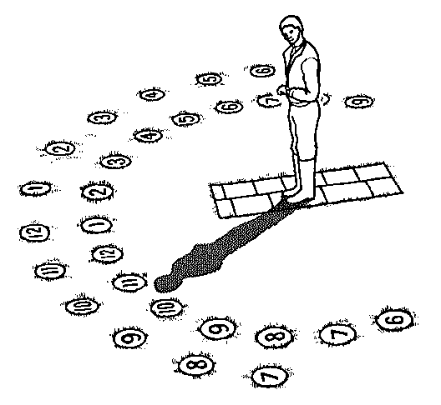 | 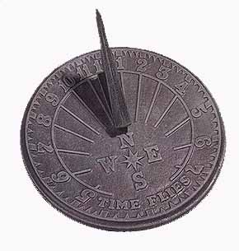
Bill Nye's Design for Seattle | Ring Style | Wall Sundial, U. of Washington
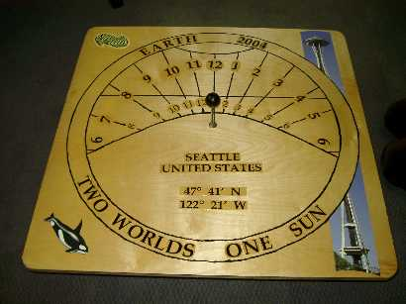 | 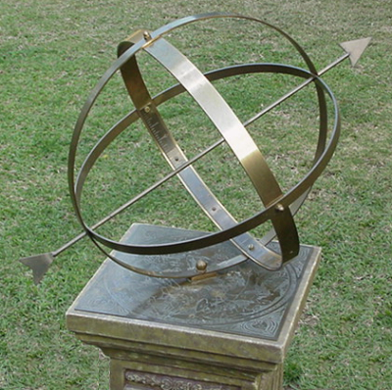 | 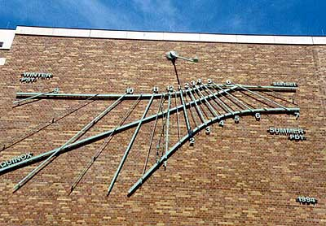
This is just a small sampling of what people have designed over 7000 years!

