*Build your Own Constellation Viewer*

*Amount of time for this lesson = 55 minutes (Each Day Here)*

1. Standards and Safety and Materials:

A. Standards – SC4.1.5 Objects in the Sky-Students describe observable objects in the sky and their patterns of movement.

W.4.2 Write informative/explanatory text to examine a topic and convey ideas and information clearly.

B. Safety Concerns: Students should be careful when using push pins. They could poke themselves.

C. Materials: 1 sheet of black construction paper (or paper towel tube)

10 3x3 squares of black construction paper

1 push pin

1 book ring

1 cereal box

1 scissors

White colored pencil or crayon

Scotch tape <http://www.bing.com/videos/search?q=constellation+video&FORM=VIRE3#view=detail&mid=7C08590E421B31EC255D7C08590E421B31EC255D>

(Material list is for 1 student)

2. Objectives:

A. SWBAT… Students will be able to **construct** Constellation viewer to understand that stars are in the solar system and are a part of a galaxy.

B. SWBAT… Students will **create** their own constellation and write a story or a myth to explain it.

3. Connections, Misconceptions, and Crosscutting Concepts

A. Real world connections: Astronomer, Astronaut, Fisherman, Farmer, Pilot, Armed Forces

B. Student connections: Constellations, Stars

C. Misconceptions: Constellations are not real, but they are used to understand which stars are which and to use for navigating and seasons.

D. Crosscutting Concepts: Patterns, movement, place in space

E. Academic Language: Constellation, stars, space, telescopes, Hubble, Myth

4. Catch/*Engagement*: <http://www.astrosociety.org/edu/surfgame.html>

5. Pre-test: See Below

6. Activity/*Exploration*:

Part 1: Lecture- Show video and discuss why knowing stars names and constellations are important in life.

Part 2: Lab

Step 1- Roll sheet of construction paper into a tube and tape (if you have a paper towel tube you can cover your tube to decorate. At the end of one side of the tube cut half way into the tube. This will hold your constellation cards. See illustration below.

Cut- but DO NOT cut all the way through the tube! ONLY half way.

Step 2- At the edge of each 3x3 construction square have student trace the tube with a white crayon or colored pencil See illustration below.

Step 3- Have students cut out lower half of the circle but leave the top of the square. See illustration below to see what cut out should look like.

Repeat will all squares- these now will be referred to as Constellation cards

Step 4- Next place one constellation card on the cereal box and the constellation template over top of the square adjusting the desired constellation over the circle portion of the constellation card. Use a push pin and poke the stars of the constellation. Have students write the name of the constellation in the rectangle portion of the constellation card.

Repeat until all desired constellations are finished. **Have students create their own constellation on one of the constellation cards.**

Step 5- Hole punch all cards and use a book ring to keep them together. Insert one finished constellation card into the cut end of the tube and look through.

When students are finished creating their constellation viewer, have them create a story or a myth about their own constellation. Read a few of the examples below so students have an understanding that some constellations have a story and to give them a model to create their own story. Students must **Write** their story in complete sentences.

7. Review/Essential Questions/*Explanation*: (Should be very closely related to your pre/post tests! Explanation piece…)

A. Low Level – What do we use to see deep into space

B. Middle Level – How would you use constellations in a career?

C. High Level –How would this information be useful if you were stranded in the middle of the ocean without a radio?

8. Assessments (Post-test)/*Evaluation*:

A. Formative: What is a constellation? Why do we need to know about constellations? Anyone know a story about a constellation they want to share? Are constellations a real story or a myth? What instrument do we use to see deep into space?

B. Post-test:

9. Timeline: A. Catch 4 min

B. Pre-test 3 min

C. Activity – 2 parts 45 min (writing may take longer, depending on student)

D. Review and Post-test 3 min

10. Enrichment/*Elaboration*: Constellation activity book

11. IEP Accommodations/Differentiation/Diversity: To accommodate you can already have 3x3 templates created for the students.

Astronomy Pre– Assessment Name ______________________

1. What is a constellation?

2. The Greek work galaxy means?

A. A lot

B. Bright

C. Milky

3. What makes up a galaxy?

4. What jobs could require the need to know the constellations for navigation purpose?

Astronomy Post– Assessment Name ______________________

1. What is a constellation?

2. The Greek work galaxy means?

A. A lot

B. Bright

C. Milky

3. What makes up a galaxy?

4. What jobs could require the need to know the constellations for navigation purpose?

Constellation template

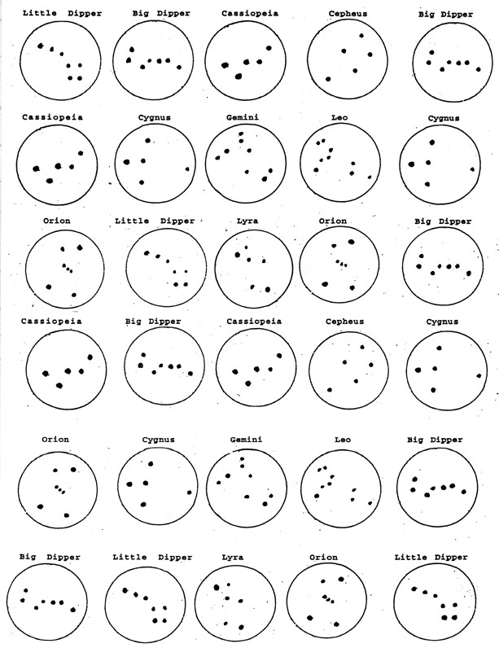

**Constellation**

**Legends**

by

**Norm McCarter**

Naturalist and Astronomy Intern

SCICON

**Andromeda – The Chained Lady**

Cassiopeia, Andromeda’s mother,

****boasted that she was the most

beautiful woman in the world, even

more beautiful than the gods. Poseidon,

the brother of Zeus and the god of the

seas, took great offense at this

statement, for he had created the

most beautiful beings ever in the form

of his sea nymphs. In his anger, he

created a great sea monster, Cetus

(pictured as a whale) to ravage the seas

and sea coast.

Since Cassiopeia would not recant

her claim of beauty, it was decreed that she must sacrifice her only daughter,

the beautiful Andromeda, to this sea monster. So Andromeda was chained to a

large rock projecting out into the sea and was left there to await the arrival of

the great sea monster Cetus. As Cetus approached Andromeda, Perseus arrived

(some say on the winged sandals given to him by Hermes). He had just killed the

gorgon Medusa and was carrying her severed head in a special bag. When

Perseus saw the beautiful maiden in distress, like a true champion he went to

her aid. Facing the terrible sea monster, he drew the head of Medusa from the

bag and held it so that the sea monster would see it. Immediately, the sea

monster turned to stone. Perseus then freed the beautiful Andromeda and,

claiming her as his bride, took her home with him as his queen to rule.

**Aquarius – The Water Bearer**

The name most often

associated with the constellation

Aquarius is that of Ganymede,

son of Tros, King of Troy.

Ganymede was an extremely

handsome young man, the most

handsome the gods and

goddesses had ever seen.

While attending to his

father’s flocks on Mount Ida,

Ganymede caught the attention of Zeus. Zeus sent his messenger eagle, Aquila,

down to earth with instructions to bring Ganymede back up to Mount Olympus.

On Mount Olympus, Ganymede served the gods by bringing them water

whenever they needed it. He also served as cup bearer to Zeus. He was

honored for his service by Zeus, who placed a constellation called Aquarius,

which means water carrier, among the stars.

**Aquila – The Eagle**

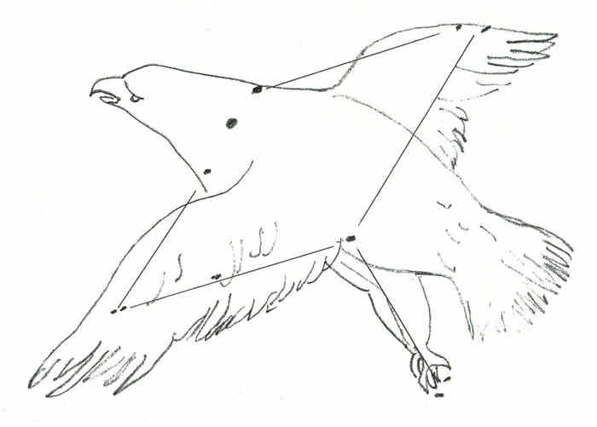In Greek mythology, the

eagle was associated with Zeus

(Jupiter), either as a servant

who carried Zeus’ messages down

to humans on Earth or as a

disguise taken by Zeus in order

to avoid his wife Hera when he

was up to some mischief.

One story of Aquila’s

service to Zeus was that of Ganymede, who was a very gentle, kind shepherd

and the most handsome mortal the gods and goddesses had ever seen. One day,

the great eagle Aquila swooped down from the sky and, landing near the

startled Ganymede, told him that Zeus had sent him to carry Ganymede to

Mount Olympus. And so, climbing up on the eagle’s broad back, Ganymede was

taken up to Mount Olympus where he served the gods by bringing them water.

**Aries – The Ram**

Athamas, the legendary king

of Thessaly, had two children,

Phrixus and Helle. He had

remarried and Ino, the children’s

stepmother, began to treat them

very badly. They were treated so

cruelly that Hermes took pity on

them and sent a magical ram to take

them away and escape their

stepmother’s wrath.

Mounted on the ram’s back, the children flew over land and sea to the

east. Unfortunately, Helle failed to get a good hold on the fleece of the ram

and as they flew over the strait that separates Europe and Asia, she fell off

and was drowned in the sea far below. That sea is called Hellespont to this day

in honor of her memory.

Phrixus landed safely at Colches, which is on the edge of the Black Sea.

In gratitude for his safe deliverance, Phrixus sacrificed the ram and gave its

Golden Fleece to the king of that country.

In honor of the ram’s great sacrifice in saving the children, Zeus placed

the ram’s constellation, Aries, in the night sky.

**Auriga – The Charioteer**

The constellation

Auriga is mentioned in two

ancient stories. The first,

relating to a charioteer, is

that of Auriga, the crippled

son of Vulcan and Minerva,

who invented a four-horse

chariot in order to get

himself around. This became

such an important invention that Zeus placed the first chariot into the skies

with the other constellations.

The second story, which is the older of the two, referred to Auriga as a

gentle shepherd who, after finding one of his pregnant goats missing, went out

into the hills and searched until he found her stranded on a rocky ledge with

her two new kids. Placing her across his shoulders and carrying the two kids in

his left arm, he returned to the rest of the herd. Some stories relate how the

two kids commemorate the two daughters of the king of Crete who fed and

cared for the infant Zeus.

**Bootes – The Bear Driver**

According to the Greeks, Bootes

was pictured as a mighty man. In his

right hand he holds a spear, and with

his left, two hunting dogs. Since he

appears to be pursuing the Great Bear

(Ursa Major) around the North Pole,

Bootes was called “The Bear Driver.”

The ‘key’ star, Arctures, can be easily

found by following the curved line

formed by the handle of the Big Dipper

outward to the first bright star.

Without doubt, Arctures was one of

the first stars to be named. It was one of the few stars mentioned in the

Bible, where it is referred to in the book of Job, thus giving it the name “Job’s

star.”