4275 Lesson Plan Outline Expectations (Number each item on your lesson plan!)

Lesson Title: The Crawl of the Crab
Amount of time for this lesson = __45___ minutes
Grade level: 3, 4, 5
1. Standards and Safety and Materials:
A. Standards –
i. 5MD - Represent and interpret data.
ii. 3.4MD - Generate measurement data by measuring lengths using rulers
B. Safety Concerns:
i. Minimal safety concerns with regular class activity
C. Materials
i. Supernova Type II Powerpoint
ii. Student Handout sheet
iii. Crab Nebula images from 1956 and 1999
iv. Rulers
v. Pencils
vi. Calculators (optional)

2. Objectives: (List them and make sure all are measurable! Bold the verbs. Three different levels!)
A. SWBAT…record and analyze data.
B. SWBAT…will measure the expansion of the crab nebula.
C. SWBAT…will observe that crab nebula expands out as a function of time.

3. Connections, Misconceptions, and Crosscutting Concepts:
A. Real world connections:
i. Recording data
ii. Measuring scale distances
B. Student connections:
i. Observe that numbers tell us something about the environment – ex: when you look at the temperature outside you know that it’s a hot or cold day
C. Misconceptions: (List those misconceptions related to your content)
i. Exploding stars are destroyed immediately after the “explosion” leaving nothing behind
ii. The Sun will explode
D. Crosscutting Concepts:
i. Patterns – students will recognize growth patterns of the SN remnant
ii. Scale, Proportion, and Quantity – students will determine scale growth of the SN remnant
iii. Energy and Matter – students will understand that SN release a great amount of energy and matter
iv. Stability and Change – students will learn how the SN remnant changes as a function of time

4. Catch/Engagement:
Show an image of a birthday cake and tell them it is something’s birthday and we are going to try to figure out how old the object is. Show the students a picture of a newly “born” ice cream cone. Show them an image of a half melted ice cream with a time stamp and another image of a completely melted ice cream with a time stamp and a value for the rate of melting. Ask the students how they might determine the age of the ice cream cone using the observations. Accept all answers. Quickly explain how students could determine when the ice cream cone was “born”. Show an image of the Crab Nebula and ask them what the celestial object is. Tell them we are going to try to figure out how old the Crab Nebula supernova remnant is using the ice cream cone process.

5. Pre-test: (Same as post-test and short – to the point… Bold the objectives you are using!)
Oral Pre-test questions. Have students “vote” on the answers and record them on the board or a piece of paper.
i. Celestial objects have a long lifetime
ii. Celestial objects move throughout space
iii. There is a simple mathematical equation to determine the growth rate of objects

6. Activity/Exploration: (Bold the verbs that match the objectives. …Can have as many parts as needed.
Include at least 1 science writing activity for the unit!)
Part 1: Lecture (Can’t be more than 10-15 minutes!)
A. SNe Type II power point (see slides with notes)
Part 2: Lab (Activities should take up 60% of the days – on average.)
A. WORKSHEETS, etc
i. Crab Nebula images from 1956 and 1999 (with lines from pulsar to knots drawn)
ii. Crab Nebula Student Worksheet
B. Step-by-step instructions
i. Go over objectives of lesson
ii. Go over an example of measuring the distance from the pulsar to knot 1 on 1956 image and 1999 image and recording data.
iii. Put students into groups
iv. Students will continue to measure the distance from pulsar to other knows on both images and recording their data in the correct data table.
v. Students from each group will share their data and I will record it on the board.
vi. Go over example of calculating the change in separation. Have students calculate the remaining separations.
vii. Go over example of determining the expansion rate. Have students calculate the remaining expansion rates.
viii. As a class, determine the elapsed time between images.
ix. Go over example of determining the age of the nebula. Have students calculate the remaining ages.
x. Have student in groups give age of nebula they calculated for each knot. As a class, calculate the average age.
xi. Go over example of year of the explosion. Have students calculate the remaining year of explosion for each knot.
xii. Have students in groups give year of explosion for each knot. As a class, calculate the average year of explosion.
xiii. Time dependent – instead of each group taking measurements and calculations for all 5 knots, give a specific knot to each group of students that they will then measure and calculate for.

Part 3: Reading:
None

Part 4: Discussion
Students will share what they learned from the lab and any questions.

7. Review/Essential Questions/Explanation: (Should be very closely related to your pre/post tests! Explanation piece…)
A. Low Level –
i. Type II SNe are exploding stars
ii. The age of the crab nebula is 960 years old
iii. The crab SNe exploded in 1054 AD
B. Middle Level – (Application/Applying and/or Analysis/Analyzing)
i. The crab nebula is expanding/growing as a function of time
ii. The crab nebula is expanding at a certain rate
C. High Level – (Synthesis/Evaluating and/or Evaluation/Creating)
i. Students could create an explanation on why the crab nebula is expanding (probably not enough time spent on this lesson for high level of learning)

8. Assessments (Post-test)/Evaluation: (Bold the verbs that match the objectives and are in the activity.)
A. Formative:
i. Teacher will ask oral questions to students throughout the activity and after
B. Post-test:
i. Review Pre-test questions orally. If students are still not getting the correct answer go over that activity objective again.
C. Summative:
i. Students in each group will explain what they learned about Type II SNe and the crab nebula specifically.
ii. Students will share the math the learned/reviewed in this lesson.
D. Explain how the data will inform tomorrow’s teaching:
i. No future teaching connection

9. Timeline: A. Catch 5 min
B. Pre-test 2 min
C. Activity – 4 parts 30 min
i. Lecture 5 min
ii. Lab 25 min
D. Review and discussion 8 min

10. Enrichment/Elaboration: (Include one enrichment activity for students that might finish early)
11. IEP Accommodations/Differentiation/Diversity: What accommodations will you use to support struggling learners?
Students will be in groups so struggling students can gain support from peers
During activity I will walk around and give extra support to struggling groups

For SN Type II Powerpoint go to the website below and download the Background_Presentation.ppt on July 29 under “Crawl of the Crab”.
http://physics.uwyo.edu/~aschwortz/LASSI/activities.html

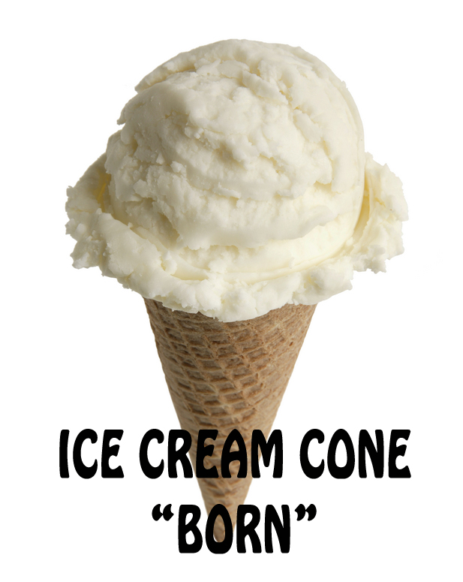
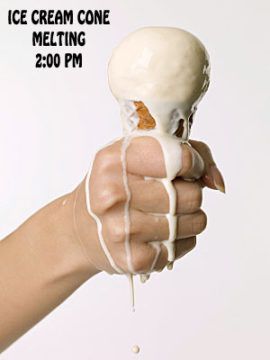
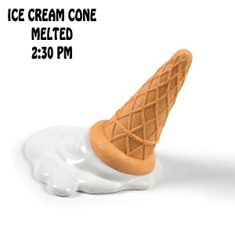
The Crawl of the Crab
Determining the Birth-year of the Crab Nebula
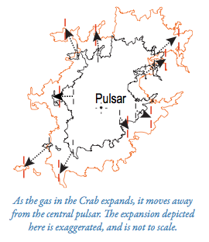

Introduction:
Two images of the Crab Nebula supernova remnant, taken 46 years apart, clearly show the expansion of the gas due to the explosion. In this exercise, you will determine the age of the Crab Nebula by measuring how much it has expanded over that period of time. You will convert the amount of expansion to a rate of expansion, and from there work backwards to determine the year the star exploded to form the Crab Nebula. In a sense, you’re trying to find the “birthday” of the Crab Nebula – except this method isn’t accurate enough to find the exact day, so really you’re finding the birth year of the Crab Nebula.

Procedure:
Examine both images of the Crab Nebula supernova remnant. One image was taken in February 1956, and the other in November 1999. Both images look similar at first glance, but if you look carefully you’ll see some differences. The images are at the same scale; the nebula itself has changed during the time between 1956 and 1999. It is this change that you will measure, and from that determine when the Crab supernova remnant was born.

Near the center of the nebula is a star marked “pulsar”. That is the collapsed core of the star that originally exploded. In both images there are 10 knots of gas marked and 10 lines extending from the pulsar to each of those knots.

- Starting with the 1956 image of the Crab Nebula, carefully measure the distance from the pulsar to each knot in centimeters. To do this, use your ruler and measure the length of the line from the pulsar to each knot.

- Record the length of the line from the pulsar to each knot in table 1 under the “Distance from the Pulsar 1956” column.

- Repeat step one for the 1999 image.

- Record the length of the line from the pulsar to each knot in table 1 under the “Distance from the Pulsar 1999” column.

- Next it’s time to measure how much the nebula expanded, or grew, from 1956 to 1999. For each knot, subtract the length of the line found in the 1999 from the length in the line found in the 1956 image. Record the value in table 1 under the “change in separation” column.

- To determine the age of the nebula, you need to find the expansion rate, or the amount the nebula has grown versus time. First you need to calculate the time elapsed from the 1999 image and the 1956 image. We will do this as a class. Record our calculation in table 2 under the “elapsed time” column.

- To determine the expansion rate of the Crab Nebula you need to divide the separation amounts by the time difference. For each knot take the “change in separation” found in table 1 and divide by the elapsed time we calculated as a class (found in table 2). Record the expansion rate for each knot in table 3 under the “expansion rate” column.

- Now that you have the rate of expansion, you can calculate the age of the Crab Nebula. We need to use the question:

$$rate=distance ÷time$$
Rearranging it to calculate the time:
$$time=distance ÷rate$$

Using the expansion rate you calculated in question 6 (found in table 3), and the distance of each knot from the pulsar for 1999 you found in question 2 (found in table 1 under the “Distance from the pulsar 1999” column), calculate the age of the nebula for each knot.
Record the age for each knot in table 4 under the “Age of the Crab Nebula” column.

- Calculate the average age of the nebula using the ages you derived for each of the knots. Record this value at the bottom of table 4.

- Given the date of the image you used to find the age, in what year did the star explode to form the Crab Nebula? To find the date for each knot subtract 1999 from the value you calculated for the age (found in table 4). Record each value in table 5 under “Year of Expansion”.

- Calculate the average year star exploded to form the Crab Nebula.

Knot | Distance from the Pulsar (cm)  1956 | Distance from the Pulsar (cm)  1999 | Change in Separation from  1956 to 1999 (cm)
1
2
3
4
5
6
7
8
9
10
Table 1

Table 2
Elapsed Time | (years)

Table 3
Knot | Expansion Rate (cm/year)
1
2
3
4
5
6
7
8
9
10

Table 4
Knot | Age of the Crab Nebula
1
2
3
4
5
6
7
8
9
10
AVERAGE

Table 5
Knot | Year of Expansion
1
2
3
4
5
6
7
8
9
10
AVERAGE

