Pfrazier Lassi Lesson Plan 2:
Graphic Design (grades 5-8)
80 minutes
- Standards and Safety Materials:
WSS
SC4.2.3 Students identify and use appropriate scientific equipment
SC4.2.1 Students research answers to science questions and present findings through appropriate means
SC4.2.2 Students use the inquiry process to conduct simple scientific investigations.
NGSS
5-ESS1-2.  3-5-ETS1-2. | Represent data in graphical displays to reveal patterns of daily changes in length and direction of shadows, day and night, and the seasonal appearance of some stars in the night sky.  Generate and compare multiple possible solutions to a problem based on how well each is likely to meet the criteria and constraints of the problem.
CCSS Math
CCSS.Math.Content.4.OA.C.5
Generate a number or shape pattern that follows a given rule. Identify apparent features of the pattern that were not explicit in the rule itself. For example, given the rule "Add 3" and the starting number 1, generate terms in the resulting sequence and observe that the terms appear to alternate between odd and even numbers. Explain informally why the numbers will continue to alternate in this way.
CCSS.Math.Content.6.SP.A.2
Understand that a set of data collected to answer a statistical question has a distribution which can be described by its center, spread, and overall shape.
CCSS.Math.Content.5.MD.B.2
Make a line plot to display a data set of measurements in fractions of a unit (1/2, 1/4, 1/8). Use operations on fractions for this grade to solve problems involving information presented in line plots. For example, given different measurements of liquid in identical beakers, find the amount of liquid each beaker would contain if the total amount in all the beakers were redistributed equally.

B. Safety Concerns: Minimal Safety Concerns with regular class activity
C. Materials: Graph samples worksheet; Heat vs. Temp worksheet; computer and printer for Excel; Sticky notes

2. Objectives:
A. Students will be able to classify sample data sets as closest to bar graphs, line graphs, pie graphs, scatter plots, or other.
B. Students will be able to interpret some graphical displays and create a sample scatter plot.
C. Students will be able to appraise the best choice of graphical display depending on the data information.
3. Connections, Misconceptions, and Crosscutting Concepts:
A. Real world connections: Information displays of wide variety of subjects; Wonder at todays’ graphing capabilities; Astronomical data set; begin collection of graphs from magazines, news online, weather, textbooks, parents work, etc.
B. Student connections: Become interested in the pictures of information – graphs!; Going beyond the typical elementary graphs; Sorting graphs
C. Misconceptions: Picture graphs, bar graphs, line graphs, algebraic graphs are like the ones they see on tests; graphs are limited to the type on Excel; Graphic Representations are different from graphs in school.

D. Crosscutting Concepts:

Systems and System Models
- Models can be used to represent systems and their interactions. (MS-ESS1-2)

Interdependence of Science, Engineering, and Technology
- Engineering advances have led to important discoveries in virtually every field of science and scientific discoveries have led to the development of entire industries and engineered systems. (MS-ESS1-3)

E. Academic Language: Graph/Graphical representations; Statistics; Comparing and Contrasting information; Data; Distribution; Number; Shape; Quadrant; Vertical; Horizontal; Axis
4. Catch/Engagement
Magazine graphs- show some then collect (like we did with leaves when we were little) at home or online throughout month to display on bulletin board.
http://www.uen.org/Lessonplan/preview?LPid=15231 – TED talk on statistical information made more interesting; Show pieces of this throughout year.
5. Pretest –included below - (verbs are highlighted on the actual test!)
6. Activity/Exploration:
Part 1: Lecture
X- Watch and discuss more of the TED talk noticing and pausing for the actual graph pics
Y- Question background knowledge of graph types. Grab a few of the pretests to put up on doc cam and share the basic types from some who knew them well. What do Graphs do for us? Why do we need them? Can you see how extremely diverse and engaging they have become from this video. Let’s look at some more.
Part 2: Lab
M- 1. Sort/Classify pics into categories; 2. Practice Excel with Astronomy Data
N-
1. “Before you is a sheet of different graphical representations. Use small sticky notes to label the types of graphs (Bar, Circle, etc.) and lay these on your desk vertically or horizontally. Cut them up carefully and sort/classify them into the types listed on the directions. Some are certainly under the ‘other’ category.
2. (Teacher determine groups or individual depending on skills) Create Excel Scatter Plot using Heat vs. Temp student handout, w/Excel- Intro and discuss purpose. (briefly discuss the astronomy, science, data, and directions and model for excel: “You will notice that the graph is here to draw. I would like you to NOT draw it as if we look at the data what do you notice? There are negative numbers and the graph only looks to have one quadrant. You could adjust. But instead, let’s go to Excel and practice data management here!” “Click on Word Office and bring up a blank excel sheet. You will need to type in Cell A1 the word the word ‘Heat Energy’. You may need to drag the cell to right bigger. In Cell B1 type the word Temp. IN all the Cells below HE, type in the numbers (1100-1725). IN all the cells below Temp type in the numbers (-10-75). Once you have completed that click on the A1 cell hold down and drag through the B27 Cell so both columns are highlighted. Then click Insert at the top and go to scatter and click the first pic.” AT this point as a few finish look and discuss/interpret information. Print graph to turn in for grade by clicking graph and cut and paste to a work doc.
IF have time, then click other graph types to show how useless some of them would be for this objective and which other ones work a bit but do they see the value of the scatter plot?!
Part 3: Reading- Have a student send a spreadsheet to me and put up to have us walk through once more for any who didn’t quite finish the see the whole process.
Part 4: Discussion- How can you see this will help you? What problems occurred? Common errors: typing – especially #’s, highlighting, x vs. y axis; printing; Did you learn something about Heat and Temp simply from this activity! “Should help in Physical Science!”
7. Review/Essential Questions/Explanation:
A. Low Level: Can you recall and describe the types of graphs we’ve seen and discussed?
B. Middle Level: How do we interpret this scatter plot? What is it contrasting?
C. High Level: Did you construct the graph correctly? Effectively? Precisely? Can you defend a position regarding heat and temperature?

8. Assessments (Post-Test)/Evaluation:
A. Formative-check all sort activities; print and turn in excel graph- (verbs are highlighted on the actual test!)
B. Post-test- included below (verbs are highlighted on the actual test!)
C. Summative- Map and Math 180 Tri-annual Tests
D. Review and Post-test- class average must be 80% or the next class we will need to review, discuss, and take post-test again.
9. Timeline: A. Catch -10 minutes (two day lesson)
B. Pre-Test- 10 minutes
C. Activity/Discussion/Student LASW(Look at Student Work) - 45 minutes (will go into next day)
D. Review and Post-test- 15 minutes
10. Enrichment/Elaboration:
Quasars and Large Data Sets; Even just the first steps of finding on Google, reading the background, and observing the numbers themselves would be great extension.
11. IEP Accommodations/Differentiation/Diversity:
Could reorder the page so they are already sorted then they just have to cut out and maybe play a matching game; Write out the types of graphs; lesson the number to do; partner help; They could even look at images only online and google different kinds of graphs and simply copy and paste a few of their own to a doc of their own.

Graphic Design Pretest/Posttest

- What do you think is the most common Graphic Representation type?

A. Picture Graphs B. Bar Graphs
C. Line Graphs D. Circle Graphs

- Quickly sketch an example of each of the above graphs. Write the type of graph in words below your sketches. You don’t need titles or labels!

- Interpret the information being shared in the graph below in at least 3 sentences.
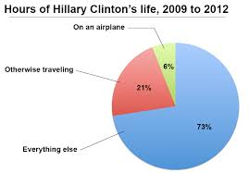

Graphical Representations
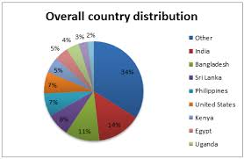 | 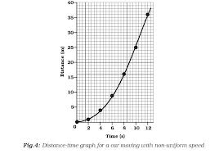 | 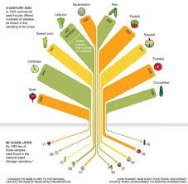 | 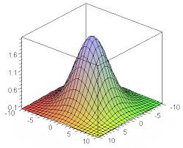 | 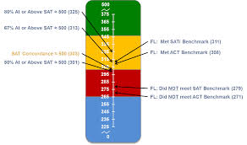
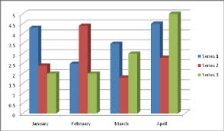 | 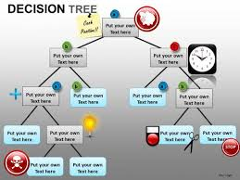 | 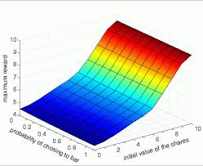 | 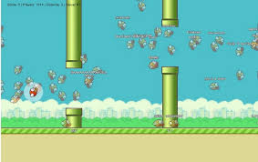 | 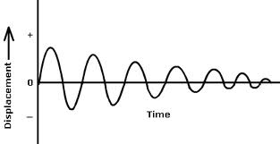
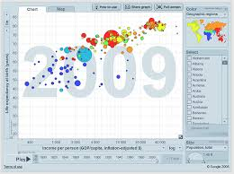 | 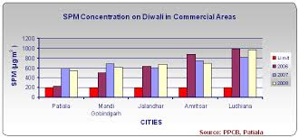 | 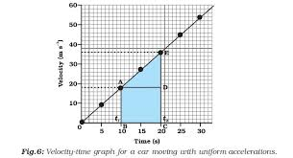 | 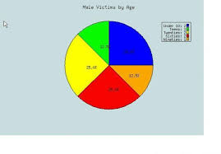 | 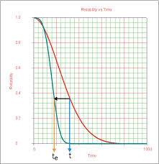
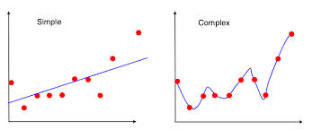 | 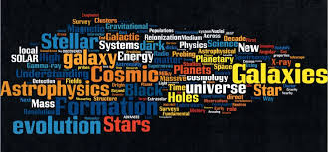 | 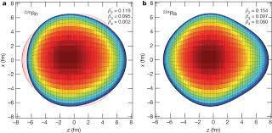 | 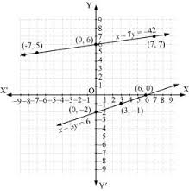 | 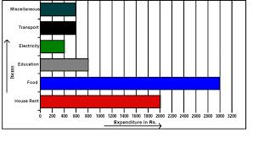

Directions:
- Cut these 20 graphical representations into individual rectangles.
- Sort them by type:
Circle Graph, Bar Graph, Line Graph, Scatter Plots, or Other
- Discuss as you sort. Be sure everyone has a voice. Help each other. Come to as best agreement as possible. Be able to defend your choices.

- Each person in your group will need to share regarding one of the types; why each fits, or doesn’t fit in others, and what the information might be about?!

Student Handout
Heat vs. Temperature
Name:________________________________________ Date:_______________

Mystery Substance Phase Change Diagram

Purpose: Your task is to create a phase change diagram the following data for a mystery substance. Once the graph is completed, you are to identify regions of freezing/melting and evaporation/condensation.

Temperature | Heat Energy (J) |  | Temperature | Heat Energy (J)
-10 | 1100 |  | 35 | 1425
-5 | 1125 |  | 35 | 1450
0 | 1150 |  | 35 | 1475
5 | 1175 |  | 35 | 1500
10 | 1200 |  | 35 | 1525
10 | 1225 |  | 40 | 1550
10 | 1250 |  | 45 | 1575
10 | 1275 |  | 50 | 1600
15 | 1300 |  | 55 | 1625
20 | 1325 |  | 60 | 1650
25 | 1350 |  | 65 | 1675
30 | 1375 |  | 70 | 1700
35 | 1400 |  | 75 | 1725
Part 1: Create a Phase Change Diagram using the above data:
“Mystery Substance” Phase Change Diagram

Temperature, °C
Heat Energy, Joules

