4275 Lesson Plan Outline Expectations (Number each item on your lesson plan!)

Learning About Light: Seeing Visible, Infrared, and Ultraviolet Light
Amount of time for this lesson = __90___ minutes (Each Day Here)
Grade Levels: 2, 3, 4, 5

1. Standards and Safety and Materials:
A. Standards –
i. NS.5-8.1 Science as Inquiry: Abilities necessary to do scientific inquiry
ii. NS.K-12.2 Physical Science: Light, Energy
iii. NS.K-12.5 Science and Technology: Understanding about science and technology
B. Safety Concerns:
i. Minimal safety concerns with regular class activity
C. Materials:
i. Diffraction gratings
ii. Source of white light (light bulb and stand)
iii. White Board
iv. Colored pencils
v. Visible Light Observation Worksheet
vi. Electromagnetic Spectrum poster
vii. Infrared Camera
*Note: if you do not have an IR camera the follow materials v-xiii are not necessary. Instead use the video “More Than The Eye Can See” found at the Cool Cosmos website.
viii. Ice Cubs
ix. Hot liquid
x. Cups
xi. Black garbage bag
xii. Piece of Plexiglass (12”X12” or so)
xiii. Hair dryer
xiv. Camera tripod
xv. 2 projectors
xvi. Infrared image prediction worksheet
xvii. UV sensitive beads
xviii. Strong
xiv. UV beads worksheet

2. Objectives: (List them and make sure all are measurable! Bold the verbs. Three different levels!)
A. SWBAT… investigate the electromagnetic spectrum
B. SWBAT… explain why they choose their mystery planet based on the numerical evidence provided
C. SWBAT… describe a planet based on numerical data

3. Connections, Misconceptions, and Crosscutting Concepts:
A. Real world connections: (List them - Like careers)
i. Explain how energy auditors, military, firefighters, and astronomers use light for their job
ii. Observing and recording observations
B. Student connections: (List them - What will they understand? Phone, tree, etc…)
i. What enables you to see?
C. Misconceptions: (List those misconceptions related to your content)
i. Infrared light is the same as night vision
ii. UV sensitive beads glow
D. Crosscutting Concepts: (List them here – e.g. patterns, movement, function, etc…)
i. Patterns – students will recognize there is a pattern to the order of the electromagnetic spectrum
ii. Cause and Effect – ultraviolet light causes the UV beads to turn colorful
iii. Energy and Matter – light is a form of energy. There are different “levels” of energy known as wavelengths

4. Catch/Engagement:
Show a common image in visible, IR, and UV light. Ask students to explain how each image is different. Ask students what they think causes the differences in these images.

5. Pre-test:
Oral Pre-test questions. Have students “vote” on the answers and record them on the board or a piece of paper.
i. Does the human eye see all light?
ii. Are there ways to detect visible and invisible light?
iii. Does the Sun give off more than visible light?

6. Activity/Exploration: (Bold the verbs that match the objectives. …Can have as many parts as needed.
Include at least 1 science writing activity for the unit!)
Part 1: Lecture (Can’t be more than 10-15 minutes!)
X – (Include all lecture notes, PowerPoint slides, etc… at end of this lesson)
i. Electromagnetic Spectrum Image
Y – (Step by step plan of delivery goes here… Construct a lesson as I lecture…)
i. Ask students if anyone knows how astronomers study objects in space since they physically can’t go to the object themselves to study it.
Ask students what on our bodies is able to detect light.
Ask students if they know the name of the light that we detect with our eyes.
ii. Tell students they will learn about the different forms of light, some we can see with our eyes and some we cannot see.
iii. (after the visible light activity) discuss the electromagnetic spectrum.
Part 2: Lab (Activities should take up 60% of the days – on average.)
M – (Include all worksheets, directions, etc… at end of this lesson)
i. Visible Light Observation Worksheet
ii. IR Prediction Worksheet
iii. UV Bead Worksheet
N – (Step by step directions go here… Create a lesson plan individually)
VISIBLE LIGHT
i. Tell students they are going to learn more about white, visible light. Introduce the diffraction grating and how to use it, emphasizing the rules.
ii. Pass out a diffraction grating to each student and have him/her look at the light bulb through the diffraction grating. Give the students a couple minutes to experiment looking at different things in the room through the grating.
iii. Have a class discussion on what the students saw when they looked at the white, visible light through the diffraction grating. Ask the students what this is telling us about white light. Explain how the diffraction grating works and how it separates the white light into the individual colors of the rainbow. Explain what a spectrum is and tell the students that they are looking at the visible spectrum.
iv. Hand out the visible spectrum worksheet to each student and have him/her put in order the colors that they observe, starting with the color that is closest to the light bulb. It might be helpful to do the first two colors together as a class. Go over the answer.
v. Discuss the electromagnetic spectrum and show the class a poster. Explain that visible light only makes up a tiny portion of all the light/energy that is in the Universe and that the rest of the energy/light is visible.
vi. Explain what a wavelength is, giving examples of short wavelength energy on the electromagnetic spectrum and examples of long wavelength energy on the electromagnetic spectrum.
INFRARED LIGHT (IR light)
vii. Tell the students they are now going to learn about the form of energy that has a longer wavelength that visible light. You can tell the students the answer or pose this as a question.
viii. Ask the students if they know what infrared (IR) radiation is. Describe and point out IR radiation on the electromagnetic spectrum.
ix. Ask the students how they think we “see” IR radiation seeing as its invisible light.
*If you do not have access to an IR camera show the “More Than The Eye Can See” video and skip to the IR prediction worksheet.
x. Tell the students that you are going to do a couple demonstrations for them and during the demonstrations they need to be thinking about what IR radiation is. Do the arm in the garbage bag and Plexiglass demonstrations, asking for a volunteer each time. Ask students what these demonstrations tell us about IR radiation? What is it?
xi. Explain the colors and temperature scale of the IR image. Do the hair dryer and ice cube mustache demonstrations to define the hottest and coldest parts of the image. Discuss how all the other parts of the image is a spectrum, with blue being cool and yellow being warm.
xii. Have students predict how they think a cup of hot water will look in IR, how a cup of ice cubes will look in IR, and how a cup of hot water with an ice cube in it will look in IR on the IR Prediction Worksheet. Give students 5-10 minutes to make their predictions. Have some students share. Show the hot water, ice cube, and hot water with ice cube image to the students and ask if anyone was surprised by what they saw?
xiii. Explain that everything that has a temperature will put out infrared light. Even things that we think of as being cold, like an ice cube, puts out heat. Cold objects put out less heat than warm objects. The warmer something is the more heat it puts outs and the colder something is the less heat it puts out. This is why hot objects glow more brightly in the IR because it puts out more heat and more IR light.
xiv. Ask students what some real-world applications of IR imaging could be then give them some examples.
xv. Ask students what on our bodies can detect IR radiation that we receive from the SUN.
ULTRAVIOLET LIGHT (UV light)
xvi. Tell students they are now going to learn about the invisible radiation that has a shorter wavelength than visible light. Ask students what the name of this radiation is.
xvii. Ask students if the Sun gives off UV light like it gives off IR and visible light and ask them if they can think of a way we can “see” or detect UV light.
xviii. Introduce the UV beads
xix. Hand out a couple of beads to each students and UV Bead worksheet. Tell the students they are to make at least 4 observations of these beads inside the classroom under the “inside” column. As a class, have some students share some of their observations, making sure that someone notes that they are “white” in color.
xx. Pass out the string and some more beads and have the students make a bead bracelet.
xxi. Have the students take their bead bracelet, their observation worksheet, and a pencil out into the sunlight. Give the students a minute or two to exclaim the wonderment at the changing color beads. Have them make at least 4 observations of the beads when exposed to sunlight under the “outside” column of the worksheet.
xxii. Collect the bracelets and go back inside. Have the students share some observations of the beads when they were exposed to UV sunlight. Hand back the bracelets and note how, once inside, the beads turn back to white. Ask the students what this is telling us about the kind of light that is given off by regular light bulbs.
xxiii. Explain the good and bad properties of UV radiation that we get from the Sun.
xxiv. Review the three main forms of energy that were discussed and ask the students if they have any questions.
Part 3: Reading (All readings should include before/during/after activities)
i. No readings
Part 4: Discussion (Students will list and describe parts of a good lesson.)
i. Students will predict, explain, and discuss throughout the lab.

7. Review/Essential Questions/Explanation: (Should be very closely related to your pre/post tests! Explanation piece…)
A. Low Level – (Knowledge/Remembering and/or Comprehension/Understanding)
i. Students will know there are multiple forms of light, some visible and some invisible
ii. Students will know we can detect all forms of light
iii. Students will understand the difference between visible, IR and UV light
B. Middle Level – (Application/Applying and/or Analysis/Analyzing)
i. Students will apply what they know about light to help them explain what they see in multiple wavelengths
C. High Level – (Synthesis/Evaluating and/or Evaluation/Creating)

8. Assessments (Post-test)/Evaluation: (Bold the verbs that match the objectives and are in the activity.)
A. Formative: (How will you check for learning/understanding in class?) – Oral questions?
i. Teach will ask oral questions to students throughout the activity and after
B. Post-test: (Say, “Same as pre-test”; Compare w/pre-test to inform teaching!)
i. Review pre-test questions orally. If students are still not getting the correct answer go over that activity objective again.
C. Summative: (How will you check for final learning/understanding?) –
i. Students will be able to name and explain the three types of light discussed in this activity
ii. Students will be able to explain how we can detect each form of light discussed
iii. Students will be able to explain an infrared image
iv. Students will be able to share which visible color is closest to the light source and which is furthest
D. Explain how the data will inform tomorrow’s teaching.
i. No future teaching connection

9. Timeline: A. Catch 2 min
B. Pre-test 3 min
C. Activity – 4 parts 80 min
D. Review and Post-test 5 min (Put as many sections as you need)

10. Enrichment/Elaboration: (Include one enrichment activity for students that might finish early)
i. Have students draw what they look like in IR
11. IEP Accommodations/Differentiation/Diversity: What accommodations will you use to support struggling learners?
i. I will walk around during the activities and help any student who is struggling.
ii. I will have students work in groups to gain support from their peers

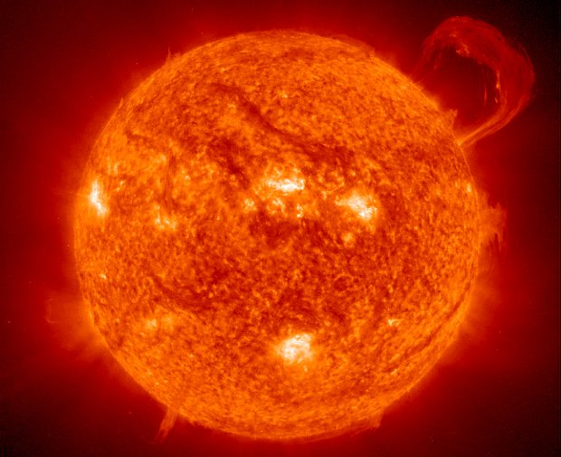
Sun in Visible Light

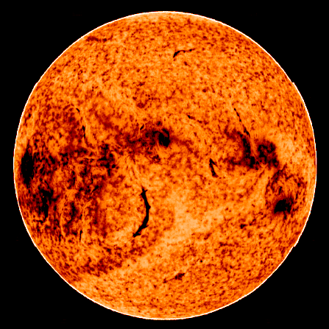
Sun in IR light

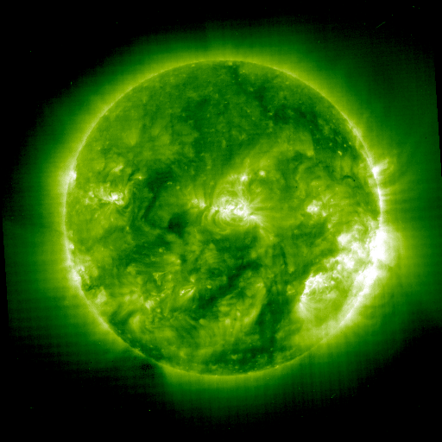

Sun in UV light

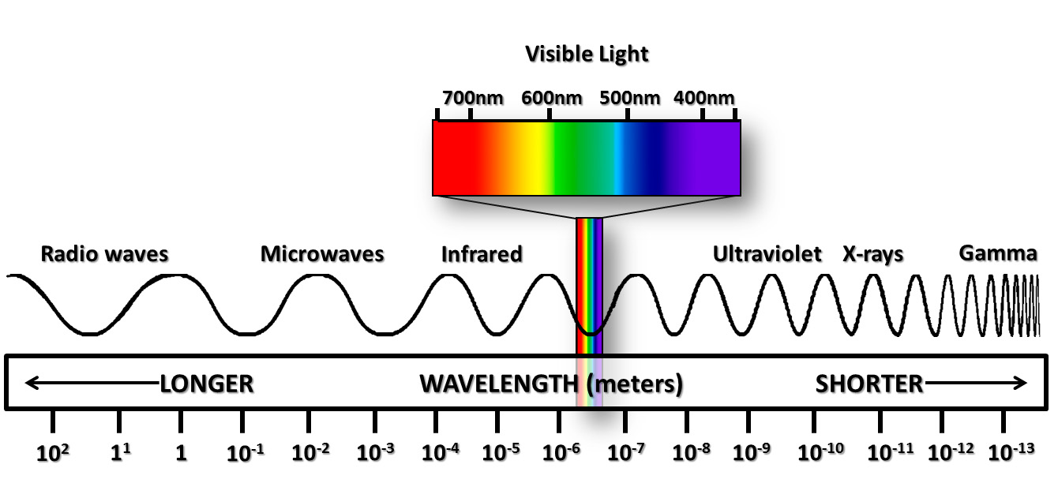
Electromagnetic spectrum

VISIBLE SPECTRUM WORKSHEET
Draw what you see when you look through the diffraction grating on the right side of the rectangle. Make sure you put the colors in the correct order.

L
I
G
H
T

S
O
U
R
C
E

The diffraction grating turns white light into the colors of the .

Make a hypothesis of what hot water will look like in infrared light and what ice cubes will look like in infrared light.

Hot Water

Cold Water

Make a prediction of what an ice cube in hot water will look like in Infrared.

Ultraviolet Bead Worksheet

What do the beads look like when you are inside?
Picture | Observations
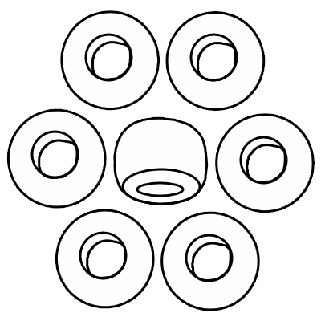

What do the beads look like when you are outside?
Picture | Observations

What kind of light do solar beads detect?
Advantages (Uses) | Disadvantages

