*Lesson Title: Title (Each Day Here)*

*Amount of time for this lesson = _____ minutes (Each Day Here)*

1. Standards and Safety and Materials:

A. Standards - (Wyoming? NGSS? Number and write it out)

B. Safety Concerns: Minimal safety concerns with regular class activity”

C. Materials: Styrofoam ball

Stick

Before lesson: Push the stick halfway to the center of the Styrofoam ball. Remove it, pour glue into how and reinsert the stick. Let dry.

Lamp

Sharpie Marker

Moon Phase Chart on transparency (see below)

Computer

Smart board or projector

Moon Phase Record Chart (see below)

Oreo cookies (extension)

Plastic knives (extension)

Plates (extension)

2. Objectives: (List them and make sure all are measurable! **Bold** the verbs. Three different levels!)

A. SWBAT… Students will be able to **construct** model of the moon in order to visually see the phases of the moon

B. SWBAT… Students will **create** a month long moon study

C. SWBAT… Students will understand the phases of the moon and describe why the moon goes into phases

3. Connections, Misconceptions, and Crosscutting Concepts:

A. Real world connections: Farmers, Astronauts, Oceanographers, Forest service, Agriculture

B. Student connections: Moon Phases, Waxing, Waning, Gibbous, Crescent,

C. Misconceptions: The Earth casts a shadow on the moon, that is why there are moon phases.

D. Crosscutting Concepts: Patterns of the moon  
 E. Academic Language: Waxing, Waning, Gibbous, Crescent, rotation, orbit, 1st quarter, 2nd quarter, 3rd quarter, 4th quarter, revolution

4. Catch/*Engagement*: Simulation of the moon phases (lab portion of the lesson)

5. Pre-test: See below

6. Activity/*Exploration*

Part 1: Lecture: Ask students briefly describe how the moon changes shape in our sky.

Part 2: Lab: Give each student a Styrofoam ball. It will represent the moon, they will be the Earth, and the light will be the sun.

2. Spread students across the room and turn out the lights. Show how to simulate the moon’s motion. Holding the moon between your face and the light, show that the side of the moon facing you gets no sunlight. Let students do this with their moons.

3. Turn slowly counterclockwise, holding the moon in front of your face. Let students do the same and tell them to watch the light on the moon as they turn. (The light on the ball appears as a thin crescent on the right side.)

4. Tell students to continue to slowly rotate, keeping the moon in front of their faces, high enough so that shadow falls on it. Have them keep up with your position. Describe what they should be seeing. (*More light falls on the right side of the moon until one side is fully illuminated—a full* *moon*.)

5. As they continue to rotate, point out that the right side of the moon begins to darken and light falls on the left side. Rotate to the beginning position, facing the sun.

6. Repeat the rotation and introduce names of the phases. When moon, sun, and Earth are lined up, no light shines on the side of the moon we face (new phase). Following that is the thin crescent, the first quarter, the gibbous moon, and, finally, the full moon when the sun is on one side of Earth and the moon on the other. Have students notice where the sun is during all phases.

7. Have them continue to rotate so they can see the phases in reverse after they pass the full moon.

Name these phases: gibbous, last quarter, crescent. Tell students to rotate slowly several times and watch to see the phases change.

Part 3: There is no reading for this lesson.

Part 4: Discussion: Show the transparency of The Moon’s Phases and point out how the sun illuminates the moon, just as it did in the simulation.

• Pass out Moon phase log Have students begin to watch the moon each evening, for the full month.

7. Review/Essential Questions/*Explanation*: Look over the transparency to make sure students understand what we would see on Earth compared to the location of the sun and the moon.

8. Assessments (Post-test)/*Evaluation*: (**Bold** the verbs that match the objectives and are in the activity.)

A. Formative: Walk around and be sure students understand what they see during lab. Ask students to create a model of the separate moon phases using oreo cookies.

B. Post-test: Same as Pre test

C. Summative: The class will review the material learned the following day, and if 70% of the students understand moon phases then we will talk about eclipses.

9. Timeline: A. Catch 2 min

B. Pre-test 3 min

C. Activity – 4 parts 45 min

D. Review and Post-test 8 min (Put as many sections as you need)

10. Enrichment/*Elaboration*: Create the moon phases with oreo cookies. Tell students the name of the moon phase and have them create the phase by using a knife to take away the white portion of the inside of the cookie. This could also be used as the assessment piece of this lesson.

11. IEP Accommodations/Differentiation/Diversity: Do the simulation with the struggling students twice if needed.

|  |  |
| --- | --- |
| Name: __________________________ | Date: __________________________ |

**Moon Phases Assessment**

1. Maddie must keep a moon journal for a homework assignment. Her sketches of how the moon appeared on three different clear nights are shown below. Based upon Maddie's drawings, it appears that the moon is waxing.   
  
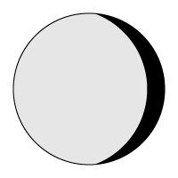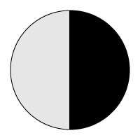

1. True

b. False

2. As viewed from the Earth, the moon appears in the sky as shown below. Which best describes the phase of the moon?   
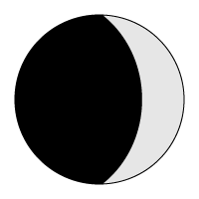

a. Crescent

b. Quarter

c. Full

d. New

3. Grace makes a diagram using the moon image seen below. She draws the Earth to the left of the moon and the sun to the right of the moon. Based on Grace's diagram, which statement is most correct?

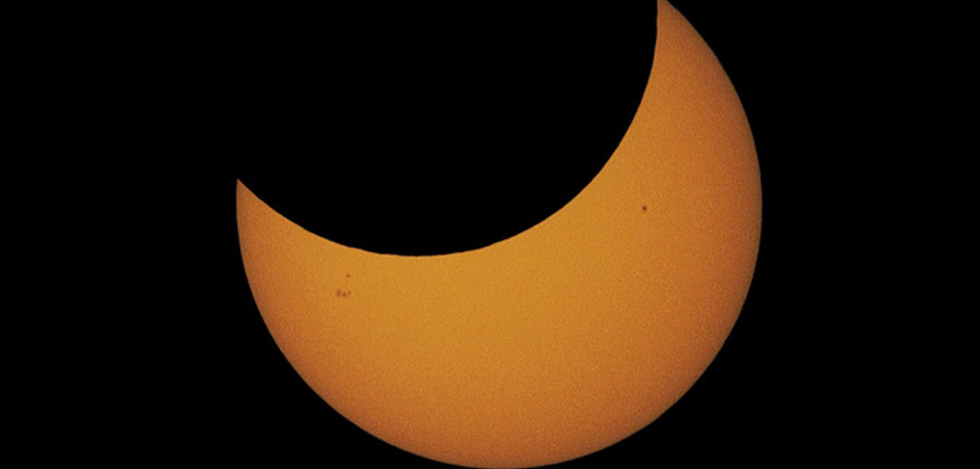

1. A lunar eclipse will be seen from some locations on Earth.
2. A lunar eclipse may be seen from some locations on Earth.
3. A solar eclipse will be seen from some locations on Earth.
4. A solar eclipse may be seen from some locations on Earth.

4. Javier is creating a moon phase diagram as part of an astronomy project. He drew an image of the moon shown below. Which of the following best describes the moon phase that could be represented by Javier's drawing?   


1. New
2. Full
3. Quarter
4. Gibbous

5. What phase would the moon be in if the Earth was located directly to the right of the moon on the diagram below?   


1. New
2. Full
3. First quarter
4. Third quarter

6. The phase of the moon that follows the waning crescent is called the

1. Full moon.
2. New moon.
3. Waxing crescent.
4. Third quarter.

7. The phase of the moon that follows the waning gibbous is called the

1. First quarter.
2. Third quarter.
3. New moon.
4. Full moon.

8. When the people on Earth cannot see a moon, which phase is the moon in?

1. Full Moon
2. Waxing Crescent
3. New Moon
4. Waxing Gibbous

9. The waxing gibbous moon rises in the afternoon.

1. True
2. False

10. How many days is it from one full moon to the next full moon?

|  |  |
| --- | --- |
| Name: __________________________ | Date: __________________________ |

**Moon Phases Assessment-KEY**

1. Maddie must keep a moon journal for a homework assignment. Her sketches of how the moon appeared on three different clear nights are shown below. Based upon Maddie's drawings, it appears that the moon is waxing.   
  


1. True

**b. False**

2. As viewed from the Earth, the moon appears in the sky as shown below. Which best describes the phase of the moon?   


**a. Crescent**

b. Quarter

c. Full

d. New

3. Grace makes a diagram using the moon image seen below. She draws the Earth to the left of the moon and the sun to the right of the moon. Based on Grace's diagram, which statement is most correct?



1. A lunar eclipse will be seen from some locations on Earth.
2. A lunar eclipse may be seen from some locations on Earth.
3. A solar eclipse will be seen from some locations on Earth.
4. **A solar eclipse may be seen from some locations on Earth.**

4. Javier is creating a moon phase diagram as part of an astronomy project. He drew an image of the moon shown below. Which of the following best describes the moon phase that could be represented by Javier's drawing?   


1. New
2. Full
3. Quarter
4. **Gibbous**

5. What phase would the moon be in if the Earth was located directly to the right of the moon on the diagram below?   


1. **New**
2. Full
3. First quarter
4. Third quarter

6. The phase of the moon that follows the waning crescent is called the

1. Full moon.
2. **New moon.**
3. Waxing crescent.
4. Third quarter.

7. The phase of the moon that follows the waning gibbous is called the

1. First quarter.
2. **Third quarter.**
3. New moon.
4. Full moon.

8. When the people on Earth cannot see a moon, which phase is the moon in?

1. Full Moon
2. Waxing Crescent
3. **New Moon**
4. Waxing Gibbous

9. The waxing gibbous moon rises in the afternoon.

1. **True**
2. False

10. How many days is it from one full moon to the next full moon?

**29 1/2**



