Lesson Title: Measuring Distances - Parallax and Trigonometry
Amount of time for this lesson = __55___ minutes – Grade 10, 11

1. Standards and Safety and Materials:

A. Standards - Common Core Mathematics
CCSS.MATH.CONTENT.HSF.TF.B.7
(+) Use inverse functions to solve trigonometric equations that arise in modeling contexts; evaluate the solutions using technology, and interpret them in terms of the context.*
CCSS.MATH.CONTENT.HSG.SRT.B.5
Use congruence and similarity criteria for triangles to solve problems and to prove relationships in geometric figures.
CCSS.MATH.CONTENT.HSG.SRT.D.11
(+) Understand and apply the Law of Sines and the Law of Cosines to find unknown measurements in right and non-right triangles (e.g., surveying problems, resultant forces).
B. Safety Concerns: minimal safety concerns with regular class activity
C. Materials - Index cards, meter sticks, tape measures, paper, and calculators

2. Objectives:
Students will be able to apply Trig. concepts (Sine, Cosine, law of Sines, etc) to determine relationships between angular
size and physical/linear size.
Students will be able to use angular size to measure physical sizes.
Students will be able to measure distance using parallax.

3. Connections, Misconceptions, and Crosscutting Concepts:
A. Real world connections: astronomy (astronomers), surveyors, engineers, mathematicians
B. Student connections: Triangles exist in astronomy (and other areas of real life) and we can use trig. properties to solve
for angles and lengths.
C. Misconceptions: Students will not understand the types of triangles being used and misapply trig. relationships
D. Crosscutting Concepts: scale proportion quantity, system and system models

4. Catch/Engagement: Have students hold their thumbs at arm’s length and close one eye and then switch and notice their thumbs jump. Have students move their thumbs closer to their face to observe more displacement. Explain the concept of parallax.

5. Pre-test: How do scientists measure stars really far away? What type(s) of triangles are used in measuring really far distances?

6. Activity/Exploration: See student handout. Students will create an angular measuring device by applying right triangle trig. ratios and then test their angular device to measure a real life distance outside of the classroom.

7. Review/Essential Questions/Explanation: How do you create a measuring device?
How can we test for error in a measuring device?
How can a distance be determined when it cannot be physically measured?

8. Assessments (Post-test)/Evaluation:
A. Formative: Oral questions regarding the essential questions.
B. Post-test: Same as pretest.
C. Summative: Students will turn in lab notes and work from handout.
D. If class average is below 80%, I will review the trig. ratios need in finding distances for parallax.

9. Timeline: A. Catch 3 min
B. Pre-test 3 min
C. Activity – 4 parts 40 min
D. Review and Post-test 9 min

10. Enrichment/Elaboration: Students who finish early can find another object in town to find the distance to with their angular notecard.

Student Handout
Measuring Distances — Parallax

Name: Date:

Launch
First, let’s explore parallax a little. Hold your thumb at arm’s length, and look at it only using one eye. Now switch eyes. Describe what happens:

Now bend your elbow at a 90 degree angle so that your thumb is only half as far from your eyes. Observe your thumb with one eye closed, and then switch eyes — what is different from when your arm was fully extended?

This apparent “jump,” or angular shift, is due to parallax. Physically it is the same effect that astronomers use to measure distances to relatively nearby stars.

Introduction
Being able to measure distances to astronomical objects is fundamental to astronomy — but how do we do it? For nearby objects, like the Moon, we can bounce laser beams off them to find distances. But what about more-distant stars?

The first step in the “distance ladder” uses Trigonometry and the principle of parallax — the shift in the apparent position of an object along two different lines of sight, relative to a distant background. In this activity, you will calibrate an angular measuring device, and use it to measure the distance to an object on the other side of town. To figure out how this works, we need to remember some trig.

Review of Trig. Law of Sines
Sin Ө = $\frac{opp}{hyp}$ Sin $\frac{A}{a}$ = Sin $\frac{B}{b}$ = Sin $\frac{C}{c}$
Cos Ө = $\frac{adj}{hyp}$ Law of Cosines
Tan $Ө$ = $\frac{opp}{adj}$ a² = b² + c² - 2bcCosA

Activity
Part 1: Angular Size and Distance

1. The closer an object is, the larger it appears — that is, the larger its angular size. The relationship between the distance (D), the physical size (L), and apparent angular size (α) of an object is something that we need to figure out using trigonometry.

Write an equation to solve for the angle α if we know L and D (what trig. ratio has those two sides of a triangle.)

L
α

D

Would this equation be different for an angle in radians or degrees?

Notice that L and D need to be in the same units. Today we’ll use meters (m), but we could easily use centimeters (cm), astronomical units (AU), or lightyears (ly). We will calculate our angle in degrees.

Let’s use these relationships to calibrate an angular ruler (in this case a notecard) at your arm’s length. Your objective is to delineate your index card into 1 degree segments when you hold the card at arm’s length.

- Hold your card at arm’s length and have a partner measure the distance from your eye to your card. D = ______________ cm
- Compute the physical size (L) on the card which will cover (subtend) 1 degree at arm’s length: (rearrange and use your equation from before)

L = _____ cm

- Use a ruler to make small marks across the long side of the card using L _____ cm from your above calculation.
- At arm’s length, these steps correspond to 1 degree in separation.
- If your arm was twice as long, L would become: _________ cm
- If instead we wanted marks every 0.25 degrees, L would become: ________ cm

2. Using your now-calibrated angular ruler (notecard), measure the angular size of the indicated line on the whiteboard at the front of the room, while standing at the back of the room. Make sure to also measure the distance at which you’re measuring the angular size!

D = ___________ m (Distance away from whiteboard)
α = ___________ degrees (Using your notecard, how many angular degrees
wide is the indicated line)

Using your previous equation, calculate the physical linear height of the whiteboard:

L_{computed} = ___________ m

Now, directly measure the size of the chalkboard with a meter stick or tape measure:

L_{direct} = ____________ m

Compare the two measurements by calculating the percent error below:
(See if you can remember how to calculate percent error.) Write down your formula and calculate how accurate your calibrated angular ruler is below.

What do you think is the largest contribution to the percent error? How can you reduce it?

Now that you’ve calibrated your angular ruler, let’s use it to measure the distance to something we can’t directly measure with a ruler/tape measure — just like astronomers do.

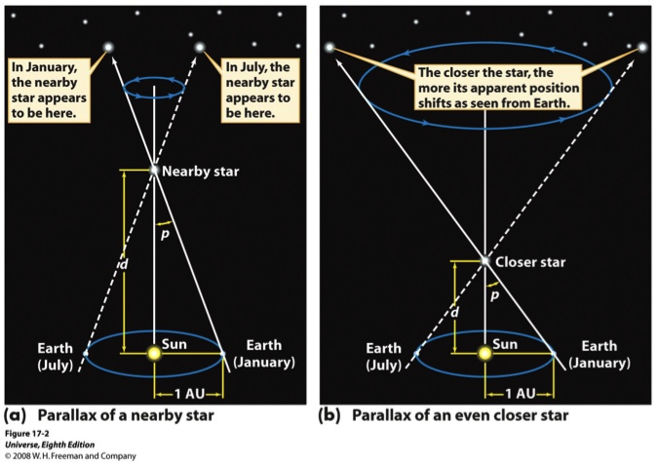

3. Now, imagine your head was so large that the width between your eyes was the diameter of Earth’s orbit around the sun. If you opened and closed one eye, then the other, the nearby stars would “jump” back and forth relative to the more distant stars, like your thumb jumped relative to more distant objects in the room.

The distance between vantage points (the size of the Earth’s orbit in the example above) is called the baseline (B), and the apparent angular shift relative to distant objects is called the parallax angle (p):

You’ll notice that this is a similar triangle we used before, but with the linear size now the baseline (B) and the angular size (p): now the parallax angle. Now label the triangle with these new vocabulary terms.

Let’s go outside and make some measurements. We’ll be measuring the distance to the ____________________________________________________________________.

- First, establish your baseline. Pick two locations separated by at least 15 m where you have a clear view to the object. Measure your baseline of where you want to view our object from.

B = ______________ m

- Draw a sketch of where your object falls relative to the more distant background from side one of your baseline. The place at which your object overlaps the background is called reference point 1 — remember what it looks like!

View from location 1:

- Now do the same for the other edge of your baseline. Where your object overlaps the background is called reference point 2.

View from location 2:

- From the second viewpoint, use your angular ruler to measure how many degrees the object appears to have shifted compared to the background, this is the parallax angle between reference point 1 and reference point 2.

p = _______________ degrees

- Label the triangle below with your measurements

Now, find the values for half of the triangle, so we can use our equations from before.

____
_______

__________

and now compute the distance to the object using your previous equations below:

4. Compare your measurement with those of your classmates

Your measurement: _______________ m

Measurement 2: _______________ m

Measurement 3: _______________ m

Measurement 4: _______________ m

Measurement 5: _______________ m

Measurement 6: _______________ m

Measurement 7: _______________ m

Average: _________________ m

- How accurate do you think YOUR measurement is (within 1 m, 10 m, 100m m)?

- Do you think that taking an average of your measurement with several others’ gives a better estimate of the TRUE distance? Why

