Joe Meyer—LASSI Summer 2014
Lesson Title: Finding an Expansion Function for a Super Nova Explosion
Amount of time for this lesson = 55 minutes, High School CCSS Mathematics

1. Standards and Safety and Materials:
A. Standards – CCSS for High School Math: F-LE2: Construct linear…functions…given a graph, a description of a relation, or two input-output pairs (include reading these from a table); ALSO part b. Recognize situations in which one quantity changes at a constant rate per unit interval relative to another.
B. Safety Concerns: minimal safety concerns with regular class activity.
C. Materials: student handout, centimeter ruler, Chromebook allowed but not required, as each student has one.

2. Objectives:
A. Students will be able to differentiate a linear from an exponential data trend.
B. Students will be able to describe what happens when a supernova occurs.
C. Students will be able to convert measurements in centimeters to arcseconds using a provided scale.
D. Students will be able to model the expansion of a supernova by using SN1987a size data.

3. Connections, Misconceptions, and Crosscutting Concepts:
A. Real world connections: Astronomer, astronaut, mathematician/teacher.
B. Student connections: stars in the sky, previous work done in class with functions.
C. Misconceptions: the change in the independent variable is not 1 unit, so students may have to be more creative.
D. Crosscutting Concepts: patterns, mathematical tables, graphs, & functions, science/astronomy
E. Academic Language: supernova, arcsecond, mathematical model (table, graph, function).

4. Catch/Engagement: Show the video to illustrate a Type II Supernova 1987a at https://www.youtube.com/watch?v=JduQrZAEHX8 (1:35). Then show Hubble images of Supernova 1987a at https://www.youtube.com/watch?v=3T-FoEgcvXY (1:02).

5. Pre-test: HAVE PRE-MADE & PRINTED OUT ON A SMALL PIECE OF PAPER (can also put post-test on back side)
- What is characteristic in a scatter plot of a linear trend? What is characteristic in a scatter plot of a exponential trend?
- What happens when a supernova occurs?
- If 1.6 cm represents 1 arcsecond, how many arcseconds does 3.2 cm represent?
- Can we model what happens to a supernova over time? If so, what type of mathematical model would work well and why?

Introduction: (student copy will be fill-in-the-blank in underlined areas)

- Linear data has a straight trend.
- Exponential data has an increasing or decreasing trend.
- A supernova is a stellar (star) explosion.
- Watch video https://www.youtube.com/watch?v=QfNqBKAvkpw
- Watch video https://www.youtube.com/watch?v=Ooon7MlPtgg
- Discuss image as a class at http://www.ucolick.org/~bolte/AY4_00/week4/arcsec.gif

Procedure:
- Use a random or pre-determined method to pair up students.

- Issue Student Handouts & discuss:
The following images are radio wave images (at 8 GHz) of a Supernova that occurred in 1987, thus the name “SN1987a”. Each image was taken at a different date, as shown. It is turned sideways to maximize the size for measurements. Let’s discuss as a class.

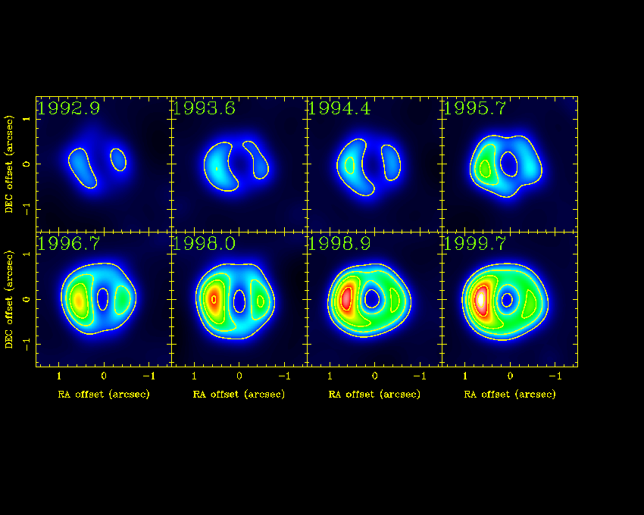
- Calculate how many years after 1987 each of the years is (1992.9 would be 5.9 years after 1987). Record these values in the data table below.
- Calculate how many years since the last image year in the table (1993.6 would be 0.7 years after 1992.9). Record these values in the data table below.
- Using your centimeter ruler, measure the entire width (from left to right with paper turned horizontally) of the colored portion of each image. Record your measurements in the data table.
- Transfer your measurement in cm down to the arcseconds scale to estimate how many arcseconds each measurement is. Record your estimates in the data table.

Note: A second of arc (arcsecond, arcsec) is 1⁄60 of an arc minute, or 1⁄3,600 of a degree (unit of rotational angle).

Data Table

Year | Years after 1987 | # years since last image | Distance across Supernova (cm) | Distance across Supernova (arcseconds)
1992.9 |  | XXXXXXXXXXXXXX
1993.6
1994.4
1995.7
1996.7
1998
1998.9
1999.7

- Graph the data in the table between “years after 1987” and “distance across supernova in arcseconds.

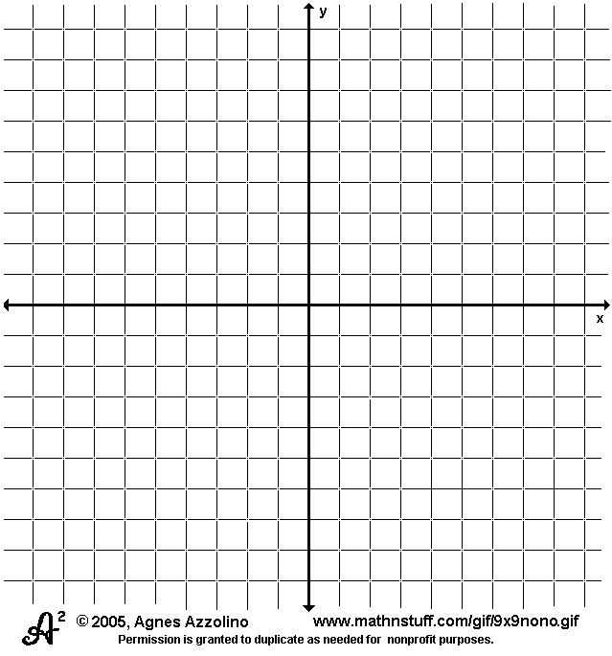

- Does the relationship between “years after 1987” and “distance across supernova in arcseconds” seem to be linear or exponential? Explain your choice.

- Find an explicit function to model your data. Be sure the type you use (linear or exponential) fits the trend in the graph. Explain or show how you get different parts of your equation.

- What does each part of your function mean? Be sure to include the “units” from the data table and your graph in your explanation.

- Could your function model anything else in space besides the supernova SN1987a? Explain.

7. Review/Essential Questions/Explanation: (Should be very closely related to your pre/post tests! Explanation piece…)
A. Have student pairs cross check with another group.
B. Have volunteers present their graph.
C. Have other volunteers present their function.
D. Discuss parts K & L as a class.

8. Assessments (Post-test)/Evaluation:
Give Pre-test again as Post-test:
- What is characteristic in a scatter plot of a linear trend? What is characteristic in a scatter plot of a exponential trend?
- What happens when a supernova occurs?
- If 1.6 cm represents 1 arcsecond, how many arcseconds does 3.2 cm represent?
- Can we model what happens to a supernova over time? If so, what type of mathematical model would work well and why?

10. Enrichment/Elaboration: For extra credit, challenge students to find a similar stellar event with time sequences images and repeat this activity.
11. IEP Accommodations/Differentiation/Diversity: What accommodations will you use to support struggling learners?

- Assure 2 special needs students are not paired.
- Allow students to use their Chromebooks to research if need be during any portion of activity.
- Be sure it is very quiet when appropriate.

Finding an Expansion Function for a Super Nova Explosion—Student Handout

1. Standards and Safety and Materials:
A. Standards – CCSS for High School Math: F-LE2: Construct linear…functions…given a graph, a description of a relation, or two input-output pairs (include reading these from a table); ALSO part b. Recognize situations in which one quantity changes at a constant rate per unit interval relative to another.
B. Safety Concerns: minimal safety concerns with regular class activity.
C. Materials: student handout, centimeter ruler, Chromebook allowed but not required, as each student has one.

2. Objectives:
A. Students will be able to define a supernova.
B. Students will be able to understand what happens after a supernova explosion by using SN1987a.
C Students will be able to define the unit arcsecond.
D. Students will be able to model the expansion of a supernova by using SN1987a.

3. Connections, Misconceptions, and Crosscutting Concepts:
A. Real world connections: Astronomer, astronaut, mathematician/teacher.
B. Student connections: stars in the sky, previous work done in class with functions.
C. Misconceptions: the change in the independent variable is not 1 unit, so students may have to be more creative.
D. Crosscutting Concepts: patterns, mathematical tables, graphs, & functions, science/astronomy
E. Academic Language: supernova, arcsecond, mathematical model (table, graph, function).

4. Catch/Engagement: Show the video to illustrate a Type II Supernova 1987a at https://www.youtube.com/watch?v=JduQrZAEHX8 (1:35). Then show Hubble images of Supernova 1987a at https://www.youtube.com/watch?v=3T-FoEgcvXY (1:02).

Introduction: (student copy will be fill-in-the-blank in underlined areas)

- Linear data has a _____________ trend.

- Exponential data has an ______________ or _______________ trend.

- A supernova is__________________________.

- Watch video https://www.youtube.com/watch?v=QfNqBKAvkpw
- Watch video https://www.youtube.com/watch?v=Ooon7MlPtgg
- Discuss image as a class at http://www.ucolick.org/~bolte/AY4_00/week4/arcsec.gif

Procedure:
The following images are radio wave images (at 8 GHz) of a Supernova that occurred in 1987, thus the name “SN1987a”. Each image was taken at a different date, as shown. It is turned sideways to maximize the size for measurements. Let’s discuss as a class.

- Calculate how many years after 1987 each of the years is (1992.9 would be 5.9 years after 1987). Record these values in the data table below.
- Calculate how many years since the last image year in the table (1993.6 would be 0.7 years after 1992.9). Record these values in the data table below.
- Using your centimeter ruler, measure the entire width (from left to right with paper turned horizontally) of the colored portion of each image. Record your measurements in the data table.
- Transfer your measurement in cm down to the arcseconds scale to estimate how many arcseconds each measurement is. Record your estimates in the data table.

Note: A second of arc (arcsecond, arcsec) is 1⁄60 of an arc minute, or 1⁄3,600 of a degree (unit of rotational angle).

Data Table

Year | Years after 1987 | # years since last image | Distance across Supernova (cm) | Distance across Supernova (arcseconds)
1992.9 |  | XXXXXXXXXXXXXX
1993.6
1994.4
1995.7
1996.7
1998
1998.9
1999.7

- Graph the data in the table between “years after 1987” and “distance across supernova in arcseconds.

- Does the relationship between “years after 1987” and “distance across supernova in arcseconds” seem to be linear or exponential? Explain your choice.

- Find an explicit function to model your data. Be sure the type you use (linear or exponential) fits the trend in the graph. Explain or show how you get different parts of your equation.

- What does each part of your function mean? Be sure to include the “units” from the data table and your graph in your explanation.

- Could your function model anything else in space besides the supernova SN1987a? Explain.

Enrichment/Elaboration: For extra credit, find a similar stellar event with time sequences images and repeat this activity.

