Are We There Yet? Walking the Solar System
Grade 5

1. Standards and Safety and Materials:
A. NGSS Standards: ESS1.B: Earth and the Solar System
B. Safety Concerns: minimal safety concerns with regular class activity
C. Materials: Pencil, Measuring tape
2. Objectives:
A. Students will construct a scale graphical display of the solar system.
B. Students will measure distances accurately.
C. Students will demonstrate understanding of scale.
3. Connections, Misconceptions, and Crosscutting Concepts:
A. Real world connections: Engineer, Architect, City Planner
B. Student connections: Locations across town, state, and country
C. Misconceptions: Scale of solar system
D. Crosscutting Concepts: Scale, Proportion, Quantity
4. Catch/Engagement
A. Visual: Photos of planets and Sun
B. Auditory: The Planets by Gustav Holst
C. Taste: Cheese puffs
5. Pre-Test: See below
6. Activity/Exploration
Part 1: Lecture
X – See photos below showing position and order of planets.
Y – 1. Photo of Solar System
2. Discuss terrestrial vs. gas planets
3. Discuss dwarf planets
4. Distances within town of Evanston
5. Discuss purpose of constructing scale model
Part 2: Lab
M – See instruction handout below
N – Lab Procedure
- Introduce scaled distance table
- Discuss how measurements were converted
- Name beginning and endpoint in hallway
- Discuss procedure for measuring and create small student groups
- Describe jobs within group, ensure that each student has a task:
  - Tasks: Read table, Measure, Mark, Inspector, Data Resource
Part 3: Reading: See below
Part 4: Discussion: Students will know order of planets and relative distances
between them.
7. Review/Essential Questions/Explanation
A. Low Level – What is the order of the planets in the Solar System?
B. Middle Level – What is important for accurate measurement?
C. High Level – How does a model help us understand scale?
8. Assessments
A. Formative: Teacher will assist groups during class to check for understanding.
B. Post-test: Same as Pre-test
C. Summative: Students will construct a model of solar system distances in the
hallway.
D. Material will be reviewed at the beginning of the next lesson as it builds
directly on this information.
9. Timeline: 35 minutes total
A. Catch: 2 min
B. Pre-test: 3 min
C. Activity: 22 min
D. Review and Post-test: 8 min
10. Enrichment/Elaboration: Extra Activity
A. Write on a sticky-note which planets are gas and terrestrial planets and place
them in the hallway in the correct position.
11. IEP Accommodations/ Differentiation/Diversity: Students will work in small groups,
chosen by the teacher to include a mixture of ability levels.

Pre/Post Test

- How many planets are in our solar system?

- List the three closest planets to the Sun:

- What are the next three planets in order?

b.
c.
4. Name the last three planets including the one dwarf planet:
a.
b.
c.
5. Which planets are terrestrial planets?
a.
b.
c.
d.
6. Which four planets are gaseous planets?
a.
b.
c.
d.

Instructions:
The sun is the starting point for the scaled model outside the classroom.
Measure beginning from the wall where the sun is posted.
Pluto will already be posted.

Group 1: The first planet is Mercury. Measure 4 feet from the sun and place the planet label on the wall. Next, measure toVenus.

Group 2: Locate Earth at 10 feet from the Sun. Next, locate Mars.

Group 3: Position Jupiter 53 feet from the Sun. Next, label Saturn.

Group 4: Label Uranus 194 feet from the Sun.

Group 5: Locate Neptune 304 feet from the Sun.

Object | Distance from Sun  (millions of km) | Scaled Distance  (feet)
Mercury | 58 | 4
Venus | 108 | 7
Earth | 150 | 10
Mars | 228 | 15
Jupiter | 778 | 53
Saturn | 1427 | 97
Uranus | 2871 | 194
Neptune | 4497 | 304
Pluto | 5913 | 400

Introduction Photos

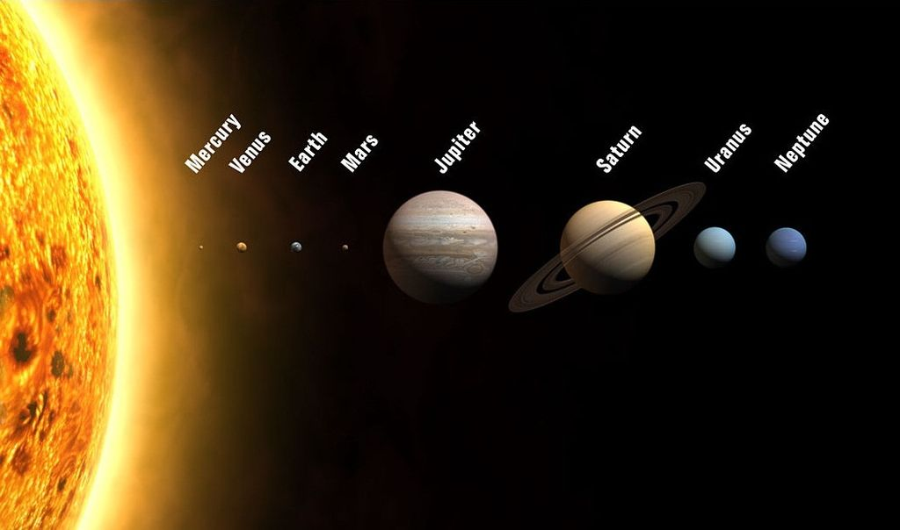

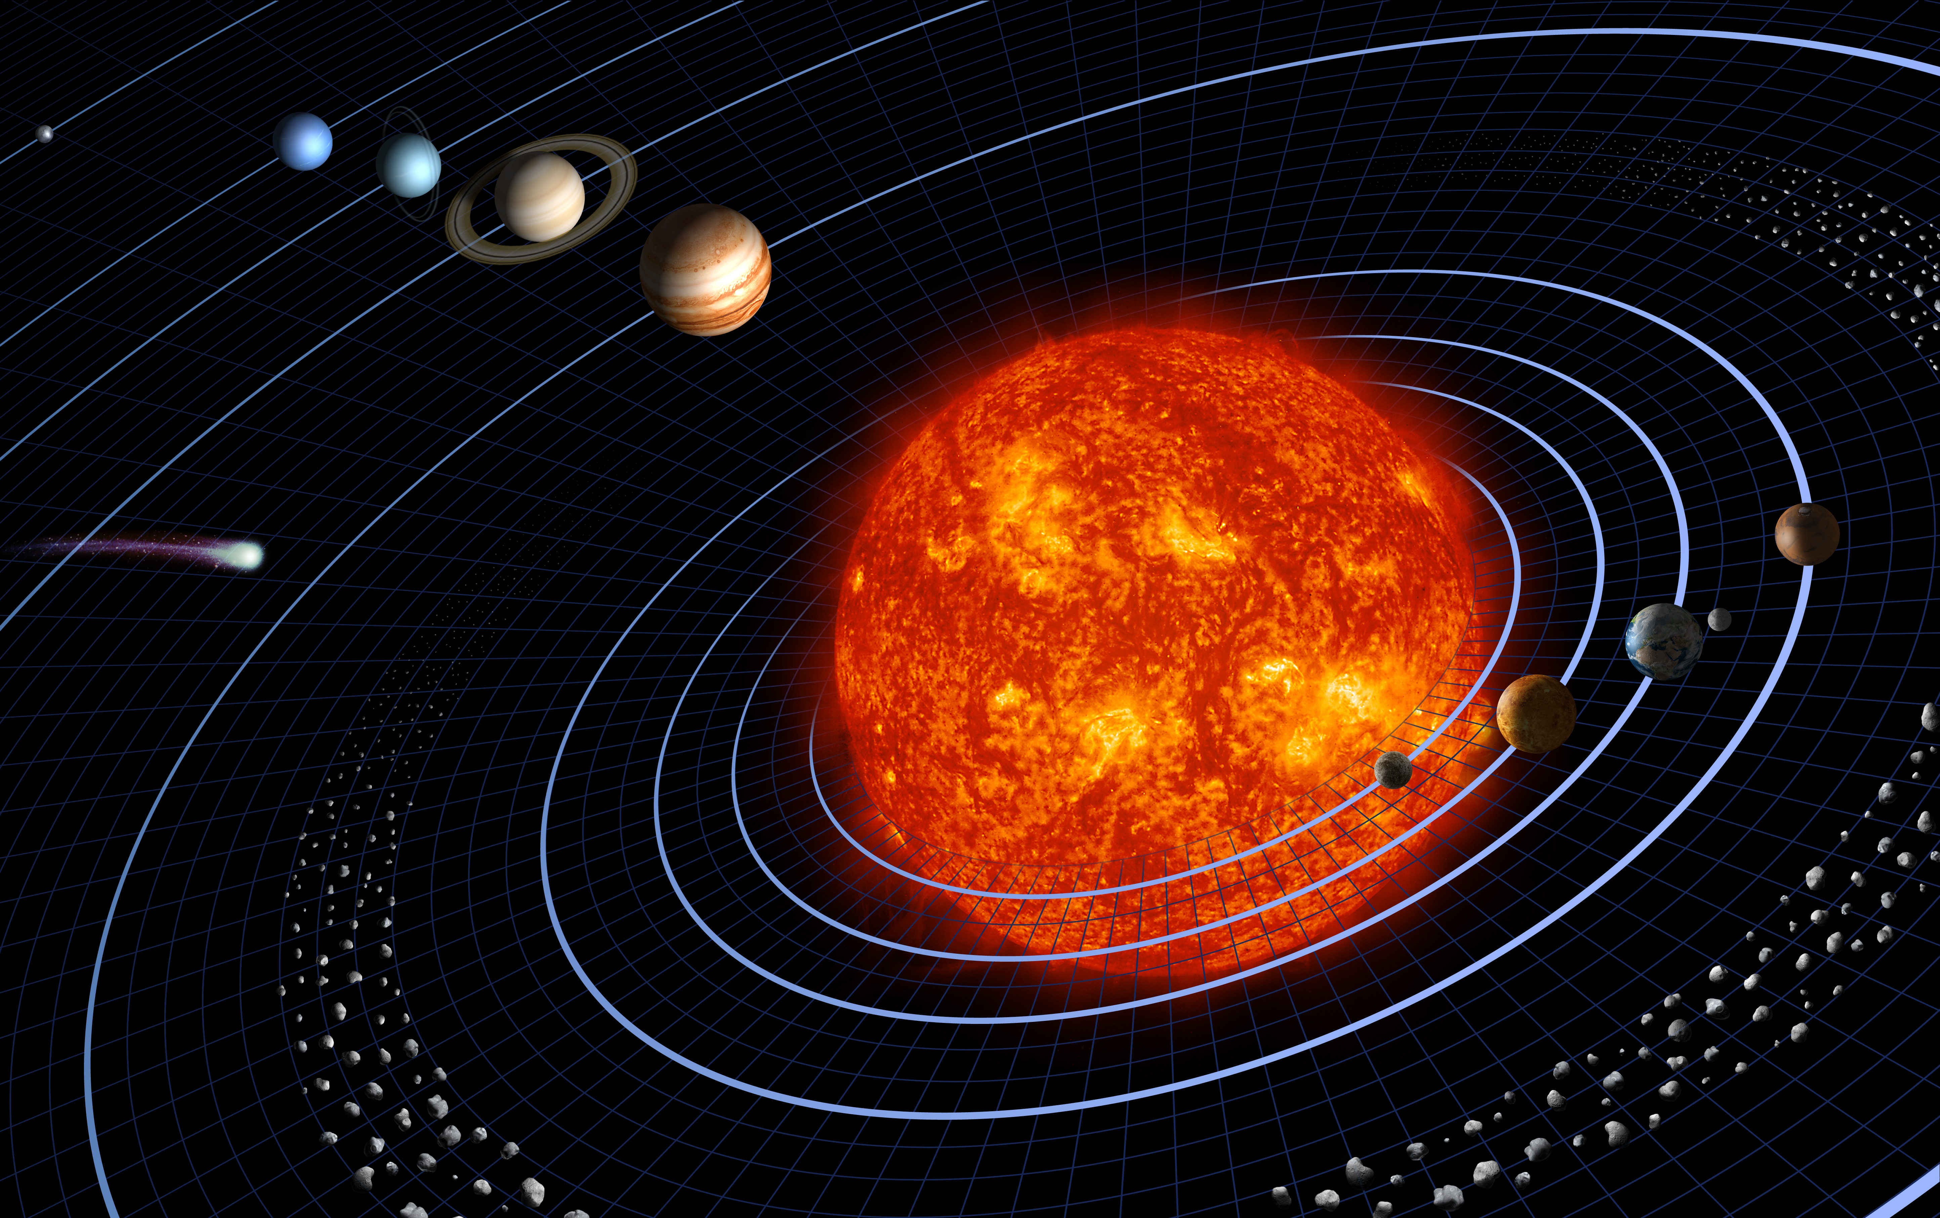

Reading

Our Solar System is a small part of a spiral galaxy, the Milky Way. The Solar System consists of the Sun and eight planets: Mercury, Venus, Earth, Mars, Jupiter, Saturn, Uranus, and Neptune. The largest object of our Solar System is the Sun. Pluto is a dwarf planet, the farthest from the Sun. Four planets are terrestrial planets, consisting of rock and metal: Mercury, Venus, Earth, and Mars. The last four planets are gaseous planets: Jupiter, Saturn, Uranus, and Neptune.
To get an idea of the very large scale of our Solar System, a model can be created. The model is like a map that shows large distances in a small area. Today, we will be working together to create this map of the Sun and the planets.

