Shrink Them Down to Size: Making a Scaled Planet Diagram
Grade 3

1. Standards and Safety and Materials:
A. NGSS Standards: ESS1.B: Earth and the Solar System
B. Safety Concerns: minimal safety concerns with regular class activity
C. Materials: pencil, ruler, compass, color pencils, tempera paint, watercolor paint,
scissors
2. Objectives:
A. Students will construct a scaled diagram of the planets and Sun.
B. Students will measure circles accurately.
C. Students will demonstrate understanding of scale.
3. Connections, Misconceptions, and Crosscutting Concepts:
A. Real world connections: Engineer, Astronomer, Agriculture
B. Student connections: Scale models, toys, globe
C. Misconceptions: Relative scale of planets
D. Crosscutting Concepts: Scale, Proportion, Quantity
4. Catch/Engagement
A. Visual: Photos of planets and Sun
B. Auditory: The Planets by Gustav Holst
C. Taste: Jawbreakers or other spherical candy
5. Pre-Test: See below
6. Activity/Exploration
Part 1: Lecture
X – See photos below of each planet.
Y – 1. Demonstrate scale and proportion through photos of Solar System
and individual planets.
2. Discuss scaled diameter table and conversions.
3. Review construction and measuring of scaled planets.
4. Review various colors and surfaces of planets and Sun.
Part 2: Lab
M – See instruction handout below
N – Lab Procedure
- Introduce scaled diameter table
- Discuss how measurements were converted
- Review relative positions of planets
- Discuss procedure for measuring and drawing circles
- Create small student groups
- Describe jobs within group, ensure that each student has a task:
  - Tasks: Read table, Measure, Draw, Quality Inspector, Cutting, Coloring/Painting
Part 3: Reading: See below
Part 4: Discussion: Students will know relative sizes of planets.
7. Review/Essential Questions/Explanation
A. Low Level – Which is the largest and smallest planet?
B. Middle Level – Are the planets together as large as the Sun?
C. High Level – Does the size of the planets relate to their closeness to the Sun?
8. Assessments
A. Formative: Teacher will assist students during class to check for understanding.
B. Post-test: Same as Pre-test
C. Summative: Students will construct a model of the planets that demonstrates
understanding of measuring and scale.
D. Material will be reviewed at the beginning of the next lesson as it builds
on this information.
9. Timeline: 35 minutes total
A. Catch: 2 min
B. Pre-test: 3 min
C. Activity: 22 min
D. Review and Post-test: 8 min
10. Enrichment/Elaboration: Extra Activity
A. Research one planet and write a paragraph providing details about that planet.
11. IEP Accommodations/ Differentiation/Diversity: Students will work in small groups,
chosen by the teacher to include a mixture of ability levels.

Pre/Post Test

- What is diameter? Draw a sketch.

- Which planet is the smallest in diameter?

- Which planet is the largest in diameter?

- What are some causes of surface features and colors of the planets?

Instructions:
The Sun is by far the largest body in the solar system. How large are the planets in relation to the Sun? You will be creating scaled illustrations of each planet to show this relationship.

Group 1: Create an illustration of Mercury and Venus following the measurements in the table below. Place them in the hallway in the correct position.

Group 2: Create an illustration of Earth and Mars following the measurements in the table below. Place them in the hallway in the correct position.

Group 3: Create an illustration of Jupiter and Saturn following the measurements in the table below. Place them in the hallway in the correct position.

Group 4: Create an illustration of Uranus following the measurements in the table below. Place them in the hallway in the correct position.

Group 5: Create an illustration of Neptune and Pluto following the measurements in the table below. Place them in the hallway in the correct position.

Object | Diameter  (km) | Scaled Diameter  (cm)
Sun | 1392000 | 200.0
Mercury | 4800 | 0.6
Venus | 12000 | 1.6
Earth | 12700 | 1.8
Mars | 6700 | 1.0
Jupiter | 140000 | 20.0
Saturn | 120000 | 17.2
Uranus | 52000 | 7.4
Neptune | 50000 | 7.2
Pluto | 2300 | 0.4

Introduction Photos

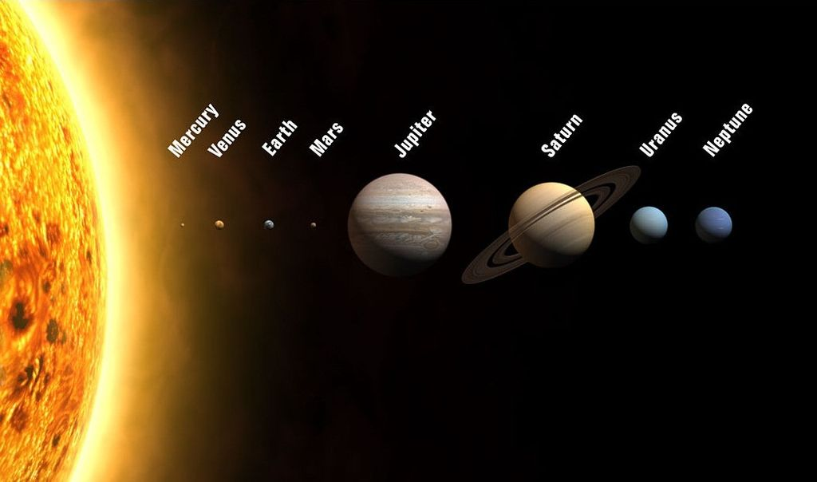

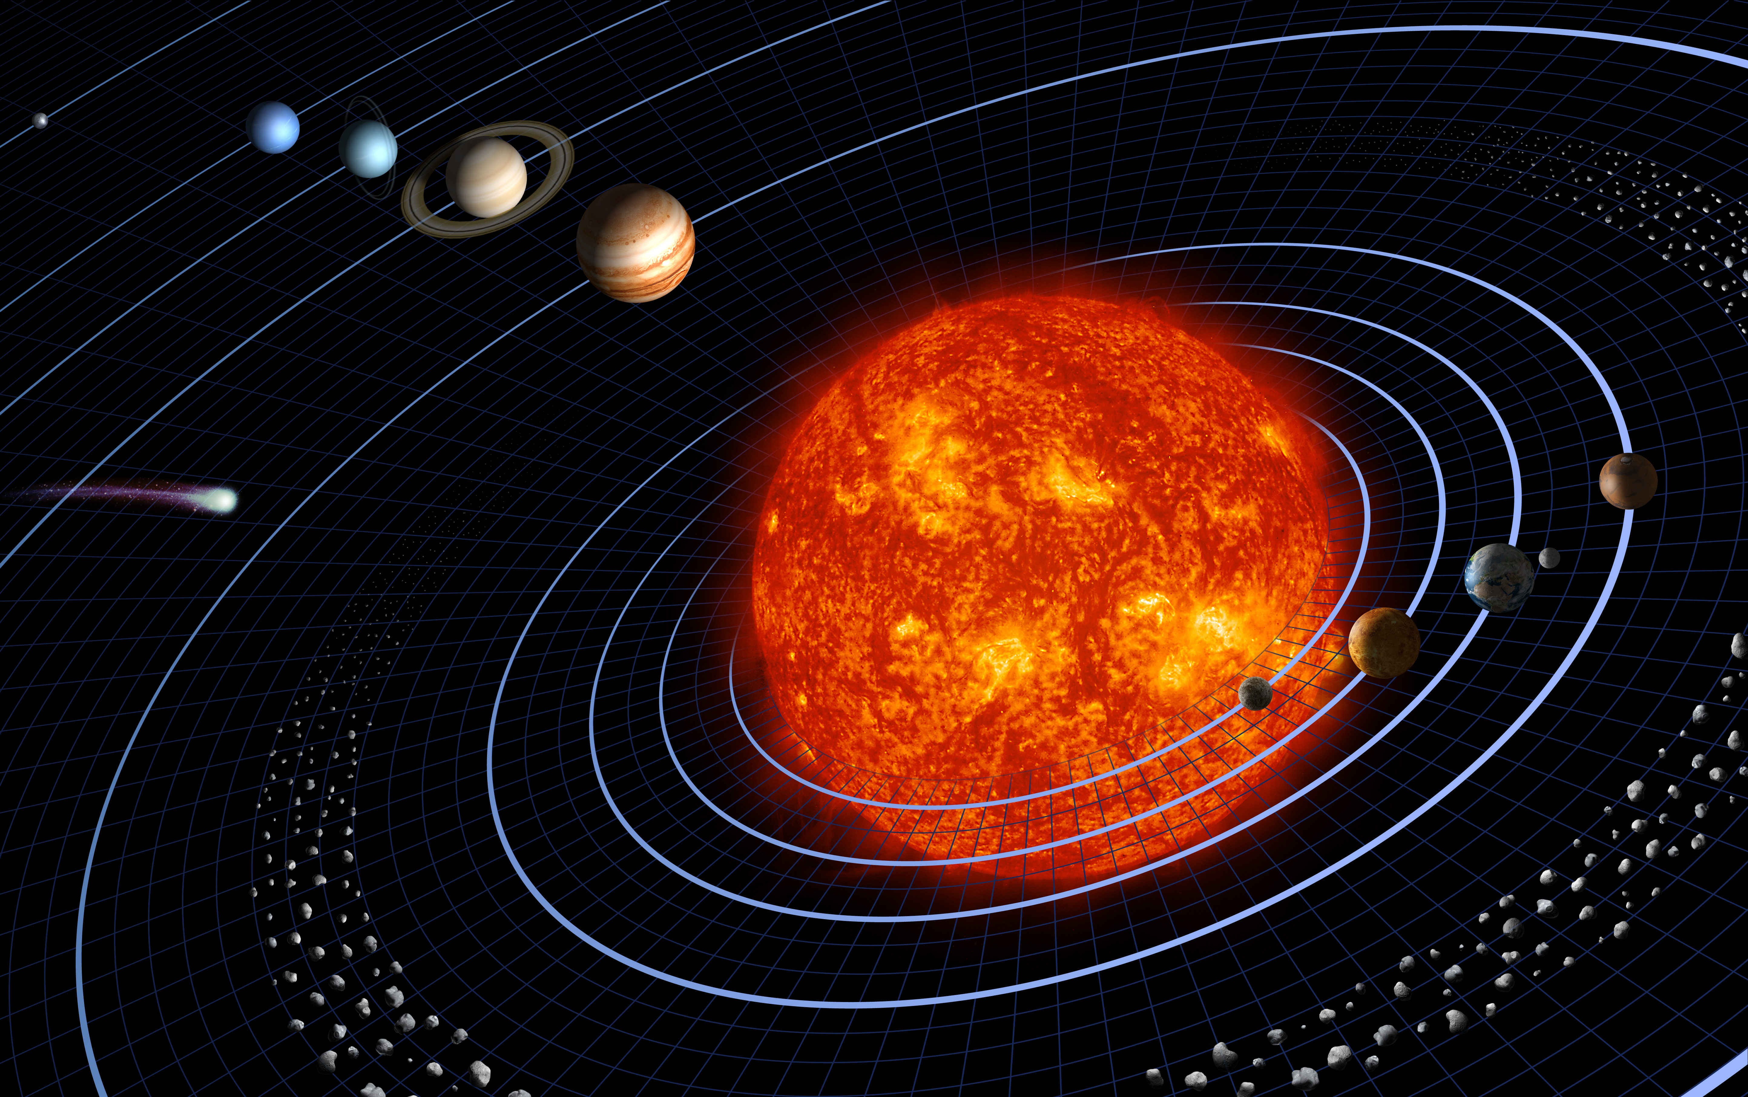

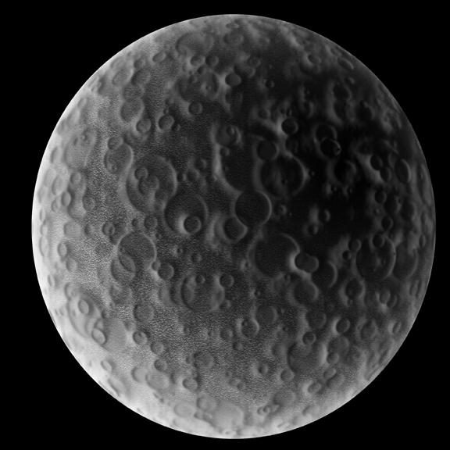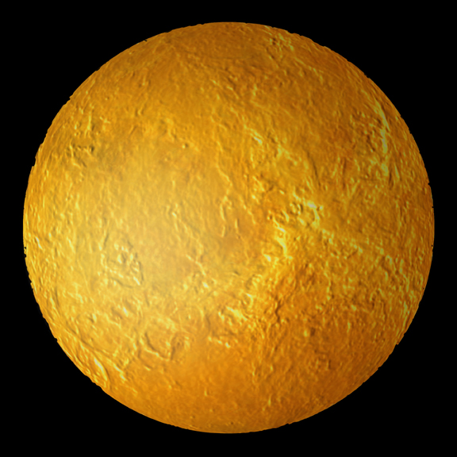
Mercury Venus

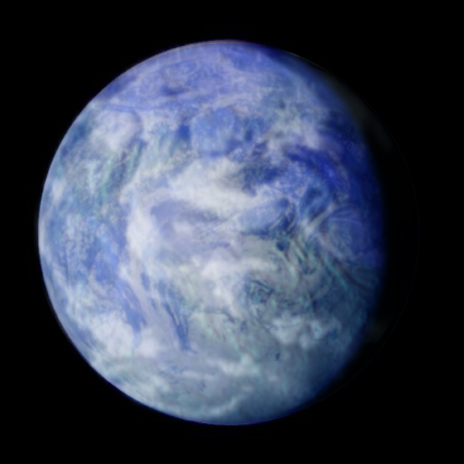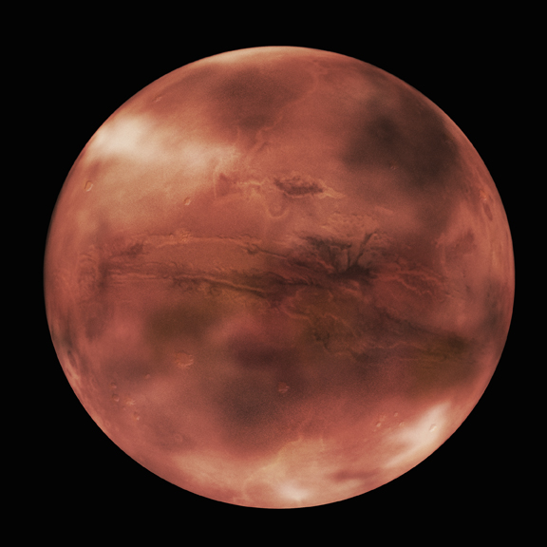
Earth Mars

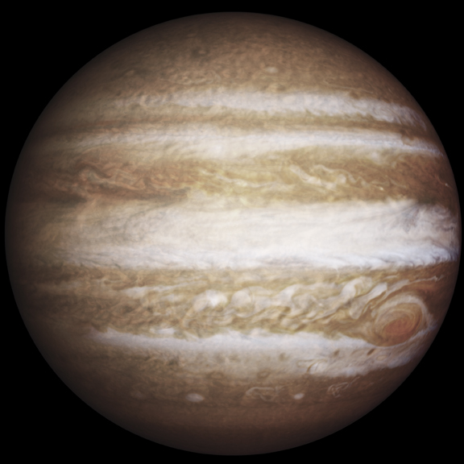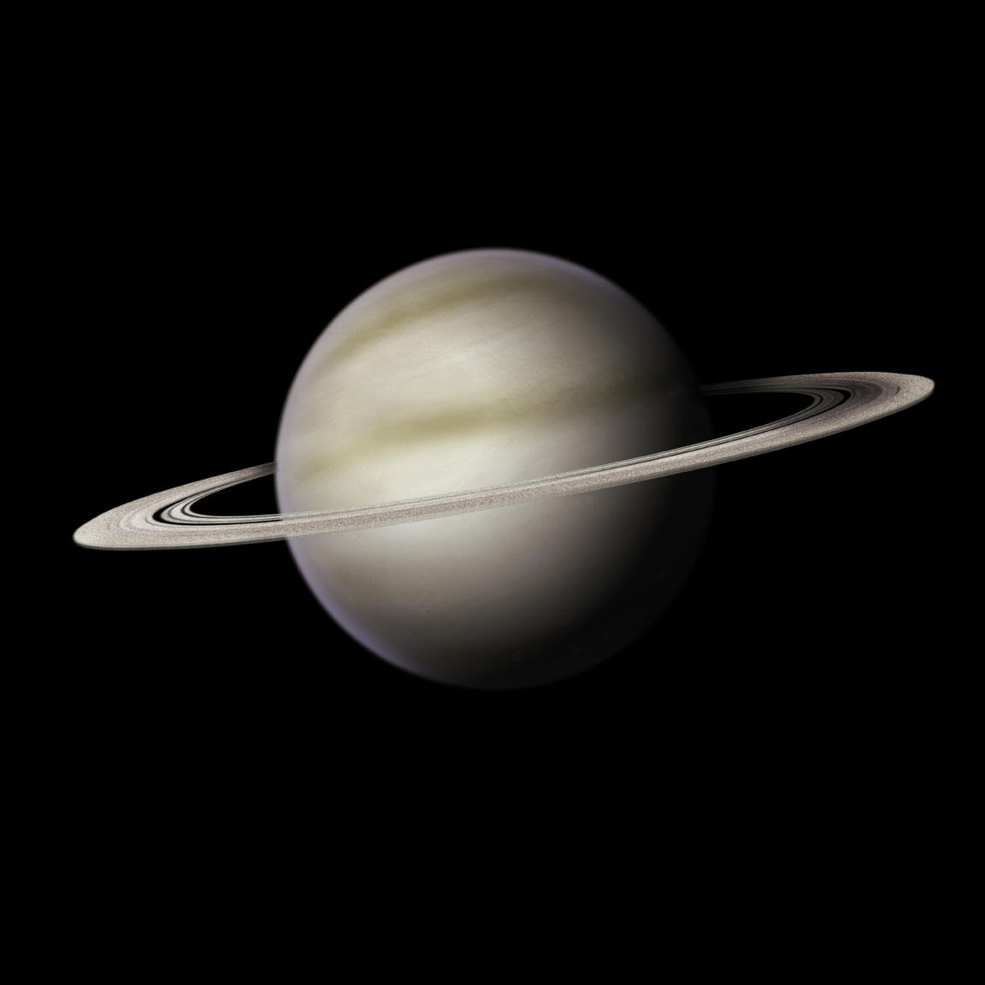
Jupiter Saturn
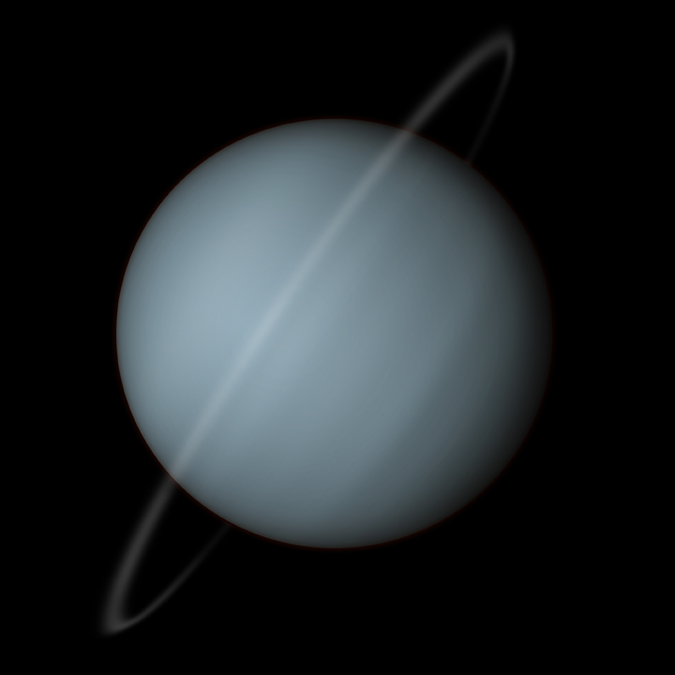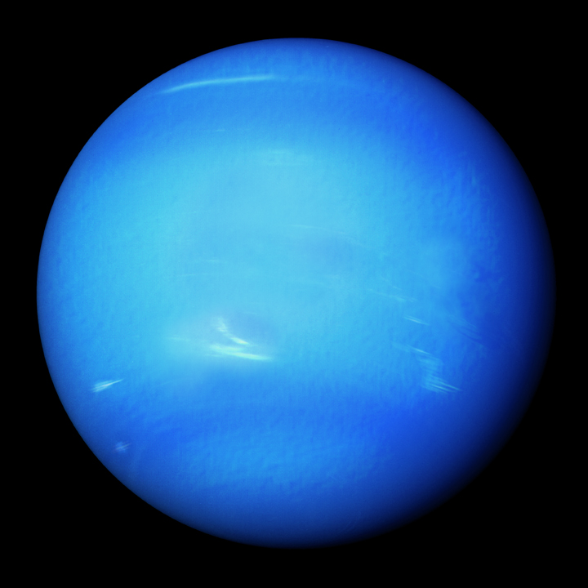
Uranus Neptune
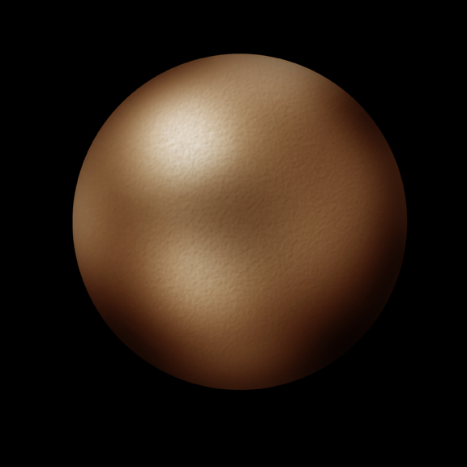
Pluto

Reading

The Solar System consists of eight planets and one dwarf planet. The smaller planets are closer to the Sun while the larger planets are further away. Almost all of the mass, or material of the Solar System is contained in the Sun. The largest planet in the Solar System is Jupiter, but it is only 1/10 the diameter of the Sun. The Sun is 100 times as large as the Earth in diameter. For this diagram, the Sun will need to be fairly large to keep the smaller planets visible. If the Sun were made too small, some planets would be barely visible.

