University of Wyoming
AstroCamp

Satellite Assembly Exercise
Neutral Buoyancy Lab/Spacewalk Simulation

Purpose:
To introduce students to NASA astronaut training operations.
To allow students to use their spatial reasoning skills to assemble an object.
To give students the opportunity to use and develop nonverbal communication skills while completing a task as a team.
To give students the opportunity to work together in a unique environment, which models a zero-gravity environment.
To give students the opportunity to interact with members of the outside community through training and instruction.
To give students a chance to exercise while scuba diving.

Wyoming State Science Standards Addressed:
Standard 2:
Students demonstrate knowledge, skills, and habits of mind necessary to safely perform scientific inquiry. Inquiry is the foundation for the development of content, teaching students the use of processes of science that enable them to construct and develop their own knowledge. Inquiry requires appropriate field, classroom, and laboratory experiences with suitable facilities and equipment.

Benchmark 4:
Students recognize the relationship between science and technology in meeting human needs.
Benchmark 5:
Students properly use appropriate scientific and safety equipment, recognize hazards and safety symbols, and observe standard safety procedures.
Standard 3:
Student recognize the nature of science, its history, and its connections to personal, social, economic, and political decisions. Historically, scientific events have had significant impacts on our cultural heritage.
Benchmark 2:
Students explore how scientific information is used to make decisions.
2a The role of science in solving personal, local, and national problems.
2b Interdisciplinary connections of the sciences and connections to other subject areas and careers in science or technical fields.

Goals:
Students will work in groups to complete an assigned task (building a PVC satellite) while developing teamwork skills.
Students will use their listening skills in order to follow directions.
Students will use spatial reasoning skills/problem solving skills in two different environments (dry land/pool) to complete the assigned task.
Students will use pictures to decipher how to construct the assigned satellite.
Students will understand the importance of cooperation and following instructions in order for successful construction of satellites to take place.

Entry Level:
Students will need an understanding of the forces at work during the spacewalk simulation.
Students will need information about real life spacewalk training.
Students will need instruction on how to use scuba gear properly while submerged in water.
Students will need instruction on how to construct the PVC satellites.

Premise:
Students will be learning about training operations astronauts must complete before attempting spacewalk missions. Students will participate in constructing satellites as a team outside of the spacewalk simulation environment in order to prepare for the simulation assembly. Teams will be given a picture of the assembled satellite, the parts for creating the satellite, and the hardware for stabilizing the satellites, then will be directed to assemble the satellite using their spacial reasoning and problem solving skills. The teams will practice using nonverbal communication skills outside of the pool to aid in successful construction while using scuba gear. The time for this activity varies depending upon the skill level of the students, how well instructions are followed, and quality of equipment. Estimated time for all activity is 4-5 hours.

Supplies:
PVC Pipe cut and ready to assemble
~40 bolts and wing nuts for Cube structure
~26 bolts and wing nuts for Arch structure
Pictures of completed cube structure
Pictures of completed arch structure
Open area outside of pool
Swimming Pool Scuba Instructors and Gear

Activities:

Introduce: Begin activities by asking students to reveal what they know about spacewalk training and the science behind it. Allow about 10 mins for questions and discussion.
Instruct: Training for spacewalk activity, also known as extravehicular activity EVA), takes place at NASA’s Neutral Buoyancy Laboratory(NBL) in Houston, TX. The pool is 202ft long, 102 ft wide, 40 feet deep (20 feet above ground, 20 feet below ground level), and holds over 6 million gallons of water. A large pool to say the least; however, the International Space Station, at 350ft x 240ft when complete, does not fit inside the NBL. Buoyancy is the power of a fluid to exert an upward force on a body placed in it. Gravity is a constant force pulling us and everything towards the center of earth. Buoyancy and gravity, along with other weights and forces, work together /against each other in this activity and at the NBL to keep objects from floating or sinking. Neutral buoyancy is a key to EVA training because equipment and astronauts alike neither sink nor float in this lab. When training in the NBL,astronauts do not feel weightless, as they would while in orbit; however, neutrally buoyant objects share similar characteristics as items in orbit, such as the ISS or the Hubble Space Telescope. The NBL is currently the best available method for EVA training. Without this lab, astronauts would encounter many problems when repairing or working on objects in orbit. (Source: NASA – Neutral Buoyancy Laboratory http://www1.jsc.nasa.gov/dx12/site/index.shtml)
Questions:
Why is it important that NASA and other astronauts train for extravehicular activity or EVA (also called spacewalk in this activity)?
Why is it important to work as a team when constructing large objects?
What forces are at work on your body and the satellite materials during this project?
What benefits, if any, do you, the community, the nation, and the world receive as a result of spacewalk missions? i.e ISS or Hubble repair
What different careers require many people to assembly large objects in unique, nontraditional environments?
Does nonverbal communication challenge your team during this exercise? If so, how?

Assembly Practice:
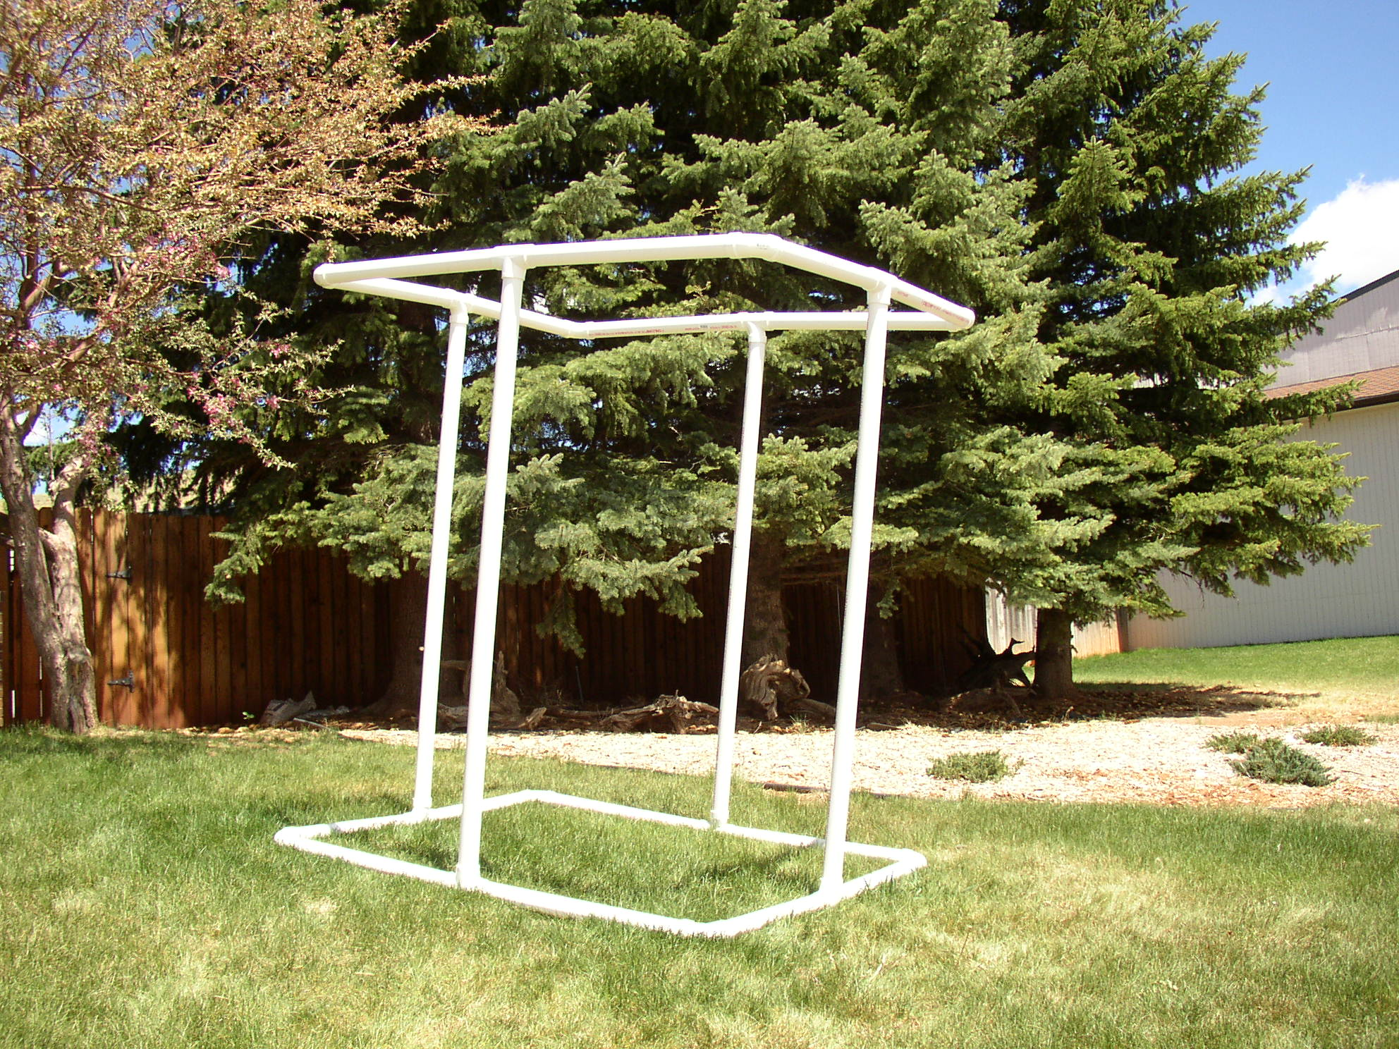
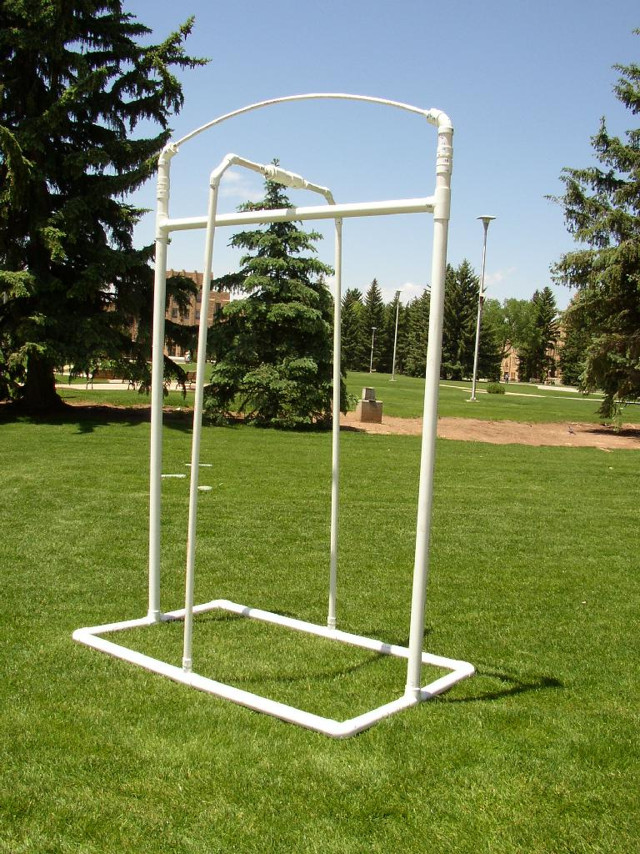
Cube Structure Arch Structure

- Meet all campers and staff at an open area outside Corbett Pool.
- Begin by explaining the training NASA astronauts complete before being able to go on EVA missions and the science behind this process. (see Premise) Allow students to ask questions/use questions from Premise to engage students. Share with students the dimensions of the ISS and NBL and compare that to the experience at Corbett Pool.
- Emphasize that students will not only practice assembling the structure outside of the pool, but will also create a nonverbal communication system to use underwater during this practice.
- Encourage students to choose a role in the construction of the satellites.
  - 10 students total
  - Deliverers – These students will be responsible for bringing parts to builders (2-4 students)
  - Builders – These students will be responsible for assembling specific sections of the satellite. e.g. 2 students assemble 2 corners numbered 1-12, 2 students assemble the arch numbered 50-60, etc. (#’s are not accurate, but given as example only)
  - Assigning jobs like these will prevent students from trying to build different parts of satellite too soon and will keep the construction more organized.
- Allow student groups to choose roles as Deliverers or Builders
- Separate campers into two teams.
- Give each team the correct materials, along with picture of their satellite and direct teams to begin construction. Assist with any problems or obstacles the teams may encounter.
- After teams have fully assembled their structure using verbal communication, regroup students and direct them to device a construction plan for underwater assembly. Remind them to practice nonverbal signals they will use underwater. Give them time to practice their signals.
- Have students reassemble the satellites using their new nonverbal communication system and playing their part (Builder or Deliverer).
- Once satellite is assembled, have teams disassemble satellites, and prepare for scuba instruction.

Scuba Instruction and “Neutral Buoyancy” Assembly
Direct students to listen to scuba instructors, stick with their teams, and be patient while assembling in the pool.
Have students share ideas of what obstacles their teams may encounter while in the pool and brainstorm ideas of how to fix/work around those obstacles.

Created by Michelle Miller, University of Wyoming AstroCamp, June 2006

