Draft by Paul E. Johnson 2012, 2013 © for UW Astronomy class use only
________________________________________________________________________
Chapter 1 - The Universe: an Overview

I roamed the countryside searching for answers to things I did not understand. Why shells existed on the tops of mountains along with the imprints of coral and plants and seaweed usually found in the sea. Why the thunder lasts a longer time than that which causes it and why immediately on its creation the lightning becomes visible to the eye while thunder requires time to travel. How the various circles of water form around the spot which has been struck by a stone and why a bird sustains itself in the air. These questions and other strange phenomena engaged my thought throughout my life.
-- Leonardo di Vinci, Renaissance Man

Chapter Preview

This chapter provides an overview of the Universe and the study of astronomy that will follow in subsequent chapters. You will look at astronomy from multiple perspectives, as a science, from an historical point of few, and from the aspects of time and space. No other branch of science has the overall scope of astronomy: from the subatomic particle to the Universe as a whole, from the moment of creation to the evolution of intelligent life, and from Aristotle to space-based observatories.

Key Physical Concepts to Understand: The Scales of Time and Space

- Introduction

The purpose of this book is to provide a basic understanding of astronomy as a science. This study will take us on a journey from Earth to the stars, planets, and galaxies that inhabit our Universe. But it is important not just to catalog and classify each of the objects that we find on our way. To develop a true and meaningful understanding of astronomy we need to find connections between these objects. In studying pond life, a biologist might find eggs, tadpoles, small adolescent fish, and large adult fish occupying the same pond. One question that might first occur to the biologist is, “Are these all fundamentally different organisms, or do they represent different stages in the evolution of a single fish?” Our experience at shopping malls (where we see pregnant women, infants, toddlers, adolescents, young adults, the middle-aged, and the elderly) should give us some insight. Using this insight as a basis for our inquiries, we ask ourselves whether or not different cosmic entities are related, one evolving from the other, and more generally what is their evolutionary story? By studying pond life the biologist can piece together a story about the origin of adult fish from eggs; by studying people at the mall we could infer a coherent picture of how humans evolve (assuming that we didn’t know already). Similarly, the main goal of the astronomer is to put together a story, based on real observational evidence, of the origin of the Universe, the origins of stars, the origins of planets, and even the origin of the conditions in our Universe necessary for life.

But fleshing out a complete story is not possible without understanding the mechanisms behind the evolution. Our biologist wants to understand the life cycle of the fish by attempting a complete understanding of the anatomy and physiology of the fish down to a cellular level. Only then is the story complete. The story is then not just one of outward change but includes genetics, fertilization, embryology, metabolism and growth, and much, much, more. Similarly the astronomer tries to relate the outward appearance seen in the evolution of stars and planets by the fundamental laws of physics. For example, it is important for the astronomer to know the answer to the question “Why do stars emit light?” Are they converting gravitational energy into light as they shrink? We’ll come back to that question later.

One major difference between the astronomer and the biologist, or almost any other scientist for that matter, is that the objects studied by the astronomer cannot be brought into the laboratory or studied up close in the field (with the exception to field trips to other planets). Experiments cannot be contrived to produce a convenient test of a theory. The astronomer can only observe what is happening in the Universe through the telescope. In the last 100 years, clever astronomers have devised innumerable ways to make the detections necessary to piece together some significant pieces to the stories that we search for, the same stories sought by the ancients. Where do we begin?

- Why is Astronomy Important?

As we spend time studying astronomy, it is important for us to ask “Why is astronomy important?” Is it the important as motivation for the development of the space program? Does its chief importance lie in the use the motion of stars and planets in tracking the passage of time? Certainly both are true to some extent. But perhaps the most important reason for studying astronomy is a cultural and philosophical reason; we study it to gain perspective of our place in the Universe, in time and space. This is one of the main reasons we study the liberal arts. History and geography are cases in point. But history is limited in time to the study of human history, the last several thousand years, the length of time recorded in writing. Geography is limited in space to the surface of the Earth. History and geography are severely limited in time and space. Astronomy is an attempt at a study of everything on the largest temporal and spatial scales (Figure 1); it is a study of the Universe as a whole. But, make no mistake, it is not, nor does it substitute for theology. Astronomy is a science, and as such it is based solely on observed evidence. Theology is based largely on faith.

- Astronomy as a Science

One of the most important reasons to study astronomy is to view it as an example of a science, to see the real inner workings of science and the scientific method. Just the use of the phrase “the scientific method” is misleading. First, scientists do not just use one method in their work, but a combination of hunch, intuitive exploration, and educated stumbling as well as the more traditional use of 1.) production of an hypothesis, 2.) experimental verification or refutation of the hypothesis, and 3.) modification of the hypothesis if necessary. Second, the scientific method does not qualitatively differ in the method by which rational human beings make decisions that affect their everyday lives. Think about the behavior of the person who can’t start their car. They begin by formulating a series of hypotheses, or testable ideas, starting with the one judged to be most likely, and testing each in turn until they find the correct hypothesis (or they give up and call a mechanic). The first hypothesis might be “Is my gas tank empty?” or “Is my battery dead?” The first can easily be tested by turning the ignition switch and reading the gas gauge, the second by turning the ignition switch on and listening for the starter turning the engine.

The use of the scientific method in astronomy is more complex and sophisticated and the measurements are more precise. Scientists make extensive use of models, intellectual constructions used to make predictions. In the next two chapters we will examine some of the most important models in the historical development of science, models which attempt to explain the apparent motions in the sky of the stars, Sun, planets, and Moon. For example, a successful model or explanation of the rising and setting of the Sun and stars is that the Earth is really spinning like a top, once every 24 hours.

- The Spatial Scale of the Universe

Key Videos:
- http://www.powersof10.com/film This one is especially well done.
- https://www.khanacademy.org/science/cosmology-and-astronomy/v/scale-of-the-large
- https://www.khanacademy.org/science/cosmology-and-astronomy/v/scale-of-the-small
- https://www.khanacademy.org/science/cosmology-and-astronomy/v/scale-of-earth-and—sun
- https://www.khanacademy.org/science/cosmology-and-astronomy/v/scale-of-solar-system
- https://www.khanacademy.org/science/cosmology-and-astronomy/v/scale-of-distance-to-closest-stars
- https://www.khanacademy.org/science/cosmology-and-astronomy/v/scale-of-the-galaxy
- https://www.khanacademy.org/science/cosmology-and-astronomy/v/intergalactic-scale

In spite of the ability of scientists to measure and describe the size of the Universe in numerical terms, it is still as incomprehensible to human beings as it always has been. We are intellectually confined to grasping measurements within our direct experience. We can easily absorb the notion of particles a millimeter across (roughly the distance between the dot and the stem in a letter “i” on this page) to 50 miles (a healthy commute by automobile). Trips greater than 10,000 miles are generally beyond the experience of humans. The ability to resolve objects less than 0.1 mm with the unaided eye is also outside our ability. Aided with the microscope, the telescope, and sophisticated laboratory experimental apparatus, the scientist can measure objects as small as the atomic nucleus to the Universe as a whole.

Let us preview our exploration of the Universe.

- The Solar System

Deciding to explore our cosmos, we start on journey at the planet Earth that will lead us to the far reaches of the known Universe. Imagine travelling in a futuristic spacecraft at velocities near the speed of light (300,000 kilometers/second or 186,000 miles/second), not practical to us as citizens of the 20th century except as a thought experiment. As we blast off from our home planet we can see the entire globe in one glance, it’s oceans, mountains, and plains, even more spectacular in one view than we experience close up (Figure 1). We see not some static relic, but a living, evolving world. At a glance we can see the vast changing weather patterns: a typhoon over the south China Sea, clear spots over the north Atlantic and the Arctic (Figure 2). The Northern Hemisphere is experiencing winter and exhibits snow on its mountain ranges (Figure 3). The Southern Hemisphere is in the middle of summer and displays the green plumage of its growing season. As we travel around the Earth to the night side lose the color of oceans and mountains, and see instead the monochrome picture of thousands of dots over our planet’s cities, the result of millions of homes, offices, and factories brightly lit (Figure 4).
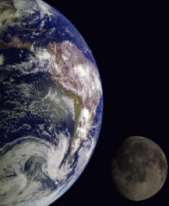
Figure 1. The Earth and Moon from space.

Less evident are the signs of a geological active earth, scarred from the ravages of a molten center: volcanic activity (Figure 5), and the shifting and cracking of the Earth’s surface as it cools slowly, over billions of years.

Figure 2. A satellite image of a typhoon over the South China Sea. From http://earthobservatory.nasa.gov/IOTD/view.php?id=52308

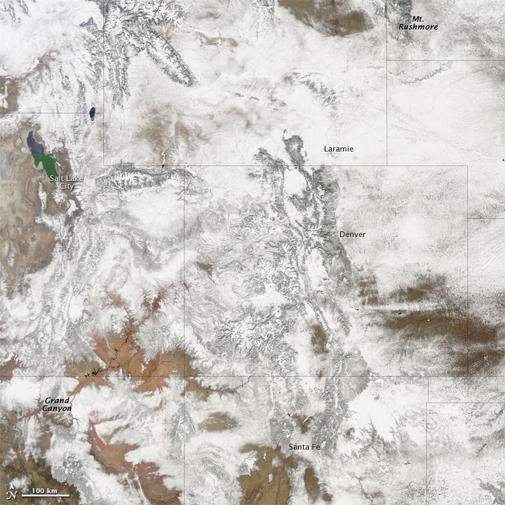
Figure 3. Snow covering the Rockies. “Snow cover stretched from South Dakota’s Mt. Rushmore to Arizona’s Grand Canyon in late February 2010, after snowstorms blanketed the Rocky Mountains.” From http://earthobservatory.nasa.gov/NaturalHazards/view.php?id=42797

Figure 4. The United States at night. “This image of the United States of America at night is a composite assembled from data acquired by the Suomi NPP satellite in April and October 2012.” From http://earthobservatory.nasa.gov/IOTD/view.php?id=79800
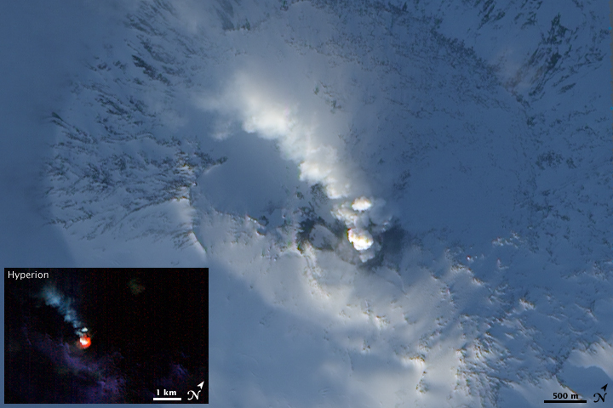
Figure 5. “Antarctica’s Mount Erebus may be covered with glaciers, but they do little to cool the volcano’s molten core. The world’s southernmost volcano to show activity during recorded history, Erebus holds a lava lake and occasionally experiences explosive eruptions.” From http://earthobservatory.nasa.gov/IOTD/view.php?id=37043

As we move away from the Earth we see its smaller sister planet, the moon (Figure 6). At its distance it is convenient to measure distances in light travel time; it takes light about 1.3 seconds to travel the distance from the Earth to the Moon. Although our spacecraft is traveling 25,000 miles per hour, it is less than 1% the speed of light.

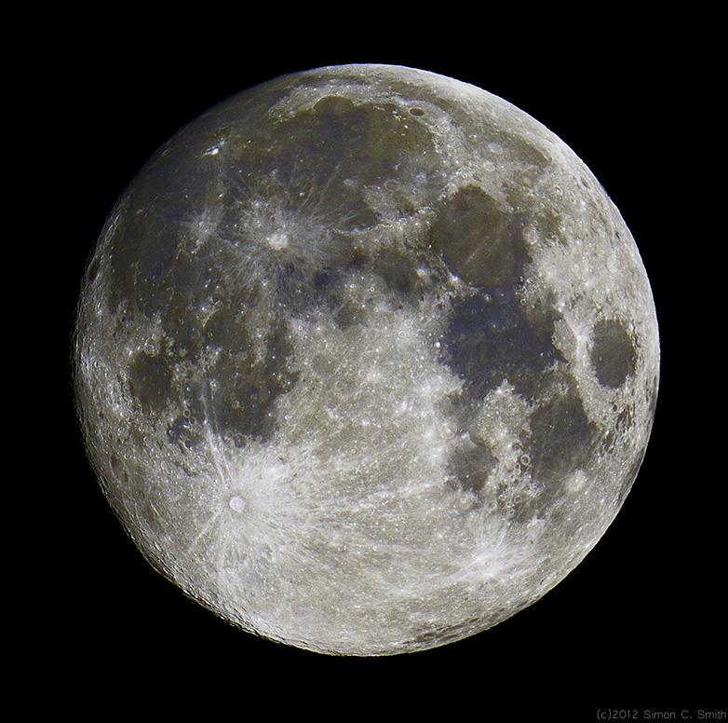
Figure 6. “Rising at sunset, the gorgeous Full Moon of August 31 became the second Full Moon in a month. According to modern reckoning, that makes it a Blue Moon” From Astronomy Picture of the Day http://apod.nasa.gov/apod/ap120901.html

The Moon is a pristine relic of an earlier epoch. Next to Earth it appears naked, without cover of atmosphere, vegetation, or oceans. In the absence of an atmosphere and its accompanying erosion, it remains much the same as when it originally formed. Its pocked and cratered surface gives us a hint of what the Earth must have looked like when it formed, 4.6 billion years ago.

As we leave the Solar System we can look back and see the Sun and its entourage of planets, their moons, comets, asteroids, and planetary rings (Figure 7). The Sun dominates the Solar System, containing 99% of its mass and generating virtually all of its light. Although master of its planetary system, it is just one among many stars in the galaxy that we call the Milky Way. The blazing light from the Sun originates deep inside, where there resides a thermonuclear furnace, able to power the Sun at its current rate for 10 billion years before it will die, first swelling out to the orbit of Mars, then forming a cold dense solid star, the size of the Earth.

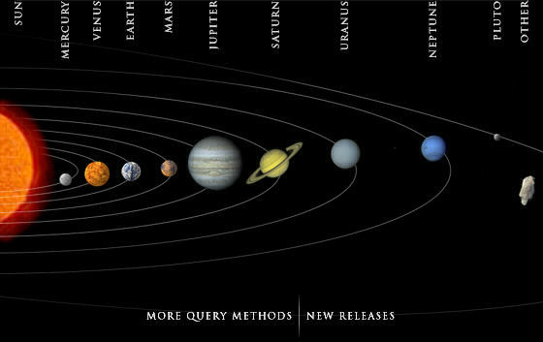
Figure 7. The Solar System. The relative sizes are to scale, but are exaggerated with respect to the distances between planets. From the JPL web site: http://photojournal.jpl.nasa.gov/.
Jupiter (Figure 8) contains 90% of the mass of the Sun’s planets. The Earth and the other planets could be looked on as the debris left from the formation of the Sun and Jupiter. Jupiter is more like the Sun than the Earth, harboring no solid surface. It is largely a sphere of gas and liquid, but because of its low mass it will never reach the high temperature necessary for thermonuclear ignition; it will never be a star.

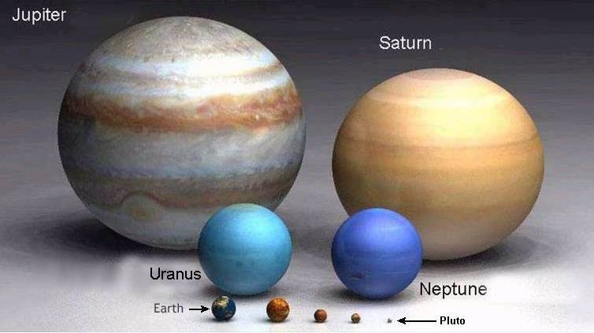
Figure 8. Relative sizes of Jupiter and the other planets. From http://schoolworkhelper.net/relative-sizes-and-distances-in-our-universe/

Of the remaining seven planets, three have solid surfaces like the Earth, and three are gas giants with rings, like Jupiter. Pluto doesn’t seem to really belong to either group, and seems to resemble a moon more than anything (although it has its own moon, Charon).

As we leave the Solar System for the nearest star, Proxima Centauri, we see a vast faint swarm of comets shrouding the Solar System out to the point where gravity no longer pulls on our humble starcraft (Figure 9). We see nothing else nearby over this vast distance covering three light years (taking three centuries to cover at our slow 25,000 mph).
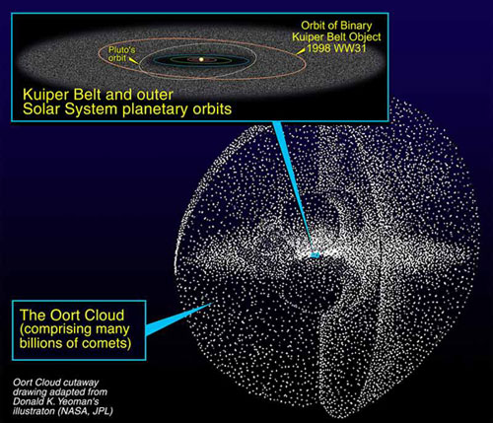
Figure 9. The Oort comet cloud. “A region of comets lying beyond Neptune's orbit has remained fairly undisturbed since then. It is known as the Kuiper Belt, and it's the source of short-period comets like Halley.” From http://herschel.jpl.nasa.gov/solarSystem.shtml

- The Milky Way and Beyond

As we travel to Proxima Centauri we see the background stars in their familiar configurations as constellations, and the bright band of light across the sky, known as the Milky Way (Figure 10). The Sun now appears as any other star, a faint orange pinpoint of light.
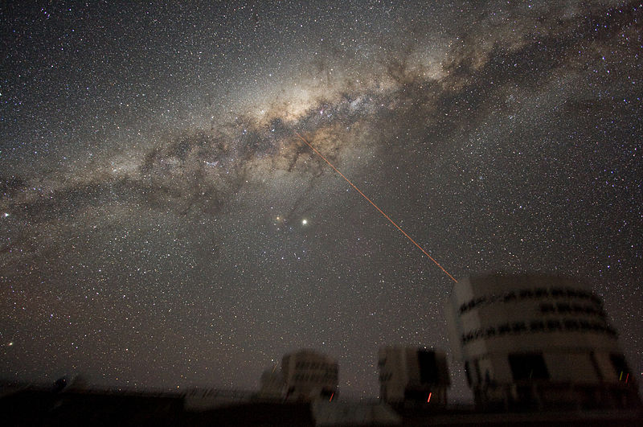
Figure 10. “An image of the Milky Way's Galactic Center in the night sky above Paranal Observatory in Chile.” From http://en.wikipedia.org/wiki/Milky_way

Now imagine accelerating our starcraft to the speed of light, and beyond! The constellations become distorted and begin to lose all familiarity, as we pull out of the disk of the Milky Way Galaxy. We begin to see the external appearance of the Milky Way (Figure 11). The Sun, Proxima Centauri, and the nearby stars making up constellation merge into the other 100 billion stellar members of the Milky Way galaxy. Before we could only guess at the external appearance of our own galaxy; looking at it from the outside, it now becomes crystal clear. It is a spinning disk of stars and interstellar gas and dust, with the brightest stars outlining a spiral pattern in the disk. From edge to edge the galactic disk is 100,000 light years across.

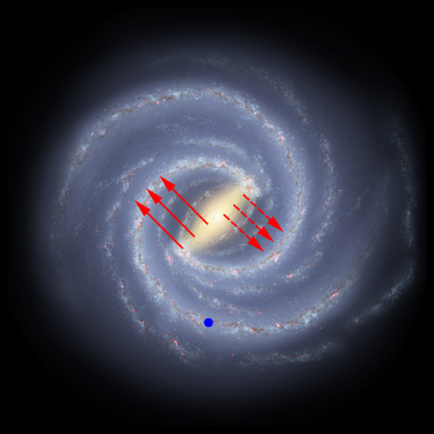
Figure 11. “Artist’s impression of Milky Way, with central bar. Small blue dot is Earth – not to scale! Solid red arrows show high-speed stars moving away from Earth, discovered by SDSS-III. Dashed arrows show stars moving toward Earth, which are expected to be seen in a future sky survey.” From http://earthsky.org/space/astronomers-identify-stars-in-the-milky-ways-central-bar

We also see that the Milky Way is not alone, but is one member of a family of galaxies, some two dozen strong, bound by the force of gravity, the same force that binds stars to the galaxies themselves, the same force that holds the planets in their orbits around the Sun. Some 2 million light years away is the Andromeda, our sister spiral galaxy, one neighbor in the Local Group of galaxies, with about the same size and characteristics as the Milky Way. It is considered our neighbor in astronomical terms. In human terms, the light that we see when we view Andromeda from the Earth was emitted before our species walked the Earth.

As we leave the Local Group of Galaxies we enter space occupied by other clusters of galaxies, some with thousands of members (Figure 12). These clusters fill the entire known Universe, which occupies a volume with a 10 to 15 billion light year radius.

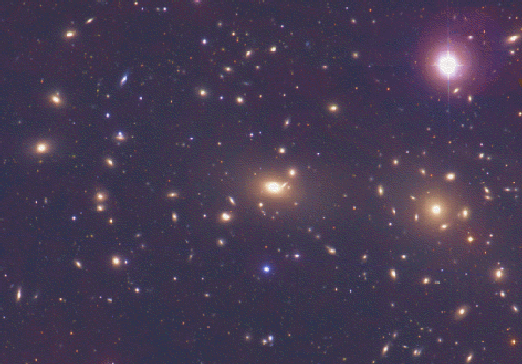
Figure 13. A cluster of galaxies

- The Time Scale of the Universe

Imagine if we could travel back in time as well as space, in a time machine that would allow us to watch the history of the Universe unfold, from the moment of creation, at the Big Bang, to the present. It is difficult, if not impossible, for science to address the time prior to the moment of creation, for science is, by definition, a method based on experiment, prediction and verification; there is no way we can repeat the Big Bang in order to verify theoretical predictions. The Big Bang is the simplest theory that we have to explain observations of the Universe made during the current epoch.

Theorists assume that the Big Bang originated as a sea of light and exotic particles at inconceivably high temperature and density. As the Universe expanded during the first several seconds of the Big Bang, this sea of light cooled, condensing out nuclear particles: first electrons and quarks, then combinations of quarks: protons, and neutrons. This era was the beginning of the radiation dominated Universe, where the matter that existed was uniformly spread throughout the small Universe by high-energy radiation. During the first three minutes of cosmic time, the nuclei of primitive elements formed: hydrogen, helium, and lithium.

Over the first 100,000 years of cosmic history the Universe continued to expand and cool, forming the first whole atoms, nuclei of protons (and sometimes neutrons) orbited by electrons. As electrons came to be wrapped up in atoms, the Universe became transparent to light. Light then stopped bouncing off of matter; each went its own separate way. This light continues to expand today, where it is seen as an infrared and microwave wavelength radiation that fills the entire sky. It fills our entire sky at infrared and microwave wavelengths. As light and matter separated, matter was left to condense by gravitation, forming the earliest stars and galaxies.

Even as the Universe as a whole is expanding, the interminably persistent force of gravity acts to coalesce matter into a hierarchy of knots and clumps: planets and stars, star clusters, galaxies, and even clusters of galaxies. First the largest objects formed, clusters of galaxies and galaxies themselves, then later the smaller stars and planets.

Our own Milky Way galaxy formed shortly after the Big Bang, out of a spinning and collapsing cloud of hydrogen mass, massive enough to eventually collapse into 100 billion stars and their unseen planets. Star formation has taken place in two generations. The first took place about 10 billion years ago, collecting the available hydrogen and helium gas into billions of stars, powered by a thermonuclear alchemy that converted hydrogen and helium into the heavier elements so essential for life as we know it: carbon, nitrogen, oxygen. As the short-lived members of the first wave of stars died, having exhausted their nuclear fuel, they spewed recycled gas back into space, sometimes in the death throes of an exploding star. From this recycled gas the second wave of stars, including our Sun, would form.

About 5 billion years ago, the Sun and planets formed, condensing out of a cloud of gas, now composed of not only hydrogen and helium, but carbon, nitrogen, oxygen, silicon, iron, and heavier elements as well. First the materials in this gas condensed to form small dust grains. These then coalesced to form small pea-sized chunks of ice and rock, which in turn combined to form larger clumps of material. This allowed for the formation of the rocky and icy planets, which contain a large dose of the heavier elements. As a result, our earth is composed mainly of hydrogen, oxygen, silicon, iron, and aluminum. The earth formed as a molten body, which formed a solid crust. Some of the other solid solar system bodies remained quite small. Evidence for them resides in the debris left after the formation of the solar system: rocky asteroids and meteorites and icy comets. The vast majority of this debris collided with the planets and the resulting impacts left the solid planets scarred by craters, some with diameters comparable to the radius of the planet. This episode of cratering may have lasted for 1 billion years.

At about the same time that the episode of cratering ended for the Earth, primitive life is thought to have begun on Earth as well as the geological changes that we see evidence of today: volcanic activity, mountain building, erosion, and the motion of the vast continental, crustal plates floating and shifting on a soft layer of semi-molten rock.

The accepted history of primitive life on Earth is sketchy. It is thought that several billion years ago that chemical evolution on the Earth’s surface, spurred on by the effects of sunlight on simple organic compounds, caused the formation of amino acids and eventually some self-replicating precursor to DNA. What we do know from the fossil record over the last several hundred million years is that the complexity of life has gone through an explosion in complexity and diversity, culminating (for us anyway) in the appearance of humans on the planet about 2 million years ago.

Human existence on our planet has gone through several rapidly accelerating phases of development, prehistoric man, the development of written languages (historic man), and the age of technology (technology adequate for us to explore our own universe) or the space age.

We tend to look at the Universe with a time scale associated with our own lives. Any time interval longer than our own life is considered a long time. But a person’s lifetime is short compared to an historical time scale - the written word extends back in time several thousand years. But even historical time is insignificant compared to geologic time - geological features such as mountains take millions of years to form. And the cosmic time scale - the time scale for formation of stars, planets, and the evolution of the Universe as a whole - extends back 10-20 billion years ago.

The Historical Development of Astronomy

The historical development of astronomy mimics the spatial scale of astronomy. Astronomers have explored the Universe from the inside out, from the inner Solar System to the furthest galaxies; physicists in general explored the Universe from the outside in, from the macroscopic to the subatomic. The Earth, Sun, Moon, Mercury, Venus, Mars, Jupiter, and Saturn were known to the ancients. In the early 17th century the telescope was invented and first used to explore the Universe. Galileo noticed for the first time that the Milky Way was a band of faint stars and not an atmospheric phenomenon. In the late 18th century the astronomer William Hershel proposed that the Milky Way was a disk of stars with the Solar System positioned in the middle. It wasn’t until the 20th century that astronomers realized that glowing patches of light in the sky are actually galaxies outside our own Milky Way galaxy, each containing billions of stars. In the last half of the 20th century scientists have been able to measure the size and age of the Universe as a whole and have begun to model its formation and evolution.

Key Words & Phrases

Big Bang - the explosive event in which the universe was created some 15 billion years ago
light year - a unit of distance (not time), the distance light travels in one year, or 9.46 x 10¹² km
quark - elementary particles out of which protons, electrons, and neutrons, among others, are made
Universe - all space with all matter and electromagnetic radiation contained in it

________________________________________________________________________
Chapter 2 - The Sky from Earth: Our Window on the Universe

If the Lord Almighty had consulted me before embarking on the Creation, I should have recommended something simpler.
--Alfonso X, King of Leon and Castile (1252-1284)

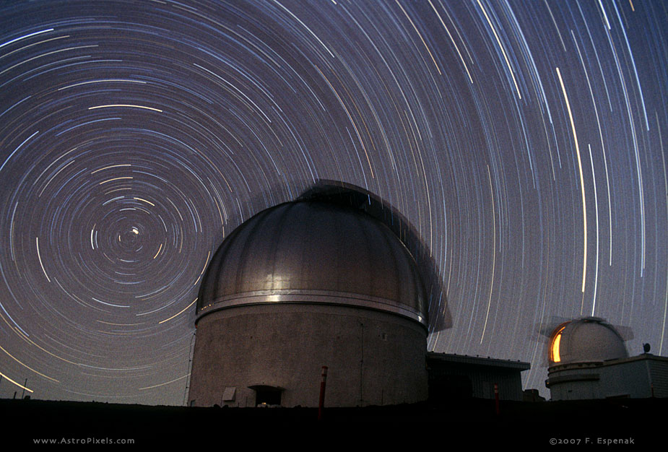
Chapter photo, Figure 1: Star trails. A long exposure photograph of an observatory dome at Mauna Kea Observatory, latitude +20° showing the circumpolar motion of stars around Polaris. From http://astropixels.com/startrails/MKO/MK89-207.html

Chapter Preview

An understanding of the sky is as important as knowing any of the basic components of our natural environment. But understanding the sky is also fundamental in tracing and comprehending the historical development of astronomy as a science. In this chapter we will follow the daily and yearly rhythms and patterns of the Sun, stars, and planets that were instrumental in developing an appreciation of our place in the Universe and in the development of the science. After developing an understanding of the motions of the Sun, Moon, Planets, and Stars, we will follow with an historical development of science in explaining these phenomena in Chapter 3.

Key Physical Concepts to Understand: Daily and Annual Motions of the Sun, Moon, Planets, and Stars

- Introduction

Ancient peoples were certainly more aware of the sky than we are today. First, before the advent of artificial lighting, the night sky was more vivid with stars and constellation, as we see today when we spend time away from our urban environment at night. We can imagine the shepherd watching over his sheep at night with little to do but ponder the stars. But stars were not just objects of wonder. The seasonal motions of celestial objects were important to primitive agrarian societies as a calendar, enabling the prediction of the best times for planting and harvesting, and as a compass for navigating by sea or land. These motivations for studying the sky are largely ignored in modern society.

If one studies the sky at night over a period of time, one notices several kinds of motions. Patterns of stars rise and set each night, as do the moon and planets. Over the course of the year the patterns of stars we see at night slowly changes, each season characterized by its own set of constellations. The planets rise and set daily, but over the year they slowly shift their position with respect to the background stars, sometimes even reversing their course.

II. The Constellations: Our Guide to the Heavens

Constellations are patterns of stars in the sky usually associated with some legendary beast, god, goddess, or icon as a convenient way of remembering and locating individual stars. The star groups don’t usually resemble the mythological object for which they are named. They aren’t even really neighbors in space; although they appear close together on the sky, in reality some members of any constellation are much farther away than others. Constellations are also used as a convenient way of mapping the sky into 88 regions with boundaries of varying size and shape, just as a geographical location on the Earth can be conveniently referenced by the country within which it resides.

Many ancient civilizations, including the Egyptians, Chinese, and Mesopotamians, categorized stars by the constellation to which they belong. In subsequent years, many other cultures have developed their own constellations based on the mythology of that society. The Norse, Native American, Greek cultures are three cultures, among many, that independently developed and named their own constellations. Today we usually use the constellations as they were named by the Greeks and Romans, although some constellations, such as Microscopium (the Microscope), are of modern origin. Each bright star in a constellation is named according to its brightness, by the constellation name and a Greek letter, beginning with alpha. For example, in Ursa Majoris (the Big Bear or Big Dipper) the brightness star is alpha Ursa Majoris, followed by beta Ursa Majoris, and so on.

The summer triangle, composed of the bright stars Deneb, Vega, and Altair, dominates the summer sky and is overhead at about midnight. Deneb is at the top of the Northern Cross (in the constellation Cygnus, the Swan), Vega is found in the constellation Lyra (the Harp), and Altar in Aquila (the Eagle).

The autumn sky in early evening is marked by the Great Square. Three of the stars forming the Great Square are in Pegasus, Markab, Sheat, and Algenib; the forth is alpha Andromeda. Between Polaris and the Great Square is Cassiopeia, the upside down “w.”

The early-evening winter sky (Figure 3) is dominated by three of the brightest stars in the sky, Betelgeuse (pronounced “beetle juice”), Sirius, and Procyon, which form the winter triangle. Betelgeuse is found in Orion (the Hunter), Sirius in Canis Major (the Big Dog), and Procyon in Canis Minor (the Little Dog). The winter triangle straddles the Milky Way, the billions of stars making up the galaxy in which we reside. Orion easy to find from the three bright stars that make up its belt.

In the spring, the early-evening sky (Figure 2) is dominated by the Big Dipper (or Big Bear, Ursa Majoris), and the Little Dipper (or Little Bear, Ursa Minoris). The pointer stars in the end of the Big Dipper guide one to the North Star, Polaris, in the handle of the Little Dipper. On the other side of Polaris from the Big Dipper, lies Cassiopeia, seen as six stars forming a “w” on its side.

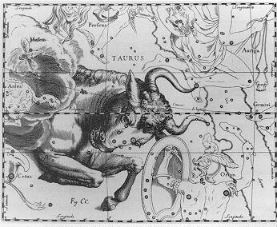
Figure 2. Circumpolar stars at latitude 45 N.
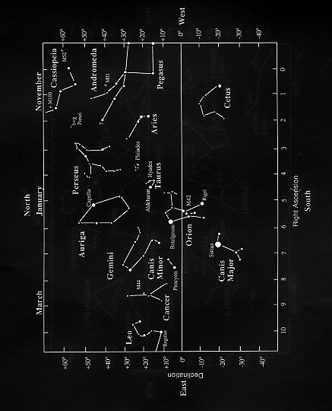
Figure 3. The winter sky.

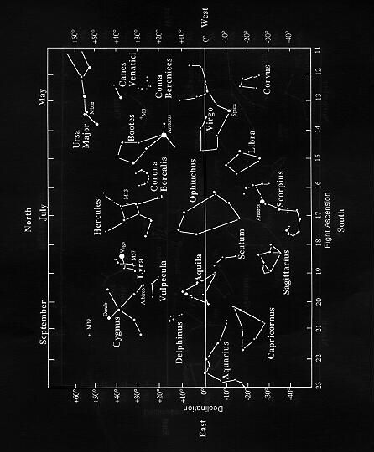
Figure 4. The summer sky.

As the nighttime constellations change from season to season, so does the position of the Sun against the background constellations. The twelve constellations of the zodiac are strung out along the ecliptic, the path followed by the Sun in the sky. These are the constellations that are seen just after sunset just where the Sun has set and right before sunrise at the position that the Sun will rise. The zodiacal constellation that is seen at overhead at midnight (or on the horizon at sunset or sunrise) can be used to determine the time of year.

Table 2.1: Passage of the Sun through the zodiac.
Constellation | Date of Occupation by the Sun
Capricorn | January 19 - February 18
Aquarius | February 18-March 13
Pisces | March 13-April 20
Aries | April 20 - May 13
Taurus | May 13 - June 21
Gemini | June 21 - July 20
Cancer | July 20 - August 11
Leo | August 11 - September 18
Virgo | September 18 - November 1
Libra | November 1 - November 22
Scorpius | November 22 - December 1
Ophiuchus | December 1 - December 19
Sagittarius | December 19 - January 19

III. The Celestial Sphere: Daily Motion

The apparent motions of the Sun and stars, and to a large extent the Moon and planets, can be described as a combination of their daily (or diurnal) motions and their annual motions. All rise in the East and set in the West each day, except for the stars near Polaris in the Northern Hemisphere. This apparent daily motion is a result of the spin of the Earth on its rotational axis. There is also an apparent annual, or seasonal, motion of the Sun and stars is due to the Earth’s real motion around the Sun (or revolution, not to be confused with rotation), which we will examine in Section IV. Finally, the Moon orbits the Earth, producing a changing appearance over the course of the month (Section VI).

WebNote: Diurnal and Annual Motion of Celestial Objects

The diurnal motion of the Sun and stars is dependent on latitude (Figure 5). From the Northern Hemisphere stars appear to circle Polaris daily (if Polaris is visible from a particular latitude) in circular orbits. Since Polaris is always directly overhead at the North Pole (latitude 90 N), stars circle the sky in a motion parallel to the horizon. The same occurs at the South Pole, although there is no south polar star equivalent to Polaris. At the Earth’s equator, Polaris is always on the horizon; so stars circling Polaris will rise and set perpendicular to the horizon. The angular distance of Polaris to the horizon is just equal to the latitude. An observer who finds Polaris 45° from the horizon will be at a latitude of 45 N. Thus stars that are separated by less than 45° from Polaris will be seen to circle Polaris at a rate of once every 24 hours, but will never set. These stars are the circumpolar stars. For mid-latitudes in the Northern Hemisphere, Ursa Minor, Ursa Major, Draco, and Cassiopeia are always above the horizon. For this reason, they serve as handy guideposts when finding your way around the night sky.
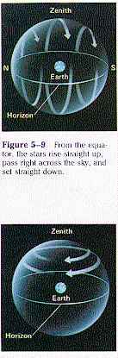
Figure 5. Diurnal motions of the stars vs. latitude.
(P 94-5.9&5.10)

IV. Annual Motion and the Seasons

One of the most common misconceptions among educated people about astronomy is the reason for the seasons. Seasons are not a result of the varying distance between the Earth and Sun. The Earth’s distance from the Sun does vary by about 1%, but this in itself would not produce a temperature variation that is significant compared to seasonal temperature variations. The Earth is actually closer to the Sun during winter in the Northern Hemisphere. Finally, when the Northern Hemisphere is experiencing winter, the southern latitudes are in summer.

The 23.5° tilt of the Earth’s axis with respect to its orbital plane is the ultimate cause of the seasons. This tilt causes variations in the directness and intensity of sunlight hitting the surface of the Earth and in the length of the day, over the course of the year. Longer days with more direct sunlight cause summer to be warmer than winter, which has a shorter daylight period and less intense sunlight.

In Figure 6 we see that during Northern Hemisphere summer (which we will now simply refer to as summer) when the Earth’s north pole is pointed toward the Sun, the Sun’s rays are the most direct since the Sun is, on average, higher in the sky during the day than it is in winter. This produces a higher intensity of sunlight striking the ground in summer than in winter. You can see this for yourself by shining a flashlight onto a flat surface in a dark room (Figure 7). When the flashlight is pointed perpendicularly at the surface the beam is spread over a relatively small circular area. As the flashlight is tilted toward the surface it is spread over a larger elongated area, decreasing the intensity, or amount of light energy measured per unit area of the Earth’s surface.

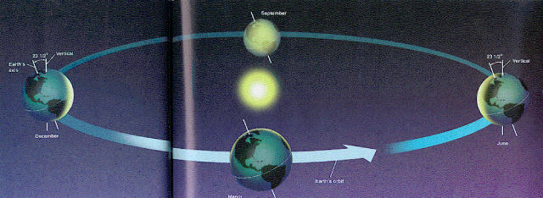
Figure 6. Seasons and the tilt of the Earth’s axis. The Earth’s axis is tilted 23.5° from the vertical and always points in the same celestial direction as the Earth revolves about the Sun. The Earth’s North Pole points toward the Sun in June, causing summer in the Northern Hemisphere, and points away from the Sun in December, causing winter in the Northern Hemisphere. In September and March, at the equinoxes, there are equal hours of night and day at all points on the Earth.

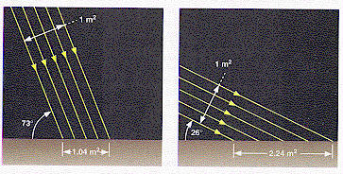
Figure 7. Solar insolation in summer and winter. In summer the Sun is high in the sky and solar energy is relatively concentrated as it strikes the surface of the Earth. In winter the Sun is low in the sky and solar energy is relatively spread out over the Earth’s surface.
(FMA 62-3.5 modified)

The length of daylight hours also changes over the year (Figure 8). When the north pole is tilted toward the Sun, the Sun rises in the northeast, sets in the northwest, and is seen higher in the sky during the day, resulting in longer daylight hours (for the Northern Hemisphere); daylight lasts longer than 12 hours. The Sun appears highest in the sky on the day that the North Pole is tilted directly to the Sun, about June 21st. This date and the direction of the Sun in the sky on this date are referred to as the summer solstice. When the north pole is tilted away from the Sun, the Sun rises in the southeast, sets in the southwest, and is seen low in the sky during the day, resulting in short daylight hours (again, for the Northern Hemisphere); daylight is less than 12 hours. The Sun appears lowest in the sky on about December 21st, the winter solstice. The difference in the number of hours of daylight between summer and winter becomes more extreme the farther north one lives. At the equator daytime is 12 hours year round. At latitudes above 66.5 N, the Arctic Circle, and below 66.5 S, the Antarctic Circle, the Sun doesn’t appear above the horizon on the winter solstice and circles above the horizon 24 hours a day on the summer solstice. On March 21st, called the vernal equinox, the Sun rises due east, is seen directly overhead, and sets due west, resulting in 12 hours of daylight. On September 22nd, called the autumnal equinox, the Sun again rises due east, is seen directly overhead, and sets due west, resulting in 12 hours of daylight. The equinoxes are also the two points in the sky where the ecliptic (the path of the Sun in the sky) crosses the celestial equator, for the Sun crosses the celestial equator on September 22nd and March 21st.
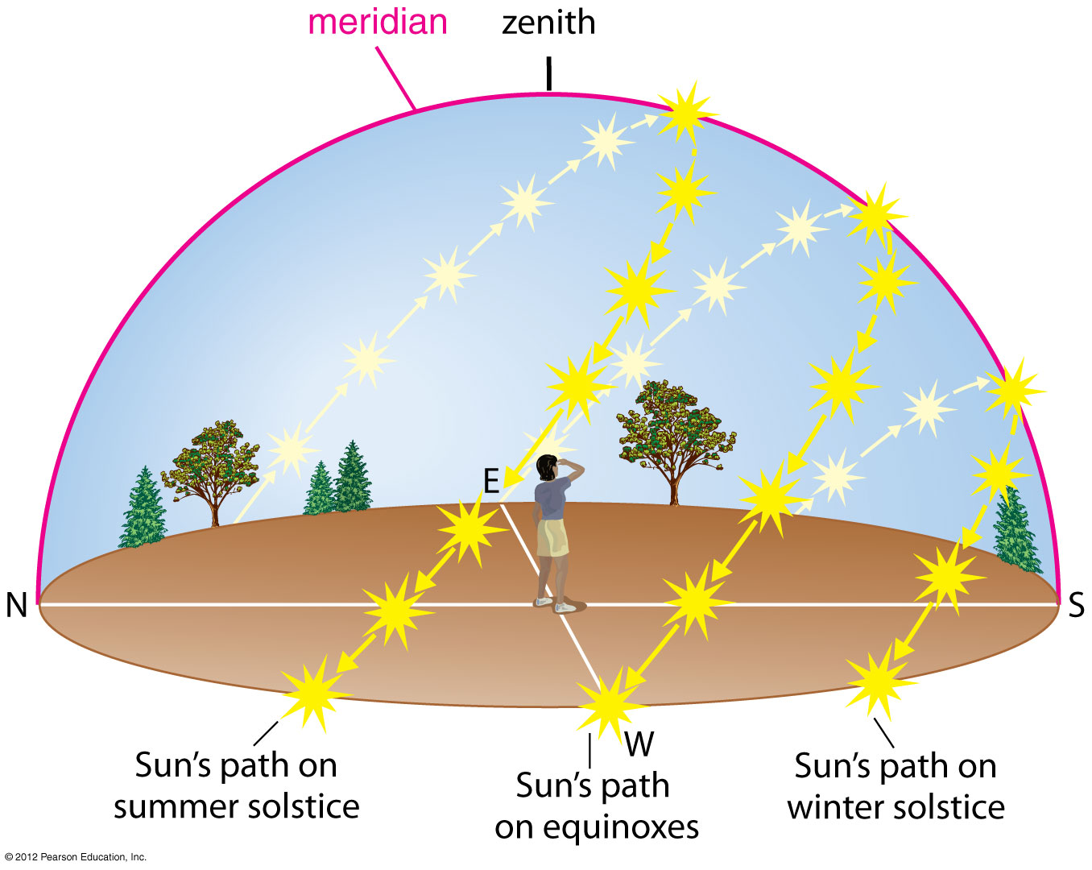
Figure 8. Motion of the Sun across the sky on four different days of the year.

The total amount of sunlight hitting the surface of the Earth per unit area, or solar insolation, is the intensity of sunlight multiplied by the length of the day. Since both solar intensity and length of day are larger during the summer than the winter, the net effect is that temperatures on Earth are higher during the summer than the winter. The differences in solar insolation vary most extremely at high latitudes. At the equator solar insolation does not vary significantly over the year so there are essentially no seasons at 0° latitude.

WebVideos: Size of the Universe

https://www.khanacademy.org/science/cosmology-and-astronomy/v/seasons-aren-t-dictated-by-closeness-to-sun

https://www.khanacademy.org/science/cosmology-and-astronomy/v/how-earth-s-tilt-causes-seasons
https://www.khanacademy.org/science/cosmology-and-astronomy/v/are-southern-hemisphere-seasons-more-severe

Angles in Astronomy

One of the most important mathematical tools available to the astronomer is the use of angles. Astronomical objects are all at great distances from the Earth, and these distances are not always well known. In addition, we can only see the sky in two dimensions. It is therefore common astronomical practice to refer to the size of or separation between objects in terms of angular separation. The Moon has an apparent diameter of ½ °, for example.

To illustrate this concept, try the following experiment. Pick an object at eye level, a picture hanging on the wall for example, and position yourself about five feet from the object. Holding a ruler at arm’s length, measure the length of your object, as projected on the scale of the ruler. Now back up another five feet and repeat the measurement. How did the apparent size of the object change? You have measured an apparent change in the size of the object, although its true physical size remained the same. The use of length is not a convenient method of describing the apparent size of an object viewed from a distance. Instead we use the angle that it occupies, in units of degrees (Figure 9).

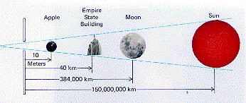

Figure 9. Objects of dramatically different size can appear to have the same angular size if their distance from the observer increases in proportion to object diameter.
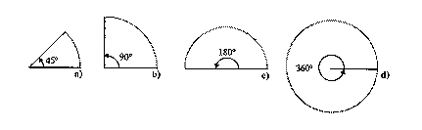
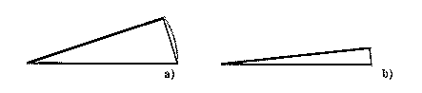
Figure 10. Panel a: Angles swept out by line segments joined at a point. Panel b: As the angle α becomes small, the arc swept out by the angle closely approaches the length of the line segment that connects the ends of the arc.
(JC 10-2.1 & 11-2.2)

Figure 10 shows the angles swept out by two line segments joined at a point. An angle of 360° sweeps out a full circle with a circumference of 2πr. A smaller angle sweeps out a fraction of a circle, obeying the following relationship:

Equation 2.1: s/2πr = α/360°,

where s is the length of the arc and α is the size of the angle, in degrees. For small angles, the type usually encountered in astronomy, the arc of length s, approximates a straight line. Angles that are a fraction of a degree are measured in astronomy using arc-minutes and arc-seconds. The arc-minute is 1/60th of a degree, and the arc-second is 1/60th of an arc-minute, or 1/3600th of a degree.

Using Equation 2-1, we can determine the diameter of the Moon, if we know its distance. The mean distance of the Moon is 384,000 km. The mean diameter is 31 arc-minutes or approximately 1/2°. Substituting these values into Equation 2.1, we obtain:

0.5°/360 = diameter/(2πdistance),

or the diameter of the Moon is approximately 3300 km.

V. Celestial Coordinates - Locating Objects on the Sky

In order to precisely the positions of celestial objects on the sky, astronomers use coordinates similar to the ones we use to specify the position of an object on the surface of the Earth, latitude and longitude. Before we discuss astronomical coordinate systems it is important to review this geographic system of coordinates (Figure 11).

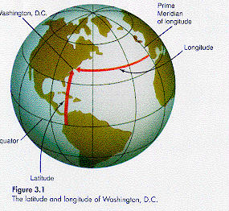
Figure 11. Geocentric coordinates. The latitude and longitude of Washington, D.C.
(FMA 60-3.1)

The surface of the Earth is approximately spherical, rotating about an imaginary axis that intersects the surface of the Earth at the north and south poles. Midway between the poles is the equator. The equator is a great circle, any circle lying on the surface of the Earth whose radius is equal to the radius of the Earth. A meridian is any great circle which intersects the north and south poles. The prime meridian is defined as the meridian passing through Greenwich, England. Meridians are used to designate the position of a point on the Earth in the Earth-West direction. To designate how far an object is, north or south, from the equator, we use parallels. A parallel is the intersection between the surface of the Earth and a plane perpendicular to the Earth’s axis. The equator is one such parallel. (All such planes are in themselves parallel, hence the name.)

Parallels and meridians intersect at right angles to form a grid covering Earth’s surface. Latitude and longitude are the coordinates in this grid that specify the location of a point on the surface of the Earth. Latitude is the angular separation (north or south) of a location from the Earth’s equator along a meridian (or how far the parallel upon which it sits is from the Earth’s equator), in degrees. Longitude specifies the angular distance between a location and the prime meridian. The north and south poles have latitudes of 90 N and 90 S respectively (with no longitude, since longitude is not definable at the poles).

A coordinate system that is analogous to the latitude and longitude system is used to specify the positions of celestial objects on the sky, which we can think of as an imaginary celestial sphere (Figure 12). (A third coordinate, distance, is needed to completely specify the location of a star in three dimensions.) We define a north celestial pole and south celestial pole as the intersection of the Earth’s rotation axis with the celestial sphere. The plane that defines the Earth’s equator also intersects the celestial sphere, defining the celestial equator.

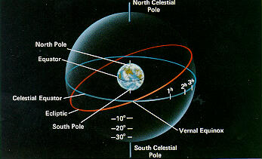

Figure 12. Celestial coordinates. The celestial equator, celestial north pole, and celestial south pole are extensions of their terrestrial counterparts onto an imaginary celestial sphere. The ecliptic is the path of the Sun on the sky, or equivalently the intersection of the plane of the Earth’s orbit with the celestial sphere. Right ascension, the celestial equivalent of longitude, is the angle measured along the celestial equator, from the vernal equinox. Declination, the celestial equivalent of latitude, is the angular distance from the celestial equator.
(P 91-5.5 modified)

Now that we have a celestial sphere with poles and an equator, we can define a system of latitude and longitude, similar to that used to specify coordinate on Earth. This system uses right ascension and declination, where declination specifies the angular distance of a star from the celestial equator (analogous to latitude) and right ascension specifies the angular distance from a specified meridian (similar to longitude). The declination of Polaris, for example, is approximately 90 N.

- Phases of the Moon

As the Moon orbits the Earth we see different lunar phases over the course of a month (Figures 13 and 14). Ancients employed lunar phases to keep track of the passing of time. Lunar phases are determined by the fraction of the sunlit hemisphere of the Moon seen by earth-based observers. A complete cycle of lunar phases is seen over a lunar month or 29.5 days. However, the sidereal lunar period, the period of the moon with respect to the stars, is 27.3 days (this is the period that you would measure by timing the Moon moving in front of one particular star twice in succession). The difference is a result of the Earth’s motion around the Sun. To get to the same lunar phase the Moon must orbit the Earth once and then an additional fraction of an orbit to get the same geometrical alignment between Moon, Sun, and Earth (Figure 15).

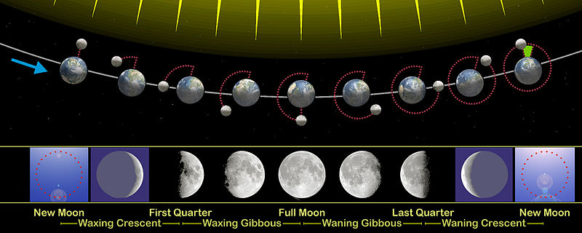Figure 14. Phases of the Moon. Phases of the Moon, as seen looking southward from the Northern Hemisphere. The Southern Hemisphere will see each phase rotated through 180°. The upper part of the diagram is not to scale, as the Moon is much farther from the Earth than shown here.
From http://en.wikipedia.org/wiki/Lunar_phase
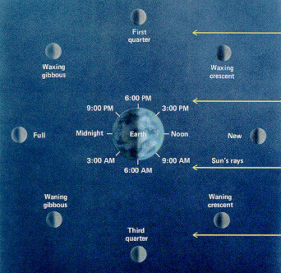
Figure 15. Phases of the Moon. Looking down on the Moon’s orbit about the Earth, we see the relationship between the Moons phases, the position of the Moon in its orbit, and the time that the Moon is seen overhead. (P 113-6.3)

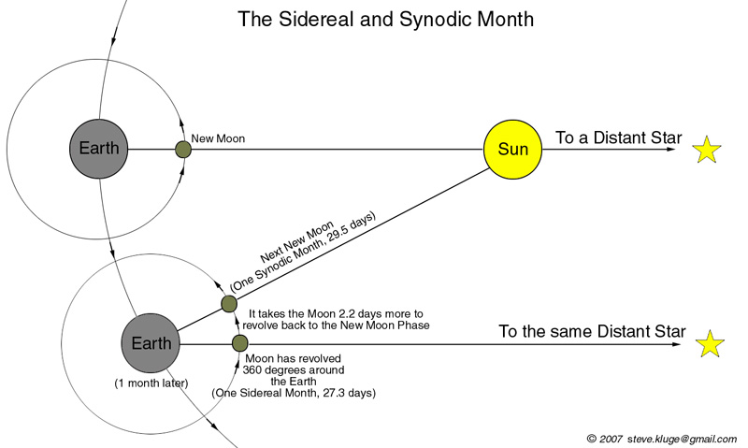

Figure 16. Synodic and sidereal periods. From stevekluge.com

When the Moon appears close to the Sun in its orbit, little of the moon’s illuminated side is seen from the Earth; we call this a new moon. Over the next seven days the moon appears as an increasingly fat crescent, as more of the moon’s sunlit surface shifts into view. This phase is referred to as the waxing crescent phase (one definition of the word wax is “to increase in size or intensity”). After seven days the moon is seen as a first quarter moon (one quarter of the cycle of lunar phases having passed), or half-illuminated. First quarter refers to the fraction of the moon’s period, not the fraction of the moon that is illuminated. From seven to fourteen days, when the moon appears to have more than half its surface illuminated it is called a gibbous moon. It is now in a waxing gibbous phase. At 14 days the moon is opposite the sun in its orbit; it is now appears fully illuminated and is called a full moon. From 14 to 22 days the moon appears as a waning (or decreasing) gibbous moon, as the fraction of the moon’s illuminated surface appears to decrease. At 22 days the moon is once again half-illuminated, and the moon is at third quarter. Between third quarter and new moon it appears as a waning crescent.

There is a correlation between the phase of the Moon and the time of day that it is seen overhead. The Moon’s rising and setting times occur later by about 50 minutes each day. At new moon the Moon is seen near the Sun, rising at sunrise, overhead at noon, and setting at sunset. At full moon the Moon is 180° from the sun in the sky and rises at sunset, appears overhead at midnight, and sets at sunrise. At first quarter the Moon is 90° from the Sun in the sky, rises at about noon, is overhead at dusk, and sets near midnight.

WebVideo: Phases of the Moon http://www.youtube.com/watch?v=YdI1aDjWLlY

VII. Eclipses

Total solar eclipses are one of nature’s most dramatic phenomena (Figure 17). Eclipses occur when the Moon’s shadow falls on the surface of the Earth, a solar eclipse, or the Earth’s shadow falls upon the surface of the Moon, a lunar eclipse. In order for a solar eclipse to occur, the Moon must pass directly between the Earth and Sun, blocking sunlight that would otherwise strike the Earth. This can only happen at new Moon. For a lunar eclipse to occur, the Earth must pass directly between the Moon and Sun, blocking sunlight that would otherwise hit the Moon. This can only happen at full Moon. Why isn’t a solar or lunar eclipse seen at every full or new Moon (Figure 18)? This doesn’t happen because the Moon’s orbit is tilted by about 5° with respect to the ecliptic. Two conditions are necessary for an eclipse, the Moon must be in either a new or full phase and the Moon must lie in the plane of the ecliptic. The maximum number of times that the Moon is close enough to the ecliptic, at new or full moon, in a single year is seven, with solar and lunar eclipses occurring with about equal frequency.

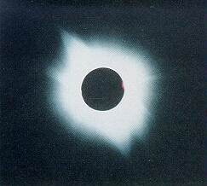

Figure 17. The total solar eclipse of July 11, 1991, photographed from near La Paz, Mexico. The hot outer atmosphere of the Sun, the corona, is clearly visible.
(FMA 78-3.21)

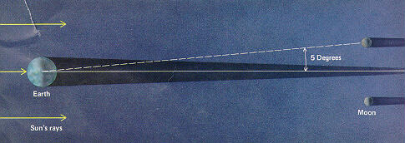
Figure 18. Geometry of a lunar eclipse. The Moon’s orbit is inclined with respect to the Earth’s orbit about the Sun. As a result, a lunar eclipse is not seen every new moon, but only when the Sun, Earth, and Moon are in alignment.
(P 115-6.7)

There are three types of lunar eclipses, depending on where the Moon passes through the Earth’s shadow (Figure 19). The shadow of the Earth can be divided into two regions, the umbra, where all direct sunlight is blocked, and the penumbra where only a fraction of the light from the Sun is blocked from the Moon. An umbral eclipse occurs when the Moon passes through the umbra of the Earth’s shadow, and is completely covered by it for a time. This interval is called the time of totality and lasts for no longer than 1 hour and 47 minutes. The Moon will not be totally invisible during totality, but will appear to have a dim reddish cast, because it is illuminated by red light that is bent by the Earth’s atmosphere onto the Moon, much as a lens focuses light (Figure 20). A penumbral eclipse occurs when the Moon passes only through the penumbra of the Earth’s shadow. It is difficult to notice, because it is only manifested as a slight dimming of the Moon’s intensity. A partial lunar eclipse occurs when only part of the Moon passes through the penumbra, and the Moon appears as if a piece has been taken out of it.

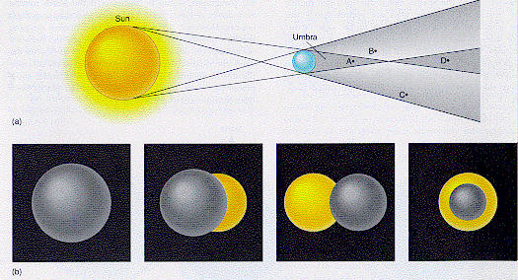
Figure 18. Geometry of an eclipse. a) The Earth casts a shadow consisting of a dark umbra (A and D) and partially illuminated penumbra (B and C). b) The three types of eclipse correspond to how the Moon would look at the four lettered points: A - total eclipse, B&C - partial eclipse, and D - annular eclipse.
(FMA 76-3.19)

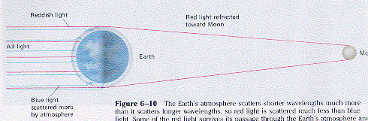.
Figure 19. Lensing of light in the Earth’s atmosphere during a solar eclipse.
(P 116-6.10)

WebCalendar: Solar and Lunar Eclipses in the Near Future
http://eclipse.gsfc.nasa.gov/eclipse.html

Although the Sun is much larger than the Moon, a quirk of nature places them at distances from the Earth so that the Moon and Sun have approximately the same angular size on the sky, about ½°. During a solar eclipse the Moon blocks out light emission from the surface or photosphere of the Sun, so that emission from the outlying, spectacular corona, or upper atmosphere of the Sun, which is not normally seen, is viewed. This allows astronomers to study the corona and provides us with a spectacular view (Figure 16). During the eclipse the narrow umbra is swept over the surface of the Earth in a narrow path, called the path of totality, at high velocity, over 1700 km/hr. The path is at most 270 km wide. Observers in this swath are fortunate to see a total solar eclipse. The time of totality is less than 7.5 minutes at any given location. The rest of the Earth is in the Moon’s penumbra and sees only a partial solar eclipse.

As the Moon orbits the Earth, its distance varies by a few percent. The length of the Moon’s umbra is about 5000 km shorter than the mean distance between Earth and Moon. As a result, during more than half of all solar eclipses the Moon’s umbra never touches the Earth at all. Then the Moon is too small to cover the Sun completely, and the Sun is seen as a thin ring or annulus of light around the Moon. This is known as an annular eclipse. Annular eclipses are slightly more common than total solar eclipses.
Eclipses are intensely dramatic events. The Sun is suddenly extinguished, birds roost, the temperature drops, some plants fold their leaves for the “night”, and there is a sudden increase in wind velocity. Minutes later, the intense daylight reappears, roosters crow, and solar warmth suddenly returns to the Earth. This must have been a uniquely disturbing event to prehistoric observers.

WebNotes: Solar and Lunar Eclipses
http://www.youtube.com/watch?v=1Gs02YQNckE
http://www.youtube.com/watch?v=IKQkM474UE0

VIII. Time and Calendar

Before the invention of the clock, time was measured in days, months, and years by cyclical astronomical events – the daily rotation of the Earth, the monthly orbit of the Moon about the Earth, and the yearly revolution of the Earth about the Sun. With the advent of the clock people were able to measure time more precisely, in hours, minutes, and seconds. The early Egyptians used the date that the star Sirius first appeared in the dawn sky to warn them of the impending seasonal flooding of the Nile. Over a thousand years ago the Mayans used the height of the Sun in the sky and the phases of Venus to mark the time for planting their corn.

One method of keeping track of time is to employ the motion of the sky due to the Earth’s rotation. The time interval between two successive passages of a star through the local meridian is called the sidereal day. The time interval between two successive passages of the Sun through the local meridian is called the apparent solar day (approximately 24 hours). The two differ, the sidereal day being shorter by about four minutes. This discrepancy results from the Earth’s revolution around the Sun. It takes the Earth a little over 365 days to travel 360° in its orbit around the Sun, causing the Sun to shift about 1° a day with respect to the stars. This means if we see the Sun in front of a particular star in the sky one day, it will appear to lag 1° behind (to the East) of that star the next. This effect causes the Sun to appear to take 4 minutes longer each day to accomplish one complete lap of the sky.

The Earth does not travel in a precisely circular orbit (remember it is closer to the Sun in the winter) and the closer it is to the Sun the faster it travels in its orbit. As a result, the apparent solar day varies over the year and is not useful for keeping precisely constant time. As a result we use the mean solar day, the average length of an apparent solar day over the year, as the measure of the length of a day, 24 hours. Before the advent of the railroad, local time, referenced to the time that the Sun crossed the local meridian, was used to keep time. Each city, town, and berg kept its own time referenced to that location. After the construction of transcontinental railroads, this made train schedules complex and confusing. The world went to standard time zones centered on meridians spaced 15° apart. The Earth spins 360° per day, or 15° per hour, so that local time on two meridians spaced 15° apart differs by exactly one hour. The Earth is divided into 24 time zones, with one centered on the prime meridian at Greenwich, and the others spaced by increments of 15° with respect to Greenwich. Each time zone has a boundary extending roughly +/- 7.5° from the meridian defining that time zone. In practice the boundaries are altered to follow state and country boundaries and rivers so that people in the same geographical unit will keep the same time.

The major practical problem that arises with times zones is how to account for the date. Imagine flying eastward in a fast jet aircraft. Each time you cross a time zone it is one hour later. Flying westward you must set your watch one hour earlier when you cross a time zone. When do you change the date? By international agreement, the date changes at the time zone boundary at 180° longitude, known as the International Date Line. When one crosses the International Date Line going west, they must subtract one day from the date, traveling east they must add one day.

While standard time is useful for local and even global commerce it is not convenient for astronomy. Astronomers need a global system of time so that astronomical events, such as a solar flare or the closest approach of a comet to the sun can be specified in time in a universal time system that is independent of location on the Earth. Such a system is known as Universal Time or Greenwich Mean Time, and is simply the mean solar time at Greenwich, England.

Well before 2500 BC the Babylonians and Egyptians used a calendar based on lunar months, with one lunar month the time between successive full moons. There were twelve lunar months in a year. The practical problem is that there is eleven days difference between the orbital period of the Earth, one year, and twelve lunar months. A calendar based on the lunar month would slip by eleven days each year relative to the seasons. This was rectified when the Roman calendar, the basis for our modern calendar, was reformed by Julius Caesar in the 1st Century BC. For this reason it is known as the Julian calendar.

Before the Julian calendar, the Roman calendar contained 12 months: Martius, Aprilis, Maius, Iunius, Quintillis, Sextilis, September, October, November, December, Ianuarius, and Februarius, for a total of 355 days, 10.25 days short of the time it takes the Earth to orbit the Sun. Martius was the first month of the year, until 153 BC when the first day of the year was changed to Ianuarius 1st, in the honor of the god of beginnings, Ianuarius. Because the calendar year was ten and one quarter days short of the solar year, an extra month was added every four or five years.

By 46 BC the Roman republican calendar was three months out of sync, with the astronomical equinox occurring 3 months later than its assigned date. As a result, the seasons no longer occurred in the proper months; for example, spring occurred during the winter months. As emperor of the Roman Empire Caesar dictated the reform of the Roman calendar, advised by the astronomer Sosigenes. First Caesar added 67 days to the calendar in 46 BC, making the year 445 days long, to bring it back into sync with the seasons. Caesar changed the year to 365 days to bring it into line with the solar year. Adding an additional day to the year every four years (now called leap year) solved the problem of the additional quarter day. In 44 BC, Quintilis was renamed July in honor of Julius Caesar. Subsequently the month Sextilis was renamed August in honor of the roman emperor Augustus.

Further reform was required because of the 11 minute 15 second difference between the solar year and 365.25 days. Although this difference is small, by 730 AD it resulted in a change of 3 days in the date of the vernal equinox. Reform was not accomplished until the 16th century when Pope Gregory XIII interceded and persuaded all of the states of the Holy Roman Empire to adopt what is now known as the Gregorian calendar. The Gregorian calendar ignores the leap year at the turn of each century, unless the year is divisible by 400 (the year 1900 was not a leap year, but the year 2000 is). In order to properly align the calendar, ten days were removed from October in 1582. The Gregorian calendar was not adopted in some Protestant countries for 100 years. Russia didn’t accept the Gregorian calendar until 1917.

Summary

The dome of the sky, as viewed from Earth, is occupied by the Sun, stars, and planets. The rotation of the Earth on its axis causes these celestial objects to appear to rise in the East and set in the West. The revolution of the Earth about the Sun causes the constellations that are overhead at night to slowly change throughout the year. When combined with the tilt of the Earth’s axis with respect to its orbital plane, this annual motion of the Earth results in the seasonally changing position of the Sun, the lengthening and shortening of daylight hours, and the seasons. The phases of the Moon are caused by the changing relative positions of the Sun, Earth, and Moon. When the Earth, Moon, and Sun are aligned the result is a solar or lunar eclipse. Our calendar is based on the rate of rotation of the Earth and its orbital period.

Key Words & Phrases

apparent solar day - an interval of time, equal to approximately 24 hours, measured by two successive transits of the Sun through the local meridian
Arctic Circle - the line of constant latitude at 66.5° N, above which no sunlight in received on the winter solstice for a 24-hour period
Antarctic Circle - the line of constant latitude at 66.5° S, below which no sunlight in received on the winter solstice for a 24-hour period
celestial equator - the projection of the Earth’s equator onto the celestial sphere
celestial pole - the extension of the Earth’s rotational poles onto the celestial sphere
celestial sphere - the imaginary sphere, centered on the Earth, containing the sky
constellation - one of 88 regions of the sky named commonly named after a god, goddess or mythological beast
declination - a coordinate, along with right ascension, which defines the position of an object on the celestial sphere. The angle from a celestial object to the celestial equator
ecliptic - the path of the Sun across the sky, alternatively, the orbital plane of the Earth about the Sun
equator - a circle on the Earth’s surface which runs midway between the poles and defines 0° latitude
equinox - the two points at the intersection between the ecliptic and the celestial equator, also a.) the two times during the year which experience equal intervals of night and day over the entire Earth, corresponding to b.) the two times during the year when the Sun crosses the celestial equator
great circle - a circle on the Earth’s surface which has the same diameter as the diameter of the Earth
insolation - the amount of energy striking the Earth per unit area per unit time
International Date Line - an arbitrary line at approximately 180° longitude across which the date changes by one day
lunar eclipse - the casting of the Earth’s shadow upon the Moon
mean solar day - an interval of time, equal to 24 hours, equal to the apparent solar day averaged over the year
meridian - any great circle which passes through the Earth’s poles
parallel - a line of constant latitude on the Earth’s surface
penumbra - that part of a shadow that is not completely dark for it sees illumination from a fraction of the source of illumination
prime meridian - the meridian that passes through Greenwich, England
revolution - motion in an orbit
right ascension - a coordinate, along with declination, which defines the position of an object on the celestial sphere. The angle from the meridian containing the celestial object to the prime meridian.
rotation - spin
sidereal day - an interval of time, equal to approximately 24 hours, measured by two successive transits of the vernal equinox (or an imaginary star at this location) through the local meridian
solar eclipse - the casting of the Moon’s shadow upon the Earth
solstice - the two points on the sky occupied by the Sun when it reaches its maximum distance from the celestial equator, north and south, also the times during the year when the Earth experiences the longest period of daylight (summer solstice) and shortest period of daylight (winter solstice)
umbra - that part of a shadow that is completely dark for it sees no light from the source of illumination

Review for Understanding

- Are there stars that are not found in any constellation?
- When is the Moon visible at midnight? Noon?
- Is there a solar eclipse at every new moon? Why or why not?
- When is the next leap year? Was the year 1900 a leap year? Will the year 2000 be a leap year?
- Why is the plane of the ecliptic tilted with respect to the celestial equator?
- How does the Earth’s spin affect the apparent position of the Sun? How does the Earth’s revolution about the Sun affect its motion?
- What is the cause of the seasons?
- Why is a sidereal day shorter than a mean solar day?
- Which constellations are always seen, regardless of season, at mid-latitudes in the Northern Hemisphere (near 45 N)? Are these or other constellations seen year-round at mid-latitudes (near 45 S) in the Southern Hemisphere?
- What is the International Date Line?

Essay Questions

- If the Earth’s axis were perpendicular to the ecliptic, what would the effect be on the length of day and intensity of sunlight at mid-latitudes over the year? What would happen to the seasons?
- Uranus has a rotation axis lying in its orbital plane. Its axis always points in one direction in space as it orbits the sun every 84 years. Does Uranus have seasons? If so, describe them.
- Mercury is the closest planet to the Sun, orbiting at a distance of 57.9 million km. Does Mercury have phases? Why or why not?
- How can one determine their latitude from the rising and setting of stars?
- At any given location on Earth, penumbral lunar eclipses are observed more frequently than total solar eclipses. Why?

________________________________________________________________________
Chapter 3 - Astronomy as a Science: An Historical Perspective
________________________________________________________________________

Kepler lived in an age in which the reign of law in nature was as yet by no means certain. How great must his faith in the existence of natural law have been to give him the strength to devote decades of hard and patient work to the empirical investigation of planetary motion and the mathematical laws of that motion, entirely on his own, supported by no one, and understood by very few!
-- Einstein, published in the Frankfurter Zeitung, November 9, 1930

In questions of science the authority of a thousand is not worth the humble reasoning of a single individual.
– Galileo Galilei (1564-1642).

Chapter Preview

Astronomy is known as the Queen of the Sciences because it provided the cornerstone in the development of the scientific method. The advance of astronomy from the ancients to Isaac Newton went hand in hand with the development of the scientific method. Early astronomy was entwined with magic and mythology. The early Greek philosophers were the first to generalize specific concrete observations into general abstract laws. In this chapter we will follow the development of astronomy as a science and in particular the one of the most important ideas in the advance of science - that the Earth is not at the center of the Universe but orbits the Sun as any other planet

Key Concepts to Understand: The Scientific Method, induction and deduction, retrograde motion, the Aristotelian universe, the Ptolemaic universe, the Copernican system, Kepler’s Laws

- Introduction

Science is the pursuit of knowledge, the sometimes systematic examination of relationships and categorization of events in the world around us. It is a human pursuit, and as such it is flawed and imperfect, often to the surprise of the average citizen. Scientists often discuss the scientific method as comprised of observation, hypothesis, theory and law, and of the methodical, almost perfect way that scientists iterate between them. In reality, the scientific method is the way that everyone, from the tiniest infant to the Nobel laureate, uses their observations to construct general rules regarding the world around them (an induction) and then makes predictions on future events based on deductions (to reason from a general rule to a specific property.

One example of deduction and induction is the green apple problem, used as an illustration of the scientific method by the prominent 19th century British biologist, Thomas Huxley. If after many trips to the grocery store to purchase apples, one comes to the conclusion that all of the green apples that were tasted were sour. This is a simple statement of fact. From it one can induce (form a general theory from a series of specific, limited observations) that all green apples are sour. It is also possible that only one type of green apple is sour, that only American green apples are sour, that old green apples are sour, or that only green apples from the particular grocery where we shop are sour. We need to collect more data to be able to eliminate these alternative conclusions in order to make a reliable inference. This involves a well-organized set of experiments. Since we are sufficiently motivated to investigate the tartness of apples, we call, write, or email a number of our friends (one of whom lives in England). All of our friends, when queried, agree that the green apples that they’ve tasted, have all been sour. These include apples from England, Spain, and South Africa, as well as green apples picked right off the tree. It is possible to eliminate several of our alternative hypotheses: the cause of tartness is not peculiar to the United States, old apples, or a particular grocery. We become very confident in our hypothesis that all green apples are sour, confident enough never to use them when baking apple pie, over favorite dessert. Whenever we shop and see green apples in a bin at the grocer we deduce that they must be sour.

WebEssay: Huxley’s “We Are All Scientists”:
http://physics.uwyo.edu/~pjohnson/2013%20Web%20Site/huxley.html

- Ancient Astronomy

It is difficult if not impossible for us, as inhabitants of the modern industrialized world, to imagine what the world was like for primitive human beings, several thousand years ago. But we can imagine that human curiosity was just as strong as it is now. Life was, of course difficult; and nature must have seemed bewildering. Nature exposed itself in a dangerous and unpredictable drama of lightning and thunder, flood and drought, cyclone and plague. But along with the frightening array of unpredictable events are sets of predictable and practical natural phenomena.

Primitive peoples used the Sun and stars as a clock, using the regular rising and setting of the Sun to tell time by day and the rising and setting of stars to tell time at night. The Sun and stars also served as a rough calendar. The Sun moves in an arc across the southern sky (to those of us in the Northern Hemisphere) over the course of the day. This arc slowly shifts over the course of the year, and is highest in mid-summer, lowest in mid-winter. At the same time, the rising and setting positions of the Sun slowly shift around the horizon. The patterns of stars (constellations) remained constant, but shifted in the night sky according to the season. Seven wandering stars, the Sun, Moon, and planets were seen to move on the constant stellar background.

Use of the Sun and stars as a calendar was of great agricultural importance; it allowed them plant at the optimum time of year and to predict times of flooding. The latter was particularly important to the early Egyptians living in the Nile valley, which overflowed its banks dramatically each spring.

It should not be surprising that the importance of the Sun and Moon to some cultures elevated them to the status of deities. The Sun served not only as a time-keeping device, but dominated daily life as the primary source of warmth and light. The Moon provided a lesser source of light at night for lovers and hunters and provided a method of keeping track of time over a longer period. For seafaring people, the phase of the Moon has a practical use; is correlated with the strength and time of the tides. Calendar making in many tribes was a priestly activity; astronomy was integrated with religion.

As urban civilization developed, time keeping and calendar making increased in accuracy and sophistication; astronomical records were kept when written language was developed. The religious importance as well as the economic importance of astronomy drove the movement towards the collection of more and better astronomical observations.

We know of three ancient civilizations that recorded a systematic and relatively sophisticated study of astronomy. The ancient Babylonians (living in present-day Iraq) kept statistical records of the Sun, Moon, and planets (with astronomical records found as early as 1200 BC). Although lacking a physical understanding, they could empirically predict eclipses. They mapped star positions on the sky and set the lunar month (the orbital period of the Moon) at 29.5 days. In the Old World, they were rivaled only by the Chinese, who recorded eclipses as far back as 1361 BC.

In the New World, the Mayans were superlative astronomers who kept an accurate calendar. We know from the Mayan calendar that over a thousand years ago the Mayans used the height of the Sun in the sky and the phases of Venus to mark the time for planting.

- Greek Astronomy

The science of modern astronomy based on empirical observations was based on the work of the Greek scientist/philosophers, especially the philosophers living in the Greek cities on the Turkish coast.

In about 600 BC the Greek Thales perceived the Earth as being spherical. Two hundred years later students of the great Greek mathematician Pythagoras (known for the Pythagorean Theorem of right triangles) conceived that the world was spherical and moved through space. The Greeks developed geometry to a high level of refinement. It held a great influence over their philosophical and scientific theories. For example, the circle met the Greek ideal of a perfect geometrical figure, for it is perfectly symmetric in two dimensions, and has neither beginning nor end. Similarly they regarded the sphere as the perfect three-dimensional geometric figure. Pythagoras declared that the Universe was governed by numbers. The essential connection between mathematics and the physical Universe began with Greek mathematicians and philosophers. It is not surprising then that the Pythagoreans attempted to explain the motion of the Sun, stars, and planets in terms of circular orbits. The Greeks were the first to go beyond the simple recording and empirical prediction of astronomical events and made an attempt to reduce observations to general, abstract laws.

Plato (427-347 BC) the second of the three great Greek philosophers (followed by Aristotle and preceded by Socrates) embodies the transition from mythology to empirical science. Early in his life he believed the myth that the stars were shining chariots driven across the sky by gods. Later he came to believe that the Earth was round, because of the observed curvature of the Earth’s shadow on the surface of the Moon. He also thought that the Earth rotated on an axis. Plato reportedly lamented that he “was sorry that he had located the Earth in the center of the universe, in a place not fitting for it … since the central and most notable place should be reserved for something more worthy.”

Eudoxus (408-355 BC) tried to explain the motions of the Sun, Moon, stars, and planets using a system of Earth-centered (or geocentric) spheres (Figure 1). One or more invisible spheres carried each celestial object. The outermost sphere, carrying the stars, rotated around the early once a day, explaining the daily rising, motion from east to west, and setting of the constellations. The more complicated motions of the Sun and planets, which rise and set daily, but have paths that change with the seasons as well, required that each have three or four spheres within spheres to explain their motions. A total of 27 spheres were required to explain the known celestial objects (the stars, Sun, Moon, Mercury, Venus, Mars, Jupiter, and Saturn). The Moon, for example, is carried on one sphere whose axes are in turn fixed to a second sphere. This sphere is then attached by its axis to a third sphere. The sizes, axis orientations, and speed of rotation could be adjusted so that the position of the Moon against the background stars matched observations. Similarly, other spheres are appropriately chosen for the Sun and planets. The Greeks did not attempt to explain what the invisible spheres were made of, how they originally came about, or how they were set in motion. The Eudoxian scheme was not empirically tested, so it was not a scientific explanation in the modern sense, but it was an attempt to generalize the motion of celestial objects in a mathematical model.

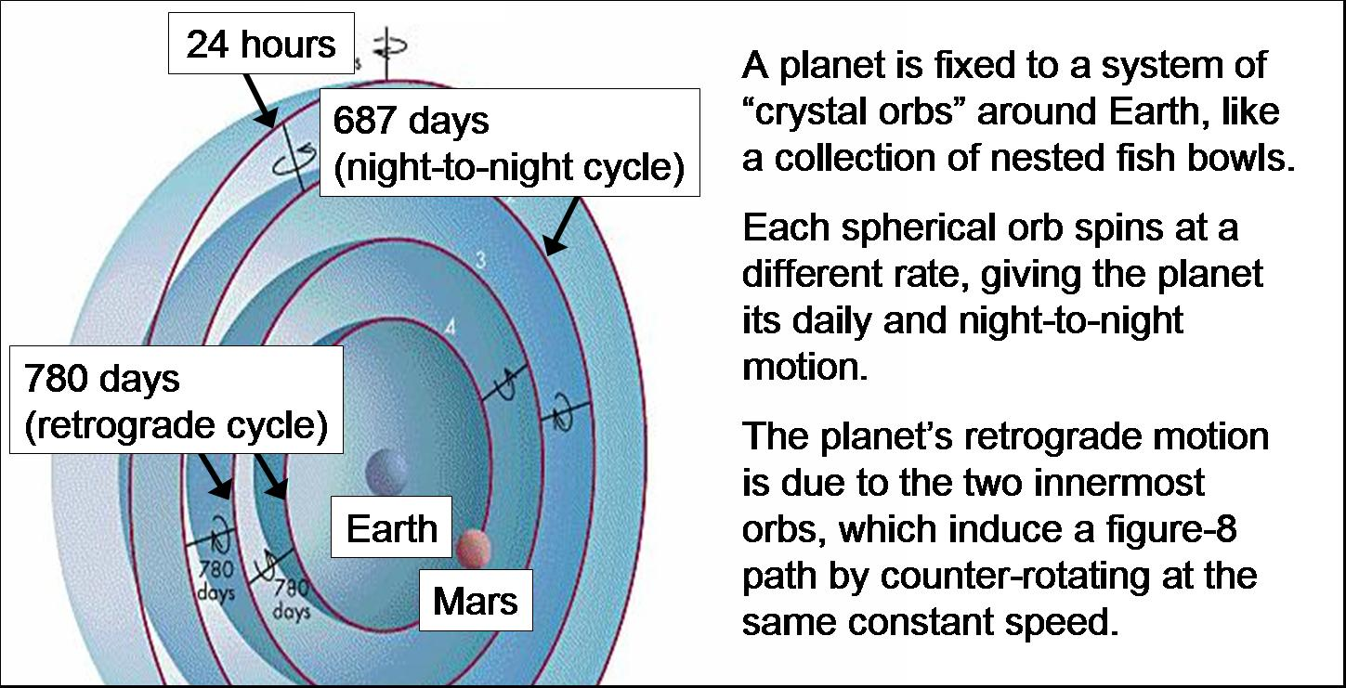
Figure 1. Eudoxian universe. From yorku.ca

- Aristotle

The great Greek philosopher Aristotle (384-322 BC), a student of Plato and tutor to Alexander the Great, was not satisfied with the rather superficial approach of Eudoxus; he developed a comprehensive physical theory on the motion of celestial and terrestrial (Earthly) objects.

Aristotle was an ardent student of nature. He determined that the Earth must be spherical from the curvature of the Earth’s shadow cast on the Moon during a lunar eclipse and the way that ships disappeared from view on the horizon (first the hull, then the mast) (Figure 2).

Figure 2. From a distance, only the upper parts of a ship are seen, due to the curvature of the Earth. From http://en.wikipedia.org/wiki/Spherical_Earth

Aristotle proposed his own physical theory of mechanics, the study of motion, based on the concepts of natural place and natural motion. Aristotle divided the Universe in two, the celestial region and the Earth-like, or terrestrial region. In the terrestrial region, objects are composed of one or more elements: fire, air, water, and earth, in order of their degree of heaviness. The natural order of things is such that earth belongs at the bottom (or center), water above earth, air above water, and fire above air. If an object is removed from its natural place, it will return in a straight line (there was no concept of gravity). This is called natural motion. If a rock (Earth-like) is set upon the surface of a lake, it will immediately sink to regain its natural place at the bottom of the lake, with other Earth-like objects. If an arrow is shot into the air similarly, this Earth-like object will fall to Earth and remain there.

The second kind of motion is violent or forced motion; a person can push or throw an object and can force it to move in any direction. In hurling a rock, for example, as long as the hand of the thrower is pushing the rock it will move in the direction that it is pushed. However, as soon as the rock leaves the hand of the thrower violent motion will cease and it will immediately fall to earth in straight-line natural motion. Unfortunately, this Aristotelian view does not match with common observation. If we view a ball being pitched or an arrow shot, we see the projectile following a curved arc (Figure 3). It certainly does not fall straight to the ground. Aristotle explained the continued forward motion of the arrow after leaving the bow as the result of air rushing in behind the arrow and pushing it forward, after it had been parted by the arrow’s tip. This awkward explanation was an obvious weakness for Aristotelian physics, but it was accepted nonetheless for over 2000 years. But such weaknesses were ignored because there was no viable alternative.
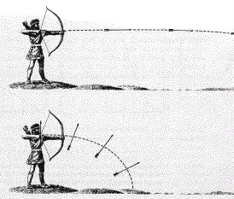
Figure 3. Comparison of the Aristotelian and Newtonian views of an archer shooting an arrow. a) In the Aristotelian view the arrow moves in the direction that it is shot in violent motion, as long as it is actively being pushed, either by the bow itself or the air between the bow and the arrow. As soon as the arrow’s violent motion ceases it falls to the ground via natural motion. b) Galileo viewed the arrow as undergoing two independent motions - a constant vertical acceleration toward the ground and a constant horizontal velocity - resulting in a curved trajectory.

The terrestrial region was viewed as being corruptible and imperfect, perhaps because people inhabit it. The celestial region was incorruptible and perfect. The terrestrial region was marked by changing, often unpredictable events, such as flood and famine, ugliness and blemish. Changeless, perfect celestial objects, such as the Sun and stars populated the celestial region. Aristotle chose a fifth element, aether, as the element comprising celestial objects. The Moon, because it has a somewhat blotchy appearance and changing phases, was regarded as at the boundary of the celestial and terrestrial. The state of natural motion in the celestial region was circular motion about the Earth at constant velocity. The circle was, after all, the perfect geometrical figure.

Aristotle had considered the idea of a moving, spinning Earth, but rejected it. His first argument was that a moving or spinning Earth would produce enormous winds at the surface of the Earth (Using currently accepted values, the surface of the Earth at the equator rotates with a velocity of 1,000 miles per hour. The Earth orbits the Sun at a velocity of 3500 miles per hour.) He also argued that an object falling on a spinning Earth would not appear to fall in a straight line. (If this argument were valid, if an object were dropped from a 40-meter high tower at the Earth’s surface (at the equator) it would move 1 kilometer to the side during the fall. Although Aristotle did not have the benefit of this knowledge he expected that the object would appear to an observer to veer to the side.) Finally, Aristotle argued that the Earth cannot orbit the Sun, if it did so, we should observe constellations appear larger and smaller as the Earth approaches them and then recedes in the opposite direction.

Aristotle proved the impossibility of the existence of a vacuum. He proposed that the velocity of an object under violent motion is proportional to the force exerted on the object and inversely proportional to the resistance of the medium to motion (e.g., air or water resistance). An object moving through a vacuum would then travel at infinite velocity, an impossibility. For Earth-like objects moving under their natural motion, Aristotle argued that falling objects of the same size and shape, but differing weight, should fall such that the heavier object will fall faster, but at constant velocity, as it has a greater attraction to the Earth.

He developed his own cosmological system with 55 interconnected spheres with the Earth stationary at the center. The major weakness of Aristotle’s model is that he assumed that the Moon and planets orbited the Earth at a constant distance. However, this doesn’t account for the up to 10% change in the Moon’s apparent size or the apparent annual variations in brightness.

The Greek astronomer Aristarchus (310-230 BC) proposed an alternative model in which the Earth as well as the other planets orbited the Sun. However, the idea was too far ahead of its time and was rejected as it didn’t obey the Aristotelian physics nor explain why we don’t observe stellar parallax, the apparent change in relative position of the stars as the Earth rotates and orbits the Sun (Figure 4), just as objects in your field of vision appear to change position as you view them first with your left eye closed, then your right eye.
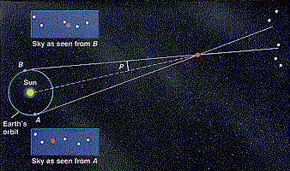

Figure 4. Parallax of nearby celestial objects. If a nearby object in space is observed successively from opposite ends of the Earth, separated by 12 hours, it will appear to have shifted with respect to the distant background stars. Tycho’s supernovae of 1572 exhibited no noticeable parallax, so he concluded that it must be a star.

In retrospect, scientists today value Aristotle’s contributions to science as a whole and to biology in particular. His views of cosmology and physics are contradicted by modern science. It is too easy to somehow assume that Aristotle was ignorant in these areas. As the science historian I. Bernard Cohen points out, “In his inability to deal with questions of motion in relation to a moving earth, the average person is in the same position as some of the greatest scientists of the past, which may be a source of considerable comfort to him. The major difference is, however, that for the scientist of the past the inability to resolve these questions was a sign of his time, whereas for the modern man such inability is, alas, a badge of ignorance….”

“How can the earth be twirling around at this tremendous speed of 1000 miles per hour and yet we do not hear the wind whistling as the earth leaves the air behind it? Or, to take one of the other classical objections to the idea of a moving earth, consider a bird perched on the limb of a tree. The bird sees a worm on the ground and lets go of the tree. In the meanwhile the earth goes whirling by at this enormous rate, and the bird, though flapping its wings as hard as it can, will never achieve sufficient speed to find the worm – unless the worm is located to the west. But it is a fact of observation that birds do fly from trees to the earth and eat worms that lie to the east as well as the west. Unless you can see your way clearly through these problems without a moment’s thought, you do not really live modern physics to its fullest, and for you the statement that the earth rotates upon its axis once in 24 hours really has no meaning…”

“These examples show us how difficult it really is to face the consequences of an earth in motion. It is plain that our ordinary ideas are inadequate to explain the observed facts of daily experience on an earth that is either rotating or moving in its orbit. There should be no doubt, therefore, that the shift from the concept of a stationary earth to a moving earth necessarily involved the birth of a new physics.”

The Alexandrians

After the conquests of Alexander the Great, the center of innovative astronomy moved from the Turkish coast to the city Alexandria, at the mouth of the Nile. There, Aristarchus of Samos (310-230 BC) perceived that the spherical Earth rotates, revolves, and is not the center of the Universe. During this period Seleucus observed that the ocean tides were correlated with the phases of the Moon and Eratosthenes measured the diameter of the Earth to within about 10% by observing the shadows cast by vertical sticks 500 miles apart (Figure 5). However, most educated Greeks of this time didn’t believe these new radical ideas in astronomy. There was no mathematical framework that would allow these concepts to be tied together so that quantitative and testable predictions of astronomical events could be made. Acceptance of a spherical and moving Earth would be delayed by centuries until such scientific proof could be demonstrated.
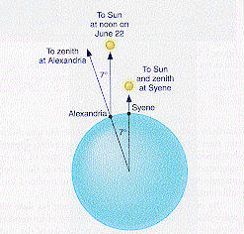
Figure 5. Eratosthenes’ determination of the Earth’s diameter. The Sun’s parallel rays strike the Earth. At noon on June 22 the Sun is observed directly overhead at Syene, while at Alexandria it is observed 7° from the zenith or approximately 1/50th of a complete 360° circle. It follows that the distance from Alexandria to Syene is approximately 1/50th of the Earth’s circumference.

VI. Ptolemy

To correct the inaccuracies in the Aristotelian model, the Greco-Egyptian astronomer Claudius Ptolemy (100-165 AD) published an elaborate scheme to predict the positions of the Sun and planets, based on the ideas of the Greek astronomer Hipparchus (circa 150 BC). Hipparchus is regarded as one of the greatest astronomers and mathematicians of all time and was central to the development of astronomy as an empirical science. Hipparchus developed spherical trigonometry as a tool to describe the motion of the Sun and Moon and used primitive tools, such as dividers and plumb line, to catalog and measure the position of celestial objects.

To explain the changing brightness of planets and their retrograde motion (sometimes planets are seen to move backwards with respect to the background constellations) Ptolemy used three devices or modifications to circular motion at uniform velocity (Figure 7). The first device was the epicycle, which was used to model retrograde motion. Each of the planets moved at constant velocity on a small circular orbit, called an epicycle, the center of which moved at constant velocity in a larger circular orbit, called the deferent, around the Sun. We now know that retrograde motion is caused by planets passing each other in their orbits. When we pass another car on the highway, it appears to move backward relative to us. Similarly, if the Earth passes Mars in its orbit, Mars appears to undergo backward or retrograde motion.
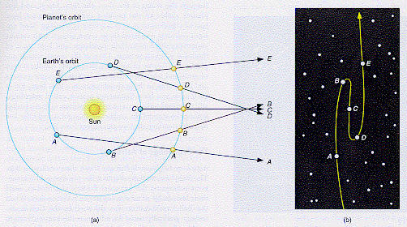
Figure 7. Retrograde motion of Mars as seen from the Earth. a) The actual positions of the Earth and Mars in 1-month intervals, and b) the apparent position of Mars with respect to the background stars, showing retrograde motion as the Earth passes Mars in its orbit. (FMA 27-1.11)

The second device, the eccentric, was introduced to explain the changing distance between the Earth and planets. Ptolemy offset the circular orbits of the planets from the Earth. The center of the orbit is called the eccentric. Throughout part of the planet’s orbit it appears to be closer and move faster than during the rest of the orbit.

The third, and least appealing of Ptolemy’s devices, was the equant. Planets were permitted to undergo nonuniform motion on the sky as long as there was some point, called the equant, from where the planet’s motion would appear uniform.

Keep in mind that Ptolemy made no pretense of believing that the epicycle, eccentric, and equant had any basis in reality. He used this framework as a mathematical model to produce predictions of the positions of the planets for navigation and calendar making. The measure of his success lay in the fact that the Ptolemaic model endured without peer for over a thousand years.

VII. Dark Ages

Two technical problems retarded the growth of astronomy during the Middle Ages. The first was the lack of a precise way of measuring time; the second was the difficulty in handling large numbers in mathematical calculations.

Sundials were used by the Chinese for more than 2,500 years before Christ and water clocks, in which flowing water drove a water wheel, were used by the Egyptians one thousand years later. Neither could tell time much more accurately than to the nearest hour. It was difficult to test mathematical predictions against measured events, such as the passage of a star overhead with this precision. Accurate mechanical clocks, using falling weights to drive the clock mechanism, weren’t invented until the 17th century.

Roman numerals were used in Europe until about 1100 AD. The Greek scientist Archimedes (287-212 BC), who developed much of the theory behind the mechanics of pulleys, levers, gears, and hydraulics, was one of the few scientists in history who was comfortable working with large numbers. In a paper called “The Sand Reckoning” he estimated the maximum number of grains of sand on all the beaches of the Earth. He did this by estimating how many grains of sand it would take to fill the Earth. His estimate is “myriad of myriads multiplied by 7 and by 10,000 myriads”, where a myriad is a Greek unit of 10,000. The result is 10⁶³ grains of sand. This is an example of the kind of number that astronomers commonly deal with. There are about 10⁶² atoms in the Earth, for example. The distance to Moon 238,857 miles or CC XXX MMMMMMMM D CCC L VII miles in Roman numerals. Imagine performing orbital calculations using the lunar distance in miles and multiplying or dividing that number by another large number. The effort would be enormous. This problem was alleviated with Arabic numerals based on the number 10 (decimal). Arabic numeral were actually developed in India in about 50 AD and first spread to the Moslem world; from there they spread to Europe in about 1100 AD. The Arabs also provided the Christian world with the first translations of the Greek astronomers.
Table 3.1: The Size Scale of Astronomical Objects
Astronomical Object | Mass | Radius
hydrogen nucleus | 1.7 × 10⁻²⁷ kg | 10⁻¹⁵ m
hydrogen atom | 1.7 × 10⁻²⁷ kg | 10⁻¹⁰ m
Earth | 6.0 × 10²⁴ kg | 6.4 × 10⁶ m
Jupiter | 1.9 × 10²⁷ kg | 7.1 × 10⁷ m
Sun | 2.0 × 10³⁰ kg | 7.0 × 10⁸ m
“typical” galaxy | 2.0 × 10⁴¹ kg | 10¹⁸ m
galaxy cluster | 10⁴²-10⁴⁴ kg | 10¹⁹-10²⁰ m
the Universe | 10⁵³ kg | 10²⁶ m

Scientific Notation

Table 2.1 shows the representative sizes of several classes objects occupying the Universe. Large numbers, such as these, are commonly called astronomically large, because astronomical distances, masses, and sizes are uncommonly large. Large numbers, as well as extremely small numbers, can be awkward to write down and use. One solution is to express them in a kind of shorthand notation known as scientific notation.

Take the number 168,000,000, or 168 million, for example. In scientific notation 137 million is expressed as 1.68 x 10⁸ where 10⁸ is shorthand for 1 followed by eight zeros, 10 x 10 x 10 x 10 x 10 x 10 x 10 x 10 (then multiplied by itself eight times, or 100 million. Any number can be expressed in this way, as a number between 1 and 10, times 10^{n}. Another example is 209,500, which can be expressed as 2.095 x 10⁵. Multiplying 2.095 by 10⁵ is equivalent to shifting the decimal point to the right by five places. Multiplying by 10^{n} is equivalent to shifting the decimal point to the right by n places.

This same technique can be used to represent numbers smaller than one. 0.00387 can be expressed as 3.87 x 10⁻³. A negative exponent in scientific notation tells us how many places the number is shifted to the left. Positive exponents are used for numbers greater than ten; negative exponents are used for numbers smaller than one.

IIX. Copernicus

The Ptolemaic system was supported in the Middle East and Europe with little change for 1400 years. Because of its complexity and inelegance it was not universally accepted. King Alfonso of Spain (1252-1284) complained, “If the Lord Almighty had consulted me before embarking on the Creation, I should have recommended something simpler”. The French philosopher Nicolas of Oresme (1320-1382) remarked that it was easier to envision the Earth spinning on its axis than the sphere containing the stars spun around the Earth. A distant, spinning celestial sphere would also imply that stars were circling the Earth at enormous and unlikely velocities. Another view was that the Universe was infinite in extent and that the Creator could have placed its center anywhere, not necessarily at the position of the Earth.

The single person who began the sequence of events that overturned Ptolemaic theory was Nicolas Copernicus, a Polish lawyer and naturalist (Figure 8). Copernicus couldn’t accept the Ptolemaic system because it was too complicated and unwieldy. He believed that celestial motions could more simply be explained by having a rotating and moving Earth. A spinning Earth would explain the daily rising, motion from East to West, and setting of the stars, Sun, and planets. The revolution of the Earth about the Sun would explain the seasonal changes in the position of the Sun and constellations, and the retrograde motion of the planets. Retrograde motion of planets would simply be due to the Earth overtaking (or being overtaken) by another planet, much as when you pass another car on the highway it appears to move backwards relative to you. Copernicus placed the Earth and planets in circular orbits around the Sun, in their correct order, with Mercury the closest, then Venus, the Earth and Moon, Mars, Jupiter, and Saturn, followed by the sphere of stars (Figure 9). He assigned distances to the planets as well. While the ratios of the distances with respect to each other were approximately correct, the values were about 20 times too small, with the Earth having a distance of 4.8 million miles to the Sun compared to its currently accepted value of 93 million miles.

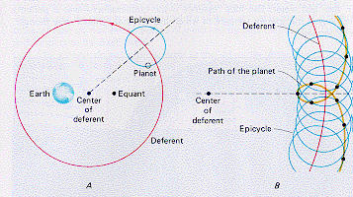
Figure 8. The Ptolemaic system. a) In the Ptolemaic system each planet moved in a circular path on an epicycle, the center of which in turn orbited in a larger circular orbit, called the deferent. In order to explain the variations in the apparent speed of planets across the sky, planets were to move at uniform apparent speed with respect to a point called the equant. The Earth and the equant were offset from the center of the deferent in opposite directions by an equal amount. b) The resulting motion of a planet on its epicycle and deferent explained the retrograde motion of the planets. (P 14-2.6)

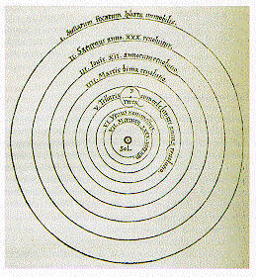
Figure 9. A schematic drawing of the Copernican universe from De Revolutionibus. The Sun, or “Sol” is at the center, with Mercury, Venus, Earth, Mars, Jupiter, and Saturn revolving about the Sun in circular orbits inside a fixed outer sphere of stars. (FMA 31-1.14)

Although Copernican theory was compelling in its elegance and simplicity, it didn’t explain planetary positions as accurately as Ptolemaic theory. In order to explain the positions of the planets with any accuracy Copernicus was forced to add epicycles and deferents to the orbits of each of the planets. It has been argued that the Copernican system was still less satisfactory in its ability to predict planetary positions compared to Ptolemaic theory. Copernicus used 48 independent motions to predict planetary position while one version of the Ptolemaic theory only required 40.

Two criticisms of Copernican theory were argued. First, this theory completely violated Aristotle’s concept of natural place and natural motion in having an Earth that moved in a circular motion that was reserved for non-Earthly bodies. Second, if the Earth moved around the Sun, then why didn’t the apparent positions of the stars shift with the seasons (stellar parallax) as the Earth moved alternately closer to then farther from constellations. Copernicus answered the latter objection: the stars are simply much too far away to observed stellar parallax. The usual objections to a spinning and moving Earth were also used (e.g., absence of a violent wind, objects not falling straight down, etc.).

Copernicus finished his work in 1530 but didn’t publish his work then, fearing the adverse reaction it would receive. He published it in the form of a book, De revolutionibus orbium coelestium (On the Revolutions of the Heavenly Spheres) on the day of his death, in 1543. The publisher included a preface remarking that this system was not meant to reflect physical reality, but was only a mathematical model to predict the positions of the planets. It was largely ignored by the Catholic Church at the time, probably because it was not seen as a threat its authority. The Protestants found the Copernican model more objectionable, with Martin Luther complaining, “The fool will turn the whole of the science of astronomy upside down. But, as Holy Writ declares, it was the Sun and not the Earth which Joshua commanded to stand still.”

However, the Copernican model began to attract considerable support from scholars. In 1583 the Dominican Friar, Giordano Bruno not only supported Copernican theory but expanded upon it. He proposed that the Earth and the other planets were similar, even suggesting that they might be inhabited by intelligent creatures with histories consistent with the events described in the Bible. Bruno suggested that the Universe is infinite in extent, filled with stars like the Sun, with many of these stars surrounded by planetary systems similar to our own, possibly containing intelligent life. Bruno was burned at the stake for these heresies. This signaled the initial significant adverse reaction to the Copernican model by the Catholic Church.

IX. Brahe

Acceptance of the Copernican model had to wait for observation proof. The cornerstone of experimental proof was to come from an unlikely source: Tycho Brahe (1546-1601), a Dane, and the foremost observational astronomer of the time. However, Tycho Brahe did not believe in the Copernican theory but believed that the planets orbited the Sun, and the Sun and Moon in turn orbited a stationary Earth. He also believed that the stellar sphere would rotate about the Earth. This theory, originally proposed by the Greek Heracleides (390-310 BC) explained retrograde motion but avoided the philosophical and practical problems with having a moving Earth. Tycho was unconventional in his personal life as well. Brahe had a partially silver nose, a replacement for a hunk of flesh removed in a nighttime duel. Brahe’s observatory, at Uraniborg (Figure 10), on an isle off the coast of Denmark, had a jail, which he used to chastise unruly research assistants.
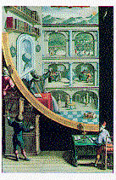
Figure 10. Tycho Brahe in his observatory at Uraniborg, Denmark. He is shown using a device for measuring the altitude of celestial objects as they cross the meridian.
(P 21-2.18)

Tycho’s observations were profound. He studied supernova 1572, an exploding star which suddenly appeared brighter than any of the planets, and then slowly faded over a year and a half into invisibility. Brahe determined from the lack of stellar parallax that this transient phenomenon was farther away than any of the planets and must therefore be a star. This contradicted the Aristotelian view that the stars were perfect and unchanging. In 1577 he observed a comet and showed that it crossed the orbits of the planets as it approached the planets. The Aristotelians had long held that comets were atmospheric phenomena.

X. Galileo

The telescope was invented in 1608, originally intended for military use. In 1609 the Englishman Thomas Harriot first used the telescope to examine the Moon. In the same year, Galileo Galilei (1564-1642), professor of mathematics at the University of Padua, in Italy, designed a superior telescope that he first used to study the sky in a systematic way. The importance of his observations was twofold. He was the first scientist to use experiments to logically support and refute theory. His observations were used to dismantle the viability of the Ptolemaic theory and the Aristotelian mechanics that supported it.

Galileo found that the surface of the Moon was far from perfect, but bore irregular features, such as mountains, craters, and valleys, similar to the Earth’s landscape. He observed blotches and blemishes on the surface of the Sun, which appeared to move as the Sun rotated. Both observations contradicted the Aristotelian prediction that celestial bodies would be perfect and blemish-free. Galileo observed that Jupiter was being orbited by four moons, and was therefore a second center of planetary motion (Figure 11). He found that Venus has phases, going from full to crescent and back again, similar to the Moon’s (Figure 12). In particular, when Venus was full it was seen close to the Sun. This can only be explained most simply by a heliocentric solar system, in which Venus orbits the Sun. Galileo saw many more stars with his telescope than could be seen with the naked eye. In particular he found that the Milky Way was not an atmospheric effect, as had been previously supposed, but consisted of a multitude of densely packed stars, which can not be separated with the unaided eye. These observations did much to destroy belief in the Ptolemaic system.
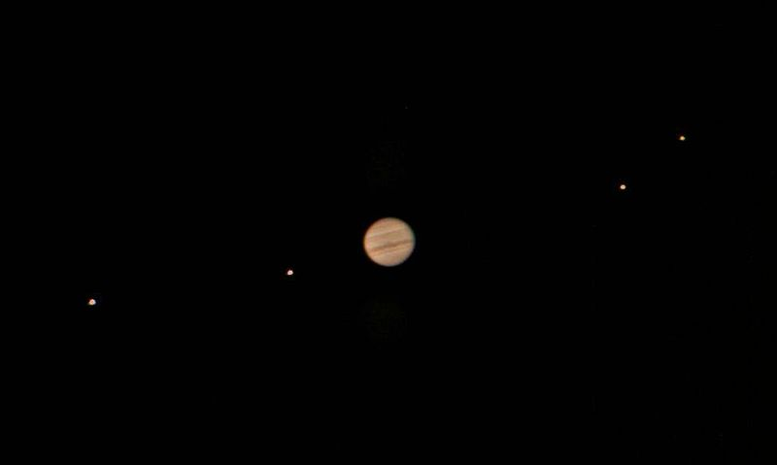
Figure 11. Jupiter and its four Galilean satellites: Io, Ganymede, Callisto, and Europa. From http://en.wikipedia.org/wiki/Moons_of_Jupiter
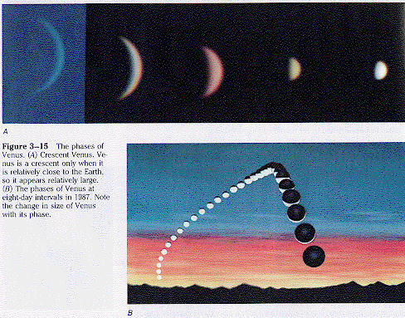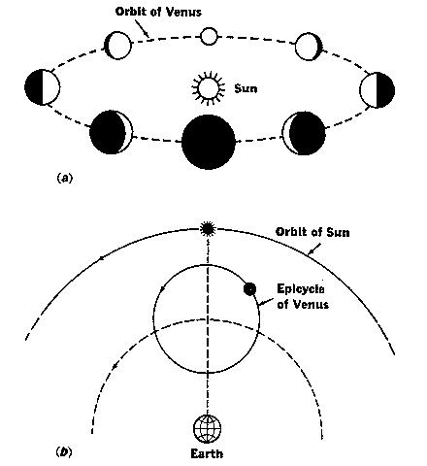

Figure 12. The Phases of Venus. a) Venus appears in a crescent phase only when has a relatively large apparent diameter, indicating that it is relatively close to the Earth in its orbit. The phases of Venus are also correlated with its angular distance from the Sun. b) These are both easily explained using a diagram showing Venus orbiting the Sun.
(a: FMA 38-3.14, b: )

In 1616 the Protestant Reformation was in full swing. The clash between Protestants and Catholics did not allow for compromise. There was no sympathy for those that resisted authority or held unconventional beliefs. In this year the office of the Pope warned Galileo against publicly supporting the Copernican model. However, in 1623, a new, more intellectual Pope was appointed, a patron of the arts and sciences. Galileo’s political naivete persuaded him to try to publish a manuscript supporting the Copernican model, in a thinly disguised dialog between three characters. The book was published in 1632 and was almost immediately banned. Galileo was forced to recant his beliefs in the Copernican system and remained under house arrest until his death in 1642. We will review Galileo’s influence on the development of laws of motion in Chapter 4.

XI. Kepler

Johannes Kepler, a polish mathematician, was born 28 years after the death of Copernicus. Kepler was extremely introverted and deeply affected by an unhappy childhood and poor health. His tenure as a professor at the University of Krakow was marked by unpopular classes and as a result, very few students. This enabled him to spend more time on his true passion, developing a mathematical model of the Universe. Kepler was a firm supporter of the Copernican heliocentric view of the Universe. Although Kepler was a mystic and spent years trying to show the relationship between the orbital diameters of the planets and the sizes of solid geometrical figures stacked one inside the other, he was also a very good experimental scientists, ultimately discarding many of his theories because they simply didn’t fit the observed positions of the planets.

Kepler’s work caught the interest of Tycho Brahe who invited Kepler to work for him at Prague, analyzing Kepler’s planetary observations. The relationship between the two was at the same time difficult and (eventually) profoundly productive. The introverted Kepler and the extroverted Brahe didn’t like each other very much, but the relationship was cemented by Brahe’s observational data, the best in the world at that time, and Kepler’s mathematical ability. Brahe hoped to gain enough insight from Kepler to initiate his own cosmological model. Kepler wanted access to Brahe’s for the same reason. Jealous of Kepler’s abilities, Brahe leaked data to Kepler a little at a time. This continued until Brahe’s death in 1601.

Kepler used Tycho’s data on the positions of the planet Mar’s to model its motion, using different combinations of epicycles, eccentrics, and equants. With this he was able to obtain agreement to 8 minutes (roughly one-eighth of a degree) of arc between his model and Tycho’s observations. This was not satisfactory to Kepler whose faith in Brahe’s data
was enormous. Kepler remarked, “these eight arc-minutes alone lead the way toward the complete reformation of astronomy.” Finally he gave up on the epicyclic approach and concluded that the orbit of Mars must be elliptical. This was an extremely difficult conclusion to reach, for it contradicted thousands of years of traditional belief in circular orbits, beginning with the early Greeks.

Out of this work Kepler formulated three laws of planetary motion, still accepted today:

Kepler’s First Law: The orbital path of each planet around the Sun is an ellipse with the Sun at one focus of the ellipse (Figures 13 and 14). An ellipse is a two dimensional geometrical figure resembling a flattened circle. It is the set of points such that the sum of the distances from any point on the ellipse to two internal points, called foci, is constant.

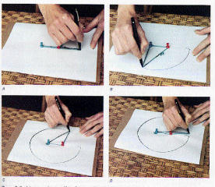
Figure 13. The ellipse. An ellipse can be drawn by attaching the two ends of a string to the two foci (plural of focus) of the ellipse, and then stretching the string taut against a pencil while drawing the ellipse.

Kepler’s Second Law: If one constructs an imaginary line between the Sun and a planet, this line will sweep out equal areas in equal times, so that planets will move faster the nearer they are to the Sun and likewise move more slowly the further they are from the Sun (Figure 14).

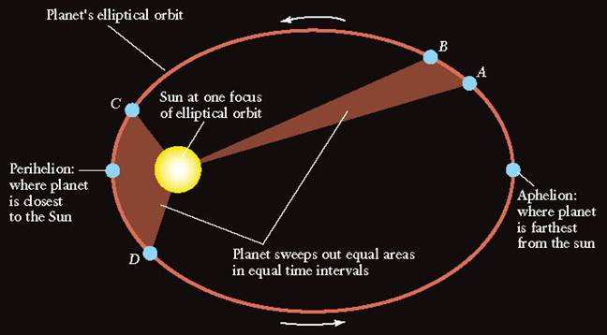

Figure 15. Kepler’s 2nd and 3rd Laws. a) Kepler’s 2nd Law states that a line between a planet and the Sun sweeps out equal areas in equal times. The shaded areas represent equal areas and therefore equal time intervals as a planet orbits with the Sun at one focus. b) Kepler’s 3rd Law implies that the more distant a planet is from the Sun the more slowly it will move in its orbit. This diagram indicates the distance that each planet moves in one year.
From http://en.wikipedia.org/wiki/Kepler's_laws_of_planetary_motion

Kepler’s Third Law: There is a relationship between the period of a planet’s orbit and its average distance from the Sun. The square of the period is proportional to the cube of the mean radius, or P² = ka³, where k is a constant. An example is the orbital radius and distance compared with that of the Earth. The Earth’s period is one year and its distance is defined as 1 Astronomical Unit (A.U.). For the Earth, k in the Third Law is one, since 1² = 1³, but only for these units of measurement. We can use this Third Law to compute the orbital period of Mars, which has a mean distance of 5 A.U. from the Sun. P² = 5³ years² = 125. Therefore the orbital period of Mars equals 11.3 years (11.3² ≈ 125).

The development of Kepler’s three laws was an intellectual landmark in the development of astronomy. The reign of perfect circular orbits came to an end, as did the concept of the Earth’s privileged position as the center of the Universe.

WebVideo: Kepler’s Laws http://www.youtube.com/watch?v=GcKiG-CuvtA

Epilogue

In retrospect we should not see Aristotelian mechanics as a completely failed scientific theory. It was a landmark in the development of the scientific method. For the first time an attempt was made to explain the physics of the Universe in terms of a set of rules based on a set of simple assumptions. These rules were used to explain simple and complex phenomena in a logical, self-consistent manner. Although the assumptions were refuted by later work, the scientific method was advanced to a higher, more sophisticated level. The next level was exemplified by Kepler, who believed that it is the observations that must dictate the theory.

Summary

Aristarchus of Samos proposed the idea that the Earth rotates, revolves about the Sun, and is not the center of the Universe in the 3rd Century BC. Because these ideas were not testable at that time, they yielded to the Aristotelian, Earth-centered view of the Universe. Ptolemy developed a geocentric model based on epicycles that was successfully used to predict planetary positions for over one thousand years. It was not until the 16th Century, AD, that the heliocentric theory was resurrected by Copernicus. Discrepancies between the Copernican theory and the actual positions of the planets were resolved by Kepler who determined that the planets orbited the Sun in elliptical orbits. Both Galileo and Brahe provided the observational evidence necessary for the acceptance of the new heliocentric theory.

Key Words & Phrases

aether - the fifth element of the Aristotelian universe, it fills the space between the stars
eccentric - in the Ptolemaic system, the circular orbits of the planets were offset from the Earth to explain their changing distance. The center of the circular orbit is called the eccentric.
ellipse - a two-dimensional figure resembling a flattened circle. It is the set of points such that the sum of the distances from any point on the ellipse to two internal points, called foci, is constant.
epicycle - a small circle of orbital motion that is itself following a larger circular motion, called the deferent, about a central point.
equant - in the Ptolemaic system planets were permitted to undergo non-uniform motion on the sky as long as their motion appeared to be uniform from some point, called the equant.
focus - one of two points in the interior of an ellipse used to define the ellipse. The sum of the distances from any point on the ellipse to the foci (plural of focus) is constant.
infer - to draw a conclusion by reasoning from evidence or premises
mechanics - the branch of physics that deals with force and motion
retrograde - the backward (west to east) motion of a planet against the background stars
science - a systematic study in which general laws are induced from observed facts and used to deduce predictions about future events
stellar parallax - the apparent motion of the stars as the Earth rotates and orbits the Sun

Review for Understanding

- What is violent motion? Natural motion?
- What is science? How is science like using experience to make predictions?
- Which Greek philosopher is credited with the ideas that the Earth rotates, revolves, and is not the center of the cosmos?
- What developments before Tycho Brahe allowed for the rapid development of observational astronomy?
- Why did Aristotle reject the idea of a rotating, revolving Earth?
- Was Ptolemy successful in using his theory in making accurate predictions of astronomical positions?
- Did Copernican theory explain the positions of the planets as accurately as Ptolemaic theory?
- How did Tycho Brahe’s observations support the Copernican view of the cosmos?
- How did Galileo’s observations support the Copernican view?
- What are Kepler’s three laws?
- Mars has an orbital radius of approximately five times that of the Earth? What is its orbital period?

Essay Questions

- Did Aristotle help or hinder the development of astronomy and mechanics?
- Is it possible to experimentally refute Tycho’s idea that the planets orbit the Sun, but the Sun and Moon orbit the Earth, if we add to it that planets orbit in elliptical (Keplerian) orbits?
- How did the philosophy of science change along with cosmology, from the time of Aristotle, up to the time of Newton?
- The heliocentric universe was proposed by the Greeks, thousands of years before the time of Copernicus. Why wasn’t it generally accepted when it was initially proposed?
- Compare and contrast Aristotelian mechanics and Newtonian mechanics.
- Read the WebEssay “We Are All Scientists” and discuss one use of the scientific method that you made this week.

________________________________________________________________________
Chapter 4 - Gravity and Motion: Orbits of the Planets

If I have seen a little further it is by standing on the shoulders of giants.
- Newton, in a letter to Robert Hooke

To understand motion is to understand nature.
-Leonardo di Vinci

Preview

Gravity is one of the most important physical concepts in understanding the Universe, for it provides the underlying structure, holding the planets in their orbits, concentrating matter into galaxies, stars, and planets, and determining the future expansion of the universe. In this chapter you will study the Universal Law of Gravitation, its historical development, and Newton’s landmark idea, that gravity acts everywhere in the Universe just as on Earth.

Key Concepts to Understand: the scientific method, gravity, Newton’s three laws of motion, orbital motion of the Moon and planets, force, inverse square law, action at a distance

I. Introduction

Kepler’s Laws describe the motions of the planets, but what causes them to move and holds them in elliptical orbits? Kepler thought that some force emanating from the Sun moved the planets in their orbits. He argued that since the speeds of the planets vary with distance from the Sun that this force must originate within the Sun. He believed that there was some force of attraction between celestial bodies that would cause them to move toward each other. He also believed that space was a vacuum and that this force could exert its influence across a vacuum. In addition, Kepler thought that the tides were an effect of the Moon, and to a lesser extent the Sun. These prescient ideas were somewhat hidden and diluted by some of Kepler’s confused and incorrect conclusions. But in many ways Kepler was ahead of Galileo, who denied that a force coming from the Sun could cause the Earth to orbit the Sun.

In this chapter we will follow the development of the laws of motion and gravitation from Galileo and Kepler to Newton. We will also examine the connection between the motion of objects on Earth and the orbits of the planets around the Sun.

II. Philoponos

Aristotelian physics was not universally accepted by pre-Renaissance philosophers. John Philoponos, a 6th Century AD Greek philosopher, was among the first recorded scientists who contradicted Aristotle and foresaw the development of more modern ideas in the physics of motion. He believed that objects would travel at a finite speed in a vacuum. Philoponos saw that a resistive medium, such as air or water, only serves to slow objects. He correctly observed that the rate of fall of an object does not depend on its weight. Philoponos also correctly explained the transmittal of force to an arrow. The arrow is set into motion only as long as the bowstring touches the arrow; subsequently, air resistance slows the arrow.

However, the support of Aristotelian mechanics was so overwhelming, that its destruction didn’t occur until the work by Copernicus and his followers led the way towards the development of an alternative to Aristotelian mechanics.

III. Galileo’s Experiments with Falling Objects

Galileo performed a series of tests on Aristotle’s theory of motion of falling objects. Galileo faced the same problem that Aristotle had faced, almost two thousand years earlier, how to measure the rate of fall of an object using primitive time-keeping devices. Aristotle had attempted to solve this problem by measuring the rate of fall of solid objects in water, which is resistive to falling objects. This necessitated that Aristotle use one set of measurements to develop both a theory for the rate of fall and another for the influence of a resistive medium on the rate of fall. Galileo wanted to avoid this problem so that he could independently measure and mathematically describe the rate of fall of an object (under what we now know to be the influence of gravity) and the influence of air or water resistance on the motion of an object. In order to slow the vertical fall of an object to a rate that could easily be measured, Galileo decided to use objects rolling down inclined planes. In order to measure the distance an object falls over a period of time, he had to slow the motion down by the use of inclined planes.

By rolling a ball done a plane at a slight incline Galileo could slow the motion of a falling object to the extent that it could be measured with a water clock. Water was simply leaked into a container over a time interval, and weighed to determine the relative elapsed time. Plotting the distance traveled versus time, Galileo found that the distance was proportional to the square of the time interval, the case for objects that are being uniformly accelerated. At some point this acceleration would cease, and the object would reach what is called its terminal velocity. Galileo determined that the acceleration of all objects at the Earth’s surface was constant, but the terminal velocity depended on the size, shape, and weight of the object. He determined that terminal velocity was determined by resistive forces (friction) experienced by the object as it falls (or rolls). Galileo was thus able to avoid the pitfall that trapped Aristotle by separating frictional effects from the natural uniform acceleration of a falling object. He believed that the force that caused this falling motion was gravity, although he didn’t pretend to known exactly what gravity was, other than a label to describe this phenomenon.

Aristotle believed that objects could only undergo one kind of straight line motion at a time; the arrow shot from bow would move forward horizontally as long as it was acted on by the bow, it would then fall vertically due to natural motion. Galileo determined that the motion of an object could be separated into two independent motions, the vertical motion and the horizontal motion. In the case of an arrow shot horizontally from a bow, the arrow drops vertically due to the force of gravity and horizontally with the velocity with which it was launched (neglecting the resistance of the air through which it travels). Contrary to the arguments of Aristotle, the arrow does not follow a straight-line path. The arrow will travel until its vertical drop causes it to collide with the ground (Chapter 3, Figure 3). Similarly, if one follows two bullets, one that is shot horizontally from a rifle, the othe1 is simply dropped from the same height above the ground at the same instant, both will hit the ground at the same time, for their vertical motion is the same. Only their horizontal motion differs (Figure 3).

Galileo discovered that in the first seconds as an object drops it falls through successively increasing distances: 5 meters, 20 meters, 45 meters, and 65 meters (Figure 1). Similarly, the velocity changes in successive 1-second intervals, 0 m/s (at rest), 10m/s, 20m/s, 30m/s, and so on. This motion is due to a constant acceleration, where acceleration is defined as the change in velocity per unit time.
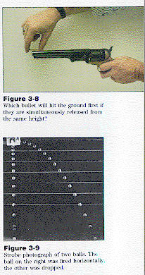
Figure 1. Simultaneous horizontal and vertical motion. a) One bullet is fired horizontally from the pistol at the same instant that the second bullet is dropped. Both will strike the ground at the same time. b) A stroboscopic photograph of two balls, one dropped at the same moment that the other is launched horizontally. Both accelerate vertically at the same rate and will hit the ground simultaneously.

Galileo found that under the influence of negligible air resistance, objects fall at the same rate regardless of mass. Robert Hooke verified this hypothesis 30 years later by dropping pairs of objects of differing mass in a vacuum.

Galileo believed that force is not necessary to maintain motion, but rather that the natural state of objects was at a constant speed, including objects at rest. Galileo’s primary misconception was that the natural horizontal motion of objects was parallel to the surface of the Earth, and would thus lead to circular motion. He perceived this as consistent with the apparent circular motion of planets around the Sun. Galileo couldn’t bring himself to abandon the Greek ideal of circular motion being the ideal and natural motion for the planets. Galileo had no idea of what gravity was or how it worked. This is perhaps best illustrated in a conversation between two characters, Simplicio and Salviati, in Galileo’s own Dialogo … sopra i due massime sistemi del mondo, Tolemaico e Copernico (“Dialogue … concerning two world systems, Ptolemaic and Copernican”). When Simplicio is asked what is it that makes bodies fall to the Earth, he replies, “… everyone is aware that it is gravity.” Salviati responds, “You are wrong, Simpllicio, what you ought to say is that everyone knows it is called gravity.”

IV. Modern Description of Motion

The scientist describes motion in terms of distance speed, velocity, and acceleration. Any discussion of mechanics must involve precise definitions of these terms.

Speed is the distance an object travels per unit time (measured in m/s or km/s in metric units or miles/hour in English units).

Equation 4.1: speed = distance traveled /time interval, or

distance traveled = speed x time interval.

When traveling we commonly compute distance traveled as our average speed on a trip multiplied by the driving time. For example, if you drive at an average speed of 60 mph for two hours, you will have travel a distance = 60mph × 2 hours = 120 miles.

It is common use the words speed and velocity interchangeably. In physics velocity and speed are related, but are not identical. Velocity has both speed and direction. A planet orbiting the Sun at constant speed is not traveling with constant velocity, because its direction of motion is constantly changing. If a person walks around a block at constant speed, they will change direction at least three times, e.g. walking north, then west, then south, finally east, before arriving back at the point of departure. In doing so the person must change velocity, but not speed.

Acceleration is the change in velocity (not speed) of a body:

Equation 4.2: acceleration = change of velocity / time interval.

An everyday example is the acceleration of a car. If a car accelerates from 0 to 60 miles per hour in 10 seconds it can be said to have an acceleration of (60 miles/hour - 0 miles/hour)/10 seconds, or 6 miles/hour/second. Objects at the surface of the Earth all accelerate at a uniform (unchanging) rate of acceleration of 9.8 meters/second/second. In other words, in the first second of fall an object will accelerate from 0 meters/second to 9.8 meters/second (acceleration = (9.8 meters/second - 0 meters/second)/(1 second)). But remember, acceleration has two components that must be specified, rate and direction. In the case of a falling object the acceleration is directed toward the surface of the Earth. Figure 2 illustrates how an object can move with a constant speed but experiences acceleration (called centripetal acceleration) from a changing velocity.

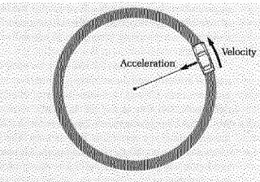
Figure 2. An object with constant speed undergoing acceleration.

V. Newton

Isaac Newton was born in England in 1642, the year Galileo died. Newton is considered by some as the most influential mind in the history of physics for his pioneering work in mathematics, optics, mechanics, and astronomy. His work in any one of the fields would have earned him a prominent place in the development of science. Following his graduation from Cambridge University in 1665 he returned to his boyhood home in Lincolnshire to live with his mother. He remained a recluse here for two years, the period that the Great Plague ravaged Europe, killing 31,000 in London alone. These two years were the most productive of Newton’s life. During this time he developed the Calculus, produced the binomial theorem in mathematics, performed experiments on the decomposition of white light into its colors using a prism, and formulated many of his ideas that would spawn his laws of motion and theory of gravitation.

In 1667, Newton returned to Cambridge where he was appointed chair of mathematics. In 1684, Newton was approached by his friend and fellow scientist, Edmund Halley. Halley was of a mind that gravity, the attractive force that caused the planets to move in their orbits, fell off with the square of the distance from the Sun. This was a logical conclusion, because the intensity of light originating from the Sun or any other object was known to fall with the square of the distance from the source. But no one at the time could show how such a force would cause planets to move in elliptical orbits. When Halley asked Newton how an object would orbit the Sun when acted on by an inverse square force, Newton replied that it would move in an elliptical orbit, and that he had proved this mathematically (Figure 3). Newton could not find his proof, but promised Halley that he would repeat it and forward it to Halley. He did this a few months later. With encouragement from Halley, Newton published his work on motion and gravity, Principia Mathematica Philosophia Naturalis, or The Mathematical Principles of Natural Philosophy. This book is probably the most single important work in physics.

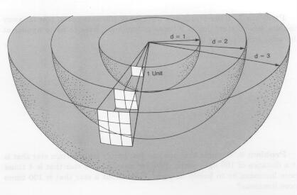
Figure 3. An illustration of the inverse square law for light intensity. The same principal applies to gravity. Light is spread over concentric spheres in accordance with the inverse square law.
(JC 105-10.2)

VI. Newton’s Laws of Motion

Almost all of the physics of motion can ultimately be expressed by Newton’s three relatively simple equations of motion. Acceleration has already been defined in the previous section. It is ironic that it was Aristotle who emphasized the value of precise definitions in making sound logical arguments. Newton’s work should be regarded as the glorious culmination of centuries of development of the art of science, beginning with the Greeks who mastered logical argument and began organized empirical science, to Galileo and Kepler who insisted that the only proof of physical theory lie in corroborating observations, to Newton who laid out the induction of a simple but elegant set of mathematical laws that at once provided the illusive explanation for the orbits of the planets and made testable predictions for virtually all motion on Earth.

Newton’s three laws describe the motion of any mass that experiences a force. Before we can understand these laws of motion we must precisely define the physical parameters used in the equations: force, mass, and acceleration. What is force? Simply the push or pull exerted on an object. This push or pull might be due to gravitation attraction, electrical attraction, or collision with an external object. What is mass? Mass is the amount of matter or “stuff” making up an object. You can look at mass as the number of elementary particles (such as protons, neutrons, and electrons, or if you prefer, quarks and electrons) constituting an object. Mass is not a measure of the heaviness of an object, although there is a direct correlation between an object’s mass and how much it weighs. (A person standing on the surface of the moon would weigh less than on the surface of the moon, assuming that they didn’t change their body mass.)

Newton’s 1st Law of Motion: A body in motion remains in motion at constant velocity unless acted on by an outside force. A body at rest remains at rest unless acted on by an external force.

Newton’s 1st Law is our modern notion of natural motion. We now know that both objects at rest and those moving at constant velocity are in a state of natural motion, or motion without an imposed force. Galileo recognized this law although he believed that the natural motion of an object was circular and not straight line. This law is illustrated by the motion of a spacecraft from the Earth into deep space, for example (Figure 4). Rocket motors are used to accelerate the craft from rest on the launch pad to a velocity greater than 11,000 meters per second, required for a spacecraft to break free of the Earth’s gravity, and greater than 42,000 meters per second, required for a spacecraft to break free of the Sun’s gravity (at the distance of the Earth). Once the rocket is accelerated to the desired cruising speed, say 50,000 m/s, it will remain at that velocity unless acted on by an outside force. Once at a distance where the gravitational influence of the Sun and planets is insignificantly small, it will travel at approximately constant velocity (constant speed in a straight line). Rocket burns need only be made to periodically correct the direction of motion of the spacecraft.

Newton’s 2nd Law of Motion: A net force acting on an object will accelerate that object in the direction of that force such that F = ma.

This law describes the vertical motion of an object dropped at the surface of the Earth. All objects at the surface of the Earth are pulled by the force of gravity. Objects sitting on the ground have a counterbalancing force imposed by the ground, pushing in the opposite direction so that they experience no net force and therefore no net acceleration. Any falling object will experience only a constant gravitational force at the surface of the Earth, which will cause a constant acceleration (neglecting air resistance). This law also means that objects will accelerate in proportion to the force imparted on them and will resist acceleration according their mass (a = F/m). This property of mass that resists motion is called inertia.

If we want to accelerate our spacecraft to a given velocity, the acceleration will be proportional to the force exerted by the rocket motors. The more massive the rocket, the more force that will be required from the rocket motors (Figure 4a).

Newton’s 3rd Law of Motion: Forces come in equal and opposite pairs; for every force acting on an object there is an equal and opposite force.

An example of Newton’s 3rd Law is the motion of a rocket or a balloon (Figure 4b). If a balloon is inflated and released, so that gas is allowed to be expelled from the balloon’s opening, it will literally take off like a rocket. As the balloon contracts it forces air out of the opening of the balloon; an equal and opposite force is exerted on the balloon by the expelled air. It is this force that propels the balloon forward. In precisely the same way, a rocket burns fuel; the resulting hot exhaust gas expands through a rocket nozzle at one end of the rocket. As the gas is pushed from the rocket, it in turn pushes the rocket forward – action and reaction.

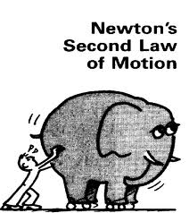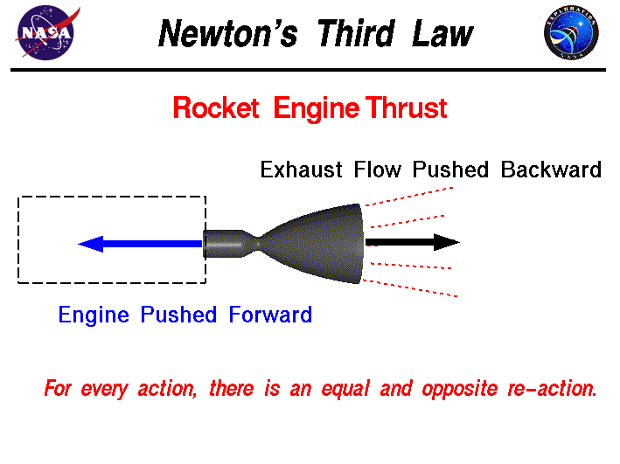

Figure 4. Newton’s three laws of motion. a) Newton’s 2nd Law. A spacecraft accelerates from the launch pad at a rate determined by the force exerted by the rocket motors - acceleration equals the mass of the rocket divided by the force of the motors. b) Newton’s 3rd Law. The force exerted by the rocket engines on the rocket is equal to the force with which hot rocket exhaust is expelled backward from the rocket. c) Newton’s 1st Law. A person on a water slide (on in a spacecraft) accelerates to cruising. It will move at this velocity unless acted on by an outside force (friction in the case of the water slide, either gravity or an additional burst of engine thrust in the case of the rocket).

It is these three fundamental laws which explain the motion of all the objects that we are familiar with. At certain extremes of motion, objects approaching the velocity of light, a simple Newtonian description of motion is not valid. For example the mass of an object is not fixed, but is determined by the relative velocity of the mass with respect to the person measuring it. One must then use a more modern 20th century theory, Einstein’s Theory of Relativity, but the simple use of Newton’s laws is viable over the vast range of phenomena that we encounter in our everyday life. This illustrates that even the most fundamental physical theories are always subject to further test and possible revision.

WebNote: Newton’s Laws of Motion

VII. Newton’s Universal Law of Gravitation

Newton inferred the Universal Law of Gravitation from the motions of the planets as described by Kepler’s laws. By comparing the forces causing the acceleration of an object dropped at the surface of the Earth to the acceleration of the Moon in its orbit he showed that they were one and the same. It is not known whether the story of Newton being inspired by an apple falling from a tree has any basis in fact. We do know that he was inspired by Edmund Halley and his query regarding the orbit of an object attracted by gravity that obeys an inverse square law. Newton wondered whether the same force that causes objects, like apples, to fall on Earth, explained the motion of planets, in particular the motion of the Moon around the Earth.

Just as an apple will accelerate toward the Earth if it is dropped, the Moon, in its nearly circular orbit about the Earth, is accelerating toward the Earth (as the car in Figure 2). An object will move in a straight line at constant speed if not acted upon by any outside force (Newton’s 1st Law). An object in a circular orbit is constantly accelerating, because it is continuously changing its direction of motion. Such constant acceleration requires a constant force. You know this if you have ever swung a bucket of water around your head on a rope (Figure 5). The pull of the rope is required to keep the bucket moving in a circle. Once you let go of the rope, the bucket will fly off in a straight line (in the horizontal direction, it falls under the force of gravity in the vertical direction). (From Newton’s 3rd Law there is also an opposite force, the rope pulling us; it is common to call this centrifugal force. Physicists call centrifugal force a fictitious force, because it is the person pulling on the rope that initiates both the force on the bucket and its acceleration, centrifugal force is just the equal and opposite response.) The Moon falls, or accelerates, around the Earth due to the attractive force of gravity between Earth and Moon.
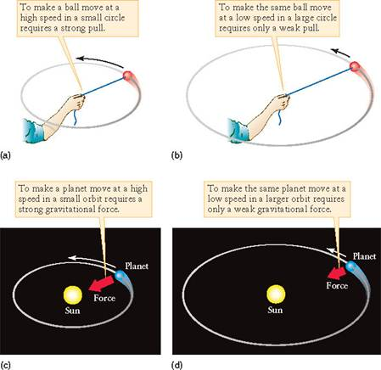
Figure 5. A mass is swung in a circle on a rope. From the point of view of the person swinging the mass, the rope is being pulled taut by the force necessary to accelerate the mass in a circular orbit. For a planet orbiting the Sun, there is a gravitational force accelerating the planet in a circular orbit. The gravitational force on the planet seems to be counterbalanced by centrifugal force, a fictitious force. In reality, the planet is freely falling "toward" the Earth in a circular orbit.

Newton wanted to compare the rate of fall of objects at the surface of the Earth with the Moon’s rate of fall toward the Earth. Knowing the distance to the Moon and its orbital period allowed him to calculate that the Moon is accelerating at a rate 3600 times less than an object at the Earth’s surface accelerates toward the Earth. This is noteworthy because the distance to the Moon from the center of the Earth is 60 times the radius of the Earth, and gravitational force was expected to decrease with the square of the distance from an object. Since 60*60=3600, Newton found it reasonable to deduce that both the apple and the Moon are falling to the Earth due to gravitational attraction, and that attraction falls with the square of the distance between an object and the center of the Earth. Newton was able to show that the acceleration of the apple and the Moon agreed to within 1%, taking into account the differences in distance. Newton also had shown mathematically that a planet acted on by an inverse square law force would obey Kepler’s laws.

Newton combined these deductions into a single mathematical equation describing succinctly the effects of gravity everywhere in the Universe:

Equation 4.3: F = GMm/D²,

where F is the force between any two masses (Remember, according to Newton’s 3rd Law, not only does the Earth pull on the Moon, but the Moon must pull on the Earth with equal force.), G the constant of gravitation, M and m are the masses of the objects attracting each other, and D is the distance between them (more precisely, the distance between their centers). Newton was able to induce that if this law held on the Earth as well as for the planets, then the law was universal. Hence the law is known as the Universal Law of Gravitation.

Newton was satisfied to use his theory to account for the motions of terrestrial and celestial objects; he wouldn’t speculate on the broader philosophical questions. How does gravity act over millions of miles of vacuum? Why does gravity act as an inverse square law?

Edmund Halley made one of the first verifications of Newton’s Laws outside the boundaries of the Earth. After studying the recorded appearance of a comet in 1456, 1531, 1607, and 1682, he successfully predicted its return in 1758 (after his death) using Newton’s laws.

In 1803, the great English astronomer William Herschel showed that a number of stars exist as binary pairs, stars orbiting around each other under their mutual gravitational attraction. More recent observations show that such stars have orbits that obey Kepler’s laws and Newton’s Universal Law of Gravitation.

One of the most powerful verifications of Newton’s Universal Law of Gravitation was the discovery of Neptune by Adams and Le Verrier in 1845. Their discovery was based on the observation of the slightly irregular motion of Uranus in its orbit, deviating from a perfect elliptical orbit. They independently hypothesized that these irregularities were caused by the gravitational attraction of a passing, undiscovered planet. Based on Newton’s Universal Law of Gravitation, they were able to predict the location of the new planet. The German astronomer, Johann Galle and his assistant Heinrich d'Arrest, discovered the planet in 1846 using the predictions of Adams and Le Verrier.

A direct experimental verification of Newton’s Universal Law of Gravitation was made in 1798 by the English physicist and chemist Henry Cavendish (1731-1810). He measured the force on two large masses by another pair of masses, by detecting the extent to which they would wind up a wire from which they were supported (Figure 6). By this means, Cavendish was able to directly measure the gravitational constant in the Universal Law of Gravitation (Equation 1).

WebVideos: Newton’s Universal Law of Gravitation
- http://www.youtube.com/watch?v=hKTNMNxW5tQ
- http://www.youtube.com/watch?v=4JGgYjJhGEE

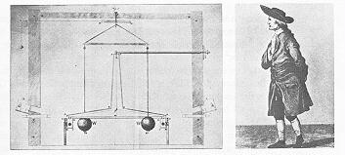
Figure 6. The Cavendish experiment. Henry Cavendish (1731-1810) measured the gravitational constant, G, by using two massive lead balls to attract two smaller masses, causing the wire from which they were suspended to twist.

VIII. Weight

As we have seen, mass is both a measure of the inertia of a body and its gravitational attraction to another body. Mass is also a measure of the amount of matter in an object. We could also measure mass by somehow counting the number of elementary particles in an object (protons, neutrons, and electrons). But mass is not the same as weight. Weight is the heaviness of an object. On Earth, weight is simply the gravitational force that attracts an object to the Earth. That’s why we refer to objects in space, far beyond the gravitational influence of large masses such as the Earth or Sun, as weightless. Although the mass of an object, such as you or I, remains basically constant over time, unless something is done to add or subtract mass, the mass of an object is dependent on where that object is located and what external body is attracting it gravitationally. As an illustration, a 180 pound person on the Earth would weigh 30 pounds on the Moon and 500 pounds floating in a balloon at the “surface” of Jupiter (Jupiter does not have a solid surface).

IX. Circular Orbits

If the Moon is falling toward the Earth due to the mutual gravitational attraction between Earth and Moon, then why don’t they collide? Newton himself used the example of the trajectory of a cannonball being fired horizontally from a mountaintop (Figure 7). The Earth is curved so that if one walks 8.4 km in a straight line, the Earth’s surface falls, on average, 5 meters from the horizontal. An object dropped at the surface of the Earth falls from rest a distance of 5 meters in the first second. So, imagine a cannon ball shot with a horizontal velocity of 8.4 km/sec from a mountaintop. In one second the cannon ball travels 8.4 km horizontally, and falls 5 meters towards the Earth, accelerated by gravity. But the Earth also curves downward by 5 meters over this same distance. At the end of one second the cannonball is at the same altitude relative to the surface of the Earth as when it started (assuming an Earth that is perfectly spherical with the exception of our mountain, and neglecting air resistance). In the next second of elapsed time the cannon ball travels another 8.4 km, falls another 5 meters, and is still no closer to the surface of the Earth. By launching our cannonball at 8.4 km/sec parallel to the Earth’s surface we have successfully put it into orbit!

F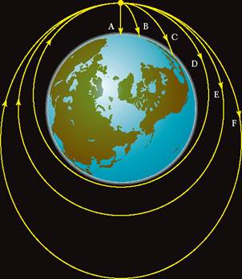
Figure 7. An illustration showing a cannonball shot horizontally from a mountaintop. If shot at a high enough velocity it will orbit the Earth.
(P 41-3.19)

What is the orbital period of the cannonball? The circumference of the Earth is 4 x 10⁴ km. The orbital period, or time it takes the cannonball to complete one orbit, is distance traveled divided by velocity (the same relation that holds for determining driving time: driving time equals distance traveled divided by average speed). In this case orbital period equals 4x410⁴km/8.4km/s or approximately 90 minutes. This is also approximately the same time interval required for an astronaut to orbit the Earth once in a near-Earth orbit. Since the Moon is 60 times farther away from the center of the Earth, it takes 3600 times longer to orbit the Earth, or 29.5 days.

Let us return to our cannonball example. What happens if the cannonball is shot at less than 8.4 km/s? It falls toward the Earth faster than the Earth curves away from its trajectory. It must then collide with the Earth. What happens if the cannonball is shot at more a velocity greater than 8.4 km/s? It can still orbit the Earth, obeying Kepler’s 1st Law so that it orbits the Earth in an elliptical orbit with the center of the Earth at one focus. However, at velocities above 11 km/s the cannonball acquires enough energy that it can escape the gravitational pull of the Earth entirely. It would then orbit the Sun in its own orbit. At about 42.5 km/s the cannonball acquires enough energy to escape the gravitational pull of the Sun as well, and would begin a journey that would take it into deep space. This initial velocity that is required by an object to escape the gravitational pull of a star or planet is called the escape velocity. The escape velocity necessary for any mass to overcome the Earth’s gravity is 11.2 km/s.

WebNote: Orbits

Summary

Kepler determined that the planets orbited the Sun in elliptical orbits, but what was the cause of these orbits? Experiments by Galileo and others led to Newton’s three laws of motion as well as the Universal Law of Gravitation. Newton determined that an inverse square law of gravity would give planets their elliptical orbits. He viewed the Moon as an object falling toward the Earth in a constant state of acceleration.

Key Words & Phrases

acceleration - the change in velocity of an object per unit time
centrifugal - a fictitious force that appears to push outward on an object following a curved path
deduce - reasoning from the general to the specific
escape velocity - the initial velocity that must be imparted to a mass to give it enough energy to escape the gravitational attraction of another mass
force - the push or pull exerted on one object by another
induce - to reason from the specific to the general, i.e. from facts to a hypothetical law
inertia - the resistance of a mass to acceleration
inverse square law - a law describing the decrease in force or intensity of light with the inverse of the square of the distance from the source
gravitational constant - the constant of proportionality in the Universal Law of Gravitation
gravity - the force of attraction between two objects as a result of their having mass
mass - the amount of matter in an object
terminal velocity - the maximum velocity reached by a falling object, as a result of friction with the medium through which it falls
velocity - a parameter that specifies the speed and direction of motion of an object
weight - the force on an object due to gravitational attraction (usually by the Earth)

Review for Understanding

- What is the difference between speed and velocity?
- Give an example of how you can move at constant speed and uniform acceleration.
- Define mass, weight, force, and gravity.
- What weighs more, a pound of feathers or a pound of lead? Which has more mass? More density?
- What are Newton’s three Laws of Motion?
- We refer to the Universal Law of Gravitation as a law. Does that mean that it is precise under all conditions?
- What is inertia?
- Is the Moon falling toward the Earth?
- How has the Universal Law of Gravitation been verified?
- At the surface of the Earth, a falling object accelerates at 9.8 m/s² (neglecting air friction). At what rate does an object accelerate at the distance of the moon?
- Two masses attract each other with a certain amount of gravitational force. If the distance between their centers is doubled, how much of a decrease is there in the force of attraction?

Essay Questions

- Should a scale that measures mass give the same reading for the mass of a person standing on the surface of the Earth and the surface of the Moon? Does a bathroom scale (based on the amount of compression of a spring) measure mass or weight? Does a balance measure mass or weight?
- Raise a piece of notebook paper and a book to eye level. Drop them simultaneously. Which one hits the floor first? Why? Now place the notebook paper on top of the book. (If it is larger than the book, fold it until it is smaller than the book.) Raise them to eye level and drop them. Do they accelerate at the same rate? Why?
- Describe the use of induction and deduction in the scientific method and in everyday life.
- Mass is related to the inertia of an object (often called inertial mass) and to the gravitational force (gravitational mass) exerted on other objects. Describe an experiment of your own design to determine whether the ratio of inertia to gravitational force is independent of the composition of an object. Assume unlimited resources.

________________________________________________________________________
Chapter 5 - Light Part I: the Cosmic Messenger

The theory that there is an ultimate truth, although very generally held by mankind, does not seem useful to science in the sense of a horizon toward which we may proceed, rather than a point which may be recalled.
--Gilbert Lewis, The Anatomy of Science (1926)

Physics is said to be an empirical science, based upon observation and experiment.
It is supposed to be verifiable, i.e. capable of calculating beforehand results subsequently confirmed by observation and experiment.
What can we learn by observation and experiment?
Nothing, so far as physics is concerned, except immediate data of sense: certain patches of colour, sounds, tastes, smells, etc., with certain spatio-temporal relations.
The supposed contents of the physical world are prima facie very different from these: molecules have no colour, atoms make no noise, electrons have no taste, and corpuscles do not even smell.
If such objects are to be verified, it must be solely through their relation to sense-data: they must have some kind of correlation with sense-data, and must be verifiable through this correlation alone.
But how is the correlation itself ascertained? A correlation can only be ascertained empirically by the correlated objects being constantly found together.
--Bertrand Russell, in The Relation of Sense-Data to Physics, 1914

Chapter Preview

Imagine the Earth a perpetually cloud-covered planet, the sky forever hidden from view. The development of astronomy would have been immeasurably retarded, for it is the observations of the Sun, stars, and planets that have motivated the development of theories of gravitation and motion in order to explain the apparent motion of celestial objects. But, with the exception of samples returned from the Moon by spacecraft and those found in meteorite collections, nearly all that we know of external worlds is carried to us by light. In this chapter you will study light and the wave model of light

Key Physical Concepts to Understand: the wave model of light, the electromagnetic spectrum, blackbody emission, the inverse square law of light

- Introduction

Astronomy is a unique science in that most of the objects that astronomers study can not be studied directly in the laboratory or even in the field. The Moon and Mars are notable exceptions on which humans and machines have landed. For other celestial objects, we must depend almost solely on the clever study of light emitted or reflected from them in order to infer their characteristics. It is essential to the astronomer and to the student of astronomy to understand light and its interaction with matter.

What is light? Of the five senses, humans have come to rely on visual information more than that from any of the other senses. We experience a wide variety of visual phenomena on a daily basis. If we had to categorize these experiences, we might come up with the following incomplete list (Figure 1):
- light bends
- light reflects
- light carries energy
- light can travel long distances, even through a vacuum
- light comes in many colors
- white light is the combination of all colors
- light is created by hot objects
The physicist would like to accomplish more than a general list of phenomena, as a scientist it is their job to reduce a long list of complex phenomenon into a simple mathematical model that can account for past experiences and predict future ones.
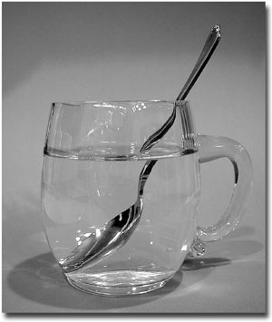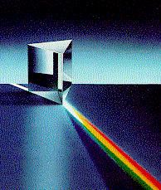
Figure 1. Reflection and refraction of light. a) A spoon in a glass of water appears to be “broken” at the boundary between air and water due to the bending, or refraction, of light at the air-water interface. b) White light is the combination of all of the wavelengths of visible light. White light is separated into its component colors (wavelengths) going through a prism, as a result of the light being bent according to its wavelength. c) Sunlight is separated into a rainbow of colors after passing through water droplets in a cloud, each of which acts as a tiny prism. c) Light is reflected from the surface of a pond.
(1a:P 51-4.6, 1b:P 47-4.1, 1c:???)

II. The Electromagnetic Spectrum

Light is only one small part of the electromagnetic spectrum, along with radio waves, microwaves, infrared radiation, ultraviolet light, X-rays, and gamma rays (Figure 2). Visible light is particularly important to astronomers, not only because our eyes are sensitive to it, but also because the Earth’s atmosphere is transparent to it (Figure 3). Although we might think of these forms of radiation as completely different, they share fundamental properties. They are all basically different colors of the electromagnetic spectrum, for the most part colors to which our eyes are insensitive. They all carry energy from place to place without transporting any matter, travel at the speed of light (in a vacuum), are reflected, and can be successfully modeled as waves. Different wavelengths of light represent different colors. For the visible light portion of the electromagnetic spectrum, the portion that our eyes happen to be sensitive to, the spectrum ranges from red on the long wavelength side to violet on the short wavelength side, in the following order: red, orange, yellow, green, blue, indigo, and violet. One way of remembering this order is to use the following mnemonic: ROY Go Bring In Violet, with the capital letters representing the colors ordered from long to short wavelengths. (One can visualize a boy bringing a cow into the barn.)

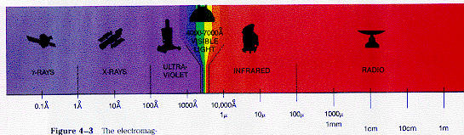
Figure 2. The electromagnetic spectrum. Icons are shown which represent satellite or ground-based observatories for that part of the electromagnetic spectrum.
(P 48-4.3)
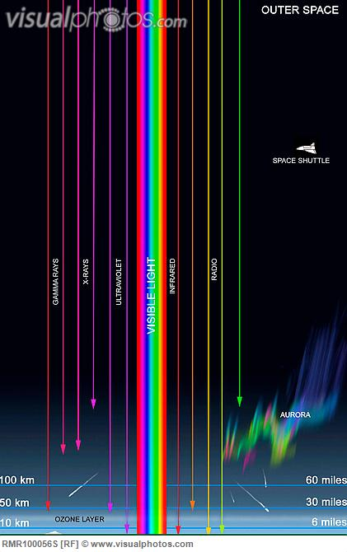
Figure 3. The transparency of the Earth’s atmosphere to electromagnetic radiation. This diagram shows which regions of the electromagnetic spectrum are useful for ground-based astronomical observations. The graph plots the altitude at which half of the light at a particular wavelength is absorbed by the atmosphere. For wavelengths where half of the light is absorbed high in the atmosphere, an insignificant amount will reach the ground. There are notable atmospheric “windows” in the visible light and radio portions of the spectrum. (P 49-4.4)

- Wave Nature of Light

Light can be successfully modeled as a wave (Figure 4). Does this mean that light really is a wave. Ultimately physicists, like all humans, cannot judge reality or truth because they, and we, are imprisoned in their own five senses. All of our knowledge comes directly or indirectly from our five senses, whether it be looking at stars through a telescope or imaging viruses with an electron microscope. We cannot tell whether light is really a wave or what gravity really is; we are limited to observing the effects of light and gravity with our five senses. Thus asking, “Is light a wave?” is not a question that the physicist can answer. The answerable question is “Can light be modeled as a wave?” If the physicist models light as a wave, he or she can make predictions based on this model that are testable. If, and only if, these tests confirm the light model, then the light model is useful, but not true! This is also true of gravity. Newton believed his model of gravity successfully modeled all known, relevant observations, but he did not speculate on what gravity really was. In the end, the physicist is bound to the practical and testable; it is the philosopher who is able to find concepts such as truth and beauty within the scope of legitimate study.
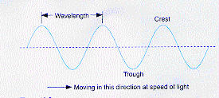
Figure 4. Light can be modeled as a wave.
(FMA 86-4.3)
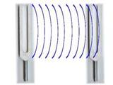
Figure 5. Light scattering and tuning forks. A vibrating tuning fork causes in air between it and another tuning fork to vibrate, which in turn causes the second tuning fork to vibrate. The analogous behavior with electromagnetic radiation is the emission of light from oscillating electrons in matter, the light is later scattered by electrons surrounding an atom or molecule at another location.

Historically, one of the most successful models of light is the wave model. (Later we will see that a particle model of light more successfully models some experimental results and is less successful at others.) Light is generated by the vibration of electrons in matter, which act like little antennae giving off radiation (Figure 5). Charged particles, like electrons, attract particles of opposite charge and repel particles of similar charge, with a force that decreases with the inverse square of the distance between particles, similar to gravity. Moving charged particles (called electric currents) also give rise to a magnetic force. (In a bar magnet the moving charges are enormous numbers of electrons orbiting their atomic nuclei, all lined up in the same direction. So charges can send electric and magnetic force across space, even in a vacuum, in the same way that masses attract gravitationally.

Charges moving back and forth, oscillating, cause variations in electrical and magnetic forces, which can be modeled as an electromagnetic wave that propagates through space at high velocity (the speed of light). This happens in antennae, an alternating current (charges moving up and down) in a length of wire will cause the emission of electromagnetic waves at the same frequency at which the charges are moving back and forth. Subsequently, this same wave causes oscillating charges in the receiving antennae, which can be amplified into a sensible radio or television signal.

If moving electrons can cause the emission of electromagnetic waves, then why don’t our bodies give off light? The answer is that they do! By virtue of the fact that our bodies are warm, the matter in them is in constant motion on a microscopic and submicroscopic level, with constituent charges also in a constant state of motion. This motion causes the emission of infrared radiation (sometimes known as “heat rays”), invisible to the human eye, but visible to rattlesnakes. This enables the rattlesnake to strike at moving animals, even in the dead of night. An image of a zebra in darkness, seen by the infrared radiation given off from its own body heat is shown in Figure 6. Infrared imagers are used by the military for detecting the enemy at night, and by rescue personnel when searching for lost hikers in rugged terrain, also at night.

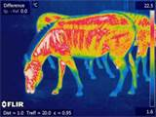
Figure 6. Infrared image of a zebra at night.

We will use water waves to describe the behavior of waves in general and electromagnetic waves in particular. Water waves are described by their speed, frequency (or equivalently, period), and wavelength (Figure 7). Electromagnetic waves always travel at the speed of light, about 300,000 km/sec in a vacuum (usually represented by c), and somewhat slower in matter, depending on the properties of matter and the wavelength of light.

Figure 7. Light waves are analogous to water waves. Both are characterized by their wavelength, speed, and frequency (or period).

If we imagine ourselves at the seashore watching the waves smashing against bathers and beach, we can envision the parameters used to describe waves. A beachgoer bobs up and down in an inner tube, continuously moving up and down, but not moving significantly moving toward or away from the beach. The vertical distance that the bather bobs up and down is the amplitude or intensity of the wave. The rate at which this person oscillates up and down is known as the wave frequency. Alternately, the period of time it takes this bather to move up and down once, in a single full cycle, is known as the period of the wave. The relationship between period and frequency is:

Equation 5.1: Period = 1/frequency.

If the bather bobs up and down once every 5 seconds, the wave period is 5 seconds and the frequency is (1 cycle)/(5 seconds) or 0.20 cycles per second. The unit of cycles per second has been named Hertz after the German physicist, Heinrich Hertz, who showed that light was an electromagnetic wave.

We can use the distance/velocity relationship that we developed in Chapter 4 to examine how far a wave can travel in any particular interval of time:

Equation 5.2: Distance = velocity * time.

In particular, how far does a water wave travel in one wave period? Suppose our beach waves travel at 10 meters/second. For a wave with a period of 5 seconds, the wave will travel 50 meters. This means that the length of a wave, measured from peak to peak or trough to trough, is 50 meters. This distance is defined as the wavelength of a wave. We can rewrite equation 5.2 as:

Equation 5.3 Wavelength = velocity * period,

or equivalently, from equation 5.1:

Equation 5.4: Wavelength = velocity/frequency.

In Table 5.1 are shown the wavelengths and frequencies of various colors of electromagnetic radiation, using the speed of light in a vacuum of 300,000 km/sec.

Table 5.1: Example Wavelengths and Frequencies of Light
Wavelength | Frequency  (Hz) | Type of Electromagnetic  Radiation
1 centimeter | 3 × 10¹⁰ | Radio
1 millimeter | 3 × 10⁹ | Microwave
10⁻⁵ meters | 3 × 10¹³ | Infrared
5 × 10⁻⁷ meters | 6 × 10¹⁴ | Visible
10⁻⁷ meters | 3 × 10¹⁵ | Ultraviolet
10⁻⁸ meters | 3 × 10¹⁶ | X-ray

To see how some everyday properties of light, such as bending and reflection, are accounted for in the wave model of light, we will look at some photographs from a ripple tank, a shallow tank of water in which water waves are used to model wave properties in general in Figure 8.

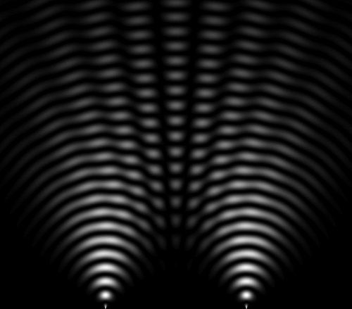

Figure 8. Interference. Interference is a vivid illustration of the wave nature of light. When the waves from two different sources meet, whether light, water, or sound waves, interference occurs. At location where the wave crests from the two sources match up, the intensity of light from the two sources reinforce each other (constructive interference). Where the crest from one source is aligned with the trough of another, waves of equal intensity will cancel each other (destructive interference). a) Interference of water waves from two sources in a ripple tank. b) Analogous to the ripple tank, laser light passing through two slits produces a similar interference pattern.

WebNote: Wave Nature of Light, is Light a Wave or a Particle?
http://www.youtube.com/watch?v=TT-_uCLwKhQ

- Colors

Different colors of light are equivalent to specific ranges of wavelength or frequency. Red light has the longest wavelength and lowest frequency of visible light, blue the shortest wavelength and highest frequency. Newton reported in his book Opticks, in 1704, his discovery that white light is simply a mixture of all the visible colors of light. When he passed white light through a single prism, light of differing colors was bent to a different degree (blue more, red less) such that the light was spread into a spectrum of colors. This was already known. If all the colors except red, for example, were blocked and the red light was passed through another prism, no additional separation was performed, one still viewed only red light. If however, we passed through an opposing prism, colored light would be remixed to form white light again. Newton performed this experiment to illustrate that the separation of white light into colors was nothing that the prism did to alter the color of the light, but was only a separation of the light into colors it already had, due to the different affect that the prism had on different colors.

Newton perceived light as being composed of particles, each with its own characteristic color. Some of Newton’s fellow scientists argued for light possessing wave-like properties. While the wave model of light can explain the bending and reflection of light, as does the particle model, it wasn’t until 1801 when Thomas Young devised the now famous double-slit experiment, that the wave nature of light was clearly demonstrated (Figure 8). Young showed that light, like water waves, exhibits interference. When waves from two different sources intersect, the wave patterns add. The points where crest meets crest exhibit wave amplitudes that are the sum of the amplitude of each individual wave. The points where crest meets trough can exhibit zero amplitude (if the individual waves are of equal intensity) because the waves cancel each other. Interference is a unique property of waves and is a clear demonstration of the necessity for a wave model of light.

WebVideo: Young’s Double Slit Interference
http://www.youtube.com/watch?v=hUJfjRoxCbk
http://www.youtube.com/watch?v=ayvbKafw2g0

V. Why is the Sky Blue? Why are Sunsets Red?

Each atom and molecule in the atmosphere acts with respect to light waves like a tuning fork does to sound waves (Figure 5). When light strikes an atom or molecule it sets it to vibrating as does sound hitting a tuning fork. It sets the atom or molecule into vibration and the result is the scattering of light in all directions. However, as the wavelength of light becomes longer than the size of a molecule (the oxygen and nitrogen molecules in air are roughly 10⁻⁸ meters across) it is less efficiently scattered by that molecule. If the wavelength of light is much larger than the size of a molecule, light will not cause it to vibrate; instead the light just passes through it. In other words, the molecule is transparent to the passage of light. In this way, gas molecules in the upper atmosphere are more transparent to red light than they are to blue light. Sunlight, which appears white, passes through the atmosphere relatively unimpeded; blue light is preferentially scattered (Figures 9 and 10). The result is that the Earth’s sky appears to be blue since what we see when we look at the sky is sunlight scattered from molecules in the atmosphere. Since blue light is scattered preferentially, the sky appears blue. If the Earth were a planet with no atmosphere the sky would appear black. The Sun is red at sunset, because blue light from the Sun is scattered away from our line of sight. At dusk or dawn Sunlight travels through more of the atmosphere than it does at noon, so the Sun is redder at sunrise and sunset. If the Earth had no atmosphere, the Sun would appear the same color at noon as it does at sunset.
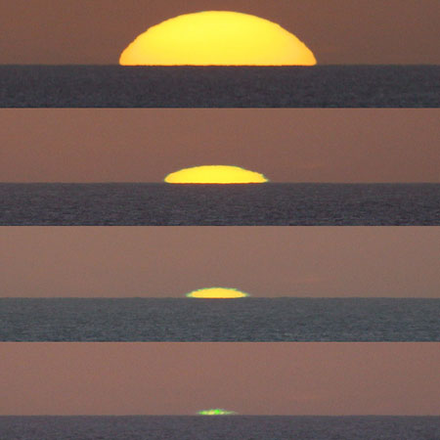
Figure 9. Sunset. Note the green flash seen in the final frame.

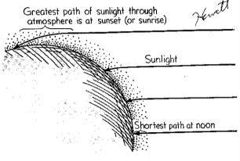
Figure 10. Schematic of a sunset. Sunlight striking the Earth at sunset travels through more atmosphere than does sunlight at noon. The molecules in the atmosphere preferentially scatter blue light out of the incoming beam of light. The resulting light then appears redder at sunset than at midday.

VI. The Inverse Square Law for Light

It is a common everyday experience that lights at night appear brighter the closer they are to you. It is not true, however, that if a light is moved twice as close to the observer that it will appear twice as bright as it was before. It is observed that the apparent brightness of objects varies as the inverse square of the distance to the observer, the same variation with distance used by Newton for gravity. What is the origin of the inverse square relationship? The inverse square law relation for light is important in astronomy for it allows astronomers to find the distance to objects for which the intrinsic brightness is known.

To understand the geometric origin of the inverse square law of light look at Figure 11. We see a light source placed in the center of three imaginary concentric spheres. This light source emits a constant amount of light energy per unit time interval. The light travels outward from the central source, spreading out over time. As light reaches each successively larger imaginary sphere, the total amount of light energy reaching the sphere per unit time is the same emitted per unit time from the light source, since the light intensity of the source never varies. However, the surface area of each successive sphere is larger than the previous one, so the light energy hitting the outermost sphere is spread out over a much larger area that the light hitting the innermost sphere. The light energy becomes more and more diluted in intensity, a measure of the light energy per unit area, as it spreads from the central source. The surface area of a sphere is proportional to the square of its radius, (4πr² to be exact). The result is that the intensity of light decreases with 1/r², or the surface area of the intersected sphere.
Figure 11. An illustration of the inverse square law for light intensity. Light is spread over concentric spheres in accordance with the inverse square law.
(JC 105-10.2)

The inverse square law for light, as well as for gravity and the electrical force, is a fundamental property of the three dimensional space that we occupy. As a central light source emits light through three-dimensional space, or a central object exhibits a force of attraction through space, it must become diluted with the square of the distance from the central object.

VII. Blackbody Radiation

What happens when a poker is heated in a flame? As is gets hotter, first it glows a dull, faint red, then it becomes brighter and its color becomes bluer. If the flame is hot enough, the poker will eventually glow white-hot. The changes in brightness and color of heated objects behave systematically, in a way that can be modeled by what physicists call a blackbody.

All objects emit electromagnetic radiation. Objects that are efficient radiators of electromagnetic radiation are also good absorbers. An object that absorbs all radiation of all wavelengths incident on it is called a blackbody. It then follows that such an object is also a perfectly efficient radiator at all wavelengths. Such an object is an idealization. But its usefulness is that even objects that are not ideal blackbodies emit light similarly under most circumstances. Some solids, such as charcoal or lampblack, absorb almost all visible and infrared radiation incident upon them, and therefore approximate blackbodies in this part of the electromagnetic spectrum. The Sun and other stars approximate blackbodies (with the addition of absorption at specific wavelengths).

The spectrum of radiation emitted from blackbodies has a characteristic shape that is dependent of the temperature of a blackbody. This electromagnetic spectrum has two main characteristics:

- Energy is emitted at all wavelengths in a continuous spectrum, with no sharp intensity variations.
- The intensity varies with wavelength. We will call the wavelength of maximum intensity

As a blackbody is heated, its spectrum changes in the following two ways:

- As a blackbody is heated from a temperature T₁ to a hotter temperature T₂ the intensity of light at every wavelength increases, thus the object appears brighter.

This effect is quantified by the Stephan-Boltzman Law:

Equation 5.5: E = σT⁴,

Where E represents the total amount of energy emitted by a blackbody, and T is the temperature of the blackbody. We come back to the Stephan-Boltzman Law in later chapters, where we will use it to estimate the amount of energy emitted by stars.

- The hotter we heat a blackbody, the shorter the wavelengths, on average, of radiation emitted by the blackbody.

The wavelength of maximum intensity λ_{max} shifts to a shorter wavelength according to Wien’s law (Figure 12):

Equation 5.6: λ_{max} = 2.898 x 10⁻³/T,

where T is in Kelvins and λ_{max} is in meters (λ is the symbol used by astronomers to represent the wavelength of light). The result is that the color of a blackbody changes in temperature. As a blackbody is heated from 3,000 K to 20,000 K its color changes from red to blue as the spectrum changes from one with a high proportion of energy from red light to a spectrum with a high proportion energy from blue light.

WebVideo: Blackbody Radiation
http://www.youtube.com/watch?v=jbxty6aDfhU

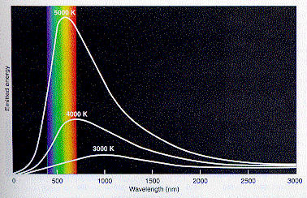
Figure 12. Light energy curves for blackbodies at three temperatures. Each curve illustrates the relative amount of energy emitted vs. wavelength. Hotter objects emit more energy at all wavelengths compared to cooler bodies. Hotter objects also appear bluer, because they emit proportionately more blue light than do cooler objects.
(FMA 91-4.8)

Table 5.2: Temperatures and λ_{max} of Various Objects
Object | Temperature | λ_{max} (in 10⁻⁶ m) | color
cold interstellar dust | 10 K | 290 | microwave
warm dust near a star | 100 K | 29 | infrared
ice water | 273 K | 10 | infrared
human being | 310 K | 9 | infrared
boiling water | 373 K | 8 | infrared
low mass star | 2500 K | 1 | near-infrared
Sun | 5800 K | 0.55 | orange1 (visible)
high mass star | 50,000 K | 0.05 | ultraviolet

Temperature Scales

The three commonly used temperature scales are Fahrenheit (°F), used only in the U.S., Centigrade (°C or Celsius), used elsewhere in the world, and Kelvin (K or Kelvins), used by physical scientists. Comparison of the three scales, at absolute zero, the freezing point of water and the boiling point, are shown in Figure 13. The Centigrade scale is based on the freezing point of water at 0° C (32° F) and the boiling point at 100° C (212° F). Then absolute zero, or the temperature at which there is no atomic motion, is 0 K, -273° C or -459° F. The Kelvin scale is an adjustment of the Centigrade scale so that absolute zero is 0 K. This makes the freezing point of water 273 K and the boiling point 373 K. The Kelvin temperature scale will be used throughout this text.

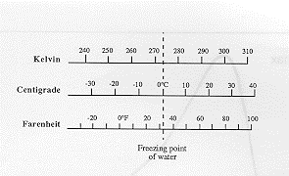
Figure 13. Temperature scales.

Summary

The electromagnetic spectrum consists of radio waves, microwaves, infrared radiation, visible light, ultraviolet light, X-rays, and gamma rays. Electromagnetic radiation, including visible light can be modeled as a wave of electric and magnetic force. The color of light is determined by its wavelength. The vibrating charges in matter cause it to emit light. The warmer the object the more energy it radiates. The temperature of an object can be determined by the wavelength of maximum intensity for emitted radiation.

Key Words & Phrases

electric force - the force between two charged particles. This force is attractive if the particles are of opposite charge and repulsive if the particles are of like charge.
electromagnetic spectrum - the spectrum of light, i.e. radiation which travels in space as a result of vibrations in electric and magnetic force. The electromagnetic spectrum includes radio, microwaves, infrared, visible light, ultraviolet, X-rays, and gamma rays.
frequency - the frequency of a wave is the number of oscillations per unit time that the wave undergoes at any one location in space.
Hertz - the unit of frequency in cycles per second.
intensity - the amount of light energy striking a surface (or passing through an imaginary surface) per unit surface area per unit time.
magnetic - the force between objects due to currents, or flowing charge, within those objects. These currents can include the aligned motion of electrons in atoms seen in magnetic materials. Magnetized iron, for example, is characterized by electrons circling the iron atoms aligned preferentially in one direction.
period - the period of a wave is the time interval required for the wave to complete one complete oscillation at one location.
wavelength - the wavelength of a wave is the distance over which the wave repeats itself once (e.g. the distance between successive peaks in the wave).
Wien’s law - the law describing the relationship between the wavelength of maximum intensity of an object and its temperature.

Review for Understanding

- Why is the sky blue?
- What is a blackbody?
- What is light?
- What demonstration could one perform to demonstrate that light behaves as a wave?
- Write the following in order of increasing wavelength: infrared, gamma ray, X-ray, visible, radio, ultraviolet, microwaves.
- If we observe two identical lamps, A and B, and A appears four times brighter than B, how much farther away is B than A?
- What is the relationship between the frequency, speed, and wavelength of a wave?
- Which is hot, a red-hot poker or a white-hot poker? Explain.
- What color does one obtain by mixing light of different colors in equal intensity?
10. What is interference?

Essay Questions

- Estimate the temperature of a body that has its wavelength of maximum intensity in the middle of the visible part of the electromagnetic spectrum.
- Why do you think that we have evolved with eyes that are sensitive to the visible part of the electromagnetic spectrum? (Hint: Use Figure 3).
- What should the temperature of a filament in an incandescent light bulb be in order to maximize its efficiency? Discuss.
- Is light really a wave? Discuss.

Figure 4. Cartoon of a boy and his cow. ROY Go Bring In Violet (Red, Orange, Yellow, Green, Blue, Indigo, Violet).
(Original)

Figure 10. Light traveling through opposing prisms.

Figure 13. Cars at night. One can visually estimate the relative distances of cars in this photograph, by assuming that all car headlights have the same intrinsic intensity, so that the headlights that appear relatively faint in this image must be relatively far away.

Figure 15. Glowing solid bodies radiate like blackbodies. a) Body heat. This infrared image shows that even a person in a dark room radiates in the infrared portion of the electromagnetic spectrum. Note the heat streaming from the nostrils. b) A crucible of molten iron emits a great deal of visible light. Its color is used to measure the temperature of the iron.

Spielberg, N. and Anderson, Bryon, Seven Ideas That Shook the Universe.
The emphasis is mine.
 Although the light from the Sun appears white, the wavelength of maximum intensity is centered in the orange part of the spectrum. It is when the light from all parts of the spectrum is added, not just the light at the wavelength of maximum intensity, that a white light is produced.

