Name: Date:

Extrasolar Planets

Objectives:
- Learn about Extrasolar planets — planets orbiting other stars
- Explain how astronomers detect and characterize Extrasolar planets

Materials
- Light source to mimic star
- Ball to mimic planet
- Light meter
- Interface

Cross-Discipline Extension Activities
Below are links to various cross-discipline activities that are extensions of this topic.

Biology
Living vs. Non-living:
http://www.flinnsci.com/media/1042381/bf10992.pdf
Chemistry
Gas Laws, Exoplanet Atmosphers
http://spacemath.gsfc.nasa.gov/weekly/10Page24.pdf
Physics/Physical Science
PhET Simulation—My Solar System:
http://phet.colorado.edu/en/simulation/my-solar-system
Earth/Geology/Environmental Science
Planet Formation Temperatures Plot (UNL Simulation):
http://astro.unl.edu/classaction/animations/solar/formationtemps.html
Math
The Goldilocks Planets—Not too hot or cold!
http://spacemath.gsfc.nasa.gov/news/7Page66.pdf
Engineering
Biomimicry in Engineering (use biomimicry to design a place for humans to live on the moon or other planets):
http://www.tryengineering.org/lesson-plans/biomimicry-engineering?lesson=76

Introduction
This is an exciting time in astronomy. Over the last few decades we have begun to detect planets orbiting stars other than our sun. We now know of over 1,000 extrasolar planets (more commonly called exoplanets) and speculate there are billions in the Milky Way galaxy alone.

But not all exoplanets are Earth-twins. In fact, we have yet to find one. Most exoplanets seem to have walked directly out of the best science fiction moves. For example, we’ve discovered planets consisting purely of water and others consisting mostly of diamond. Some planets nearly scrape their host stars once every orbit, while others exist in darkness without a host star at all.

The field of exoplanet research is moving beyond detecting exoplanets to characterizing them — understanding which molecules are present in their atmospheres — so that we may discover if they potentially harbor life.

1. The Light Curve Technique
How do you think astronomers detect exoplanets? Write down a few predictions.

Directly imaging an exoplanet orbiting its overwhelmingly bright host star is nearly impossible (it has only been done recently with phenomenal advances in technology).
So astronomers tend to look only at the exoplanet’s host star and infer the presence of a planet by noticing how the invisible planet affects its star.
While there are many methods to do this, one of the most popular techniques is to look for a transit: to notice a planet pass in front of its host star from our point of view. We cannot directly see this because we cannot resolve the disk of the star. Instead telescopes collect the total amount of light we receive from the star.
During the transit, the planet blocks some of the light we see from the star. This makes the star appear fainter, shedding light on the properties of the planet.

2. Activity: Create a Light Curve
Using the provided materials (a light source, balls of different sizes, a light meter, and an interface) we will create a model demonstrating how astronomers detect transiting exoplanets. The light source represents a distant star, the balls various planets, and the light meter and interface act as a telescope observing the distant star.
Once everything is set up, observe a planet transiting a distant star. Draw the light collected as depicted on the interface — the so-called light curve — below:

How does the size of the planet affect the light curve? Draw examples below:

But here’s a question: how do we really know this drop in the star’s brightness is due to a transiting exoplanet? What else could cause a star’s brightness to drop?

The correct answer is a lot of different things! Hopefully you came up with a few examples. The rule of thumb in astronomy is that you have to observe this drop in brightness three times in order to rule out all other possibilities. If the transit occurs in equal increments — resembling the amount of time it takes for the planet to circle around its host star and then transit its surface again (this is 1 year for the Earth) — and the light drops by equal amounts each time, then this object is definitely an exoplanet!
Not only can you provide confirmation that you’ve made a discovery, but you now know the first characteristic of your transiting exoplanet, it’s period (P). This is just how long it takes to complete one orbit, again the Earth’s period is 1 year.
Simulate an exoplanet orbiting three times. Draw the light curve below:

Calculated Period = __________ .
Congratulations! You have just created your first model of a transiting exoplanet. You will use the above light curve to answer various questions about the exoplanet. But first, because your scale is much smaller than the physical size of an exoplanet orbiting a distant star, translate your period from seconds into days. For example, if you calculated a period of 3 seconds, use 3 days throughout the rest of the lab.
Physical Period = __________ .

3. Determining the Exoplanet’s Radius
From the light curve alone we can determine a few crucial properties about the exoplanet. Below is a table of a few characteristics of the planets in our Solar System (provided by http://pds.jpl.nasa.gov/planets/). We will use this table as a reference in order to try to better understand our distant exoplanet.
Planet a P V D Mass Density Temp Albedo Pressure Atmospheric Composition (AU) (km/s) (km) (M_{Earth}) (g/cm³) (K) (atm)
Mercury 0.387 88d 47.5 4854 0.056 5.4 452 0.12 Trace Trace H₂, He

Venus 0.723 224.7d 35.0 12,112 0.82 5.2 726 0.59 90 CO₂(.96) N₂(.03) H₂O(.00003)

Earth 1.000 365.25d 29.8 12,751 1.00 5.5 281 0.39 1 N₂(.78) O₂(.21) Ar(.01)

Mars 1.524 687d 24.1 6788 0.108 3.9 230 0.15 0.007 CO₂(.95) N₂(.03) Ar(.016)

Jupiter 5.203 11.86yr 13.1 143,000 317.87 1.3 120 0.44 10 at 100km H₂(.9) He(.1) CH₄(.0007)

Saturn 9.539 29.46yr 9.6 121,000 95.14 0.7 88 0.46 20 at 200km H₂(.97) He(.03) CH₄(.005)

Uranus 19.18 84yr 6.8 47,000 14.56 1.2 59 0.56 H₂(.83) He(.15) CH₄(.02)

Neptune 30.06 165yr 5.3 46,529 17.21 1.7 48 0.51 H₂(.74) He(.25) CH₄(.01)

You have probably already noticed that the size of the planet determines how much light is blocked. In fact, the area of the light blocked when the planet transits is exactly the area of the apparent disk of the planet. So, the ratio of the area of the planet’s disk to the star’s disk should directly determine the drop in brightness, or the transit depth (TD):
TD = (area of planet) / (area of star)
Since the projected area is a circle, area = πr²
TD = (πr_{planet}²) / (πr_{star}²)
TD = (r_{planet}²) / (r_{star}²)
Make an educated guess about transit depth you observed on the previous page. This is simply the ratio of the light blocked over the total amount of light.
TD = __________ .
But without the radius of the star, you can’t find the radius of the planet. So the next step as an astronomer is to perform follow-up measurements of the star. We learned earlier about the spectroscopy of light. Say you take a look at this star’s spectrum and it matches the Sun’s spectrum phenomenally well, then you can assume that the two stars have similar radii.

The Sun’s radius is: 696,000 km. What is the radius of your exoplanet?
r_{planet} = __________.
Is this large or small compared to the planets in our solar system?

4. Determining the Exoplanet’s Semi-Major Axis
Luckily we’re not done learning about the characteristics of our newly discovered exoplanet. Take a look above at the planets’ orbital periods (P) — the amount of time it takes for a planet to circle the Sun — as compared to their semi-major axes (a) — the distance they are away from the Sun. Do you notice a pattern?

This pattern is known as Kepler’s third law and it takes on a very simple form in our Solar System:

P² = a³.

So if you know the orbital period of an exoplanet (which you do), you can determine its distance away from its star. Now Kepler’s third law is only simple when it comes to our Solar System. In other planetary systems the above equation looks pretty messy. But luckily we’re looking at a planetary system where the star looks exactly like our Sun. So go ahead and use the above equation to determine the semi-major axis of your exoplanet. But first you’ll need to convert your period into years.
a = __________ .

Your answer is now in astronomical units (a.u.), where 1 a.u. is equal to the distance from the Earth to the Sun. Again compare your answer to the table of planets within our own Solar System. How does your exoplanet differ?

We might classify your exoplanet as a so-called hot-Jupiter — a sizzing gas giant that orbits its host star so quickly and so close it might even scrape its host star’s surface. Look once more at the table above. What else can you guess about what this wacky exoplanet might be like? Is there potential for habitable life?

5. Final Thoughts and Conclusions
Our set-up was slightly biased toward larger-than-life planets. In reality planets are very small compared to their host stars. Here’s an image I took of Venus transiting our Sun in 2012.
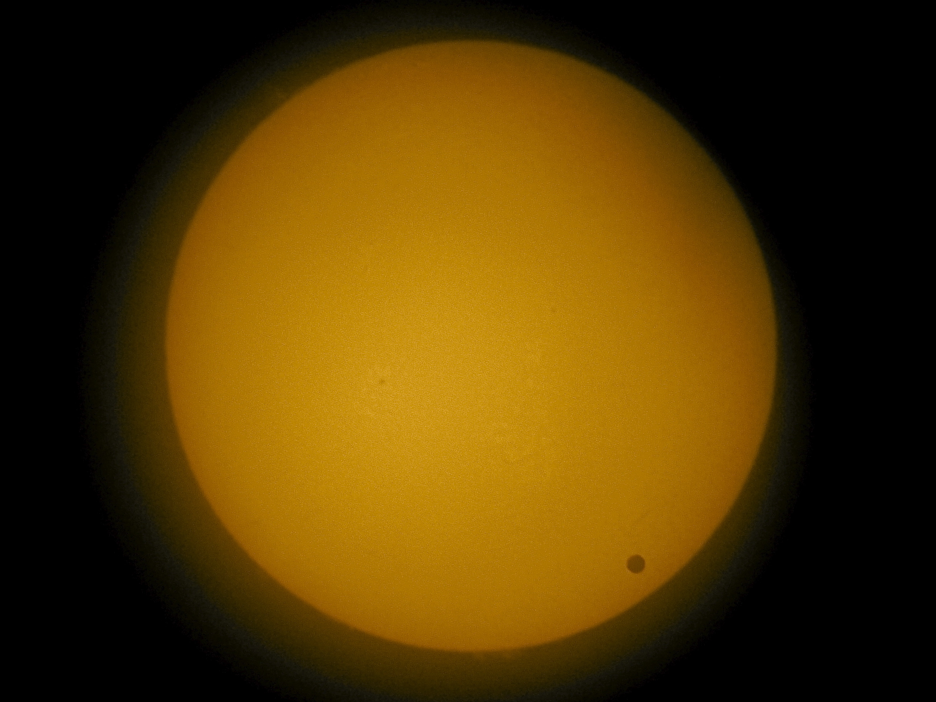
Using the previous table, calculate how dim Jupiter makes the Sun look when it transits in front of it.
TD = __________ .
What about the Earth?
TD = __________ .
As of February 26, 2014 the following histogram shows the number of exoplanets found based on type (i.e. those that appear Earth-like or Jupiter-like).
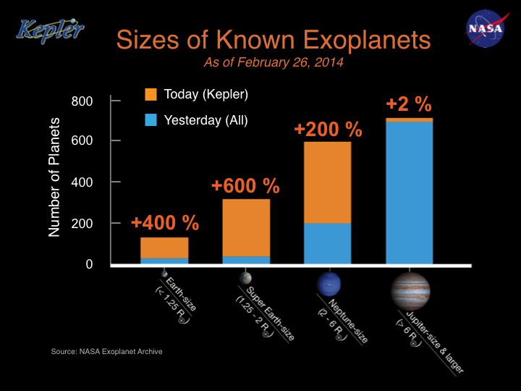
What do you notice? Why have we discovered far more Jupiter-like planets than Earth-like planets? Is this based on reality?

