Name: Date:

**Observing the Night Sky**

**Objectives:**

* Understand the difference between physical size and angular size
* Learn basic constellations and stars
* Understand the motions of the stars based on your location on Earth
* Note where the sun rises and sets on different days of the year

**Materials**

* Meter sticks

**Cross-Discipline Extension Activities**

Below are links to various cross-discipline activities that are extensions of this topic.

|  |
| --- |
| **Biology** |
| Seeing Out of the Corner of Your Eye  http://www.flinnsci.com/media/452814/bf10896.pdf |
| **Chemistry** |
| The New Alchemy:  http://www.acs.org/content/dam/acsorg/education/resources/highschool/chemmatters/chemmatters-october-2006.pdf |
| **Physics/Physical Science** |
| Kepler’s Laws of Planetary Motion, Satellite Motion, Weightlessness in Orbit:  http://www.physicsclassroom.com/class/circles/Lesson-4/Kepler-s-Three-Laws |
| **Earth/Geology/Environmental Science** |
| Atmospheric Optics:  http://www.arborsci.com/cool/atmospheric-optics-she-comes-in-colors |
| **Math** |
| Digital Camera Math!  <http://spacemath.gsfc.nasa.gov/weekly/10Page37.pdf>  Focal Lengths, Apertures, and F/ Numbers:  http://spacemath.gsfc.nasa.gov/weekly/10Page30.pdf |
| **Engineering** |
| Construct a Telescope:  http://sciencenetlinks.com/lessons/looking-into-space/ |

**Introduction**

Today we will be calibrating your hand as an angular measuring device, and then heading down to the planetarium to see the night sky in motion. We’ll see how the motion of objects in the sky changes with your location on Earth, and how the path of the Sun changes with the seasons.

**1. Angular Sizes**

The angular size, α, of an object depends on its linear (actual) size L and its distance, D, from you. The Moon and the Sun both have about the same angular size of 0.5 degrees. This is true because even though the Sun is 400 times larger than the Moon, it is also about 400 times farther away! For objects that are not too big (smaller than about 10 degrees), the angular size of an object is given by:

Since there are 57.3 degrees in one radian, we can also use:

Make sure you pay attention to your units (as you always should)! Now we can use these equations to calibrate our hands as angular measuring devices. You can then use your hand to do things like determine your latitude (if you can find Polaris), estimate how long you have until the Sun sets (I use this all the time when backpacking), or estimate how far away objects are. We will calibrate both your fist and pinky at arms length.

Hold your pinky finger up comfortably at arms length. Have a partner carefully measure the distance between your eye and your pinky.

Distance from eye to pinky: D = ___________ centimeters.

Now measure the width across your pinky to the nearest tenth of a centimeter.

Width of pinky: L = ___________ centimeters.

Finally, use this information to compute the angular size of your pinky when held at arms length.

Angular size of pinky finger: α = 57.3 × L/D = ___________ degrees.

Next, make a fist and hold it at arms length. Have a partner measure the distance between your eye and your fist.

Distance from eye to fist: D = ___________ centimeters.

Now measure the width across your fist.

Width of fist: L = ___________ centimeters.

Now, use those measurements to calculate the angular size of your fist at arms length.

Angular size of fist: α = 57.3 × L/D = ___________ degrees.

What would happen to the angular size of your fist or pinky if your arm were to suddenly become twice as long as it currently is? .

**2. Motion of the Sky from Wyoming**

With the planetarium set for the latitude of Wyoming, we will study the apparent motions of the stars as the Earth rotates. Let’s suppose you take a backpacking trip in the Wind River Range. Since the weather is nice, you decided to sleep outside your tent and watch the night sky as it passes.

First we will simulate the view looking south for about 12 hours. Focus on the path of the stars and sketch it. Make sure to draw arrows indicating the direction the stars move. I will also show you a line marking the celestial equator and a grid marking the celestial sphere. Think of the grid as lines of longitude and latitude projected onto the sky. Copy this coordinate system onto your drawing below.

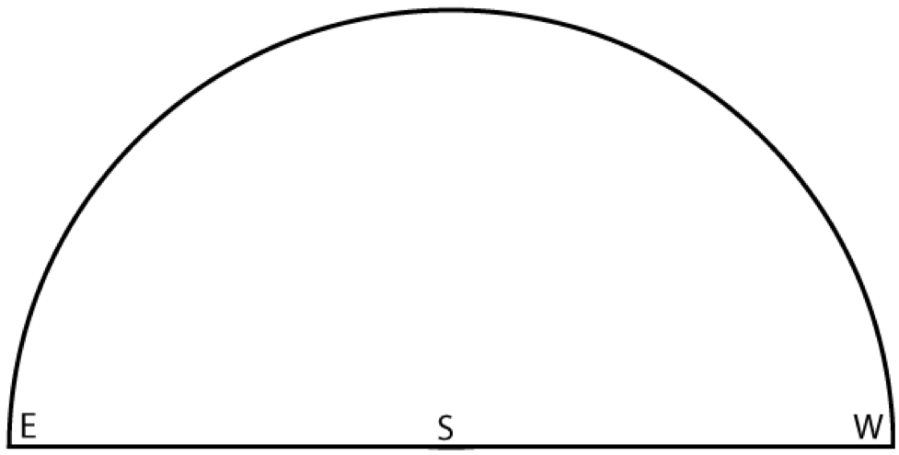

What cardinal direction (North, South, East, or West) do the stars rise above the horizon?

What cardinal direction (North, South, East, or West) do the stars set below the horizon?

Next we will simulate the view looking north. Once again, sketch the paths of some bright stars across the sky for 12 hours. Pay particular attention to Polaris and the movement of the Big and Little Dippers. Again use arrows to indicate the direction in which it moves.

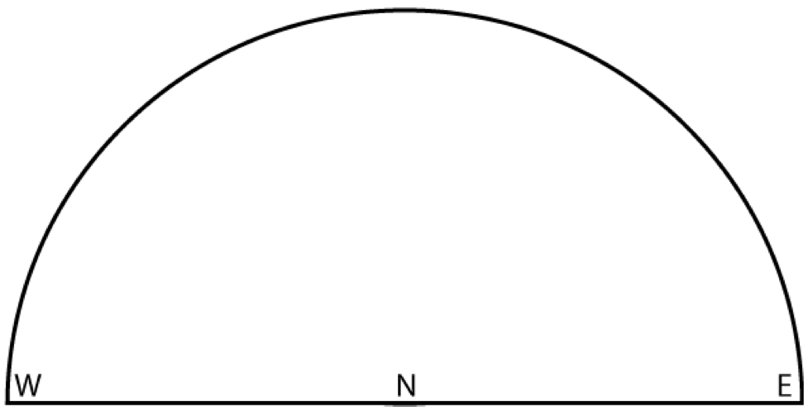

What is the altitude of Polaris? You should be able to measure it using the angular size of your fist.

Why is this number familiar?

**3. Motion of the Sky from Other Locations**

Now, predict how you think the motions of the stars will appear throughout the night if you were located at the north pole. Think about where Polaris will be at this location, and how the stars move relative to Polaris. Draw the paths that you expect.

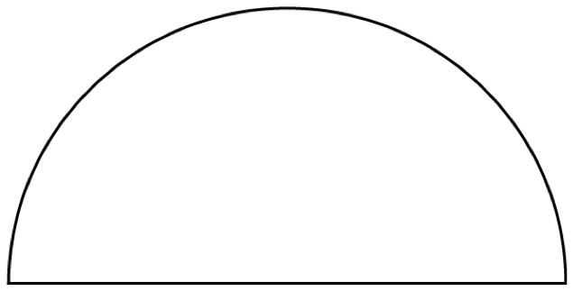

We will actually simulate the motion of the sky at the north pole. Draw the actual paths. Make sure to add cardinal directions and mark Polaris! Was your prediction close?



Now try predicting how the motions of the stars would appear throughout the night if you were located on the equator. Draw the paths that you would expect at this latitude.



We will now simulate the motion of the sky at the equator. Draw the actual paths. Make sure to add cardinal directions and mark Polaris! Was your prediction close?



**4. Position of the Sun with Seasons in the Northern Hemisphere**

Next we’ll position the planetarium to show the view from Wyoming again. Because of Earth’s 23.5 degree tilt relative to it’s orbital plane, the Sun’s height in the sky changes with the seasons.

I will show you the location of the Sun at noon on June 21st (the summer solstice). Note that the Sun is 23.5 degrees north of the celestial equator (this might be called “celestial latitude” but astronomers actually call it “declination”). Measure the altitude of the Sun above the southern horizon: __________ degrees.

Now use this information to find your latitude. In general, from the northern hemisphere:

Latitude = 90◦+(declination of Sun)◦− (elevation of Sun from southern horizon)◦

Latitude = 90◦ + 23.5◦ − _________◦ = ___________◦ (N or S?)

Now we will watch a full day as the Earth rotates. Note the very center of the circle below is the zenith — the highest point in the sky. Draw where the Sun rises, the path it takes across the sky, and where it sets. 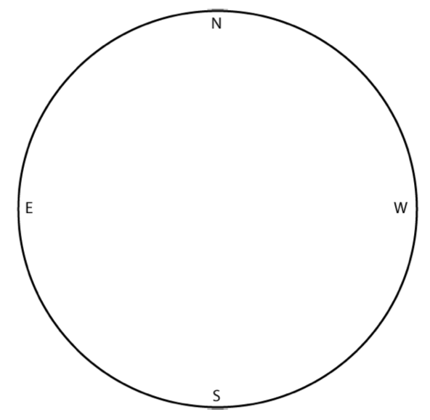

As seen from the northern hemisphere on the summer solstice, the Sun rises in the __________ and sets in the __________.

Now we will look at the location of the Sun at noon on September 21st (the autumnal equinox) or March 21st (the vernal equinox). Note: the Sun is 0 degrees north of the celestial equator (0 degrees declination). Measure the altitude of the Sun above the southern horizon: ___________ degrees.

Now use this to find your latitude. Again, from the northern hemisphere:

Latitude = 90◦+ (declination of Sun)◦− (elevation of Sun from southern horizon)◦

Latitude = 90◦ + 0◦ − ___________ ◦ = ___________ ◦ (N or S?)

I will again show you a full day as Earth rotates. Draw where the Sun rises, the path it takes across the sky, and where it sets.As seen from the northern hemisphere on the summer solstice, the Sun rises in the __________ and sets in the __________.

Finally, I will show you the location of the Sun at noon on December 20th (the winter solstice). Note that the Sun is 23.5 degrees south of the celestial equator (-23.5 degrees declination). Measure the altitude of the sun above the horizon: degrees.

Use this to find your latitude. Again, from the northern hemisphere:

Latitude = 90◦+(declination of Sun)◦− (elevation of Sun from southern horizon)◦

Latitude = 90◦ − 23.5◦ − __________ ◦ = __________ ◦ (N or S?)

Again, you will see a full day, and you should draw where the Sun rises, the path it takes across the sky, and where it sets.As seen from the northern hemisphere on the summer solstice, the Sun rises in the __________ and sets in the __________.

**5. Overarching Conclusions**

Does the Sun ever reach the Zenith from Wyoming?

Toward which cardinal direction can the Sun mostly be seen?

Based on your drawings, what is the longest day of the year?

What’s the shortest day of the year?

If you were to travel to the southern hemisphere, what differences would you notice?