Name: Date:

Spectroscopy

Hazards:
- The power supply used to run the lights is HIGH VOLTAGE. You should not need to change any tubes, but if you do please call the instructor over for assistance, and turn off and unplug the power supply before removing or inserting a discharge tube.
- The discharge tubes can become very hot during use, and are fragile. To extend their life, please keep them on for as short a time as possible (15 seconds suggested), and allow them to cool for a couple minutes between uses.
- You should not need to remove any bulbs from the power supply, but if you do please call the instructor over to assist you, and use a towel or gloves to handle the bulbs.

Objectives
- Distinguish density of a source by identifying blackbody and emission spectra
- Identify chemicals by their emission spectra
- Determine wavelengths and colors of emission spectra
- Understand the methods used by astronomers to identify the properties of objects in space.

Materials

- Diffraction grating
- Grating tube
- Spectrometer
- Incandescent light source
- VariAC
- Fluorescent light source
- Multiple discharge tubes with power supplies

Cross-Discipline Extension Activities
Below are links to various cross-discipline activities that are extensions of this topic.

Biology
Bioluminescence:
http://www.sdnhm.org/archive/exhibits/glow/glow_tguide.pdf
Chemistry
Splint Test:
http://www.flinnsci.com/Documents/demoPDFs/Chemistry/CF4455.pdf
PhET Simulation—Molecules and Light:
http://phet.colorado.edu/en/simulation/molecules-and-light
Physics/Physical Science
Color and Light Spectrum Demonstrations:
http://www.flinnsci.com/media/396342/ps10410.pdf
Earth/Geology/Environmental Science
Mineral Identification:
http://www.mnh.si.edu/education/printable_resources/09-10lessonplanminerals.pdf
Fluorescent Mineral Set:
http://www.teachersource.com/product/fluorescent-mineral-set/ultraviolet
Math
PhET Simulation—Blackbody Spectrum
http://phet.colorado.edu/en/simulation/blackbody-spectrum
Light Attenuation Using Exponential Functions:
http://spacemath.gsfc.nasa.gov/weekly/10Page96.pdf
Engineering
Build a Spectroscope:
http://www.euhou.net/index.php/exercises-mainmenu-13/classroom-experiments-and-activities-mainmenu-186/159-how-to-build-a-spectroscope

Introduction
Astronomers rely on light to convey almost all of the information we have on distant astronomical objects. From light alone we can understand the chemical compositions of distant stars and galaxies, measure distances across the observable universe, and begin to understand our place within the cosmos.

In addition to measuring the overall brightness of a given object we can also measure its spectrum: the brightness at different colors or wavelengths. Both an object’s overall light and its spectrum provide astronomers with greater insight into the characteristics of that object.

Spectra that show certain behavior are the result of specific phenomena. Kirchhoff's Laws help describe these differences:
- A hot solid, liquid, or gas, under high pressure (compact object), gives off a continuous spectrum.
- A hot gas under low pressure (diffuse gas) produces a bright line spectrum, also known as an emission line spectrum.
- A dark line spectrum, also known as an absorption line spectrum, is seen when a source of a continuous spectrum is viewed behind a cooler gas under low pressure.
- The wavelength of the emission or absorption lines depends on what atoms or molecules are found in the object under study.

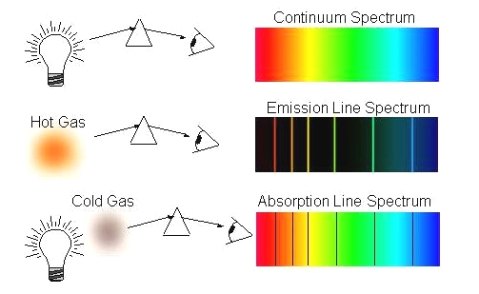
http://zebu.uoregon.edu/~imamura/122/images/kirchhoff's-laws.JPG

Why do specific absorption / emission lines depend on the molecules present in the gas?

It was a mystery until Niels Bohr developed the Bohr model of the atom. In this model, the atom consists of the nucleus in the center, while the electrons orbit around it. A hydrogen atom is the simplest to conceptualize: a single electron orbits a single proton. But as elements get heavier, more electrons are added.

Crucially, Bohr proposed that the electrons are only found in very specific orbits. The difference between orbits corresponds to a difference in energy. The electrons that are farther from the nucleus are in higher energy states than the electrons closer to the nucleus.

If you were to heat an atom, say by shining light on it, an electron might absorb energy so that it would “jump up” to a higher level. But it would only absorb an amount of energy equal to the difference between the two energy levels. If you then looked at the light source, it would be “missing” a specific wavelength equivalent to the energy stolen. This produces a dark line, or absorption spectrum.

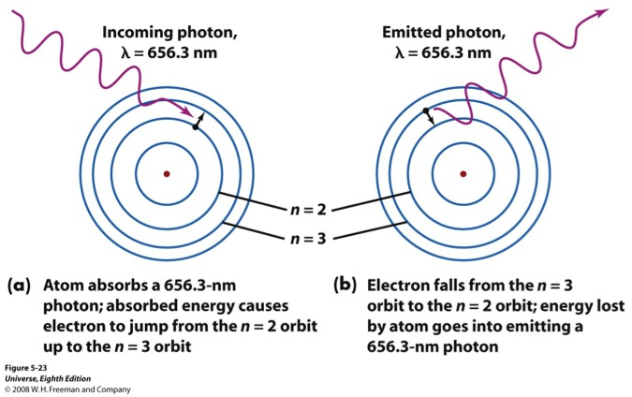
The inverse is also true: electrons in high-energy orbits can lose energy, emitting a particular wavelength of light, and “jump down” to a lower orbit. This produces an emission spectrum.

The wavelength of each absorption or emission line is related to the energy difference between the orbital levels. This in turn is dependent on the type of atom. A hydrogen emission spectrum looks different from a helium emission spectrum. So each atom has a unique spectral signature and astronomers can determine the chemical composition of a distant star or galaxy by comparing its spectrum to known gasses measured in the laboratory.

Procedure
- Use your diffraction grating to examine the light coming from the overhead fluorescent lights in the lab room. Note what you see, and sketch it on the following table with colored pencils.
- You should have an incandescent bulb attached to a variac (variable AC); the instructor will tell you what range of voltages are safe to use. At a low voltage setting, examine the incandescent bulb with your diffraction grating. Note what you see, and sketch it in your table with colored pencils.
- Adjust the variac to a higher voltage, and repeat your observation and sketch.
- Examine the first discharge tube with your diffraction grating. Note what you see, and sketch it in your table with colored pencils.
- If available, examine the same tube using a spectrometer. To use it, point the end with a vertical slit at the tube, and place your eye at the end with a circular or square opening. When you are looking through the proper end of the spectrometer, you will see a “ruler” with wavelengths superimposed on the different colors of the spectrum. Use the spectrometer to record the wavelengths of the 4 brightest lines.
- Use the charts of the spectra of different gases (available in the classroom or online) to determine what type of gas is in the tube.
- Repeat for four more unknown gasses.
- Create a table like the one attached with your observations, calculations, and answers to Question 2. List lines from left to right as you see them through the spectrometer.

Questions
    - Describe the general characteristics of the spectra you see. Were they all the same? What was different between the five different sources?

    - Which type of spectra (emission, absorption, or blackbody continuum) were each of the five light sources you looked at through the grating and/or spectrometer? Put this in your table.
    - Hydrogen (like most gasses) actually has many more lines than just the ones you saw. What are two reasons you might have missed some?

    - Explain your guesses for the different types of gases.

Light Source | Spectrum (color) | λ₁  ( ) | λ₂  ( ) | λ₃  ( ) | λ₄  ( ) | Q2 Spectrum type
Fluorescent
Cool
Incandescent
Hot Incandescent

