Name: Date:

**Measuring Distances — Parallax**

**Objectives**

* Understand the relationship between angular and physical/linear size
* Use angular sizes to measure physical sizes
* Understand the meaning of parallax
* Measure distances using parallax

**Materials**

* Meter sticks
* Tape Measures
* Paper
* Index Cards
* Calculators

**Cross-Discipline Extension Activities**

Below are links to various cross-discipline activities that are extensions of this topic.

|  |
| --- |
| **Biology** |
| Do You See What I See?  https://neuron.illinois.edu/units/do-you-see-what-i-see |
| **Chemistry** |
| Measuring Liquid Volume:  http://www.middleschoolscience.com/rainbowlab-solutions.pdf |
| **Physics/Physical Science** |
| Metric Mania  <http://sciencespot.net/Pages/classmetric.html> |
| **Earth/Geology/Environmental Science** |
| Surveying:  <http://education.usgs.gov/lessons/schoolyard/MapActivity.html>  Other, related resources may be found here:  <http://education.usgs.gov/secondary.html> |
| **Math** |
| The Last Total Solar Eclipse…Ever!  http://spacemath.gsfc.nasa.gov/Algebra1/4Page28.pdf |
| **Engineering** |
| English to Metric Conversions  <http://sciencespot.net/Pages/classmetric.html> |

**Introduction**

Being able to measure distances to astronomical objects is fundamental to astronomy — but how do we do it? For nearby objects, like the Moon, we can bounce laser beams off them to find distances. But what about more-distant stars?

The first step in the “distance ladder” uses geometry and the principle of [*parallax*](http://en.wikipedia.org/wiki/Parallax) — the shift in the apparent position of an object along two different lines of sight, relative to a distant background. In this activity, you will calibrate an angular measuring device, and use it to measure the distance to an object on the other side of town.

**Activity**

**Part 1: Angular Size and Distance**

1. The closer an object is, the larger it appears — that is, the larger its angular size. The relationship between the distance (D), the physical size (L), and apparent angular size (α) of an object is (using the small angle approximation from trigonometry):

α

L

D

Notice that *L* and *D* need to be in the same units. Today we’ll use meters (m), but we could easily use centimeters (cm), astronomical units (AU), or lightyears (ly). To work with more familiar angular units, degrees, we multiply by 57.3 because there are 57.3 degrees in a radian:



Let’s use these relationships to calibrate an angular ruler (in this case a notecard) at your arm’s length. Your objective is to **delineate your index card into 1 degree segments *when you hold the card at arms length.***

* Hold your card at arms length and have a partner measure the distance from your eye to your card. *D* = ______________ cm
* Compute the physical size (*L*) on the card which will cover (subtend) 1 degree at arms length:
* Use a ruler to make small marks across the long side of the card every *L* cm. At arms length these steps correspond to 1 degree in separation.
* If your arm was twice as long, *L* would become: _________ cm
* If instead we wanted marks every 0.25 degrees, *L* would become: ________ cm

2. Using your now-calibrated angular ruler, measure the angular size of the whiteboard at the front of the room, while standing at the back of the room. Make sure to also measure the distance at which you’re measuring the angular size!

*D* = ___________ m

α = ___________ degrees

Using the equations above, calculate the physical, linear height of the chalkboard:

Lcomputed = ___________ m

Now, directly measure the size of the chalkboard with a meter stick or tape measure:

Ldirect = ____________ m

Compare the two measurements by calculating the *percent error:*



What do you think is the largest contribution to the percent error? How can you reduce it?

3. Now that you’ve calibrated your angular ruler, let’s use it to measure the distance to something we can’t directly measure with a ruler/tape measure — just like astronomers do.

First, let’s explore parallax a little. Hold your thumb at arms length, and look at it only using one eye. Now switch eyes. Describe what happens:

Now bend your elbow at a 90 degree angle so that your thumb is only half as far from your eyes. Observe your thumb with one eye closed, and then switch eyes — what is different from when your arm was fully extended?

This apparent “jump,” or angular shift, is due to parallax. Physically it is the same effect that astronomers use to measure distances to relatively nearby stars.

4. Now, imagine your head was so large that the width between your eyes was the diameter of Earth’s orbit around the sun. If you opened and closed one eye, then the other, the nearby stars would “jump” back and forth relative to the more distant stars, like your thumb jumped relative to more distant objects in the room.

The distance between vantage points (the size of the Earth’s orbit in the example above) is called the baseline (*B)*, and the apparent angular shift relative to distant objects is called the parallax angle (*p*): 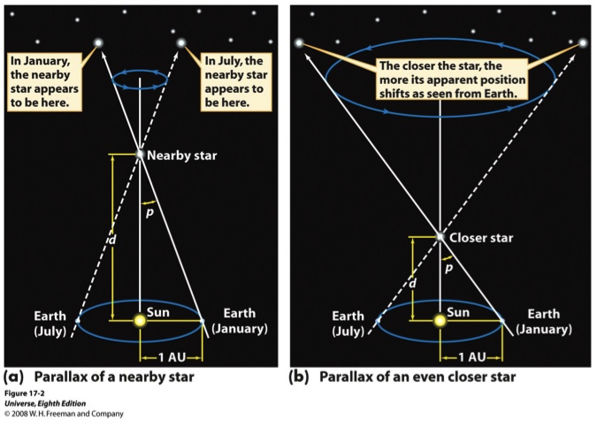

B

D

p

You’ll notice that this is just the inverse of the triangle we used before, but with the linear size now the baseline and the angular size now the parallax angle:

Let’s go outside and make some measurements. We’ll be measuring the distance to

____________________________________________________________________.

* First, establish your baseline. Pick two locations separated by at least 15 m where you have a clear view to the object.

*B* = ______________ m

* Draw a sketch of where your object falls relative to the more distant background from side one of your baseline. The place at which your object overlaps the background is called reference point 1 — remember what it looks like!

View from location 1:

* Now do the same for the other edge of your baseline. Where your object overlaps the background is called reference point 2.

View from location 2:

* From the second viewpoint, use your angular ruler to measure the parallax angle between reference point 1 and reference point 2.

*p* = _______________ degrees

* Compute the distance to the object:



4. Compare your measurement with those of your classmates

Your measurement: _______________ m

Measurement 2: _______________ m

Measurement 3: _______________ m

Measurement 4: _______________ m

Measurement 5: _______________ m

Measurement 6: _______________ m

Measurement 7: _______________ m

Average: _________________ m

* How accurate do you think YOUR measurement is (within 1 m, 10 m, 100m m)?
* Do you think that taking an average of your measurement with several others’ gives a better estimate of the TRUE distance? Why?