Name: Date:

Planetary Geology

Objectives:
- Explore terrestrial planets’ atmospheres and landscapes
- Learn to date relative ages of planetary surfaces

Materials
- Rocks of different sizes, shapes and weights
- A container full of flour and lightly coated in cocoa powder

Cross-Discipline Extension Activities
Below are links to various cross-discipline activities that are extensions of this topic.

Biology
Whose Air is it Anyway?
http://www.acs.org/content/dam/acsorg/education/resources/highschool/chemmatters/chemmatters-october-2003.pdf
Chemistry
Chemistry in the Sunlight:
http://www.acs.org/content/dam/acsorg/education/resources/highschool/chemmatters/chemmatters-october-2003.pdf
Physics/Physical Science
How much would you weigh on another planet?
http://btc.montana.edu/ceres/html/Weight/weight1.htm
Earth/Geology/Environmental Science
PhET Simulations—Plate Tectonics:
http://phet.colorado.edu/en/simulation/plate-tectonics
Math
Cloud Cover, Albedo, Transmission, and Opacity:
http://spacemath.gsfc.nasa.gov/weekly/83Clouds7.pdf
Curiosity Uses X-Ray Diffraction to Identify Minerals:
http://spacemath.gsfc.nasa.gov/news/9Page24.pdf
Engineering
Build and Earthquake-proof home:
http://sciencespot.net/Pages/classearth.html

Introduction
The relationships between a world’s size, internal heat, geologic activity, and amount of cratering are powerful tools for understanding the terrestrial planets and moons. In this lab we explore terrestrial planets’ atmospheres, temperatures, landscapes and relative ages of planetary surfaces.

Planet a P V D Mass Density Temp Albedo Pressure Atmospheric Composition (AU) (km/s) (km) (M_{Earth}) (g/cm³) (K) (atm)
Mercury 0.387 88d 47.5 4854 0.056 5.4 452 0.12 Trace Trace H₂, He

Venus 0.723 224.7d 35.0 12,112 0.82 5.2 726 0.59 90 CO₂(.96) N₂(.03) H₂O(.00003)

Earth 1.000 365.25d 29.8 12,751 1.00 5.5 281 0.39 1 N₂(.78) O₂(.21) Ar(.01)

Mars 1.524 687d 24.1 6788 0.108 3.9 230 0.15 0.007 CO₂(.95) N₂(.03) Ar(.016)

Jupiter 5.203 11.86yr 13.1 143,000 317.87 1.3 120 0.44 10 at 100km H₂(.9) He(.1) CH₄(.0007)

Saturn 9.539 29.46yr 9.6 121,000 95.14 0.7 88 0.46 20 at 200km H₂(.97) He(.03) CH₄(.005)

Uranus 19.18 84yr 6.8 47,000 14.56 1.2 59 0.56 H₂(.83) He(.15) CH₄(.02)

Neptune 30.06 165yr 5.3 46,529 17.21 1.7 48 0.51 H₂(.74) He(.25) CH₄(.01)

1. Atmospheres and Temperatures of the Terrestrial Planets
Study the atmospheric compositions of the inner planets given above (provided by http://pds.jpl.nasa.gov/planets/). Based on the compositions of the atmospheres of Earth’s nearest neighbors, what would you expect Earth’s atmosphere to consist of?

How and why does it differ from the expected pattern?

2. Speculate why Mercury lacks an atmosphere and Mars has only a thin one (atmospheric pressure on Mars is only about 0.5% that on Earth’s surface). Hint: How do Mercury and Mars differ physically from Venus and Earth?

3. Study the surface temperatures for the terrestrial planets.
- Which planet seems unusually hot for its distance from the Sun?

- How does the weight (pressure) of its atmosphere compare with Earth’s?

- What is the name for a gas that traps heat close to a planet’s surface by transmitting incoming sunlight but blocking heat reflected back from the surface?

2. Landscapes of Rocky Planets
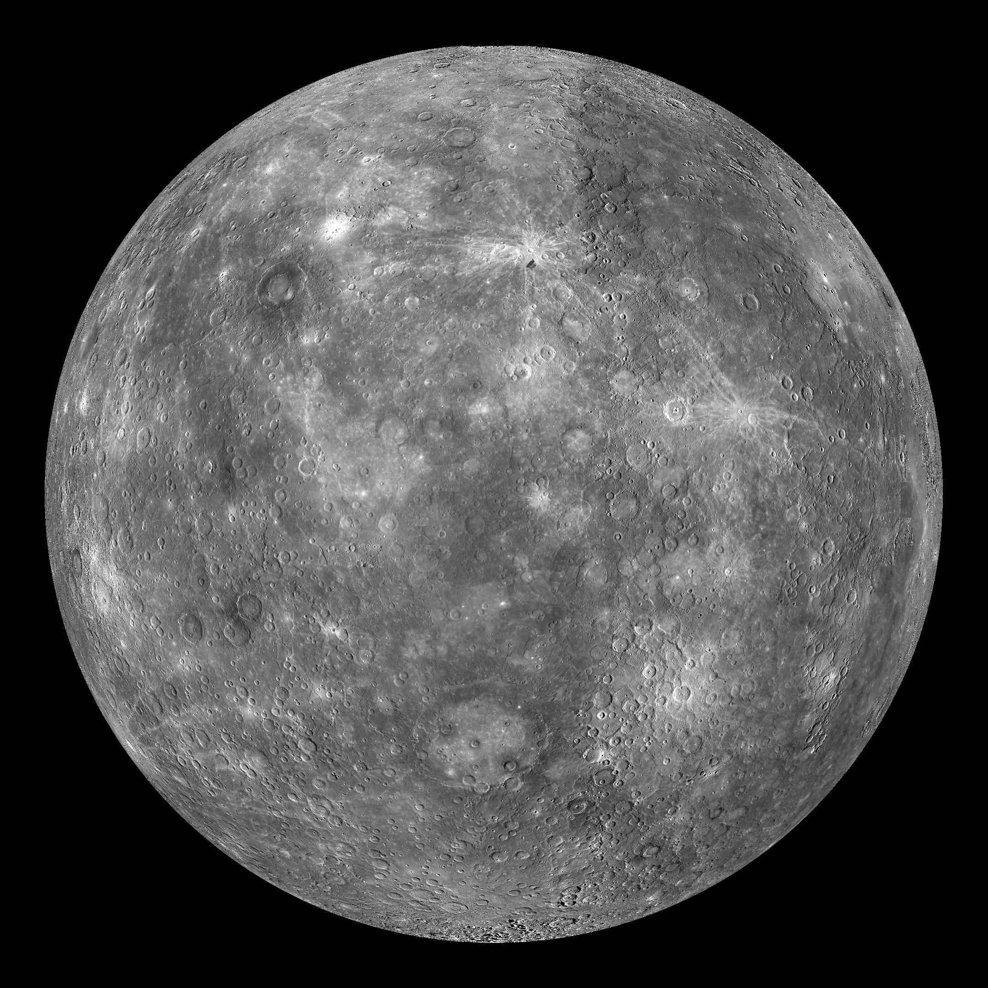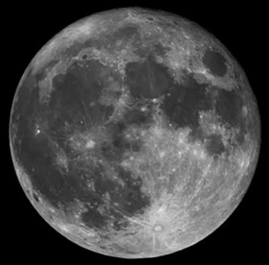
Mercury The Moon

4. Look at the NASA images of Mercury (left) and Earth’s Moon (right). Describe the surface feature that is prominent on both.

5. The light areas on the Moon are called the highlands. The darker landscape is known as the lowlands or maria. Which type of landscape is probably older? Explain your reasoning.

6. If the surfaces of Mercury and the Moon are covered with impact craters, why are such craters not conspicuous on Earth? Propose at least 3 possible explanations.

3. Impact Cratering
(For more visit http://www.nasa.gov/pdf/180572main_ETM.Impact.Craters.pdf)
The scientific method relies heavily on the use of models to make sense of the world around us. After making observations, a model can be used to synthesize the data, construct a hypothesis and finally to make predictions. Models can take many different forms — structures smaller or larger than the original, conceptual analogies, mathematical equations, or computer simulations — but all serve similar purposes to help us conceptualize and understand a phenomenon otherwise difficult to grasp.
Get into groups of three or four. Head outside and grab a few rocks. Try to find rocks of different sizes, shapes and weights. At the front of the classroom you’ll find the materials necessary to fill a container with flour. Once this is done, lightly coat the top in cocoa powder. This simulates the surface of a planet, whereas the rock simulates a meteoroid.
Attempt to recreate some of the lunar impact craters imaged below by NASA. Be creative!
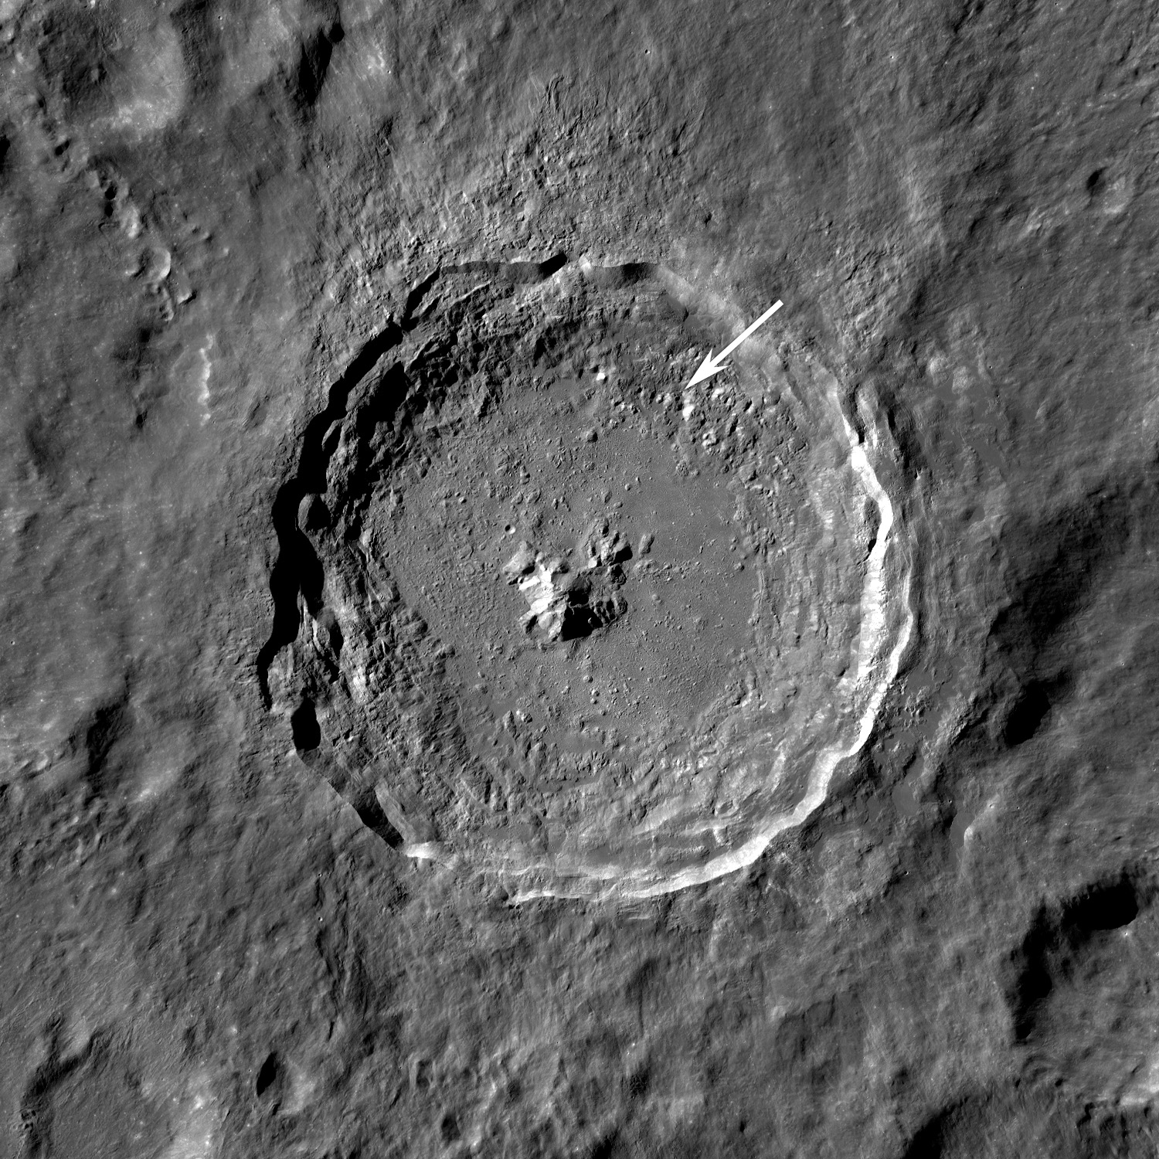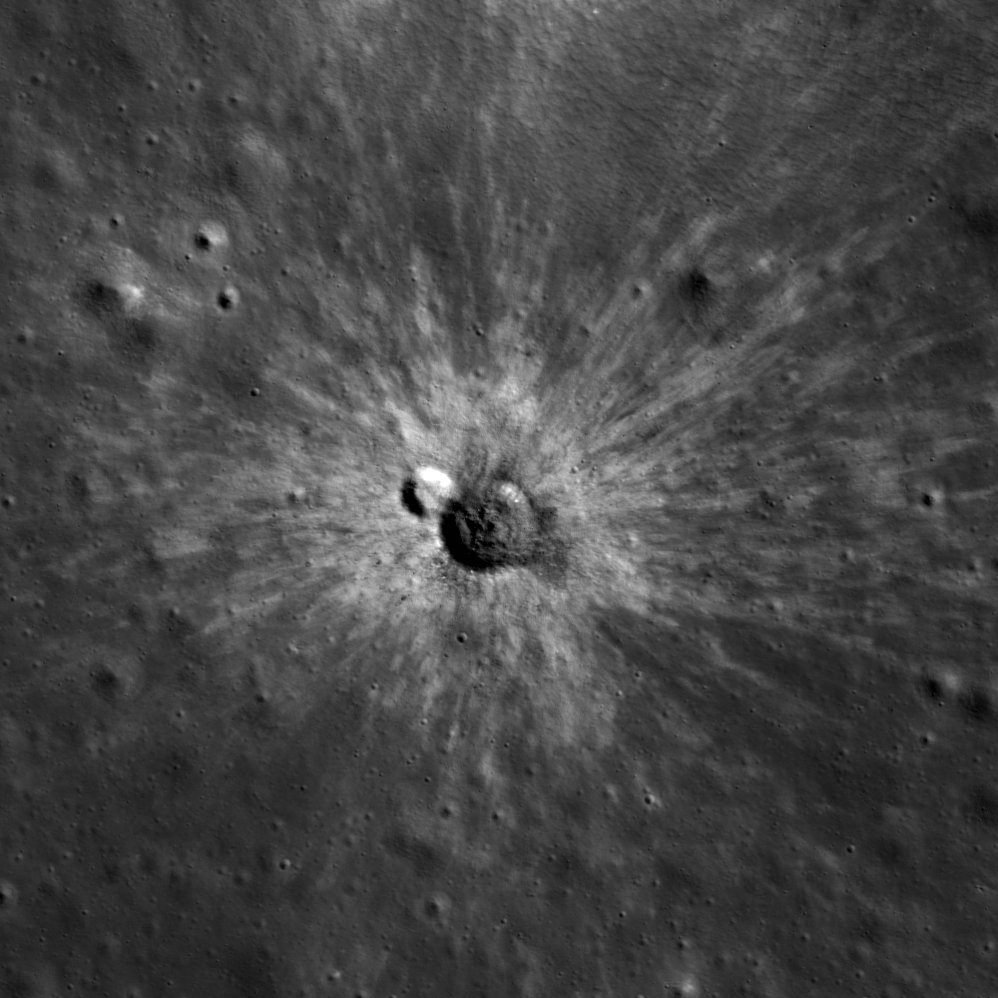
7. Write down your observations.

8. What changes when the rock hits the surface at a different velocity? What if it hits the surface at an angle? Feel free to use sketches.

9. The impact crater on the left is the infamous Tycho crater. Its ray system is so widespread that Apollo astronauts sampled its ejecta over 2000 km away from the impact crater! Recreate the crater. Measure the size of the crater and extending rays. Now assume the actual diameter of the crater is 85 km, how far do the actual rays reach?

4. Relative Ages of Planetary Surfaces
When one does not have radiogenic ages available for rocks (for example from planets where we just have images of the surface), the following three rules can be used to judge the relative age of surfaces. (The rules are often grouped together under the general name of “superposition”.)
• Law of superposition: Material deposited on top is generally younger. (Exceptions come from intrusion, tectonic overrun, etc.)
• Principle of cross-cutting relationships: A feature which cross-cuts another is younger than the rock in which it lies.
• Principle of inclusion (of younger material in older): Newer material included in or bounded by other material must be younger, for example sediments bounded in a basin are younger than the basin itself, or lava filling a crater must be younger than the crater.

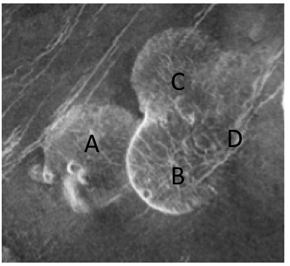
10. Venus ages through superposition: Examine the image of the Alpha Regio area on Venus, which shows several dome-shaped hills thought to represent mounds of lava. Use the principles listed above to try to find the relative ages of domes A, B, C and fracture D. Explain your reasoning and note all cases in which the relative ages of any two features cannot be resolved.

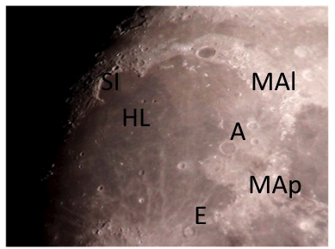
11. Lunar ages through superposition: Using the image of the large and relatively young Mare Imbrium, find the relative age (from oldest to youngest) of the following features, using principles of superposition. Explain briefly how you decided the relative age of the various features. If there are features whose relative age you can’t specify, state that.
Remember the important distinction between the age of a crater or basin, and the age of the basalt flows, which may later fill it.
(a) The two small craters marked “HL”
(b) The moderate size crater Archimedes, just to the lower left of “A”
(c) The crater Eratosthenes “E”
(d) The moderately large crater “Sinus Iridum, SI”
(e) The large Imbrium Basin (i.e. the Imbrium crater itself), whose rim forms the Montes Alpes (“MAl”) and Montes Appeninus (“MAp”)
(f) The Mare Imbrium basalt lava flows

