Study Field Background Info
For Undergraduate
Physics Majors and Minors

1. Who studies physics and how prepared are they?

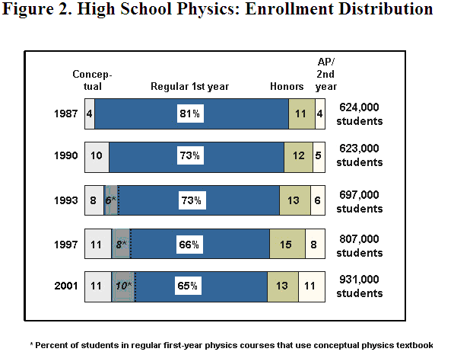
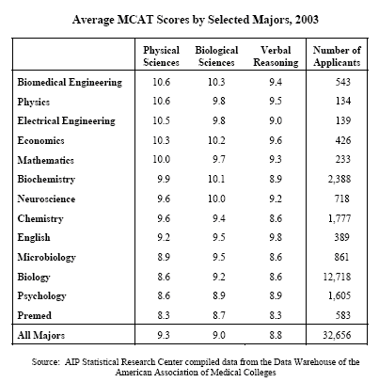
MCAT is a medical school entry exam. The performance of
Physics Majors in these exams tells something about how
prepared physicists are compared to their university peers.
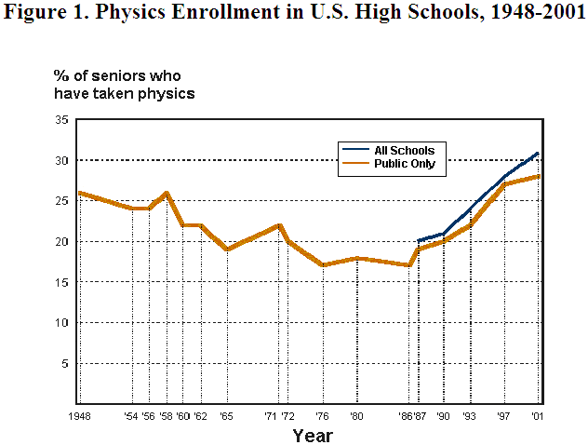

Finally, sometimes one learns fastest from the mistakes other people have already made. Here is an interesting paper on what people have done wrong in studying Physics:
http://arxiv.org/ftp/physics/papers/0605/0605152.pdf
“Five Frequently Fatal Freshmen Physics Fantasies”
The authors warn against the following: •Fantasy of the miracle finish

•Fantasy of the soft hearted professor

•Fantasy that college is a simple extension of high school

•Fantasy that weak areas won’t be tested

•Fantasy that passing is more important than learning

2. What do people do with a bachelor degree in physics?

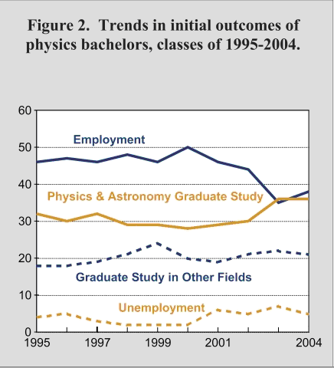

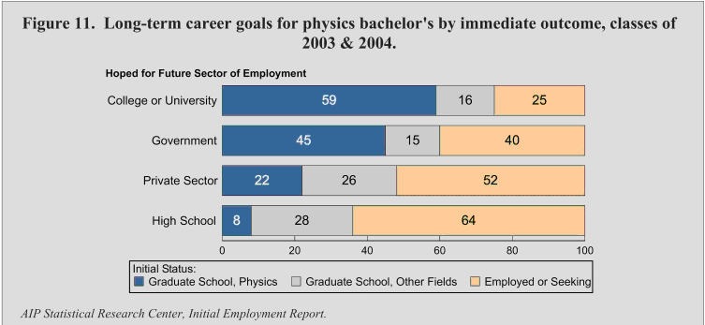
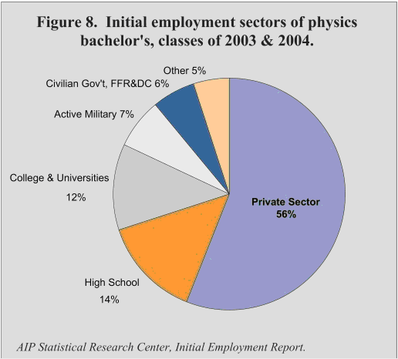

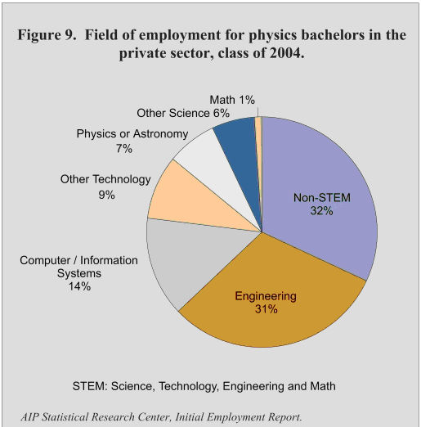

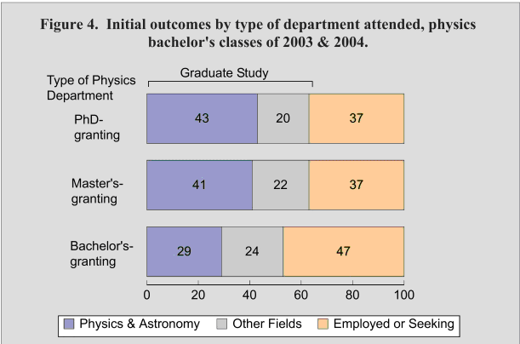
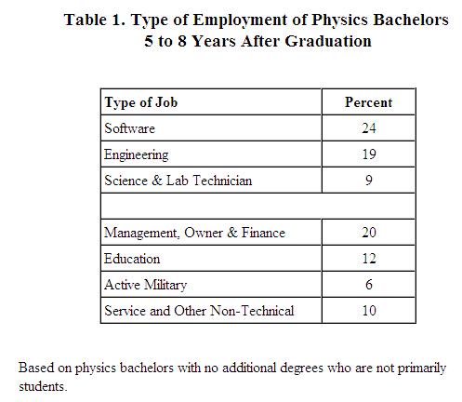
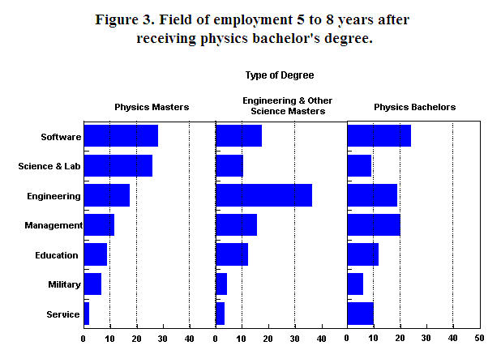
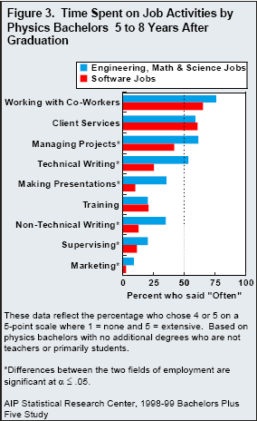
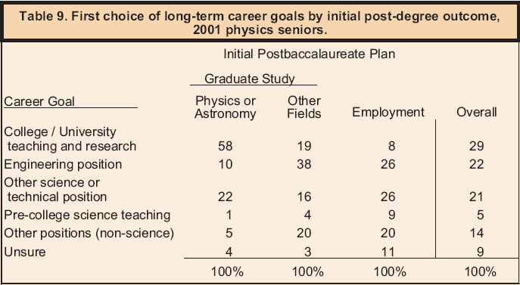
Employers that Hired Multiple

Physics Bachelors

Boeing

Constellation Energy Group

Department of Defense (DoD)

Epic Systems Corporation

General Dynamics

Honeywell

IBM

Intel

Jet Propulsion Laboratory

Lawrence Berkeley National Lab (LBL)

Lockheed Martin

Los Alamos National Laboratory (LANL)

Massachusetts General

Microsoft

MIT Lincoln Laboratory

MITRE Corporation

NASA Glenn Research Center

National Institute of Standards & Technology (NIST)

National Institutes of Health (NIH)

Northrop Grumman

Raytheon

SAIC (Science Applications International Corp.)

Schlumberger

United Space Alliance

US Patent and Trademark Office

Veritas DGC, Inc.
Employers in Colorado that Recently Hired

New Physics Bachelor Recipients

________________________________________________________________

Atmel

Ball Aerospace and Technologies Corp.

Boeing

Center Partners

Centrifuge Solutions

Colorado Division of Wildlife

ColorLink

Dentsply Friadent Cera Med

EchoStar

Fairfield Industries

Kleinfelder

Lockheed Martin

McVehil-Monnett

National Renewable Energy Laboratory (NREL)

Northrop Grumman

Quantum Corporation

Questa Engineering

Raytheon

Refmacal Labs

Research Electro-Optics, Inc.

Southwest Research Institute

Spartan

Terma Software Labs

Websciences International
3. What do physics bachelors earn after graduation?

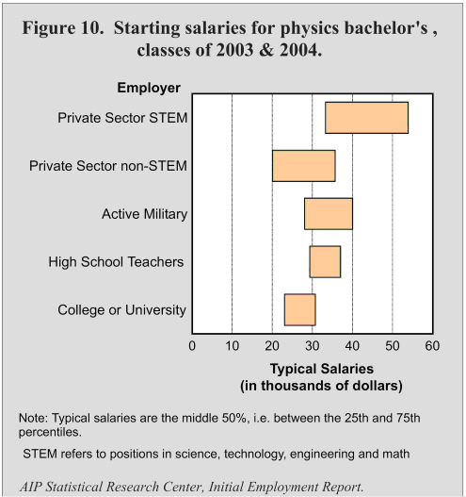

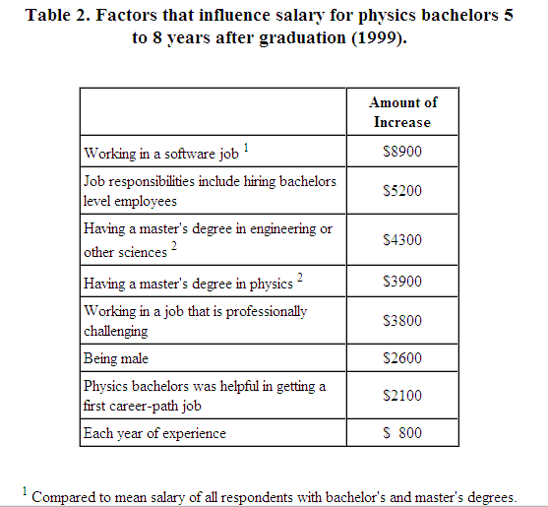

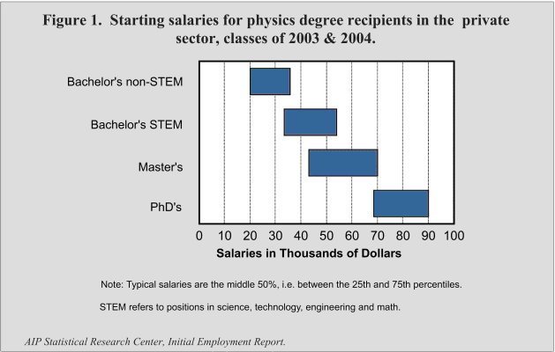

Starting salaries by field:

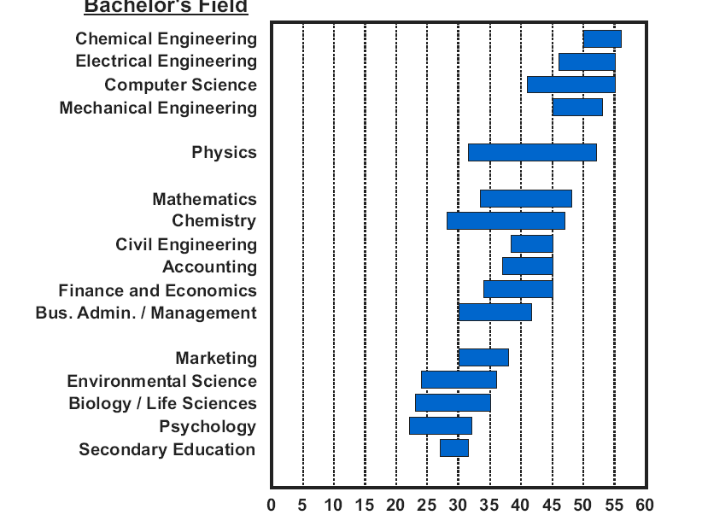
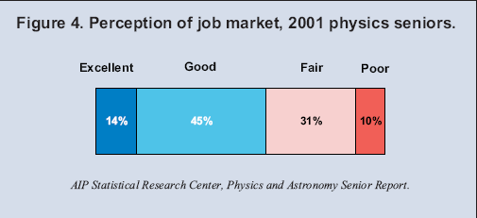

4. What do physics bachelors think about their education?

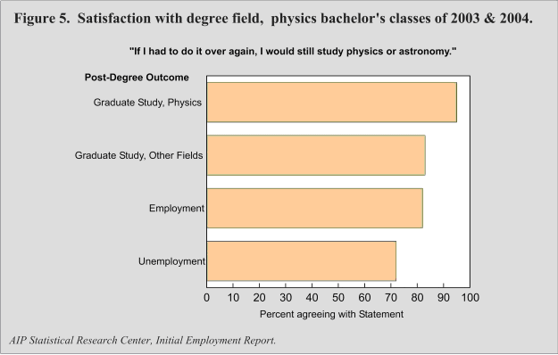
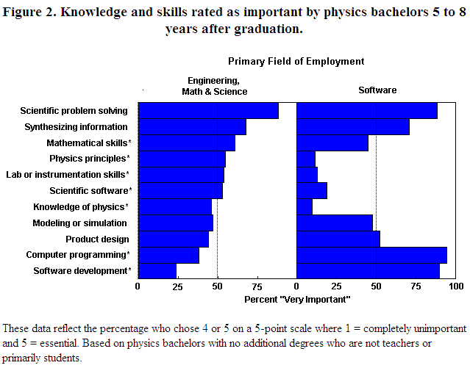
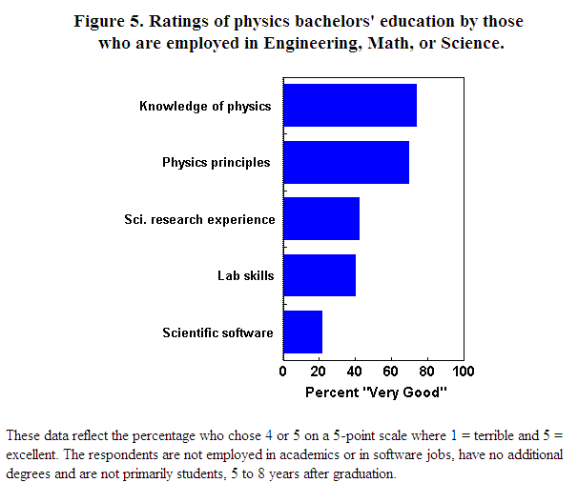
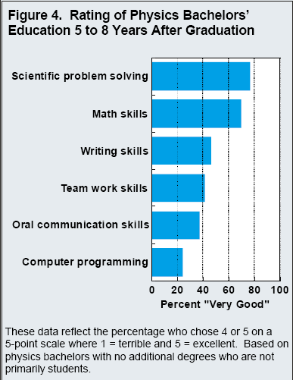

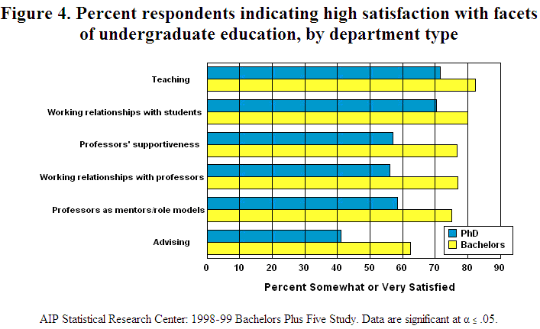

5. How do minorities do in physics?

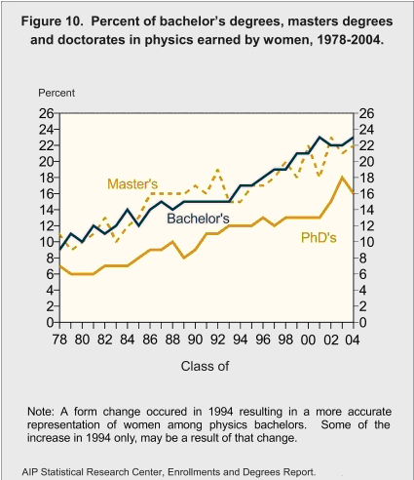

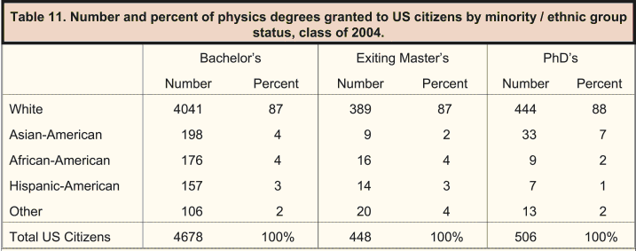
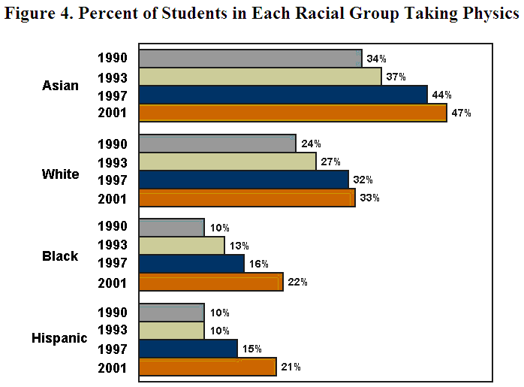
6. How do physics bachelors go on academically?

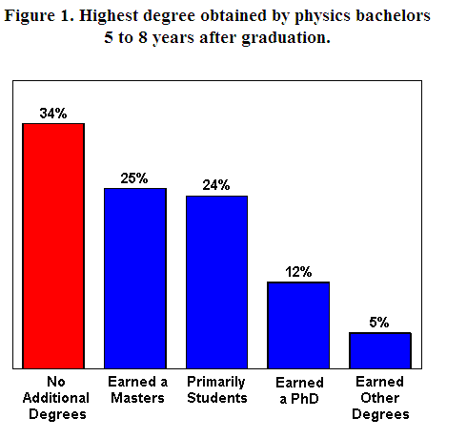

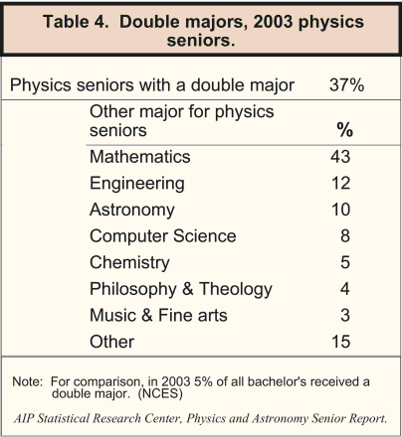

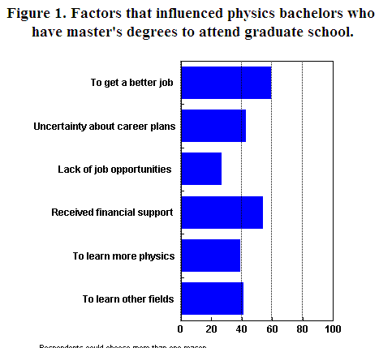

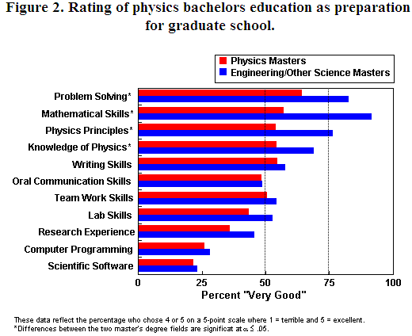
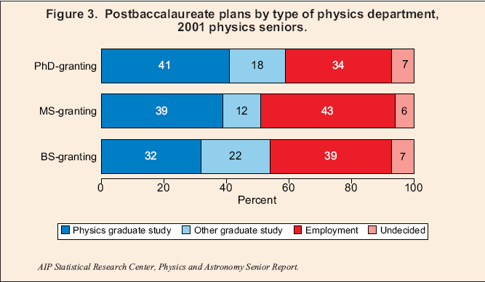

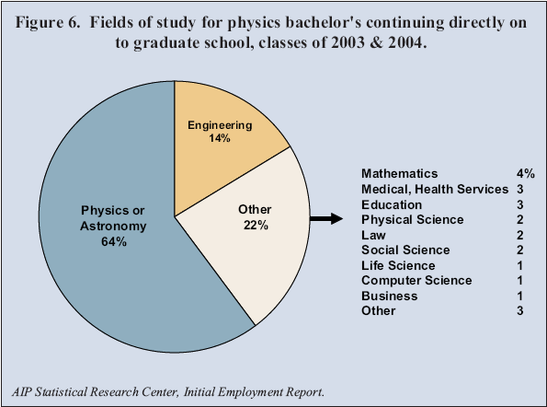

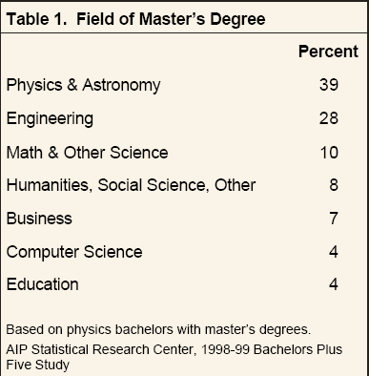

7. How do physics bachelors choose their university and what matters to them about school?

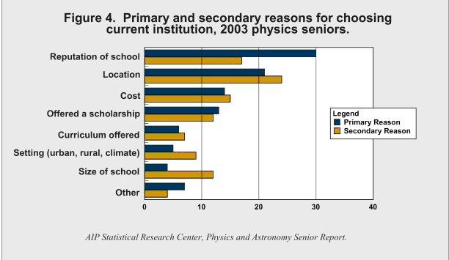

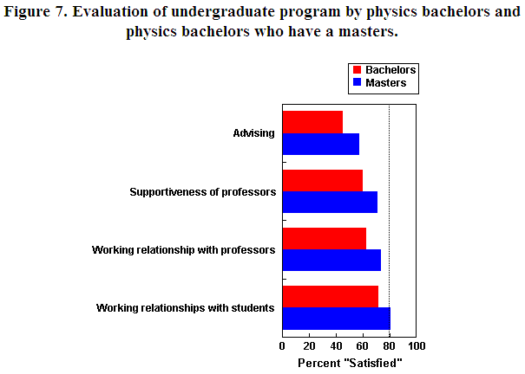
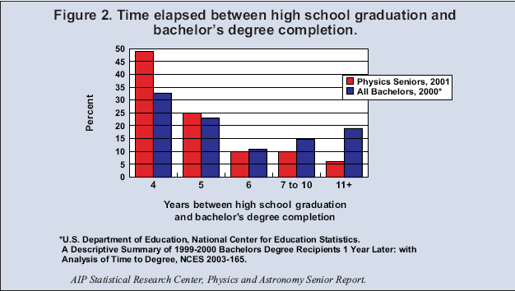

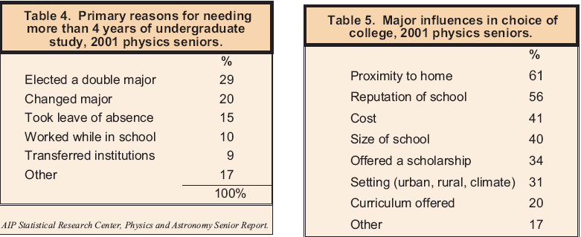
8. How does physics compare to other fields?



