Chaos

EQUIPMENT

 | INCLUDED:
1 | Large Rod Stand | ME-8735
2 | 120 cm Long Steel Rod (2) | ME-8741
1 | 45 cm Long Steel Rod | ME-8736
2 | Multi Clamps (2) | SE-9442
1 | Chaos/Driven Harmonic Accessory | CI-6689A
1 | Mechanical Oscillator/Driver | ME-8750
1 | DC Power Supply | SE-9720
1 | Rotary Motion Sensor | CI-6538
1 | Photogate Head | ME-9498A
NOT INCLUDED, BUT REQUIRED:
1 | ScienceWorkshop 750 Interface | CI-7650
1 | DataStudio Software | CI-6870

INTRODUCTION

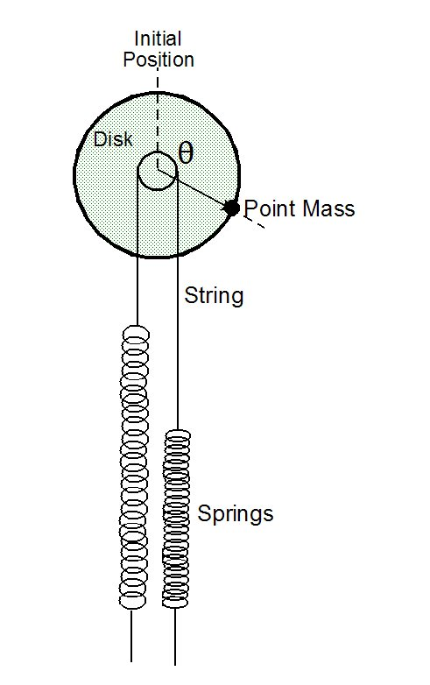
The chaotic behavior of driven nonlinear pendulum is explored by graphing its motion in phase space and by making a Poincare plot. These plots are compared to the motion of the pendulum when it is not chaotic.

The oscillator consists of an aluminum disk connected to two springs. A point mass on the edge of the aluminum disk makes the oscillator nonlinear. The frequency of the sinusoidal driver can be varied to investigate the progression from predictable motion to chaotic motion. Magnetic damping can be also be adjusted to change the character of the chaotic motion. The angular position and velocity of the disk are recorded as a function of time using a Rotary Motion Sensor. A real-time phase plot is made by graphing the angular velocity versus the displacement angle of the oscillation.

The Poincare plot is also graphed in real time, superimposed on the phase plot. This is achieved by recording the point on the phase plot once every cycle of the driver arm as the driver arm blocks a photogate.

Figure 1: Pendulum and Springs
THEORY

The oscillator consists of an aluminum disk connected to two springs. A point mass on the edge of the aluminum disk makes the oscillator nonlinear. This nonlinearity is required to cause chaotic motion. Also, the disk is magnetically damped.

Several quantities can be varied to cause regular motion to become chaotic. These variables are the driving frequency, driving amplitude, damping amplitude, and the initial conditions.

There are three different ways of plotting oscillations:

1. Angular Displacement (Θ) vs. time

2. Phase Space: Angular Velocity (ω) vs. Angular Displacement (Θ)

3. Poincare Plot: Angular Velocity (ω) vs. Angular Displacement (Θ) plotted only once per period of the driving force.

The phase space and the Poincare plot are particularly useful for recognizing chaotic oscillations. When the motion is chaotic, the graphs do not repeat.

Potential Well

This pendulum has two equilibrium points, one on each side where the torque caused by the weight of the point mass is balanced by the torque from the springs. To map the potential energy, U, versus the angle, Θ, that the pendulum point mass is displaced from vertical, the magnetic damping and the driving force are removed and the pendulum is displaced from vertical and allowed to oscillate freely. The angular velocity is measured, and thus the kinetic energy (K) can be calculated. Then the potential energy is derived from conservation of energy:

Since the pendulum starts from rest at maximum displacement, K_{i} = 0, and
Since U_{i} = constant = c,
Therefore, the shape of the potential energy well can be found by plotting the negative of the square of the angular speed (-ω²) versus the angular displacement (Θ).

SET UP

1. Mount the driver on a rod base and attach a photogate to the driver as shown in Figure 2.
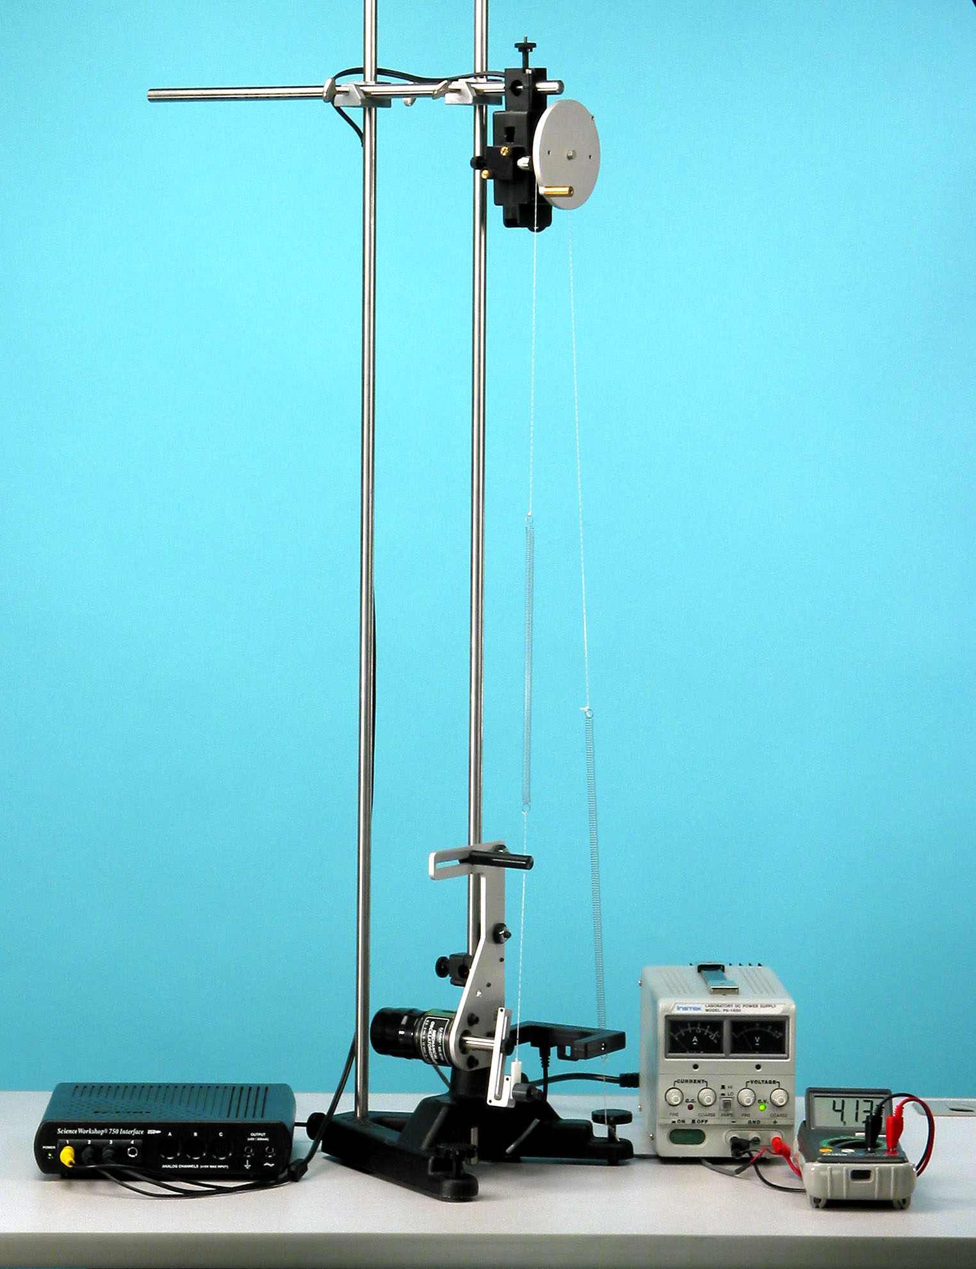
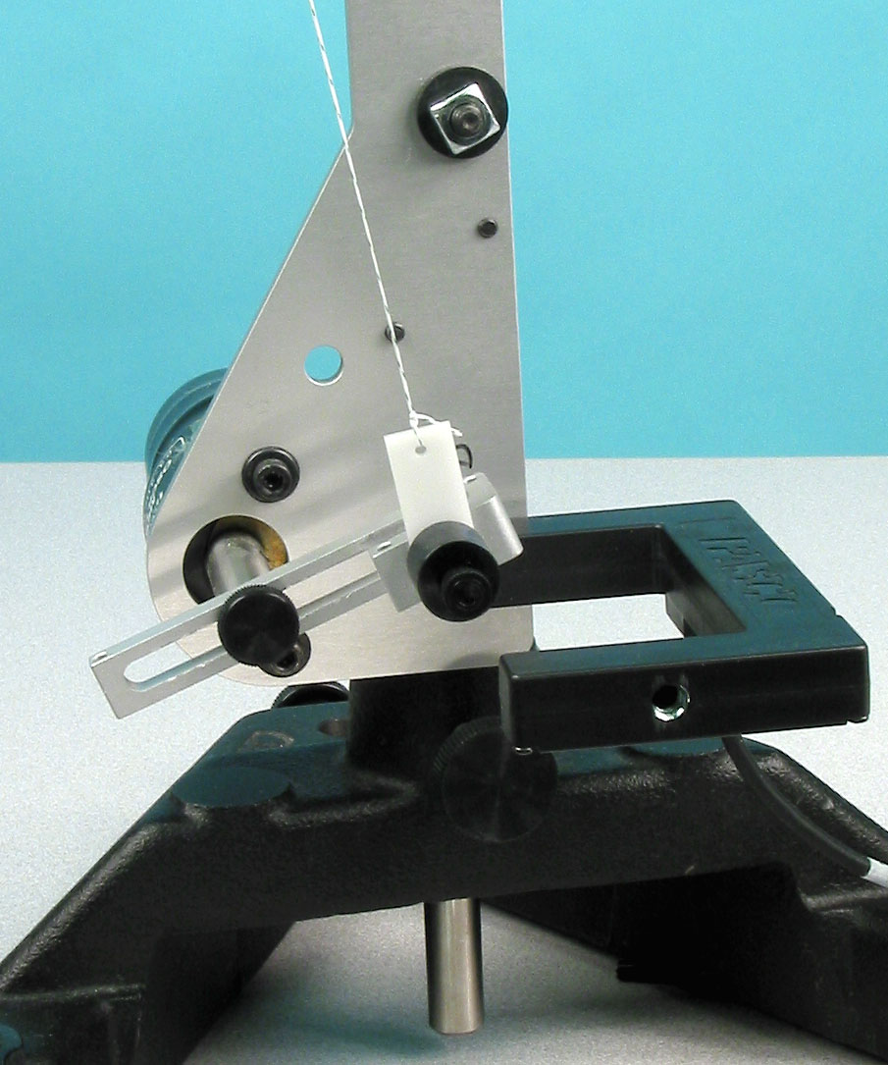

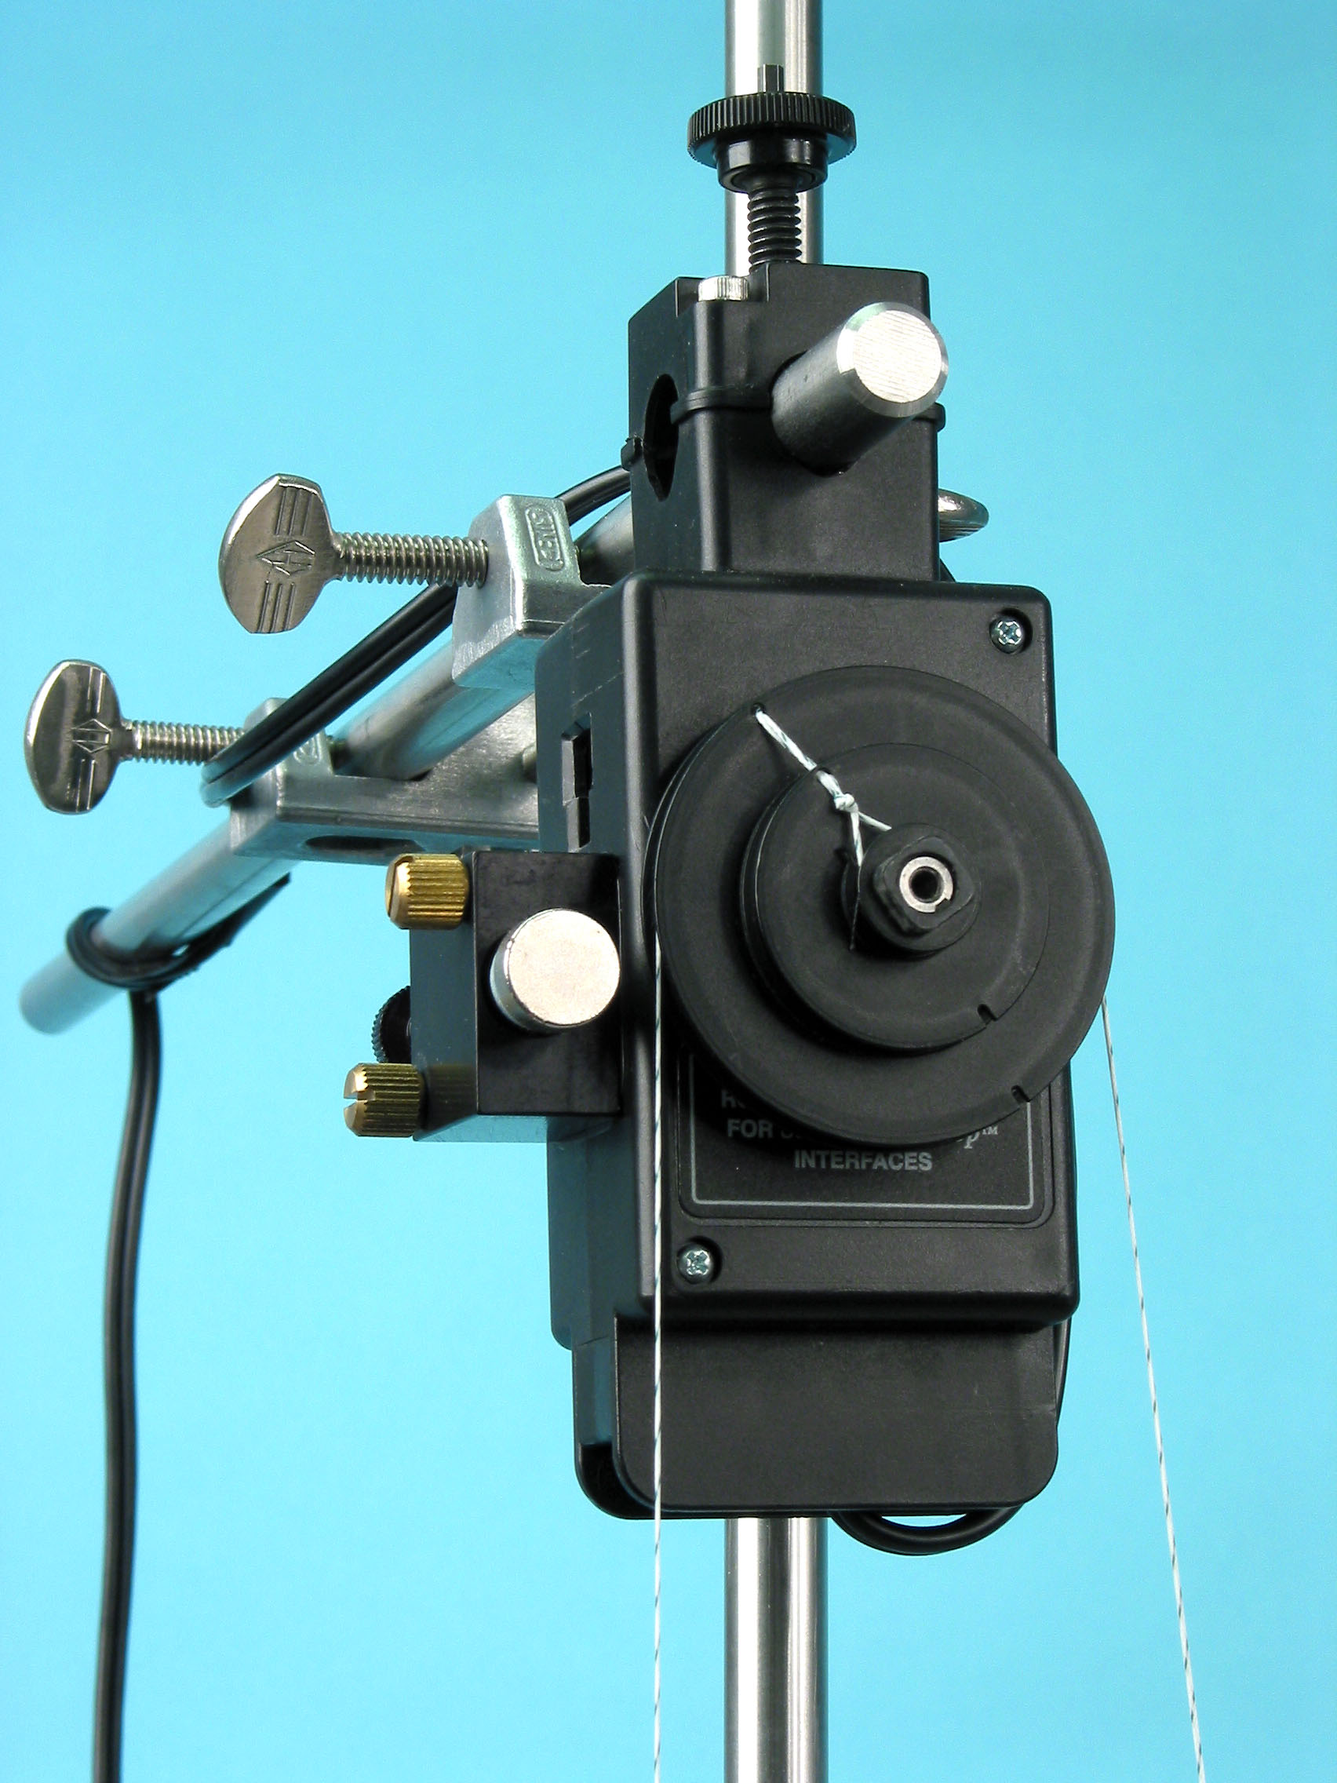
Figure 2: Driver Photogate

Figure 3: Complete Setup
Figure 4: Tying the String

2. Use two vertical rods connected by a cross rod at the top for greater stability. See
Figure 3.

3. Mount the Rotary Motion Sensor on the cross rod.

4. Cut a string to a length of about 1.5 m. Tie the center of the string around the smallest step of the Rotary Motion Sensor pulley. See Figure 4. Thread both ends of the string through the side hole on the largest step of the pulley. Wrap each end of the string once around the largest step of the pulley.

5. On the driver, rotate the driver arm until it is vertically downward. Attach a string to the driver arm and thread the string through the string guide at the top end of the driver. Tie one end of one of the springs to the end of this string. Tie the end of the spring close to the driver string guide.

6. Tie a section of string (about 10 centimeters long) to the leveling screw on the base. Tie one end of the second spring to this string.

7. To complete the setup of the springs, hold the pendulum disk in place with the point mass at the top. Then thread each of the strings from the pulley through the ends of the springs and tie them off with about equal tension is each side: The point mass should be pulled almost equally by each spring. The disk must be able to rotate one revolution in either direction without the end of either spring hitting the pulley. Also neither spring should completely close.
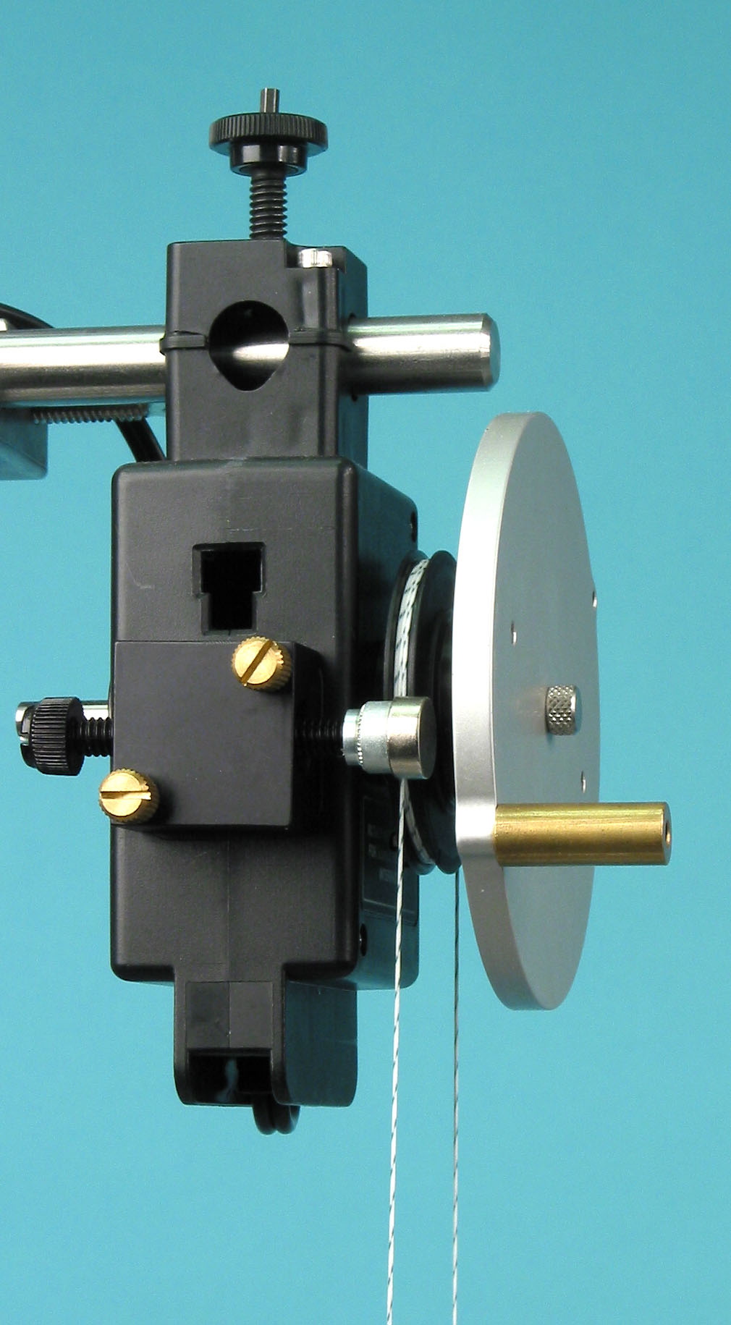
8. Attach the magnetic drag accessory to the side of the Rotary Motion Sensor as shown in Figure 5.

9. Plug the driver into the DC power supply and attach the digital voltmeter across the power supply.

10. Plug the Rotary Motion Sensor into Channels 1 and 2 on the ScienceWorkshop 750 interface. Plug the photogate into Channel 3 on the interface.

11. Open the DataStudio file called "Chaos".

PROCEDURE

Part I: Mapping the Potential Well

1. Leave the driver power supply turned off. Screw the magnet screw all the way back away from the disk to reduce the drag. Displace the point mass to one side Figure 5: Magnetic Drag far enough that the disk will oscillate all the way over
to the other side when it is released.

2. Click on START in DataStudio and release the pendulum and let it oscillate once. Then click on STOP.

3. Examine the resulting plot of potential energy versus angle. Observe that there is a double well because there are two equilibrium points. Are the wells equally deep? Why or why not?

Part II: Resonant Frequency

1. Screw the magnet toward the disk until it is about 3 mm from the disk. Without turning on the power supply that powers the driver, allow the point mass to fall into the equilibrium position on either side of the pendulum. Click on START and displace the pendulum from equilibrium and let it oscillate for a few oscillations. Click on STOP.

2. Examine the angle vs. time graph. Are the oscillations sinusoidal? Are they damped?

3. Examine the phase plot (angular speed vs. angle). What shape is it? How is affected by the amount of damping? What would it look like if there weren't any damping?

4. Measure the period of the oscillation using the Smart Tool at the top of the angle vs. time graph.

Part III: Non-chaotic Oscillations

NOTE ABOUT INITIAL CONDITIONS: For the rest of the experiment, hold the point mass end at the top and then let go when the driver arm is at its lowest point.

1. Set the driver arm for an amplitude of about 3.3 cm. Make sure the driver arm only breaks the photogate beam once per revolution. Adjust the magnet distance to about 4 mm from the disk. Turn on the power supply and adjust the voltage to about 4.5 V so the oscillation is simply one back-and-forth motion.

2. Click on START and record data for a few minutes.

3. Examine the graph of angle vs. time. Is it sinusoidal? What is the period? Is the period the same as the driving period? Why is this graph different from the graph in Part II?

4. Examine the graph of angular velocity vs. angle (the phase diagram). Why does it look the way it does? How is it different from the phase diagram in Part II?

5. Examine the Poincare plot. Why does it look the way it does? How does this plot indicate that this oscillation is regular?

Superimposing Poincare Plot on Phase Diagram:
To superimpose the Poincare plot on the phase diagram, open the Graph Settings window on the phase graph. Verify under "Appearance" that Full Color is not selected. On "Layout" click on Create New Graph and Group by Unit of Measure. Click and drag the v vs. x data onto the phase graph. Then select the v vs. x data on the graph and choose to plot data points but no connecting line. The phase data should appear in gray and should have connecting lines on. The v vs. x data should be in color and superimposed on the phase data. To return to the original configuration, you can reverse the steps taken above, or simply re-open the original file after saving your data.

6. Gradually increase the driving frequency by increasing the voltage on power supply. Give the pendulum time to respond to the change in driving frequency. Increase the frequency until the motion of the pendulum is slightly more complicated: It should not simply have one back-and-forth movement but rather it should oscillate back-and-forth with an extra back-and-forth movement on one side. Re-start the oscillation, holding the point mass end at the top and letting go when the driver arm is at its lowest point.

7. Click on START and record data for a few minutes.

8. Examine the graph of angle vs. time. Is it sinusoidal? What is the period? Is the period the same as the driving period? How is it different than the previous oscillation?

9. Examine the graph of angular velocity vs. angle (the phase diagram). Why does it look the way it does? Compare it to the previous phase diagram.

10. Examine the Poincare plot. Why does it look the way it does? How does this plot indicate that this oscillation is regular?

Part IV: Chaotic Oscillations

1. Continue to gradually increase the driving frequency to the resonant frequency by increasing the voltage on power supply. To make the motion of the pendulum very complicated, you may have to adjust the distance of the magnet from the disk. The pendulum should pause suddenly at various points in its motion and spend random times on each side of the oscillation. Re-start the oscillation, holding the point mass end at the top and letting go when the driver arm is at its lowest point.

2. Click on START and record data for an hour.

3. Examine the graph of angle vs. time. Is it sinusoidal? What is the period? Is the period the same as the driving period?

4. Examine the graph of angular velocity vs. angle (the phase diagram). Why does it look the way it does?

5. Examine the Poincare plot. Why does it look the way it does? How does this plot indicate that this oscillation is chaotic?

Further Studies

The driving frequency was varied to change the oscillation from regular to chaotic. Try adjusting the magnetic damping while holding the driving frequency at the frequency that gave chaos before.

Then try holding the damping and driving frequency constant while varying the driving amplitude.

Check the effect of initial position on the oscillations.

