Standards

The standard grading rules:

• There are three levels of standards one can achieve: Basic, Advanced, and Proficient
• The levels are related to learning outcomes according to Bloom’s Taxonomy (see appendix).
Basic Standard = Bloom 1/2 - Memorization and Understanding
Advanced Standard = Bloom 2/3 - Application and Analysis
Proficiency Standard = Bloom 3/4 - Synthesis/Evaluation/Innovation

Where and how to earn Standards

To obtain the final grade for standards you will need to accomplish certain landmarks in four areas, called categories. Some of these can be assessed during lab (in prelab or inlab), during midterm or final exam, others in lecture and seminar, and finally in report writing.

The four categories are called: experiment, report, math & theory, and COM3 skills.

In order to fulfill a standard (at any of the three levels) in any category you need to fulfill the standard in certain of the category’s sub-categories first. You will get access to our master chart for standards that allow you to trace your progress and current standing and see where you have earned a standard. A color coding informs you about standards earned per sub-category in the most recent assignments.

Here are the sub-categories for each category: (currently under further review)

• experiment: Safety,
Basic Lab Skills and Mastery of Advanced Apparatus,
Random Error and Systematic Error,
Data Decision Making
4 sub-categories

• report: Writing Metrics,
Paragraph Design and Chapter Integration,
Report Chapter Content (including lab book),
Bibliography, Research, and Deadlines
4 sub-categories

• math & theory: Preparation,
Math and distributions,
Theory and models,
Data fitting and Derivations
4 sub-categories

• COM3 skills: IT usage and Jargon,
Peer Group and Professional Standards
Presentation,
Audience and Confidence/Delivery
4 sub-categories

Some of the sub-categories are self-explanatory, on others we will comment further as we reach the assessment stage. Our actual list of standards is longer than the sixteen subcategories and is fully visible on the google sheets page where the standard record is kept. Rules are further explained on that page. An input of “1” means basic standard, “2” means advanced standard and “3” stands for proficient standard. Note, that only the category standards are turned into grades.

2021 standard sheets tbd

Further Standard rules

• Before you fulfill a higher level standard you have to fulfill the respective lower level standards in each sub-category.

• In a given subcategory you can only earn one Bloom’s level per day.

• If you fail a standard sub-category you can retake it as often as there is time for, but not on the same day (with the exception of the final exam when you can retake any standard as often as needed and time permitting).

• Some standards you will fill implicitly and we will inform you at the end of the day or the next day by updating the standard sheet for the day or when a lab report is returned. They will often show up in Google Sheets as miscellaneous.

• We may also explain on certain occasions why you may have not passed a standard to guide you toward best practices.

• The lab TAs can award basic standards. Advanced and Proficiency standards are only awarded by the instructor.

• As term progresses, students may want to be proactive, for example, they can state at the beginning of a prelab ‘I am going for a standard in systematic error and data fitting’.

The roster of achieved standards is anonymous. You can see where all the other students stand relative to you, but you won’t know who they are. If you tell any peer who you are on the anonymous roster you are in effect giving up your anonymity.

How awarded standards are converted into standard grades:

In order to get any grade from standards you need to accumulate enough sub-category standards to fulfill the standard for the whole category. You will have to go through the whole procedure again to reach an advanced standard, only this time at the advanced Bloom’s level; and then again for the proficiency level. In order to get the category basic or advanced standard you will need to achieve a basic/advanced standard in each sub-category. In order to get the proficient standard in a category, you need a proficient standard in all but one sub-category. (under revision)

Based on these achieved category standards, I will determine your per cent grade for the 20% of the course grade, which are standard based. A proficiency standard category counts 5% toward the overall standard grade, an advanced standard category counts 4.25%, and a basic standard category counts 3%.

A few examples to familiarize you with what you want to strive for: (number work under review)

4 P 20 100 % A 1P2A1B 16.5 82.5 B 1A3B 13.5 67.5 C 2 A 8.5 42.5 D
3 P 1 A 19.25 96.25 A 3 P 15 75 B 3A 12.75 63.75 C 1P 1B 8 40 D
2 P 2 A 18.5 95 A 2P 2B 16 80 B 2A 1B 11.5 57.5 C 3B 9 45 D
3P 1B 18 87.5 A 3A 1B 15.75 78.75 B 4 B 12 60 C 1A 1B 7.25 36.25 F
1P 3A 17.75 88.75 A 2 A 2 B 14.5 72.5 B 1P 2B 11 55 C 1P 5 25 F
2P1A1B 17.25 86.25 A 1P 2A 13.5 67.5 C 1P 1A 9.25 46.25 D 2 B 6 30 F
4 A 17 85 A 2P 1B 13 65 C 1A 2B 10.5 52.5 D 1A 4.25 21.25 F
1B 3 15 F
From this list you can see that I want you to strive for breadth in achieving standard levels in categories. This reflects the goals of the COM3 USP.

If, at the end of term, the average student struggles to make at least a C average on standards, I may decide to count the total number of sub-standards earned instead of the above rule, assign an appropriate letter grade to the highest standing, and adjust all other students’ standard grades to this. In that case, I may also consider grades ‘in between’ by applying partial sub-standard count toward the next standard.

Appendix - Bloom’s Taxonomy

The idea of Bloom’s Taxonomy is an education research application. Different stages of understanding a topic thoroughly by means of critical thinking are recognized and differentiated in the taxonomy. An example can be seen here:
https://www.niu.edu/facdev/_pdf/guide/learning/blooms_taxonomy.pdf

https://www.learningsolutionsmag.com/articles/1105/elearning-guild-research-reconsidering-blooms-taxonomy-old-and-new

At the fundamental level is a step that all students appreciate and strive for: the ‘memorization’ and ‘understanding’ of content. I devised a modified form of the taxonomy. In our course memorization builds the basic level. When the step has been mastered, typical tasks like listing and defining or summarizing and classifying can successfully be carried out.

What is called the advanced level in our course consists of deeper levels of mastery and recognition that include ‘analyze’ and ‘understand’. Tasks like ‘examine’, ‘identify’, ‘analyze’, ‘select’, ‘infer’, and ‘compare’ but also ‘illustrate’, ‘correlate’, ‘derive’, ‘explain’, ‘solve’, and ‘interpret’ can be carried out with increasing confidence.

The final level of proficiency relates to Bloom’s levels of ‘application’, ‘synthesis’ and ‘evaluation’. These levels are associated with tasks like ‘adapt’, ‘hypothesize’, ‘predict’, ‘model’, ‘convince’, ‘justify’, ‘debate’ and also with ‘plan’, ‘design’, ‘choose’, ‘criticize’, ‘deduce’, and ‘defend’.

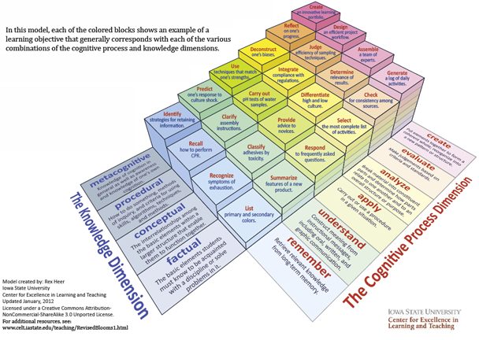
These lists are not complete and many adapted versions of Bloom’s Taxonomy circulate in the education aether.

Bloom, B. S.; Engelhart, M. D.; Furst, E. J.; Hill, W. H.; Krathwohl, D. R. (1956). Taxonomy of educational objectives: The classification of educational goals. Handbook I: Cognitive domain. New York: David McKay Company.

