Arithmetic and Algebraic Concepts

Integers, Odd and Even Numbers, Prime Numbers, Digits
Integers: . . . , -4, -3, -2, -1, 0, 1, 2, 3, 4, . . . ,
(Note: zero is neither positive nor negative.)
Consecutive Integers: Integers that follow in sequence; for example, 22, 23, 24, 25. Consecutive integers can be more generally represented by n, n +1, n + 2, n + 3, . . .
Odd Integers: . . . , -7, -5, -3, -1, 1, 3, 5, 7, . . . , 2k + 1, . . . , where k is an integer
Even Integers:. . . , -6, -4, -2, 0, 2, 4, 6, . . . , 2k, . . . , where k is an integer
(Note: zero is an even integer.)
Prime Numbers: 2, 3, 5, 7, 11, 13, 17, 19, . . .
(Note: 1 is not a prime and 2 is the only even prime.)
Digits: 0, 1, 2, 3, 4, 5, 6, 7, 8, 9
(Note: the units digit and the ones digit refer to the same digit in a number. For example, in the number 125, the 5 is called the units digit or the ones digit.)

Arithmetic and Algebraic Concepts

Percent Increase and Decrease

Percent
Percent means hundredths, or number out of 100. For example,
40 percent means 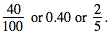
Problem 1: If the sales tax on a $30.00 item is $1.80, what is the sales tax rate?
Solution: 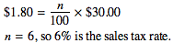

Percent Increase/Decrease
Problem 2: If the price of a computer was decreased from $1,000 to $750, by what percent was the price decreased?
Solution: The price decreased by 1,000 - 750 = 250 dollars. The percent price decrease is the value of n in the equation
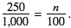The value of n is 25, so the price was decreased by 25%.
Note: 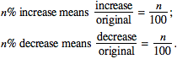

Arithmetic and Algebraic Concepts

Average and Average Speed

Average
An average is a statistic that is used to summarize data. The most common type of average is the arithmetic mean. The average (arithmetic mean) of a list of n numbers is equal to the sum of the numbers divided by n. For example, the mean of 2, 3, 5, 7, and 13 is equal to 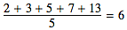.
When the average of a list of n numbers is given, the sum of the numbers can be found. For example, if the average of six numbers is 12, the sum of these six numbers is 12 x 6, or 72.
The median of a list of numbers is the number in the middle when the numbers are ordered from greatest to least or from least to greatest. For example, the median of 3, 8, 2, 6, and 9 is 6 because when the numbers are ordered, 2, 3, 6, 8, 9, the number in the middle is 6. When there is an even number of values, the median is the same as the mean of the two middle numbers. For example, the median of 6, 8, 9, 13, 14, and 16 is the mean of 9 and 13, which is 11.
The mode of a list of numbers is the number that occurs most often in the list. For example, 7 is the mode of 2, 7, 5, 8, 7, and 12. The numbers 2, 4, 2, 8, 2, 4, 7, 4, 9, and 11 have two modes, 2 and 4.
Note: On the SAT, the use of the word average refers to the arithmetic mean and is indicated by "average (arithmetic mean)." The exception is when a question involves average speed (see problem below). Questions involving median and mode will have those terms stated as part of the question's text.

Average Speed
Problem: José traveled for 2 hours at a rate of 70 kilometers per hour and for 5 hours at a rate of 60 kilometers per hour. What was his average speed for the 7-hour period?
Solution: In this situation, the average speed is 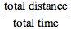.
The total distance is 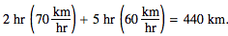
The total time is 7 hours. Thus, the average speed was 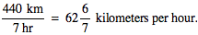
Note: In this example, the average speed is not the average of the two separate speeds, which would be 65 kilometers per hour.

Arithmetic and Algebraic Concepts

Factoring
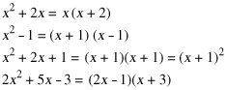

Arithmetic and Algebraic Concepts

Probability
Probability refers to the chance that a specific outcome can occur. It can be found by using the following definition when outcomes are equally likely: 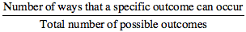.
For example, if a jar contains 13 red marbles and 7 green marbles, the probability that a marble to be selected from the jar at random will be green is 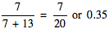.
If a particular outcome can never occur, its probability is 0. If an outcome is certain to occur, its probability is 1. In general, if p is the probability that a specific outcome will occur, values of p fall in the range Probability may be expressed as either a decimal or a fraction.

Arithmetic and Algebraic Concepts

Functions
A function is a relation in which each element of the domain is paired with exactly one element of the range. On the SAT, unless otherwise specified, the domain of any function ƒ is assumed to be the set of all real numbers x for which is a real number. For example, if the domain of ƒ is all real numbers greater than or equal to For this function, 14 is paired with 4, since
Note: the symbol represents the positive, or principal, square root. For example, not

Arithmetic and Algebraic Concepts

Exponents
You should be familiar with the following rules for exponents on the SAT.
For all values of a, b, x, y:
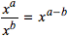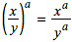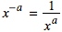
Note: For any nonzero number x,

Arithmetic and Algebraic Concepts

Sequences
The two most common types of sequences that appear on the SAT are arithmetic and geometric sequences.
An arithmetic sequence is a sequence in which the terms differ by the same constant amount. For example: 3, 5, 7, 9, . . . is an arithmetic sequence.
A geometric sequence is a sequence in which the ratio of successive terms is a constant. For example: 2, 4, 8, 16, . . . is a geometric sequence.
A sequence may also be defined using previously defined terms. For example, the first term of a sequence is 2, and each successive term is 1 less than twice the preceding term. This sequence would be 2, 3, 5, 9, 17, . . .
On the SAT, explicit rules are given for each sequence. For example, in the sequence above, you would not be expected to know that the 6th term is 33 without being given the fact that each term is 1 less than twice the preceding term. For sequences on the SAT, the first term is never referred to as the zeroth term.

Arithmetic and Algebraic Concepts

Variation
Direct Variation: The variable y is directly proportional to the variable x if there exists a nonzero constant k such that
Inverse Variation: The variable x is inversely proportional to the variable y if there exists a nonzero constant k such that
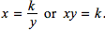

Arithmetic and Algebraic Concepts

Absolute Value

The absolute value of x is written in the form .
For all real numbers x:

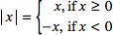

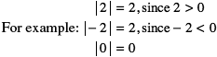

Geometric Concepts

Geometric Figures
Figures that accompany problems are intended to provide information useful in solving the problems. They are drawn as accurately as possible EXCEPT when it is stated in a particular problem that the figure is not drawn to scale. In general, even when figures are not drawn to scale, the relative positions of points and angles may be assumed to be in the order shown. Also, line segments that extend through points and appear to lie on the same line may be assumed to be on the same line. The text "Note: Figure not drawn to scale." is included with the figure when degree measures may not be accurately shown and specific lengths may not be drawn proportionally. The following examples illustrate what information can and cannot be assumed from figures.
Example 1: 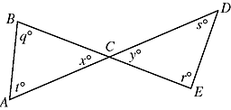
Since and are line segments, angles ACB and DCE are vertical angles. Therefore, you can conclude that x = y. Even though the figure is drawn to scale, you should NOT make any other assumptions without additional information. For example, you should NOT assume that or that the angle at vertex E is a right angle even though they might look that way in the figure.
Example 2: 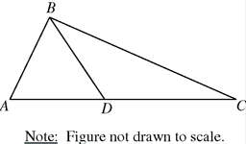
A question may refer to a triangle such as ABC above. Although the note indicates that the figure is not drawn to scale, you may assume the following:
- ABD and DBC are triangles.
- D is between A and C.
- A, D, and C are points on a line.
- The length of is less than the length of
- The measure of angle ABD is less than the measure of angle ABC.
You may not assume the following:
- The length of is less than the length of
- The measures of angles BAD and BDA are equal.
- The measure of angle ABD is greater than the measure of angle DBC.
- Angle ABC is a right angle.

Geometric Concepts

Properties of Parallel Lines
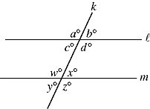
- If two parallel lines are cut by a third line, the alternate interior angles are congruent. In the figure above, c = x and w = d.
- If two parallel lines are cut by a third line, the corresponding angles are congruent. In the figure above, a = w, c = y, b = x, and d = z.
- If two parallel lines are cut by a transversal, the sum of the measures of the interior angles on the same side of the transversal is 180°.
In the figure above, c + w = 180 and d + x = 180.

Geometric Concepts

Angle Relationships
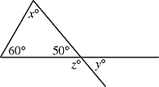
- The sum of the measures of the interior angles of a triangle is 180°.
In the figure above, .
- When two lines intersect, vertical angles are congruent.
In the figure above, .
- A straight angle measures 180°.
In the figure above, .
- The sum of the measures of the interior angles of a polygon can be found by drawing all diagonals of the polygon from one vertex and multiplying the number of triangles formed by 180°.
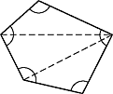 | Since the polygon is divided into 3 triangles, the sum of the measures of the angles is 3 x 180°, or 540°.
Unless otherwise noted, in the SAT, the term "polygon" will be used to mean a convex polygon; that is, a polygon in which each interior angle has a measure of less than 180°.
A polygon is "regular" if all sides are congruent and all angles are congruent.

Geometric Concepts

Side Relationships

1. Pythagorean Theorem: In any right triangle, where c is the length of the longest side and a and b are the lengths of the two shorter sides.

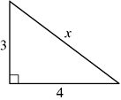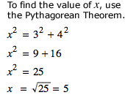

2. In any equilateral triangle, all sides are congruent and all angles are congruent. Because the measure of the unmarked angle is 60°, the measure of all angles of the triangle are equal; and, therefore, the lengths of all sides of the triangle are equal. x = y = 10 x = y = 10

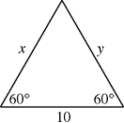

3. In an isosceles triangle, the angles opposite congruent sides are congruent. Also, the sides opposite congruent angles are congruent. In the figures below, and

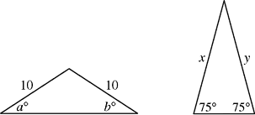

In any triangle, the longest side is opposite the largest angle, and the shortest side is opposite the smallest angle. In the figure below,

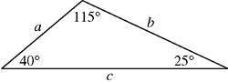

Two polygons are similar if and only if the lengths of their corresponding sides are in the same ratio and the measures of their corresponding angles are equal.

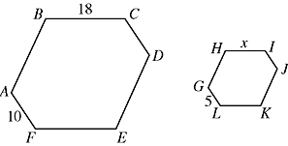
If polygons ABCDEF and GHIJKL are similar and and are corresponding sides, then
Note: means the line segment with endpoints A and F.
AF means the length of .

Geometric Concepts

Area and Perimeter

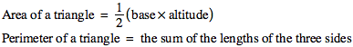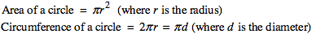

The sum of the lengths of any two sides of a triangle must be greater than the length of the third side.

Geometric Concepts

Volume

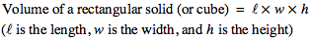

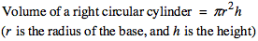

Geometric Concepts

Coordinate Geometry

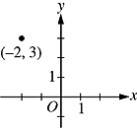

In questions that involve the x- and y-axes, x-values to the right of the y-axis are positive and x-values to the left of the y-axis are negative. Similarly, y-values above the x-axis are positive and y-values below the x-axis are negative. In an ordered pair the x-coordinate is written first. For example, in the pair the x-coordinate is and the y-coordinate is 3.

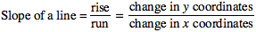

2.

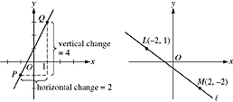

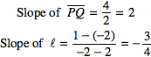
A line that slopes upward as you go from left to right has a positive slope. A line that slopes downward as you go from left to right has a negative slope. A horizontal line has a slope of zero. The slope of a vertical line is undefined.
Parallel lines have the same slope. The product of the slopes of two perpendicular lines is provided the slope of each of the lines is defined. For
example, any line perpendicular to line above has a slope of
The equation of a line can be expressed as where m is the slope and b is the y-intercept. Since the slope of line is the equation of line can be expressed as Since the point is on the line, so and the equation of line is

The equation of a parabola can be expressed as where the vertex of the parabola is at the point and If the parabola opens upward; and if the parabola opens downward.

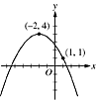

The parabola above has its vertex at Therefore, and The equation can be represented by Since the parabola opens downward, we know that To find the value of a, you also need to know another point on the parabola. Since we know the parabola passes through the point so Therefore, the equation for the parabola is

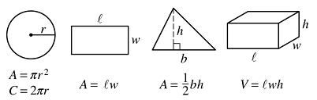

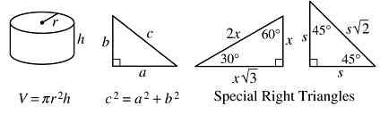

The number of degrees of arc in a circle is 360.
The sum of the measures in degrees of the angles of a triangle is 180.

