Lab 1: Heat Conduction and Temperature
Names
Purpose:
To study the heat conduction processes of thermal conductivity and thermal radiation.
Pre-lab:
1. Consider putting equal amounts of water in the freezer. One container of water is initially at room temperature, the other container contains boiling water. Which water freezes faster? Which water has initially the larger cooling rate?
The boiling water will have the larger cooling rate initially; however, the water at room temperature will ultimately freeze first.
2. If two liquids of different density are stored in a container such that they have the same surface area and both liquids have the same temperature and are in contact with reservoirs of equal temperatures and both liquids have the same emissivity energy, do they lose heat due to radiation at the same rate? Why?
Because all quantities in the heat of radiation equation are constant across the two liquids of different densities $H_{rad}=Aeσ\left(T^{4}-T_{s}^{4}\right)$, they lose heat due to radiation at the same rate.
3. In many low temperature experiments so called heat shields are used. They are made of metal and are kept at an intermediate temperature. Typical values for the application temperature, shield temperature, and outside temperature are 4[K], 77[K], and room temperature. Explain how the heat shields protect the application from the outside temperature.
Heat shields work by dissipating, reflecting, or absorbing the surrounding heat (protecting the application within).
Setup:
Temperature will be monitored of water in glass, foam, and metal containers as increasing or decreasing as a function of time (keeping the thermometer suspended in the water). Conclusions about the heat currents will be drawn. TA comments: The setup was not clearly stated. You should describe the details of the experimental setup. Even better, add a figure or a picture of the setup would be helpful.
Results:
For part A of the experiment, water was initially heated to boiling then distributed into a glass beaker and a foam cup. Temperature readings were taken from t=0, the moment the water was poured into the cup, to t=15. This was repeated twice. After finishing taking temperature readings for two trials of water starting at boiling, water was then heated to 75˚C and distributed into a glass beaker and foam cup. Temperature readings for this part were taken from t=0 (as defined above) to t=12. This was repeated twice. TA comments: every physical quantity should be accompanied by the unit. For example, t = 15 should have the unit with it, such as t = 15 min. Also, the experimental procedures along with the results of each part of the experiment should be described. Keep in mind that the reader of this report do not necessary have a lab manual.
In between trials, 50 g of tap water was poured into the beaker at 22.9 ˚C. A temperature reading was taken 3 minutes later at 28.8 ˚C, showing that the water from the tap came out cooler than the ambient temperature of the room.
For part B of the experiment, water was heated to boiling then divided between a black can and silver can. Temperature readings were collected from t=1 (1 minute after being poured into the cans) to t=12.
For both parts A and B, the rate at which the water is cooling is observed. TA comments: Next time label your raw data for me, it makes it easier to grade.
Raw Data
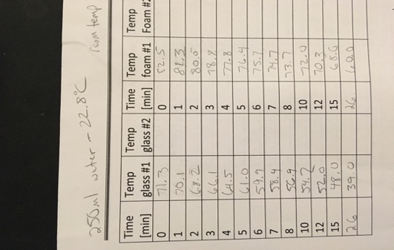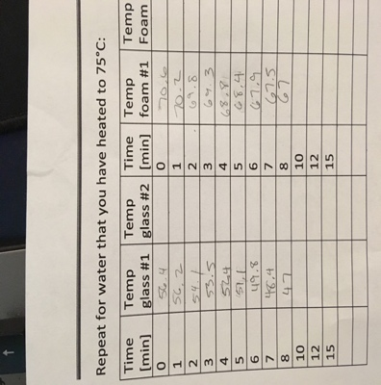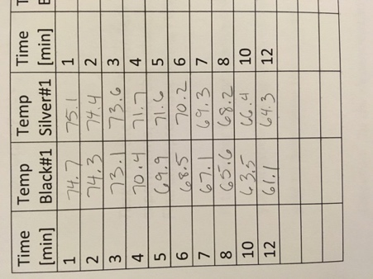 (Test 1) (Test 2) (Test 3)

Part A, Trial 1 (start with boiling water)
Time (min) | Temp glass #1 (˚C) | Temp foam #1 (˚C)
0 | 73 | 83
1 | 67.5 | 80
2 | 64.7 | 78.4
3 | 62.3 | 76.7
4 | 60.3 | 75.2
5 | 58.2 | 74
6 | 56.6 | 72.6
7 | 53.5 | 70.2
8 | 51.1 | 68.2
10 | 47.4 | 64.7
12 | 44.4 | 61.7
15 | 41.2 | 58.1

Part A, Trial 2 (start with boiling water)
Time (min) | Temp glass #2 (˚C) | Temp foam #2 (˚C)
0 | 78 | 85
1 | 76.1 | 83.5
2 | 74.8 | 81.8
3 | 72.1 | 80.5
4 | 70.3 | 79.5
5 | 68.7 | 78.3
6 | 66.9 | 77.3
7 | 64.2 | 74.6
8 | 62.3 | 73.2
10 | 56.1 | 69.7
12 | 53.5 | 67.4
15 | 49 | 63.7

Part A, Trial 1 (heated to 75˚C)
Time (min) | Temp glass #1 (˚C) | Temp foam #1 (˚C)
0 | 67.7 | 74.3
1 | 66.7 | 71.6
2 | 61.4 | 69.5
3 | 58.7 | 68.3
4 | 55.7 | 66.9
5 | 53.5 | 65.5
6 | 51.6 | 64.4
7 | 50 | 63.3
8 | 48.4 | 62.2
10 | 46 | 60.1
12 | 43.9 | 58.2

Part A, Trial 2 (heated to 75˚C)
Time (min) | Temp glass #2 (˚C) | Temp foam #2 (˚C)
0 | 74.7 | 79.7
1 | 74.4 | 78.9
2 | 71 | 77.1
3 | 68.3 | 75.3
4 | 66.2 | 73.8
5 | 64.3 | 72.2
6 | 62.7 | 70.8
7 | 56.2 | 66.7
8 | 54.9 | 62.9
10 | 51.8 | 59.2
12 | 49.3 | 56.3

Part B, Trial 1
Time (min) | Temp black #1 (˚C) | Temp black #2 (˚C)
1 | 74.9 | 74.6
2 | 72.2 | 73.3
3 | 67.9 | 68
4 | 64.9 | 65.1
5 | 62.2 | 64
6 | 59.8 | 62.9
7 | 57.7 | 61.7
8 | 55.7 | 60.5
10 | 52 | 58.1
12 | 48.7 | 56.2

*we ran out of time before making it to trial 2 TA comments: Each figure and table should be labeled with numerical order, such as Table 1 or Figure 1 etc.
Analysis:
Refer to the graphical data under results, which includes trendlines, error bars, and trendline equations. TA comments: How did you get these plots? Tell me about averages/standard deviations. How was the equation for the trendline picked/decided for using? What are the results of the analysis?
Discussion:
In the data, we observed that the best fit curve of each trial was a negative exponential, which leads us to believing that everything is approaching a thermal equilibrium. Furthermore, with each trial in Part A, we consistently found that the material of the container effected the rate of cooling; specifically, Styrofoam acted as a stronger insulator than glass. In the single trial completed in part B, we found that the color of the container effected the rate of cooling; the darker the color, the stronger the insulating ability. TA comments: The discussion should better incorporate with values to strengthen the argument. For example, “Styrofoam acted as a stronger insulator then glass” It should be accompanied by the values from your data to see how much difference is there and how much stronger it is.
Question: Is the temperature of the tap water the same as room temperature?
No, our initial measurement was 22.9˚C and after the three-minute period, it warmed to 28.8˚C (~room temperature).
Task: Plot the time dependencies of temperature for all experiments. Use the values for standard deviations as error bars. Find an appropriate fitting curve.
Refer to the graphical data found in the results section of the report.
Question: Do the dependencies differ for the containers and, if so, why?
Yes. This is due to the difference in thickness and conductivity of the containers. Furthermore, the Styrofoam lid enclosed the Styrofoam container better than the glass container.
Question (Cont.): Did it cool at a faster rate and, if so, did it cool faster at all temperature ranges?
For all of part A, the heated water poured into the glass container cooled faster than the heated water poured into the Styrofoam container (this can be seen at all temperature ranges except equilibrium). Looking at the derivative of both best fit curves shows us that the rate of change of the Styrofoam container is consistently lower in magnitude than that of the glass container (i.e. looking at part A, trial 1 graph (boiling water), the derivative of the Styrofoam curve is
dy/dx = -1.98e^-0.024x and the derivative of the glass curve is
dy/dx = -2.67e^-0.038x) TA comments: If you use Microsoft Word, please use equation editor to type equations. If you do hand writing, please write equations using correct mathematical expressions.

Question: Which heat mechanism(s) is/are responsible for the water heating up and which is/are responsible for the cooling down in the various experiments?

Thermal conduction is the heat mechanism responsible for heating water up, while thermal radiation is responsible for the cooling down in the various experiments.

Question: Did the water cool at different rates in the black and silver can? What could be the reason? Based on your explanation, which law would you apply to analyze the problem and what can you learn from the experiment about the constants in that law for the two different containers?

Yes, the water cooled at different rates in the black and silver can. The black can cooled slower, most likely because the darker color acted as a stronger insulator than the silver (similar to wearing dark colors on a hot day). Based on the Stephan-Boltzmann law, $H_{rad}=Aeσ(T^{4}-T_{s}^{4})$, you can analyze the problem to determine the constant for the black container was lower than that of the silver because the black container was able to retain more heat.

Task: Evaluate your predictions in the prelab. Did you make any wrong predictions? What are the correct answers to those questions? Why do you think your predictions were misleading?

All pre-lab predictions were correct except #2. We predicted that two liquids of different densities lose heat at the same rate; however, after completing the experiment, we realize that their constant value ($σ$) will most likely be different from one another, therefore, they will lose heat at different rates.

Conclusion:

After studying thermal radiation and thermal conductivity and conducting the experiment, we found that all things approach thermal equilibrium. With that being said, initial heat, vessel color, and vessel material all effect the rate at which the sample approaches equilibrium.

Author Contributions:

Everyone contributed equally to the experimental process. When came time for the lab report, everyone aided in contributing to each section. Furthermore, Student A typed.

Below is another type of author contributions.
Student A- experimental set-up, purpose, post lab, pre-lab, discussion
Student B-graphs, raw data, post lab, pre-lab, analysis, discussion
Student C- Pre-lab, experiment set-up and break-down, report final copy

